**Open Rocker Switch: Quick Guide**

# Introduction

The Open Rocker Switch is a dual mechanical pressure switch. A raised bar separates the right and left sides. Press anywhere on the right of the bar to activate the right switch and anywhere on the left side of the bar to activate the left switch. The switch has a 3.5 mm stereo jack. This switch has similar features to the AbleNet Rocker Switch.

# Features

Stereo 3.5 mm (1/8”) Jack

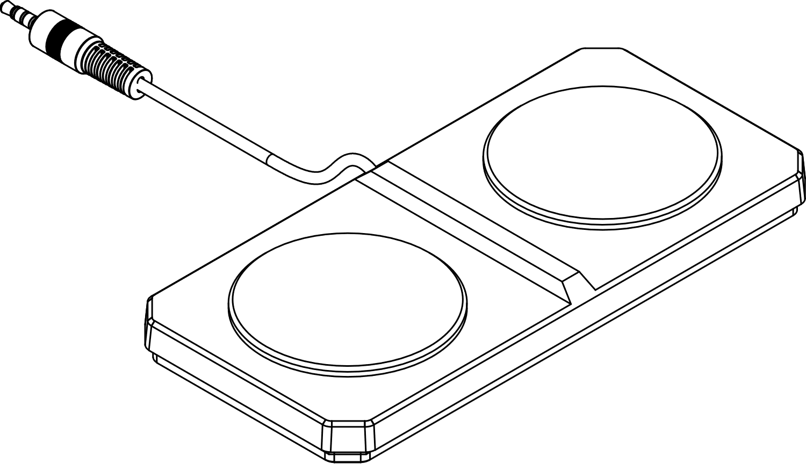

Right Activation Surface

Left Activation Surface

# Compatibility

The Open Rocker Switch is compatible with most assistive technology devices with a stereo input (e.g. SWIFTY USB Switch Interface).

The Open Rocker Switch can also be used with two mono inputs using a suitable stereo-to-mono adapter (i.e. Female Stereo to Male Mono-Left and Male Mono-Right).

# Usage

1. Connect the end of the 3.5 mm cable to the assistive device.

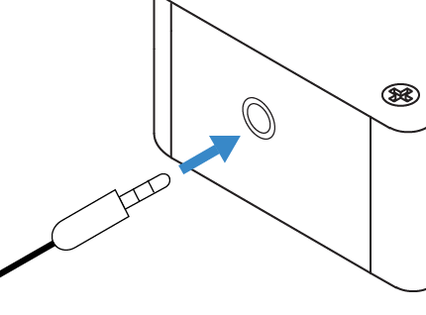

1. Activate the left switch by applying force on the left activation surface.
2. Activate the right switch by applying force on the right activation surface.

# Specifications

|  |  |
| --- | --- |
| Dimensions | L: 167 mm x W: 79 mm x T: 16 mm |
| Activation Force | 1.3N (30 – 40 gf) |
| Weight | 85 g |
| Feedback | Audible; Tactile |
| Cleaning | Damp cloth |