Overview
This document contains the necessary information to build the Open Rocker Switch, a two switch rocker style device, which can be activated by pressing the buttons on either side.
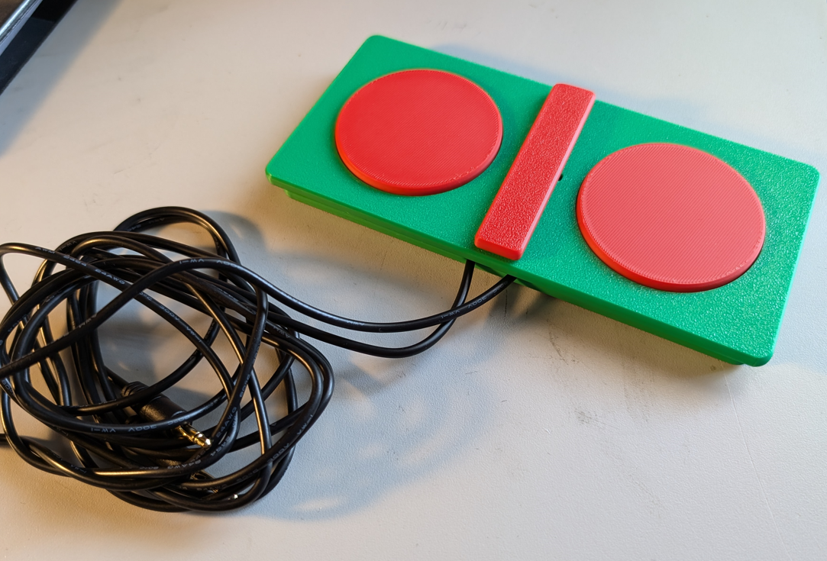

Contents
Overview 1
Maker Checklist 3
Maker To Do List 3
Items to Give to User 3
Tool List 4
Tools / Equipment 4
Supplies 4
Personal Protective Equipment (PPE) 4
Customization Guide 5
3D Printing Guide 5
3D Printing Summary 5
3D Printing Settings 5
Post-Processing 5
Examples of Quality Prints 6
Maker Component List 8
Assembly Guide 8
Open Rocker Switch 8
Open Rocker Switch Required Tools and Supplies 8
Open Rocker Switch Required Personal Protective Equipment (PPE) 8
Open Rocker Switch Assembly Steps 9
Assembled Switch 16
Testing 16
Troubleshooting 16

Maker Checklist
This list provides an overview of the steps required to build and deliver the Open Rocker Switch

Maker To Do List
- Read through the Maker Guide to become familiar with required components, tools, supplies, safety gear, and overall assembly steps.
- Talk to the User about customization options
  - Buttons and the divider can be printed in a different colour from the switch body
  - Buttons can be modified to be textured or have designs on them
  - How they would like to receive the “User Guide” (PDF or physical copy)
- Order hardware components
- Gather tools, supplies, and safety equipment.
- Assemble the device
- Test the Open Rocker Switch
- Print “User Guide” (if the User would like a physical copy)

Items to Give to User
- Assembled and tested Open Rocker Switch
- “User Guide”

Tool List

Tools / Equipment
Tool ID | Description | Required / Recommended | Notes
T01 | Soldering Iron | Required | Soldering buttons
T02 | Flush Cutters | Required | Cutting and trimming
T03 | Hot Glue Gun | Required | Attaching Buttons
T04 | Wire Strippers | Required | Stripping wire

Supplies
Supplies ID | Description | Quantity |  | Notes
S01 | Solder | 4 solder joints | Soldering switches to cable
S02 | Hot Glue | 2 small dabs | Securing buttons to device

Personal Protective Equipment (PPE)
PPE ID | Description | Notes
P01 | Safety glasses | Protecting your eyes

Customization Guide
The device can be printed in the user’s desired colour.
The buttons can be modified in Fusion 360 or another modeling program to add texture, patterns, or designs.

3D Printing Guide
The device was originally printed on a Bambu P1S using Bambu Studio
All default settings were used.

3D Printing Summary
Metrics | Single Unit
Total Print Time (hour min) | 2h25min
Total Number of Components | 6
Typical Total Mass (g) | 84g
Typical Number of Print Setups | 2

3D Printing Settings
Note that the 3D printing material should be assumed to be PLA unless otherwise noted in the table below.
Print File Name | Qty | Total Print Time (hr:min) | Mass (g) | Infill (%) | Support(Y/N) | Layer Height/ Nozzle Diameter(mm) | Notes
ORS_Top.stl | 1 | 0:54 | 29 | 20 | N | 0.2/0.4
ORS_Bottom.stl | 1 | 0:52 | 32 | 20 | N | 0.2/0.4
ORS_Button.stl | 2 | 0:15 | 9 | 20 | N | 0.2/0.4
ORS_Divider.stl | 1 | 0:07 | 4 | 20 | N | 0.2/0.4
ORS_Pin.stl | 1 | 0:02 | 1 | 20 | N | 0.2/0.4

Post-Processing
Inspect the 3D printed parts for any printing defects, sharp edges, or burrs. Sharp edges and burrs can be removed with sanding or deburring tools.

Examples of Quality Prints
Compare your 3D prints to the images here. If there are significant differences, you may need to reprint the part.
Open Rocker Switch Prints
ORS_Bottom.stl
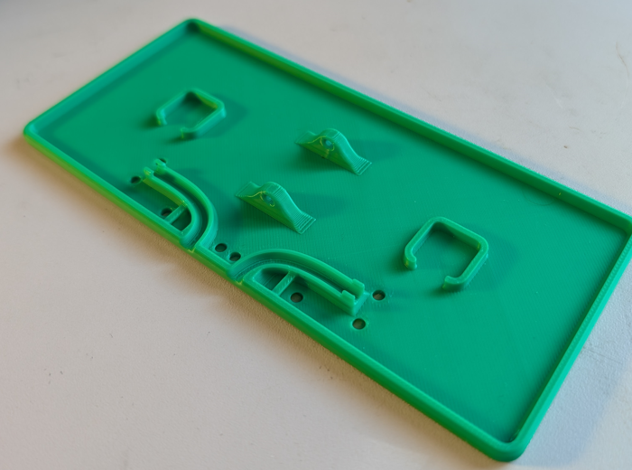 | 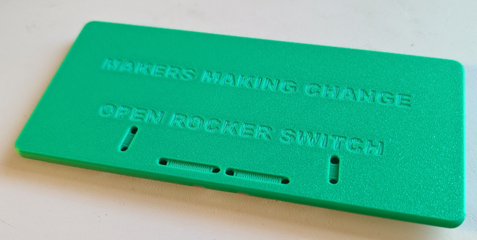
ORS_Top.stl
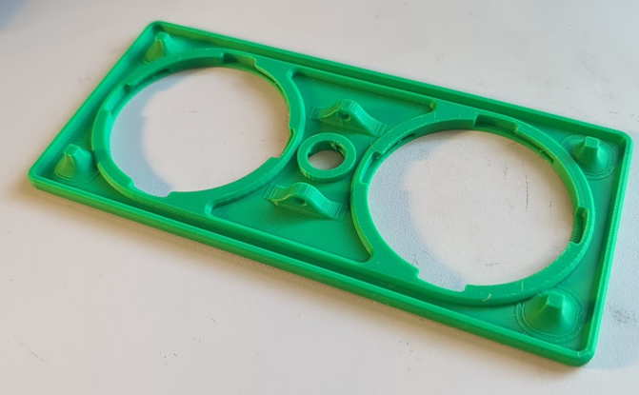 | 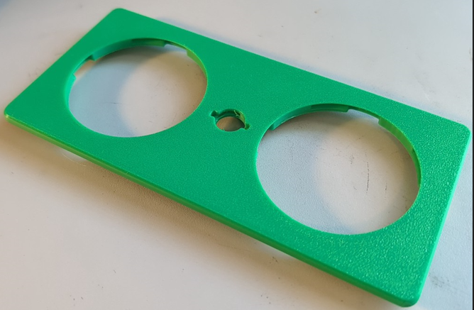
ORS_Button.stl
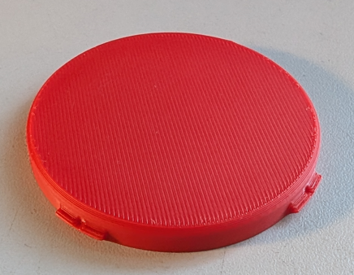 | 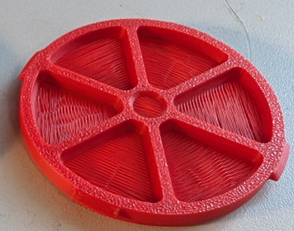
ORS_Divider.stl
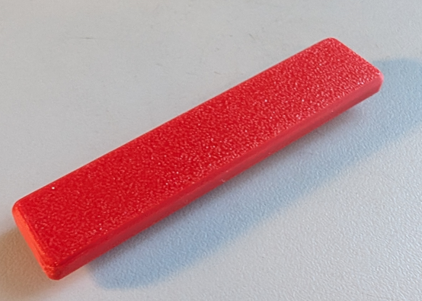 | 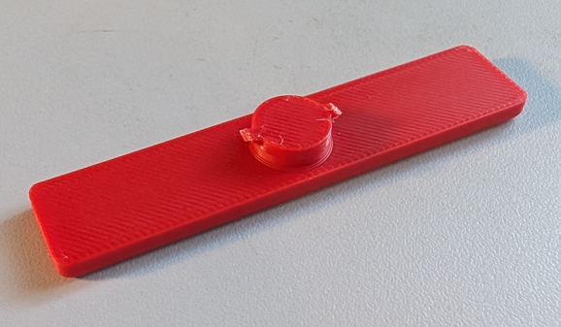
ORS_Pin.stl
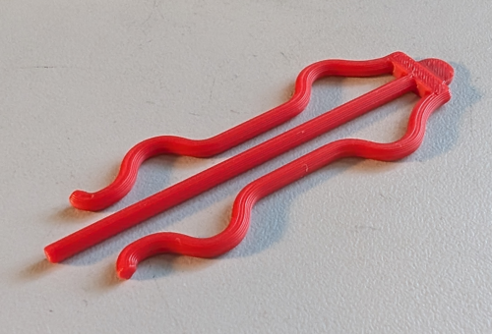

Maker Component List
Open Rocker Switch
A01 |  | ORS_Bottom | QTY: 1 |  | A02 |  | Button | QTY: 2 | A03 | Mono Cable |  | QTY: 1
 |  |  |  |  | 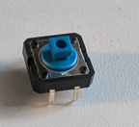 |  |  |  | 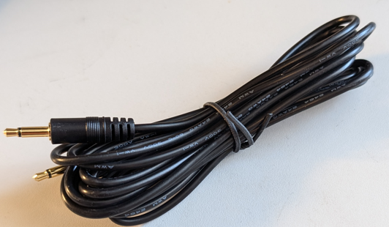
A04 | Zip Tie |  |  | QTY: 2 | A05 | ORS_Pin |  | QTY: 1 | A06 |  | ORS_Top |  | QTY: 1
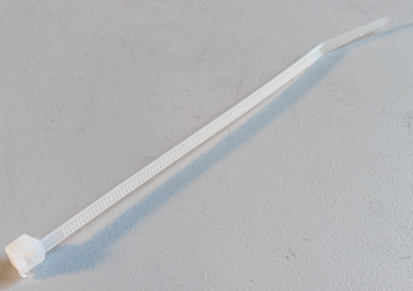
A07 | ORS_Divider |  |  | QTY: 1 | A08 | ORS_Button |  | QTY: 2

Assembly Guide

Open Rocker Switch

Open Rocker Switch Required Tools and Supplies
- T01: Soldering Iron
- T02: Flush Cutters
- T03: Hot Glue Gun
- T04: Wire Strippers

Open Rocker Switch Required Personal Protective Equipment (PPE)
- P01: Eye Protection

Open Rocker Switch Assembly Steps

Step A-01: Trim switch leads
Use a flush cutter to trim off the leads on one side of the tactile switch (A02). Make sure the leads are cut flush against the side of the switch and do not extend below the bottom of the switch.
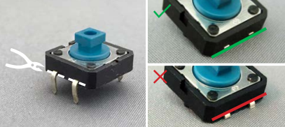

Step A-02: Straighten remaining switch leads
Straighten the remaining switch leads, ensuring they stick straight out from the side of the switch. Use the needle nosed pliers, if necessary.
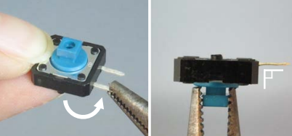

Step A-03: Trim mounting lugs
Use the flush cutters to trim the plastic mounting lugs (the plastic cylinders) off the bottom of the switch. Make sure the lugs are cut flush, with no remaining bumps.
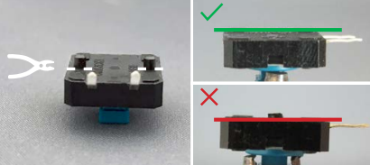

Step A-04: Cut the mono cable in half
Take the mono cable (A03) and cut it in half using flush cutters (T02).
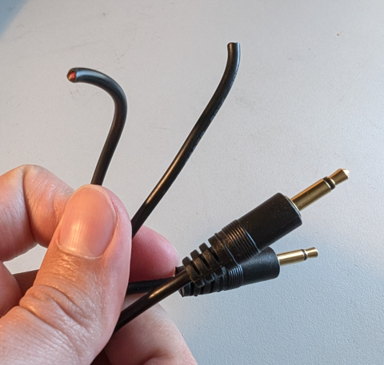

Step A-05: Strip the mono cable
Use the wire strippers (T04) to strip about 2 cm from the end of the mono cable, exposing the inner two wires. Twist the stranded wire together.
The inner wire colours may differ depending on the mono cable. Some may have one stranded wire and one coated wire, or have two coated wires. If you have two coated wires, do not twist any wires together at this step.
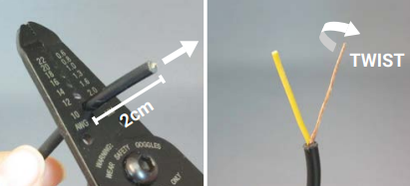

Step A-06: Strip the inner wire(s)
Strip about 1.5 cm of insulation from the end of the inner coated wire. Twist the wire strands from that wire together. Repeat this for the other coated wire, if both inner wires were coated.
The wire strands from each inner wire should not be touching each other or twisted together.
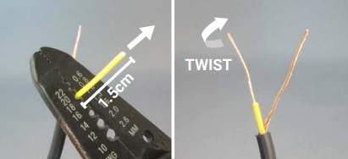

Step A-07: Wrap wires around switch leads
Hold the mono cable behind the switch and wrap one wire around one switch lead and the other wire around the other switch lead. Which wire is connected to which lead does not matter, just make sure the wires and leads do not touch each other, or the switch will be short circuited. Needle nosed pliers may help with wrapping the wires.
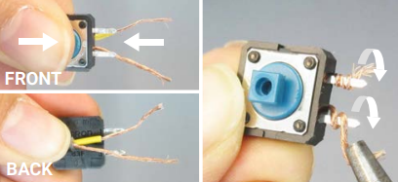

Step A-08: Fix orientation of cable
Hold the switch in place and bend the mono cable around so it sits between the leads of the switch.
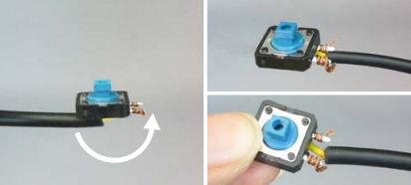

Step A-09: Solder switch joints
Solder the cable wires to the switch leads with the soldering iron (T01). Once soldered, the wires should not slip off the switch leads.
Once the switch is soldered, test the switch using a switch tester. Make sure it activates the switch tester when the switch is pressed, and turns off when the switch is not being pressed.
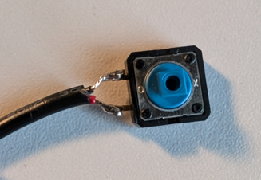

Step A-10: Hot glue the buttons to the base
Using a pinhead sized bead of hot glue, glue both switches to the square switch slots in the base of the switch(A01) using the hot glue gun (T03).
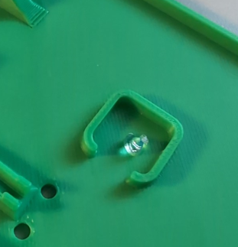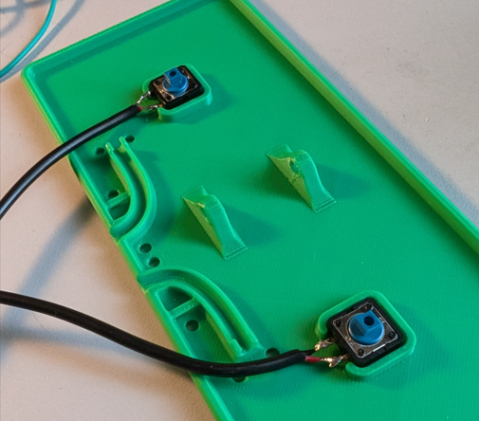

Step A-11: Insert the cable ties
Pass the tail of the cable ties(A04) through the bridge towards the centre of the switch. Lay the cables along the track on the base
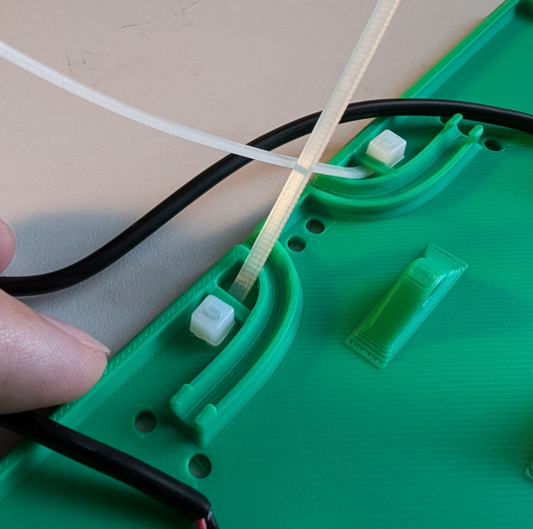

Step A-12: Loop the cable ties
Pass the tail ends of the cable ties over the cable and down through the holes at the centre of the switch. Pass them along the track on the base and up through the second hole, through the head of the cable tie. 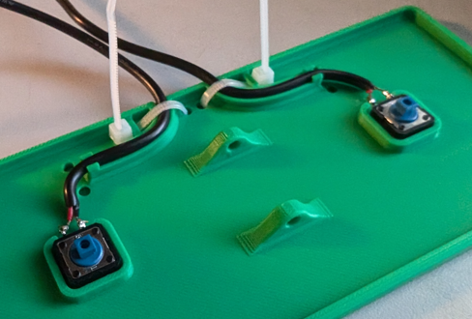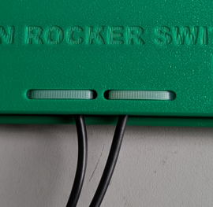

Step A-13: Tighten and trim the cable ties
Pull the cable ties tight until the cables are locked in place, then trim the tails of the cables flush with the head of the tie.
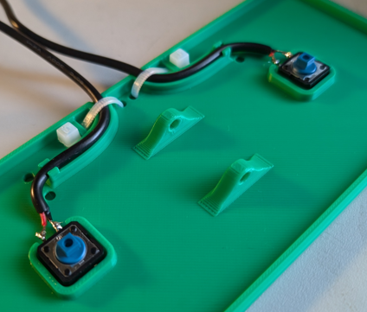

Step A-14: Attach the divider to the top
Place the divider(A07) sideways into the slot on the top of the top piece of the switch(A06), and rotate it 90 degrees to lock it in place.
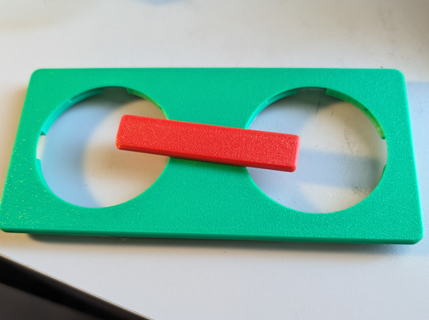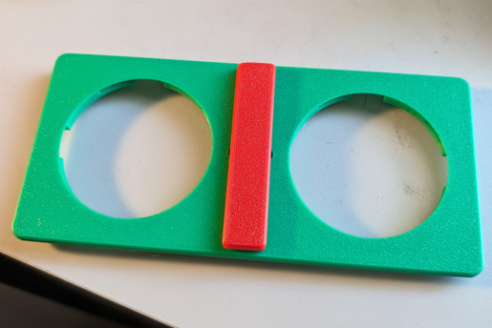

Step A-15: Attach the buttons to the top
Flip the top assembly over, and place the buttons(A08) in both of the slots int the bottom. Twist each button 45 degrees until they lock in place.
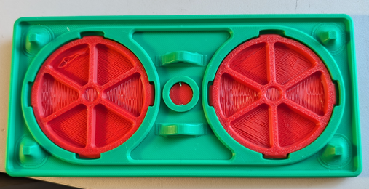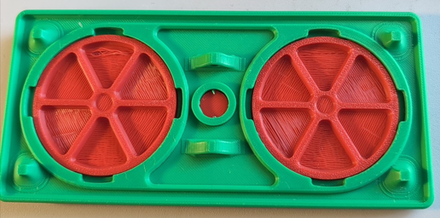

Step A-16: Pin the two halves of the switch together
Take the top and bottom assemblies and line up the holes on the posts on each. Take the pin(A05), and pass it through the holes from the far side towards the cables until you feel the pin click into place.
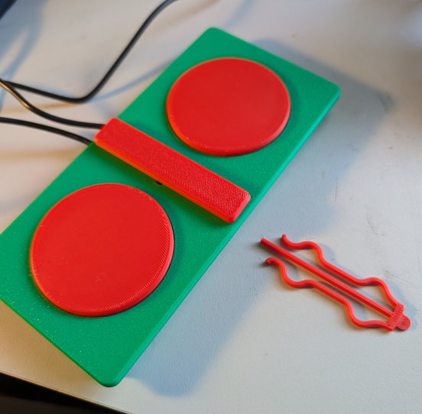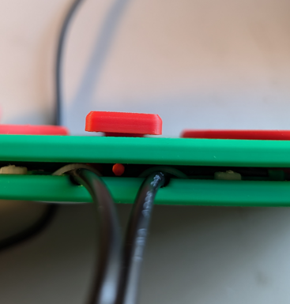

Step A-17: Test the assembled switch
Use a switch tester or a switch adapted device to test both of the cables coming out of the device. The switch tester should turn on when the switch is pressed, and turn off when the switch is not being pressed. If it does not work as expected, see the troubleshooting section.
If it works as expected, the switch is complete!

Assembled Switch

Testing
Use a switch tester or a switch adapted device to test both of the cables coming out of the device.

Troubleshooting
- Buttons press with a click but connected device not activating
  - If the buttons are clicking but the connected device is not activating, check the connections between the buttons and the cables. One of the connections on the button has most likely not been soldered correctly and circuit is not complete. Resolder the joints. If this does not solve the problem, try replacing the buttons with a new set.
- Buttons will not click when pressed
  - If the buttons will not click when pressed, they are most likely already pressed in the down position. Check that the buttons are flush against the bottom of the base. Things like improperly trimmed lugs or too much hot glue can raise the buttons up to the point where the neutral position of the top is enough to keep the buttons pressed down.
- Connected devices are always active
  - If the connected devices are always active but the button can still be clicked, check the connections between the cables and the wires. Look for any shorts between the leads on the buttons. A stray wire from the cables shorting between the two leads can cause the circuit to be always closed.

