# Overview

The goal of this GitHub resource is to help users understand how to use GitHub to download files from our GitHub repositories. This resource will not go into detail on how to clone and make your own repositories.

While we have included links to resources we have found useful in the past, we cannot guarantee that external links will remain active.

If you have any suggestions to improve this resource, you can add [an Issue to the GitHub page for our resources](https://github.com/makersmakingchange/OpenAT-Resources/issues).

Contents

Overview 1

Getting Started with GitHub 3

Repositories 3

Downloading Files 3

GitHub Issues 5

Finding Help 5

# Getting Started with GitHub

[GitHub](https://github.com/) is a developer platform that allows developers to create, store, manage, and share their code. It uses Git software, which helps with version control, and adds on other features such as bug tracking and wikis. You do not need an account to access files on GitHub, but if you want to create your own repositories or add issues to repositories, you will need to create an account.

## Repositories

GitHub organizes projects into [repositories](https://docs.github.com/en/repositories/creating-and-managing-repositories/about-repositories). These are where you can find all the work related to a project, and each of our devices has its own repository. The device pages on our website link to the repositories (you will need to be signed into your MMC account to see the link to the repository). Alternatively, if you go to [our GitHub](https://github.com/makersmakingchange), you can search the repositories to find the repository for the device you are looking for. You will see a search bar that reads “Find a repository…” to search for repositories (outlined in red in the image below). The search bar at the top of the page searches within documents for what you enter, not just for repository or document names.

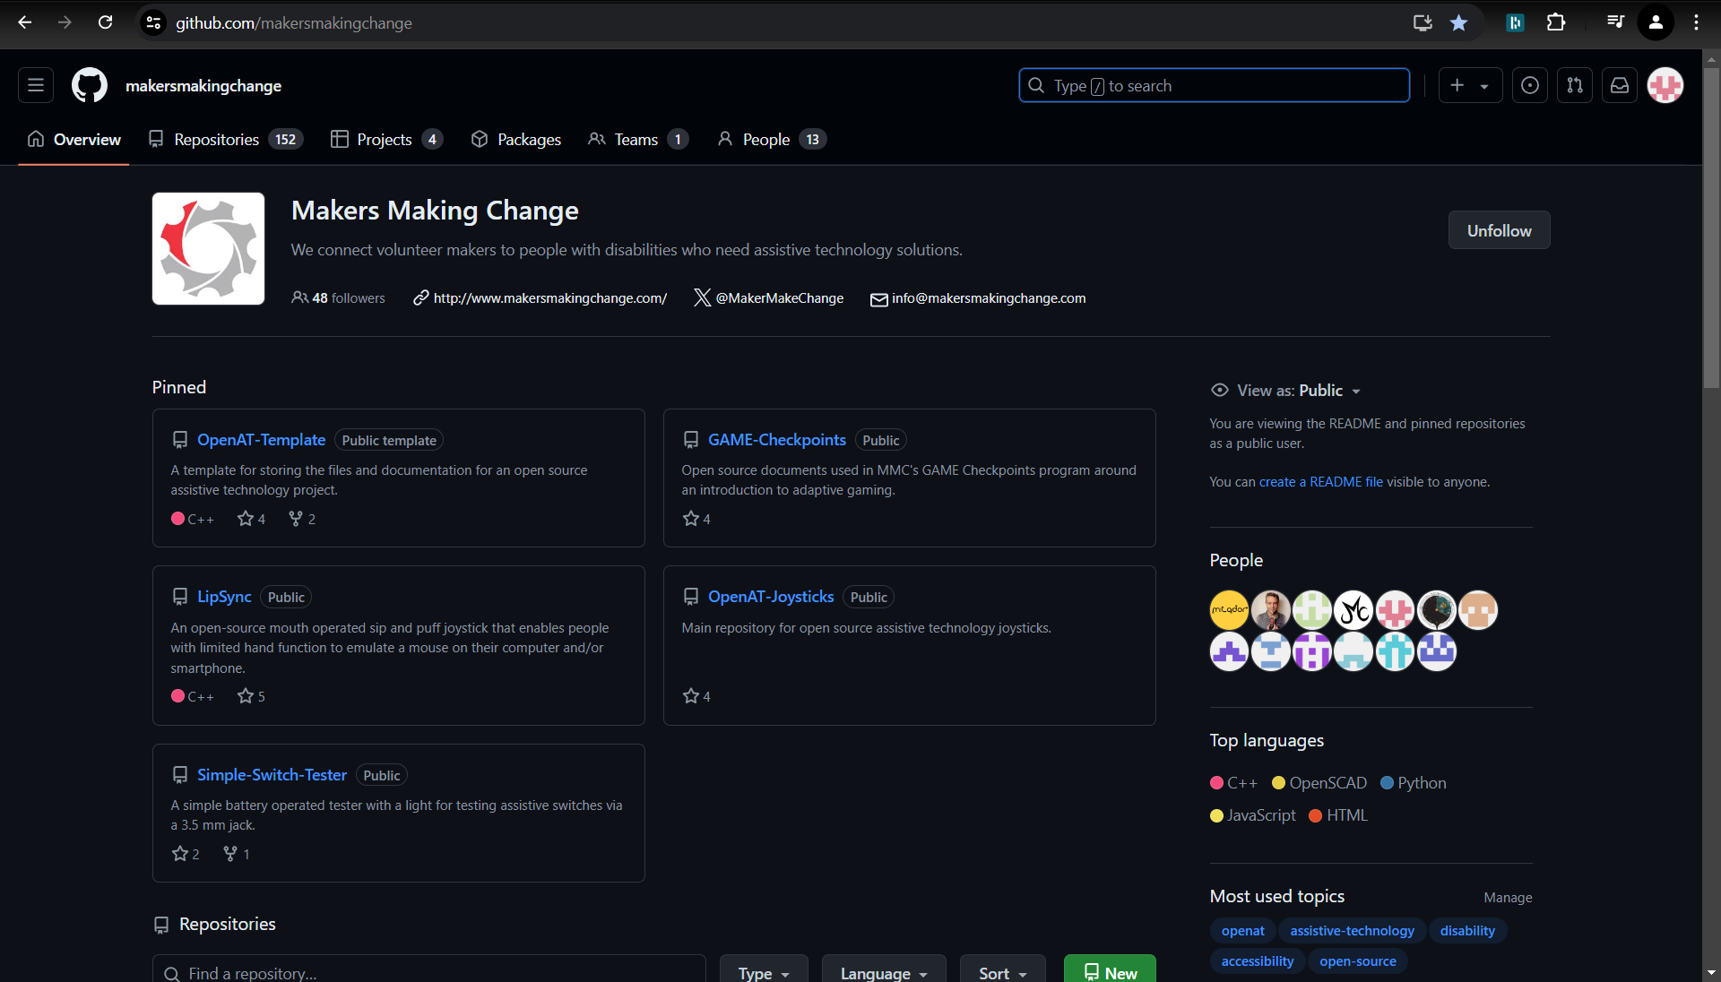

## Downloading Files

By default, files can either be downloaded from a repository individually, or a zip file of the entire repository can be downloaded. There are additional internet browser plugins that can be added to allow you to download zip files with a custom selection of files.

To download an individual file, click on the file name, then click the download icon on the file (a downward pointing arrow in the top right).

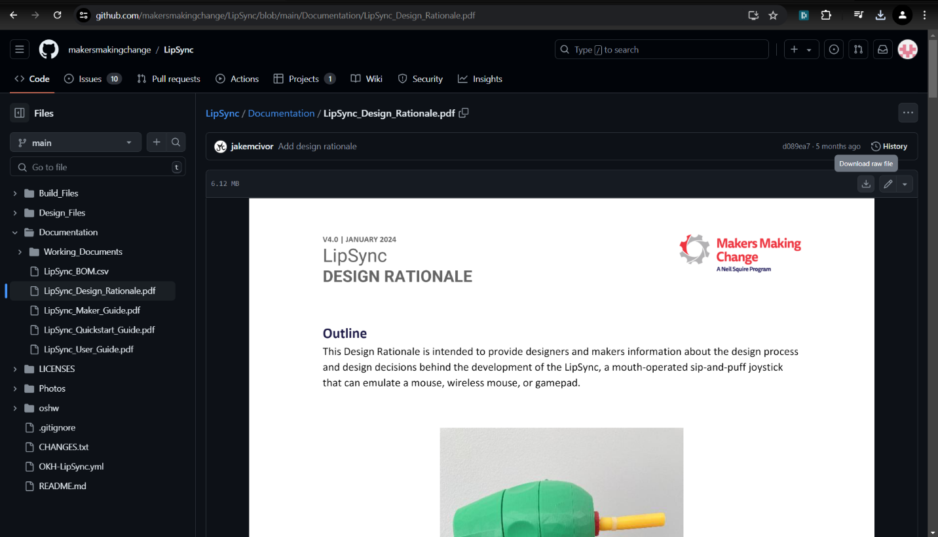

To download the entire repository in one zipped file, go to the main repository page, click on “Code”, and go down to “Download ZIP”.

## GitHub Issues

[GitHub Issues](https://docs.github.com/en/issues/tracking-your-work-with-issues/about-issues) are used for project planning. They can be used to track bugs, share ideas, and track progress. At MMC, we use Issues to track input from our community and the progress on incorporating that feedback. Feedback could be bugs in code, issues with the design, suggestions for improvements, or changes to the designs.

To submit an Issue, click on the “Issues” tab, then click “New Issue”.

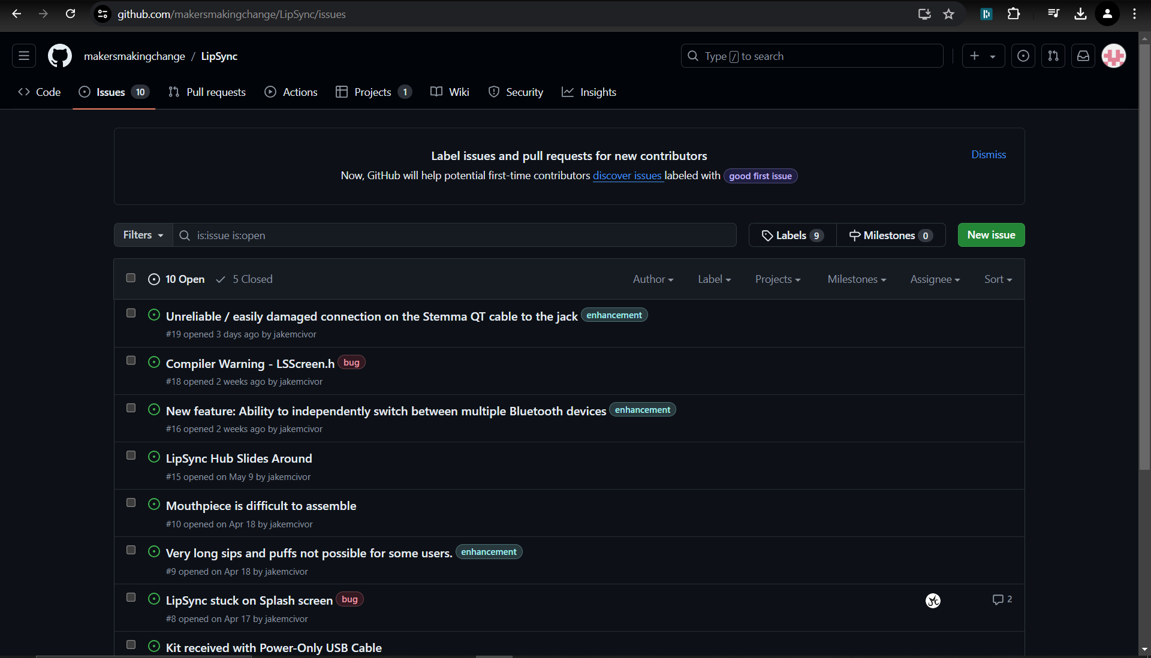

When creating an Issue, add a title that briefly describes the issue. You can also write out the details of the issue and add files. You can also add tags with labels and projects. Labels help categorize the issue (bugs, questions, document improvements, etc.), and projects let you link the tag to other projects/repositories.

# Finding Help

The online GitHub community is very active and the documentation of GitHub is thorough.

If you are having trouble with Makers Making Change repositories or devices, you can use the [Makers Making Change Community Forum](https://www.makersmakingchange.com/s/blog-article/acblb__Blog_article__c/Default) to ask questions to the MMC community. You can also post Issues to GitHub repositories.