# 3D Printing Summary

|  |  |  |
| --- | --- | --- |
| **Metrics** | **Individual Parts** | **Set** |
| Total Print Time (min) | 2:34 | 2:40 |
| Total Number of Components | 5 | 5 |
| Typical Total Mass (g) | 28 | 28 |
| Typical Number of Print Setups | 5 | 1 |

# Customization Options

The enclosure can be printed in the user’s desired colour. The Switch Slide can be printed in a contrasting color from the Enclosure Top and Enclosure Bottom to make it easier to see.

# 3D Printing Settings

## Individual Parts

|  |  |  |  |  |  |  |  |
| --- | --- | --- | --- | --- | --- | --- | --- |
| **Print File Name** | **Qty** | **Total Print Time (hr:min)** | **Mass (g)** | **Infill (%)** | **Support(Y/N)** | **Layer Height/ Nozzle Diameter(mm)** | **Notes** |
| Enclosure Top | 1 | 1:05 | 11.4 | 20 | N | 0.2/0.4 |  |
| Enclosure Bottom | 1 | 1:05 | 11.4 | 20 | N | 0.2/0.4 |  |
| Battery Cover | 1 | 0:15 | 3.3 | 20 | N | 0.2/0.4 |  |
| Switch Slide | 1 | 0:07 | 0.7 | 20 | N | 0.2/0.4 |  |
| LED Spacer | 1 | 0:02 | 0.5 | 20 | N | 0.2/0.4 | Optional; Recommended |

## Set

|  |  |  |  |  |  |  |  |
| --- | --- | --- | --- | --- | --- | --- | --- |
| **Print File Name** | **Qty** | **Total Print Time (hr:min)** | **Mass (g)** | **Infill (%)** | **Support(Y/N)** | **Layer Height/ Nozzle Diameter(mm)** | **Notes** |
| OpenAT-Switch-Latch_Set.stl | 1 | 2:40 | 28 | 20 | N | 0.2/0.4 |  |

# Post-Processing

Some post-processing may be required on the Enclosure Bottom where the battery cover screw attached to clean up any bridging that wasn’t successful.

# Examples of Quality Prints

**Enclosure Top**

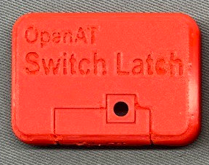

**Enclosure Bottom**

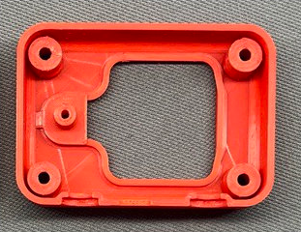

**Battery Cover**

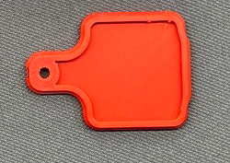

**Switch Slide**

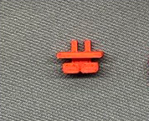

**LED Spacer**

