## Introduction

The OpenAT Switch Latch intended to convert a momentary switch input into a toggle switch output.

## Features

**Input Jack with switch:** Allows device to be turned on just by plugging in the cable (if switch is left turned on).

**Power Switch:** If the input cable is left in place, the switch to control power to the device.

**LED:** When lit, the LED indicates the switch on the output jack is toggled on (circuit is closed).

**Output Jack:** 3.5 mm output jack connects to the switch adapted device being controlled.

**Battery hatch: (case bottom)** The single screw battery hatch allows easy changing of the CR2032 battery.

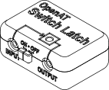

Input Jack

Output Jack

Power Switch Jack

LED

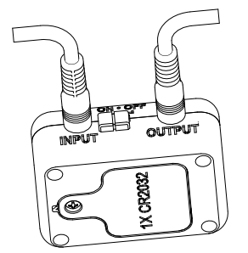

Battery hatch Jack

## Usage

To use the Switch Latch, a momentary switch is plugged into the 3.5 mm input jack. A switch adapted device is then plugged into the 3.5 mm output jack. The power switch must be enabled to use the device. However, the device will turn itself off if there is no plug inserted into the input jack.

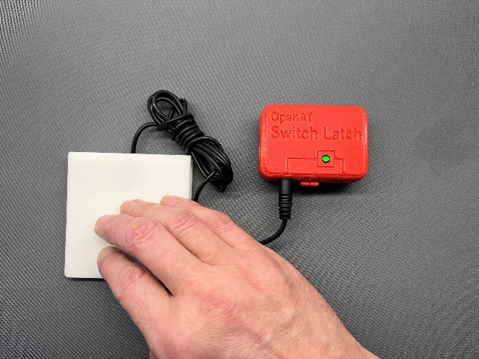

## Compatibility

Both inputs and outputs are compatible with standard 3.5 mm assistive switches and the devices they typically control.

## Specifications

**Dimensions:** 67.5 mm x 47.5 mm x 28mm

**Weight:** 45 g

**Power Consumption:** 112uA (0.11ma) on, 4uA standby (LED off).

## Cleaning

Device should be cleaned by wiping it with a damp cloth (not soaking wet), using either isopropyl alcohol (recommended) or water with 5% bleach as the cleaning agent.