# Required Components

|  |  |
| --- | --- |
| Five items for assembly: a 3D printed hardware cover, a tee nut insert, a 3D printed mounting plate, a 3D printed assembly washer, and a bolt. | **BOM**   1. Hardware Cover 2. ¼”-20 UNC Tee Nut 3. Mounting Plate 4. Assembly Washer 5. ¼”-20 UNC Bolt (Optional) |

# Required Tools

* Pliers
* Small Flat Head Screwdriver

# Required Personal Protective Equipment (PPE)

* Safety Glasses

# Mounting Plate Assembly Instructions

## Step 1: Align the Tee Nut

Align the prongs of the Tee Nut with their corresponding holes in the mounting plate. These holes may be covered by the sacrificial bridge used for printing, so a small flathead screwdriver can be used to pierce the mounting holes to make it easier to install.

**Note**: There are mounting holes for three-, four-, and six-pronged Tee Nuts.

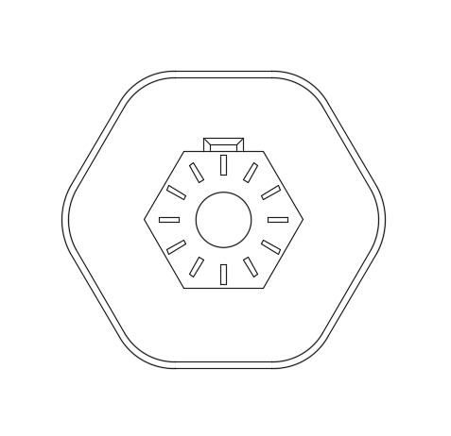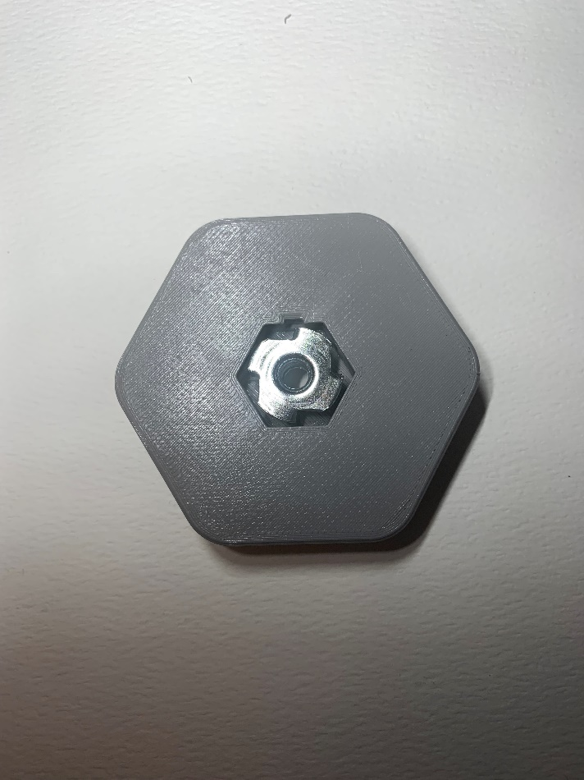

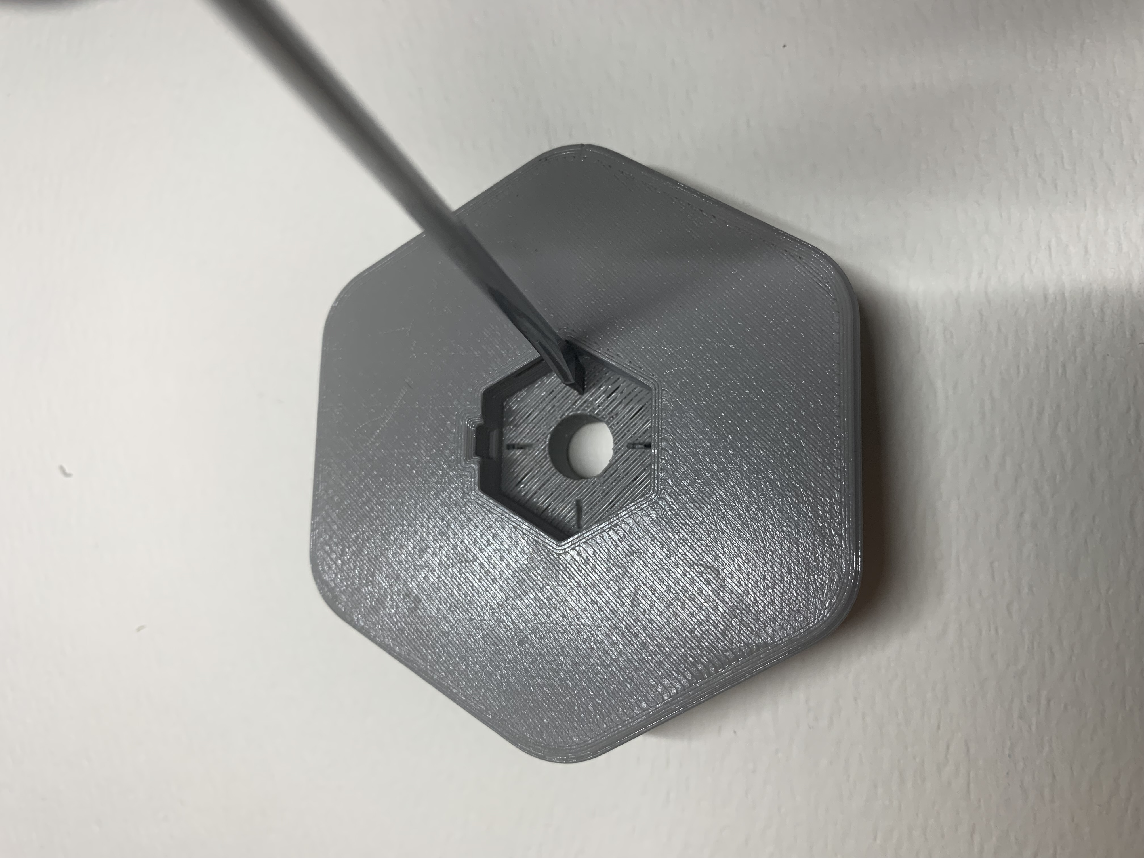

## Step 2: Install the Tee Nut into the Mounting Plate

With the Tee Nut aligned, firmly press it into the mount until fully seated. A ¼”-20 bolt can be used to help install the tee nut. Place the mounting washer onto the bolt and thread it from the top of the mounting plate and into the tee nut. Tighten the bolt until the tee nut is fully seated. Remove the bolt and discard the washer.

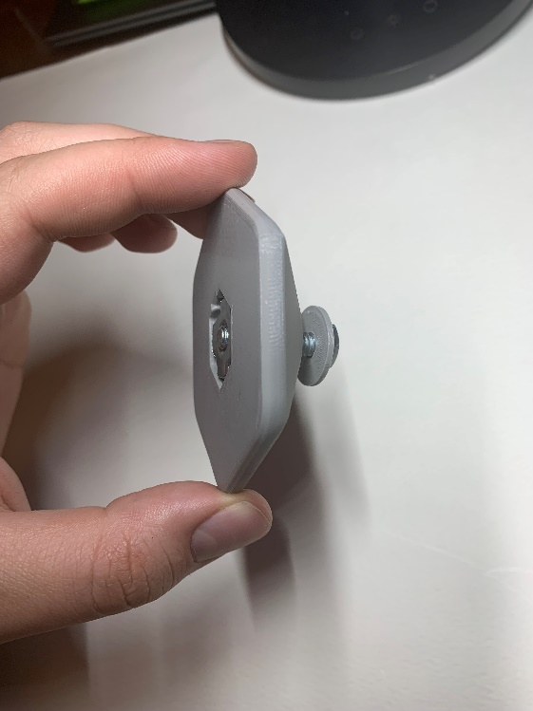A bolt being used to fully seat the tee nut into the mounting plate. 
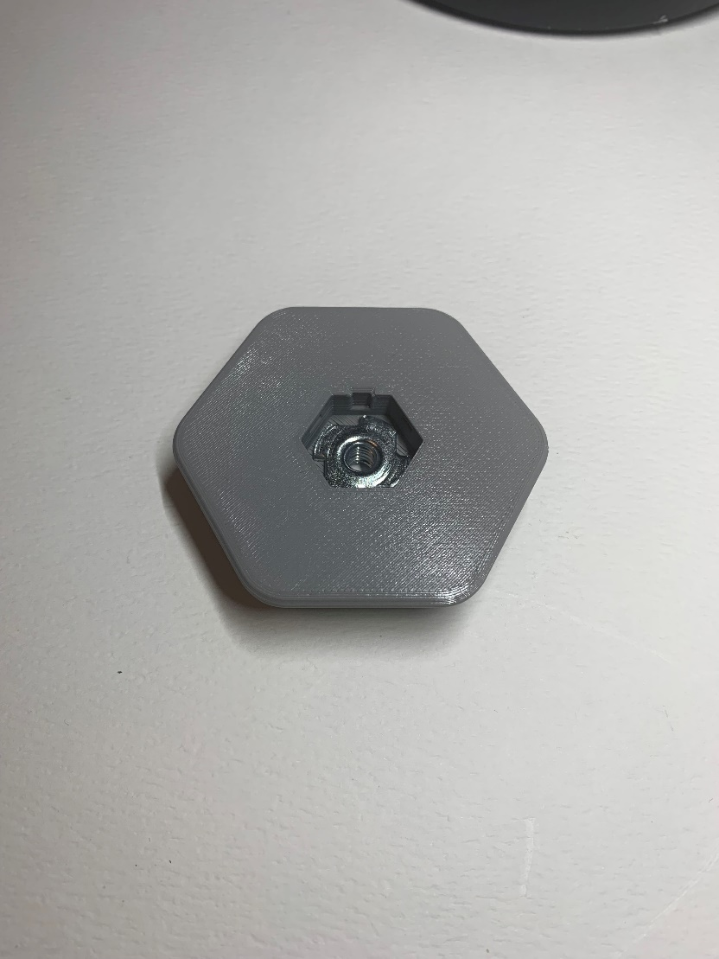

## Step 3: Install the Hardware Cover

The Hardware Cover must be installed onto the bottom of the mounting plate. Align the hexagonal cover with the hexagonal recess on the mounting plate and firmly press until it snaps into place. Pliers can be used to help insert the cover.

