# **Introduction**

The Hexagon Quick Mount is a simple mounting option for assistive devices that do not have integrated mounting hardware. This device has multiple options for both mounting plate size and tee nut length. If you are requesting this device, **please let the builder know what options work best for you**.

## **Using this Sizing Chart**

The sizing chart can be printed on standard letter sized paper (8.5” x 11”) to help determine the best options based on the devices you wish to mount. Do not use setting such as “Fit to page” that will alter the correct sizing of the following diagrams.

### **Choosing a Mounting Plate Size**

Arrange the device(s) you wish to mount onto the following diagram to determine what size works best for your application. There are three sizes available with widths of 45 mm, 65 mm, and 85 mm.

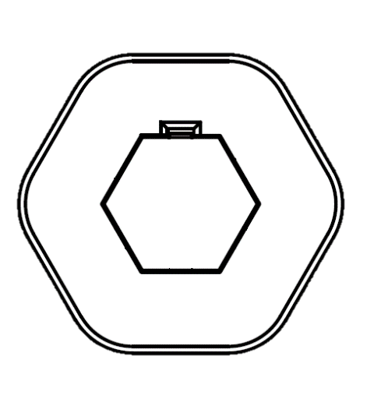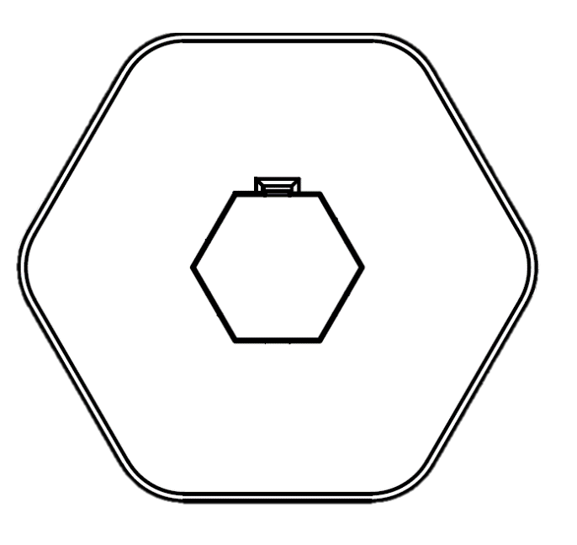

**Small Plate**

**Medium Plate**

**Large Plate**

**85 mm**

**65 mm**

**45 mm**

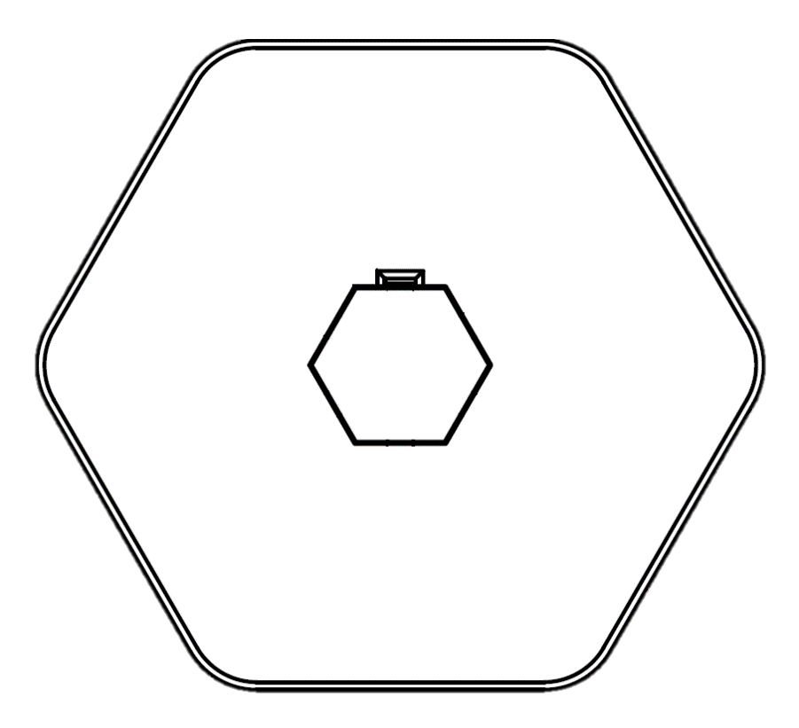

### **Choosing a Tee Nut Length**

The length of tee nut determines the approximate length of threads available for attaching the mounting plate to a mounting system. If you have a tee nut size preference, let the builder know. Otherwise, the following diagram is intended to let builders easily identify their tee nut size. Place your tee nut onto the diagram below to verify what length tee you are using.

|  |  |  |  |
| --- | --- | --- | --- |
| A steel tee nut insert. | **Tee Nut Options** | | |
| 5/16” x ¼"-20 UNC | 7/16” x ¼"-20 UNC | 9/16” x ¼"-20 UNC |
| A 5/16 inch tee nut insert. | A 7/16 inch tee nut insert. | A 9/16 inch tee nut insert. |

### **Selecting The Correct Print File**

Once you have determined your mounting plate size and tee nut length, use the following table to find the correct print file name.

|  |  |  |
| --- | --- | --- |
| **Print File Name** | **Mounting Plate Size** | **Tee Nut** |
| 45_Mounting_Plate_5.stl | 45 mm | 5/16” x ¼"-20 UNC |
| 45_Mounting_Plate_5.stl | 45 mm | 7/16” x ¼"-20 UNC |
| 45_Mounting_Plate_5.stl | 45 mm | 9/16” x ¼"-20 UNC |
| 65_Mounting_Plate_7.stl | 65 mm | 5/16” x ¼"-20 UNC |
| 65_Mounting_Plate_7.stl | 65 mm | 7/16” x ¼"-20 UNC |
| 65_Mounting_Plate_7.stl | 65 mm | 9/16” x ¼"-20 UNC |
| 85_Mounting_Plate_9.stl | 85 mm | 5/16” x ¼"-20 UNC |
| 85_Mounting_Plate_9.stl | 85 mm | 7/16” x ¼"-20 UNC |
| 85_Mounting_Plate_9.stl | 85 mm | 9/16” x ¼"-20 UNC |