## Introduction

The Hexagon Quick Mount is a simple mounting option for assistive devices that do not have integrated mounting hardware. This device uses hook and loop fastener strips to attach to an assistive device allowing it to be mounted with standard ¼”-20 mounts, like those found on readily available camera mounting accessories.

## Features

**Mounting Surface**

**Internal Mounting Threads**

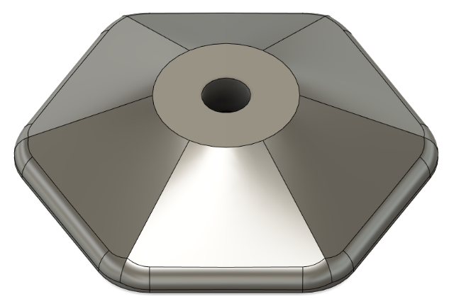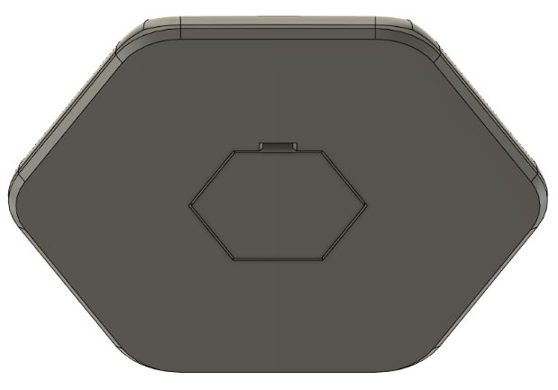

**Hardware Cover**

## Usage

### Attaching Devices

Use hook and loop fastener strips to secure one or more devices to the mounting surface.

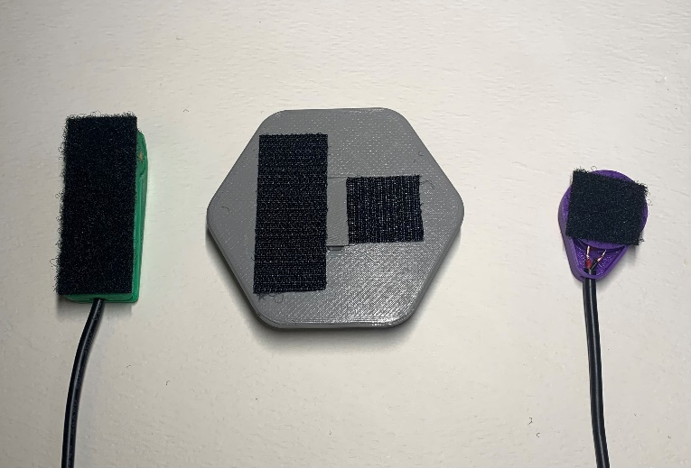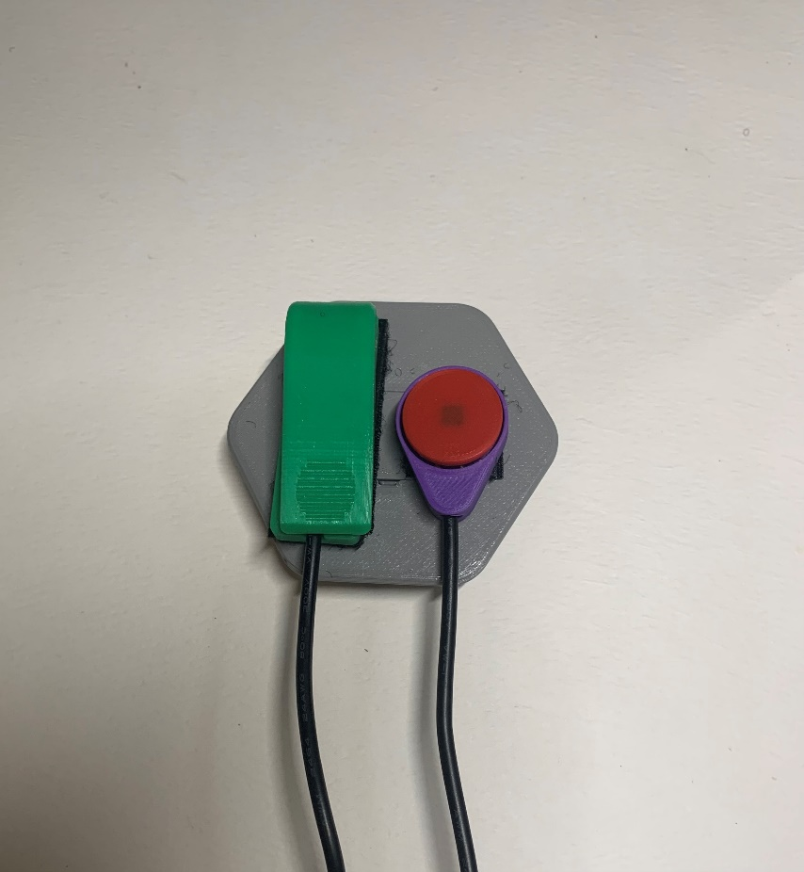

### Mounting

With your device(s) attached to the mounting surface, thread your mounting system into the internal threads of the mounting plate and lock it in your preferred orientation.

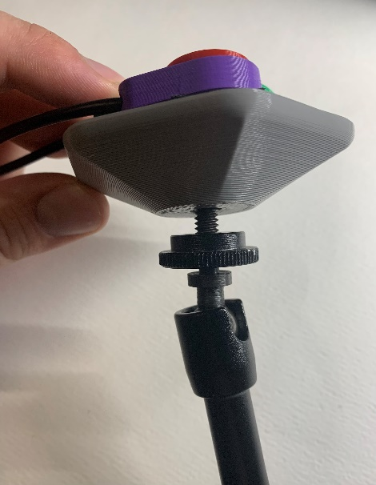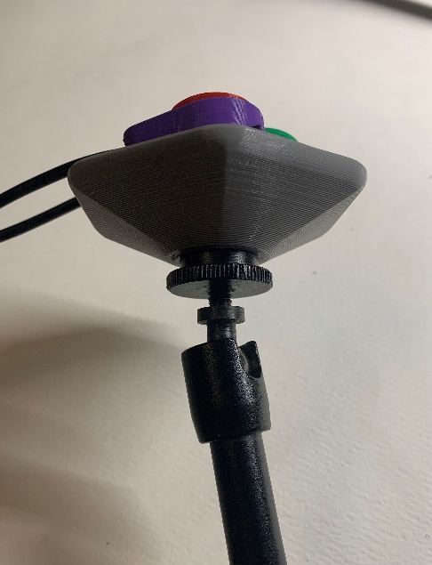A Light Touch Switch and Rain Drop Switch secured to the Magic Arm Mount using the mounting plate.


## Compatibility

The mounting plate excepts external ¼” – 20 threads like the ones commonly used in camera mounting systems. There are three available mounting plate sizes that can be selected to match the devices you wish to mount. There are also three options for threaded inserts with 5/16”, 7/16”, and 9/16” lengths of threads. Refer to the Sizing Chart for more information on sizing options.

## Specifications

|  |  |  |  |  |
| --- | --- | --- | --- | --- |
| **Mounting Plate** | **Width**  **[mm]** | **Length**  **[mm]** | **Thread Length**  **[mm](in)** | **Height**  **[mm]** |
| Small_Mounting_Plate_5-16 | 45 | 45 | 7.94 (5/16) | 15.9 |
| Small_Mounting_Plate_7-16 | 65 | 65 | 11.11 (7/16) | 19.1 |
| Small_Mounting_Plate_9-16 | 85 | 85 | 14.29 (9/16) | 22.3 |
| Medium_Mounting_Plate_5-16 | 45 | 45 | 7.94 (5/16) | 15.9 |
| Medium_Mounting_Plate_7-16 | 65 | 65 | 11.11 (7/16) | 19.1 |
| Medium_Mounting_Plate_9-16 | 85 | 85 | 14.29 (9/16) | 22.3 |
| Large_Mounting_Plate_5-16 | 45 | 45 | 7.94 (5/16) | 15.9 |
| Large_Mounting_Plate_7-16 | 65 | 65 | 11.11 (7/16) | 19.1 |
| Large_Mounting_Plate_9-16 | 85 | 85 | 14.29 (9/16) | 22.3 |

## Cleaning

Wipe with damp cloth or plastic safe cleaning wipes.