Introduction

The Camera Quick Clamp is an 3D printed adapter for attaching an assistive device to a section of 1/2 inch diameter PVC piping. The clamp has a ¼”- 20 UNC camera thread stud that is compatible with various assistive devices and/or camera mount adapters. The clamp can easily be installed, adjusted, and removed by hand.

Features

½” PVC / CPVC

Camera Tripod Stud

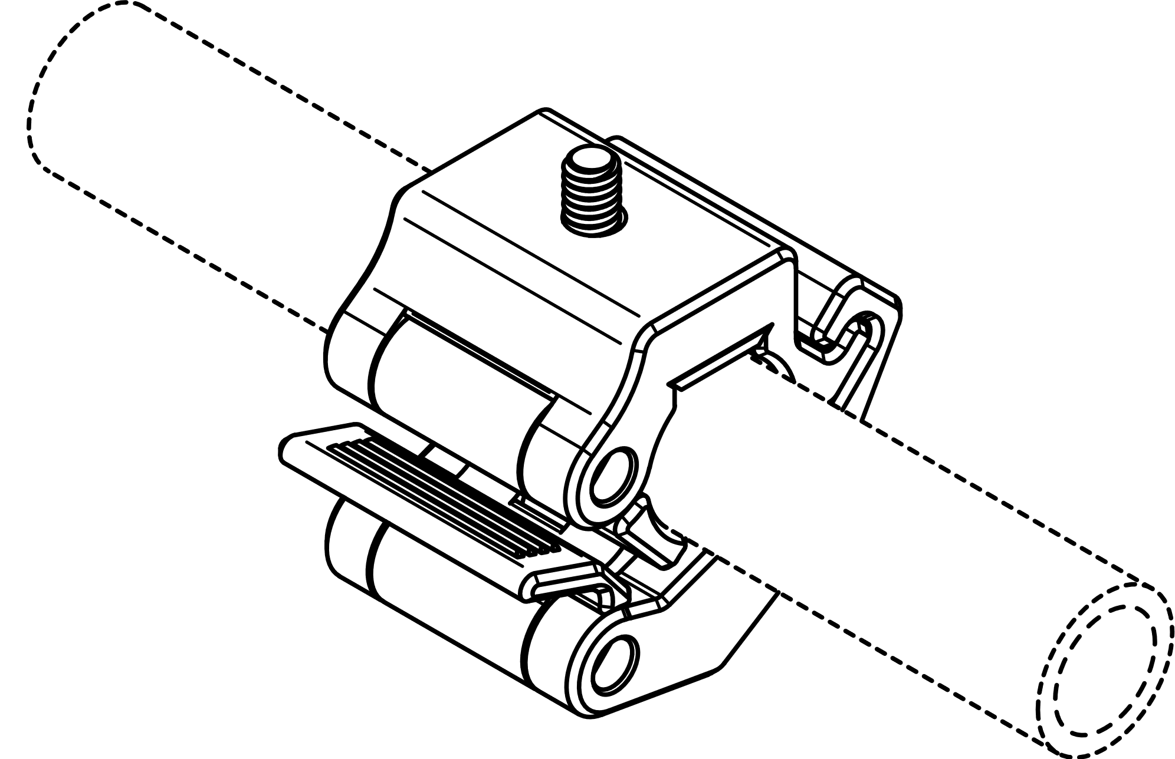

Latch Arm

Lever

Quick Clamp

Specification

|  |  |
| --- | --- |
| Envelope | Ø68 x 40 mm |
| Compatible Pipe | ½ inch PVC  ½ inch CPVC |
| Disinfection | Ethyl Alcohol, Isopropyl Alcohol, Hydrogen Peroxide |

Usage

1. Form the quick clamp around the PVC piping.

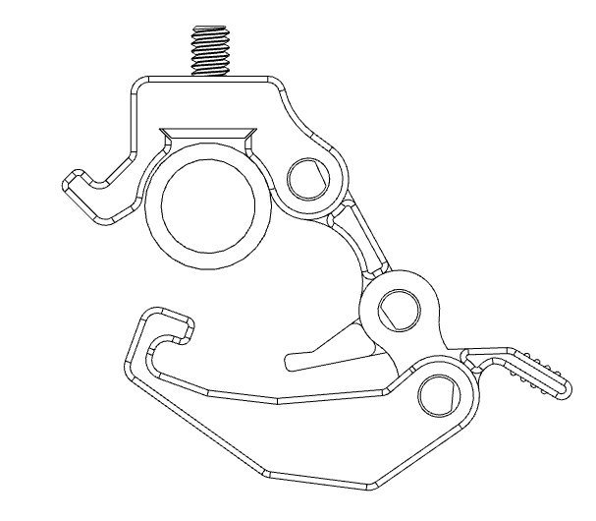

1. Position the latch arm onto the hook portion of the main body.

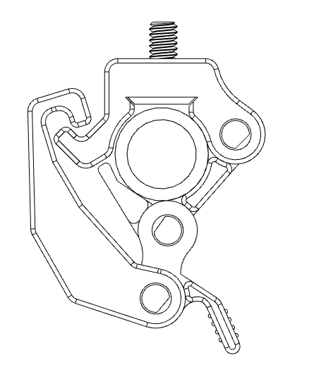

1. Press lever towards main body to tighten clamp on PVC.

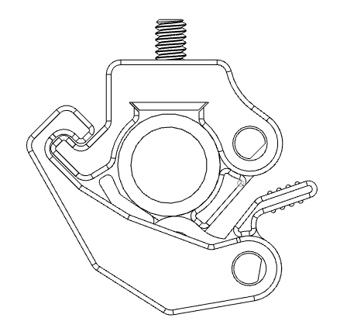

1. Attach assistive device using camera tripod stud.



