Introduction

The LipSync Desk Mount is a simple mounting solution for mounting the LipSync to a desk or table using a set of PVC piping components and C-clamps.

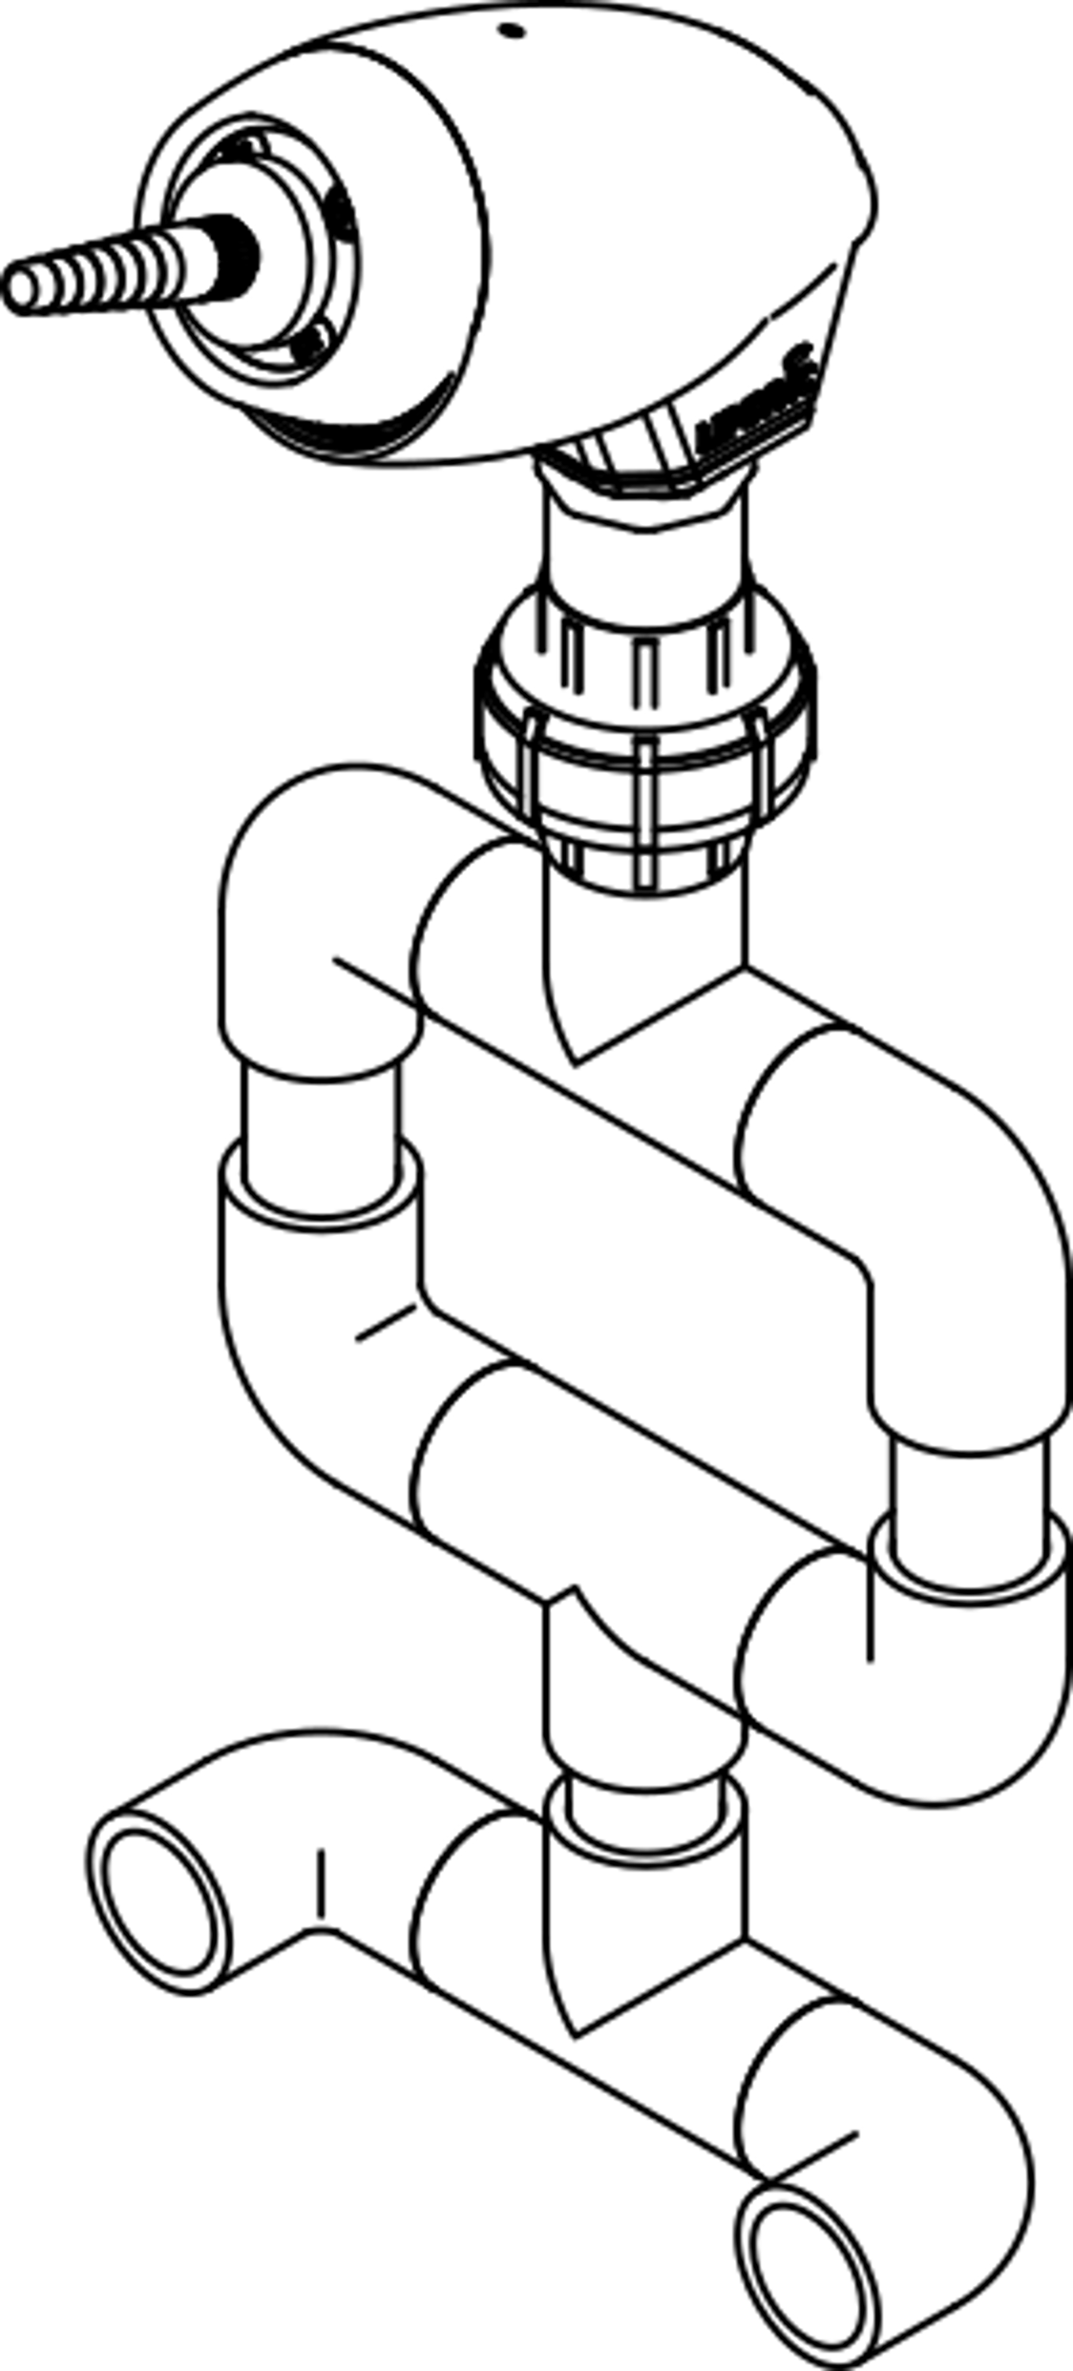Features

LipSync

Thread Adapter

Union

Bottom Elbow

Specifications

|  |  |
| --- | --- |
| Size | W 155 mm x D ~50 mm x H ~300 mm |
| Cleaning | Wipe with damp cloth |
| Disinfection | Ethyl Alcohol, Isopropyl Alcohol, Hydrogen Peroxide |

Attaching the LipSync

1. If present, remove the metal threaded adapter and threaded insert by unscrewing them from the bottom of the LipSync.
2. Being careful not to damage the USB cable, thread the PVC Thread Adapter directly into the 3D printed shell of the LipSync. Do not overtighten.

Mounting to Desk

1. Remove the LipSync from the mount by unscrewing the PVC Union.
2. Use the 2 C-clamps to clamp the bottom PVC Elbows to the table.
3. Reattach the LipSync to the mount by connecting the Union.

Adjusting the Position

The position of the LipSync can be adjusted by manipulating the PVC joints, which are held by friction.

