**PVC Mounting Kit: Quick Guide**

# Introduction

The PVC Mounting Kit is a set of readily available, cost effective components that can be used to mount a LipSync to a desk or table.

# Contents

|  |  |  |
| --- | --- | --- |
| **Component** | **Description** | **QTY** |
| PVC Pipe | ½” Dia., 25 mm Length | 7 |
| PVC Pipe | ½” Dia., 30 mm Length | 3 |
| PVC Pipe | ½” Dia., 40 mm Length | 2 |
| PVC Union | ½” Union | 1 |
| PVC Elbow | ½” Soc x ½” Soc | 6 |
| PVC Tee | ½” Soc x ½” Soc x ½” Soc | 3 |
| PVC Adapter | ½” NPT x ½” Female Soc Adapter | 1 |
| C-Clamp | 2 — 2-1/2” C-Clamp | 2 |

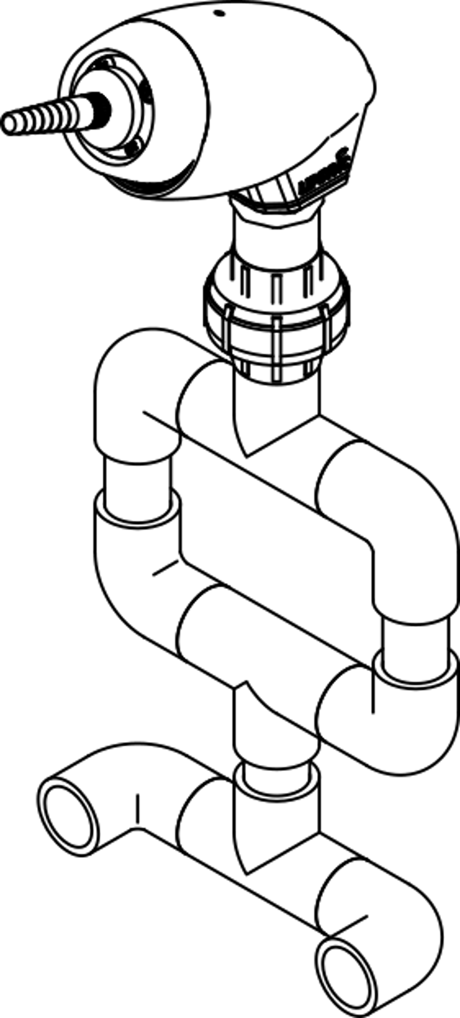

Adapter

Elbow

Union

Tee

LipSync

# Assembly

Create the connection pieces by cutting the PVC Pipe to length. Use the shorter sections to connect fittings together where you want relative movement. Use the longer sections for the middle portion. The joints should be left free of any adhesive to allow relative motion.

The PVC can be painted or covered in tape to improve the appearance of the mount.

# Setup

Remove the threaded adapter and insert from the Lipsync. Carefully thread the threaded PVC adapter into the Lipsync housing.

Use the C-clamps to attach the mount to a table or desk.

The elbow joints can be moved to adjust the position of the Lipsync.

The union can be used to adjust the rotation and quickly remove the Lipsync for storage or use elsewhere.

# Cleaning and Care

PVC can be cleaned by wiping with a damp cloth.