Introduction

The Small Button Mount is a solution for positioning small switches on a flat surface like a desk or table. It can be used to position a switch at an angle or perpendicular to the surface.

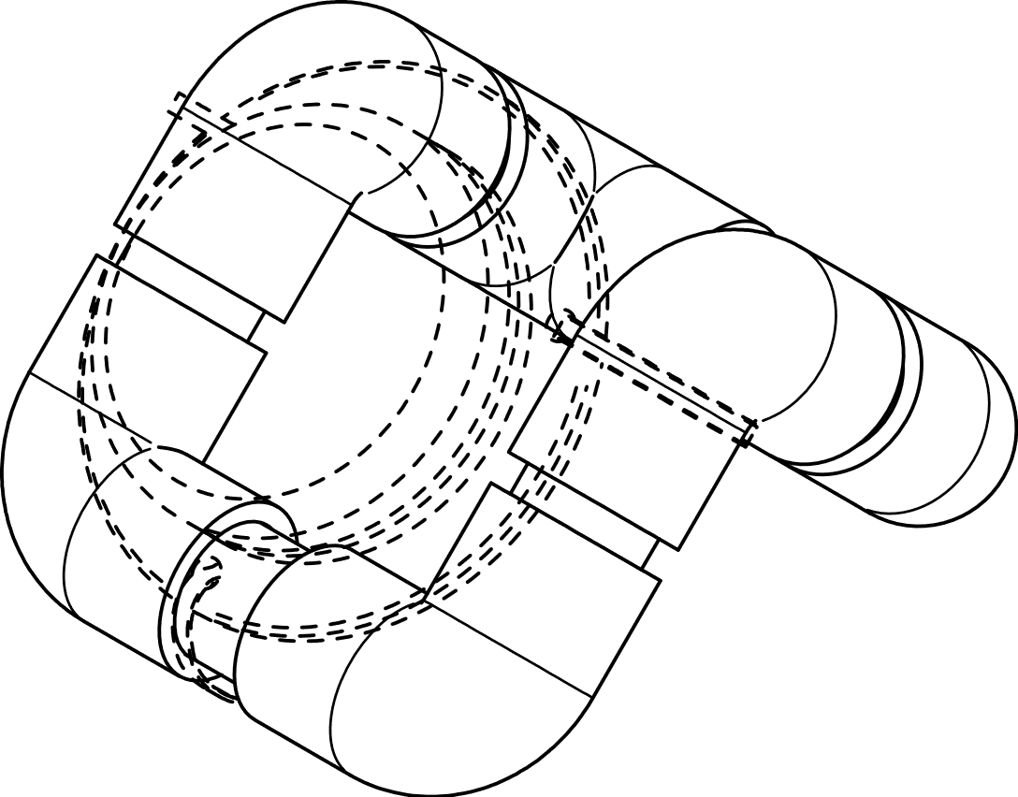Features

Small Switch

Small Button Mount

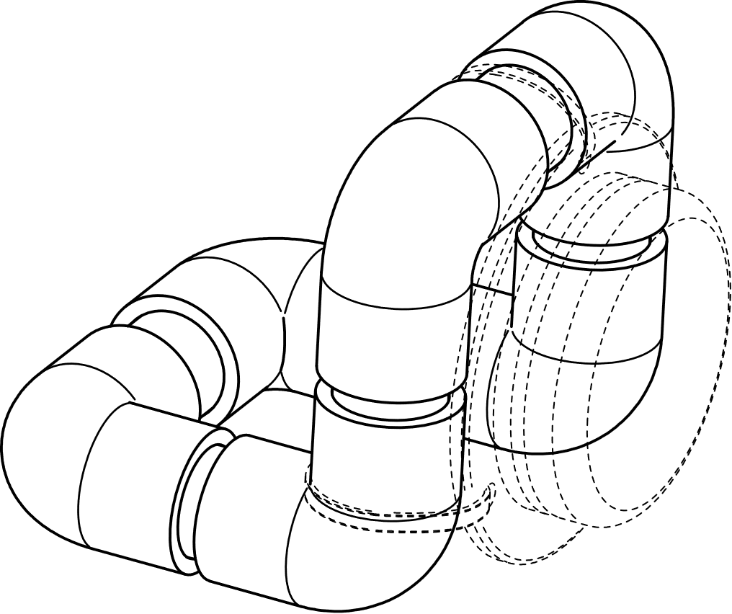

Specifications

|  |  |
| --- | --- |
| Size | L 96 mm x W 106 mm x H 96 mm |
| Disinfection | Ethyl Alcohol, Isopropyl Alcohol, Hydrogen Peroxide |

Attaching Switch – Cable Tie

1. Attach button to mount using 3 cable ties.

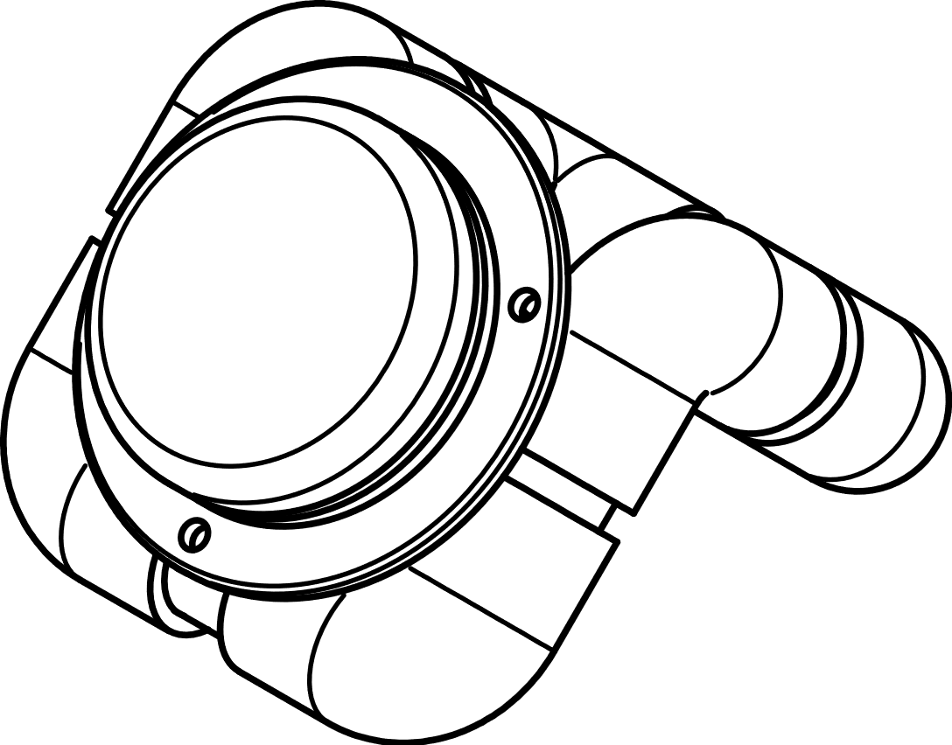

1. Position the mounted switch.

