## Introduction

This device is intended for users that cannot use traditional stylus pens for a variety of reasons. Instead of a traditional pen style stylus, it ends in a large ball that requires much less strength and dexterity to grip. The device uses a length of wire and conductive foam to allow the user to interact with the capacitive touchscreen.

## Features

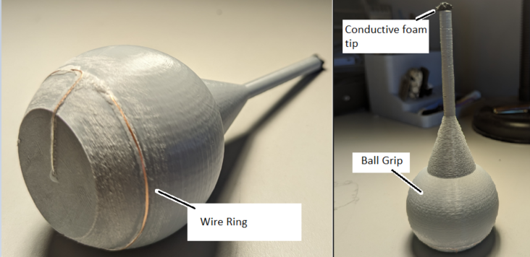

## Usage

To use the device, hold the ball with the foam stylus end facing away from the palm. For the device to work, the user must maintain skin contact with the wire along the side of the ball. The device can then be used as a traditional stylus with the foam touching the device screen.

## Compatibility

This device works with smartphones, or any other device that works with a similar capacitive style touchscreen.

## Specifications

The diameter of the ball is 60mm, and the total height is 145mm

The assembled device weighs 45 grams

## Cleaning

The device can be wiped clean with a damp cloth.