# 3D Printing Summary

|  |  |
| --- | --- |
| **Metrics** |  |
| Total Print Time (min) | 394 |
| Total Number of Components | 4 |
| Typical Total Mass (g) | 53 |
| Typical Number of Print Setups | 4 |

# 3D Printing Settings

|  |  |  |  |  |  |  |  |
| --- | --- | --- | --- | --- | --- | --- | --- |
| **Print File Name** | **Qty** | **Total Print Time (hr:min)** | **Mass (g)** | **Infill (%)** | **Support(Y/N)** | **Layer Height/ Nozzle Diameter(mm)** | **Notes (orientation, special settings, etc.)** |
| lower.stl | 1 | 2:43 | 20 | 20 | N | 0.2/0.4 | * Print in orientation given in STL |
| upper.stl | 1 | 3:43 | 31 | 20 | N | 0.2/0.4 | * Print in orientation given in STL |
| hinge_pin.stl | 1 | 0:04 | 0.5 | 20 | N | 0.2/0.4 | * Print in orientation given in STL |
| blade_pin.stl | 1 | 0.04 | 0.5 | 20 | N | 0.2/0.4 | * Print in orientation given in STL |

# Customization Options

* The device can be printed in any colour the user would like.

# Post-Processing

* Remove all supports and remove any sharp edges with sandpaper and a hobby knife.

# Examples of Quality Prints

**Photos of lower**

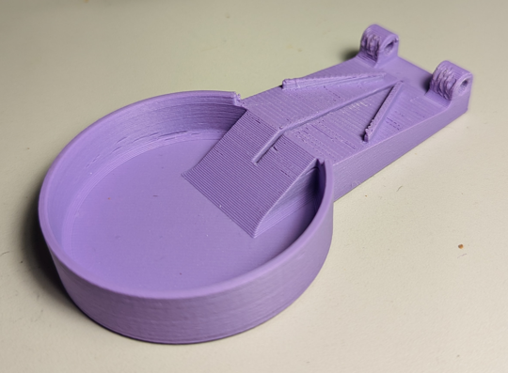

**Photos of upper**

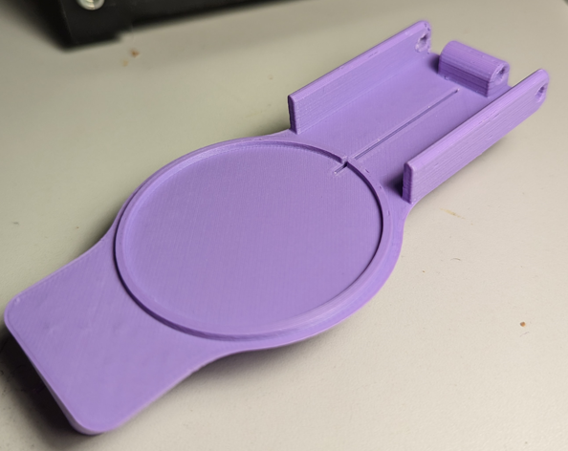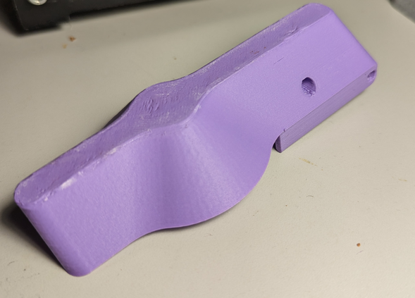

**Photos of hinge pin**

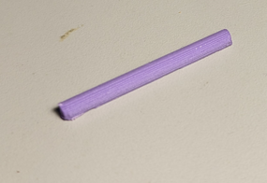

**Photos of blade pin**

