# Required Components

|  |  |
| --- | --- |
| All the parts of the pill splitter on a pale background, numbered and ready for assembly | **BOM**   1. Upper 2. Lower 3. Hinge Pin 4. Blade Pin 5. Razor Blade |

# Required Tools

* Pliers
* Sandpaper
* Hobby knife

# Required Personal Protective Equipment (PPE)

* Safety Glasses

# Assembly Instructions

## Step 1

Using pliers, insert the razor blade into the slot in the upper piece of the slicer.

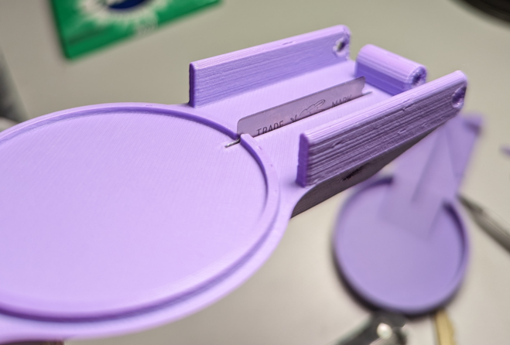

## Step 2

Insert the blade pin to secure the blade in place. Make sure the pin is centred in the upper body.

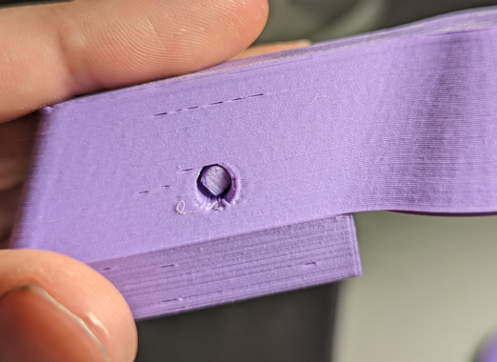

## Step 3

Place the upper body over the lower body, and align the hinge pins.

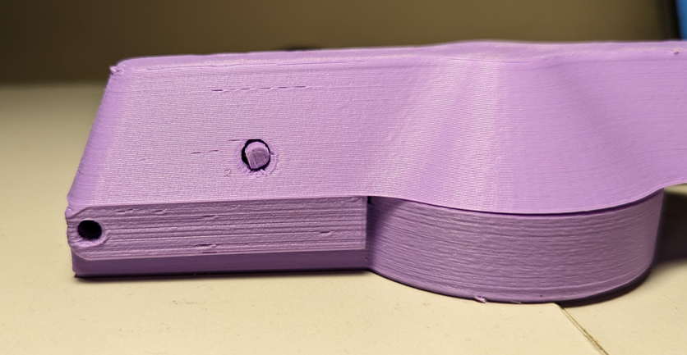

## Step 4

Insert the hinge pin, and centre it in the holes.

