## Introduction

The pill slicer is an easy to use device that slices a pill into two. This device is intended for users that need to cut pills into two and have difficulty doing so without crushing the pill.

## Features

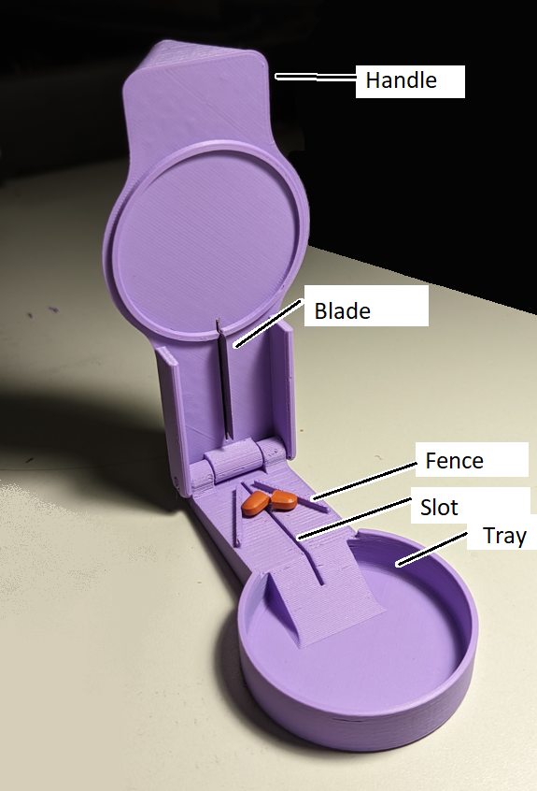

## Usage

To use, place a pill over the slot on the lower base, and center it between the two fences. Close the upper half of the device, and the built in razor blade will slice the pill in half.

## Compatibility

This device is compatible with compressed, solid type pills. Liquid or powder pills that would spill if cut in half are not ideal for this type of device.

## Specifications

Length: 125mm

Width: 60mm

Height: 35mm

Weight: 50g

## Cleaning

Device can be wiped down with a damp cloth.