# Introduction

The Playback Switch project is an attempt to design an assistive switch that can also provide audio feedback when pressed.

# Research

## Commercially Available Options

### BIGmack

#### Overview

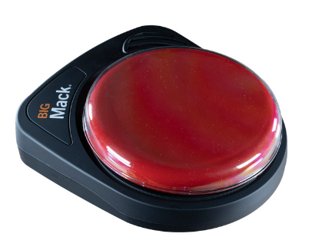

2 minute message playback

Switch output

Quick Ready mounting plate

#### Price

155 USD

#### Link

<https://www.ablenetinc.com/bigmack/>

### LITTLEmack

#### Overview

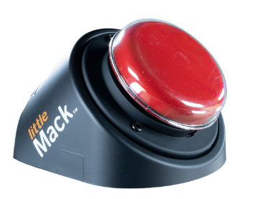

2 minute message playback

Switch output

Quick Ready mounting plate

#### Price

155USD

#### Link

<https://www.ablenetinc.com/littlemack/>

### Big Talk

#### Overview

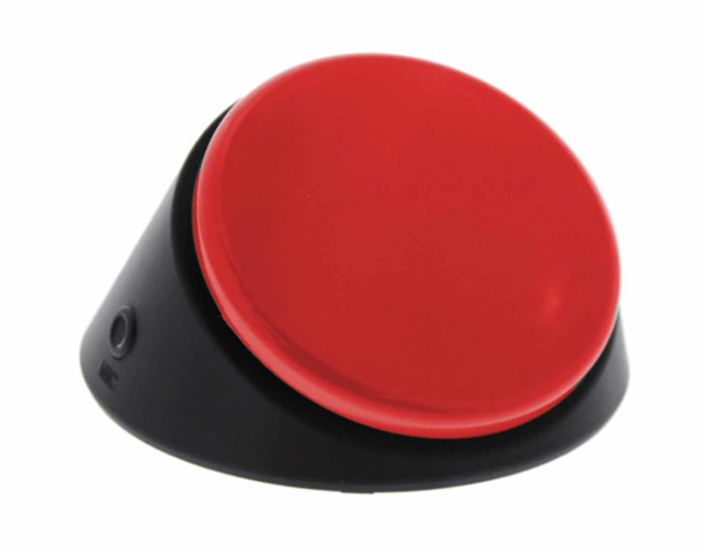

20 seconds recording time

Switch output

#### Price

149.95 USD

#### Link

<https://enablingdevices.com/product/big-talk/>

## DIY Options

None found with similar functionality

## Research Summary

All commercial options with similar functionality were priced at over 150 USD. No DIY options with similar functionality were found.

# Requirements

## Goals

|  |  |
| --- | --- |
| G01 | Create an assistive switch that can also record and play back audio messages |

## Functional Requirements

|  |  |
| --- | --- |
| F01 | Device must be able to record messages |
| F02 | Device must be able to play back messages |
| F03 | Device must be able to function as an assistive switch |

## Constraints

|  |  |
| --- | --- |
| C01 | Device must cost less than $20 dollars |

# Ideation

## Key Features

* Record audio
* Play audio on button press
* Activate connected accessible device on button press

# Prototyping

Three options were initially considered for adapting the playback button. The first option was physically stacking a second button onto the existing button so both were pressed when the button topper was pressed, which was possible because of the large flat surface on the initial button. The second option was to attach the second button in parallel to the initial button, with a 3D printed piece to distribute the press from the topper to both buttons. The final option was to attach a photo isolator to the initial button to activate both circuits with one button press while still keeping them separate.

The button used as the base of this adaptation can be found [here](https://www.amazon.ca/gp/product/B09V1JJ3D1/ref=ppx_yo_dt_b_asin_title_o08_s00?ie=UTF8&psc=1).

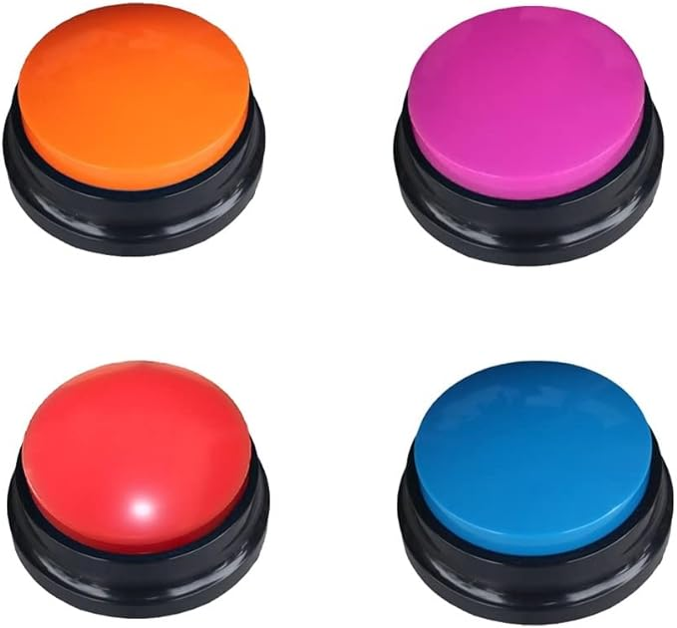

The first option is the simplest build, with no 3d prints required, but potentially poses issues with the stability and button press force. The second option is also fairly simple, but requires a 3D printed piece to transfer the force of the topper to both buttons evenly. This would require more precision when placing the button, as well as potentially needing a variety of files for different types of internal buttons. The final method only requires the one internal button, but requires an optoisolator, which is harder to solder and more difficult to work with than a press button.

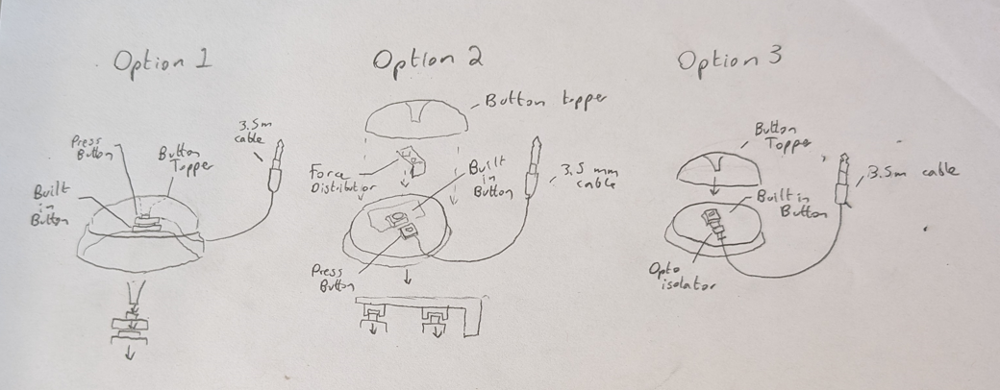

After the first method with the stacked buttons was shown to work well with no noticeable drawbacks, the next two methods were not explored further as they would just add complexity with no gain in performance. The interior view of the stacked buttons is visible in the below image.

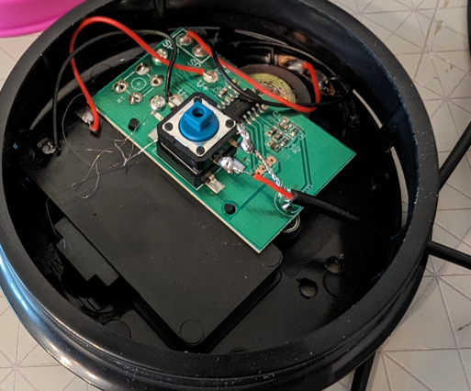

## Opportunities for Improvement / Future Work

* Mounting interface that allows the switch to work with various mounting hardware