## Introduction

The Playback Switch is an assistive switch that also plays a prerecorded message up to 30 seconds long when the button is pressed. It has a diameter of 90mm and an activation force of roughly 250 grams. The switch is made entirely with commercial, off the shelf parts, with no 3D printing involved. It has a similar functionality to the BIGmack and LITTLEmack buttons. This device is intended for users of assistive switches who would benefit from or prefer additional audio feedback when using a switch.

## Features

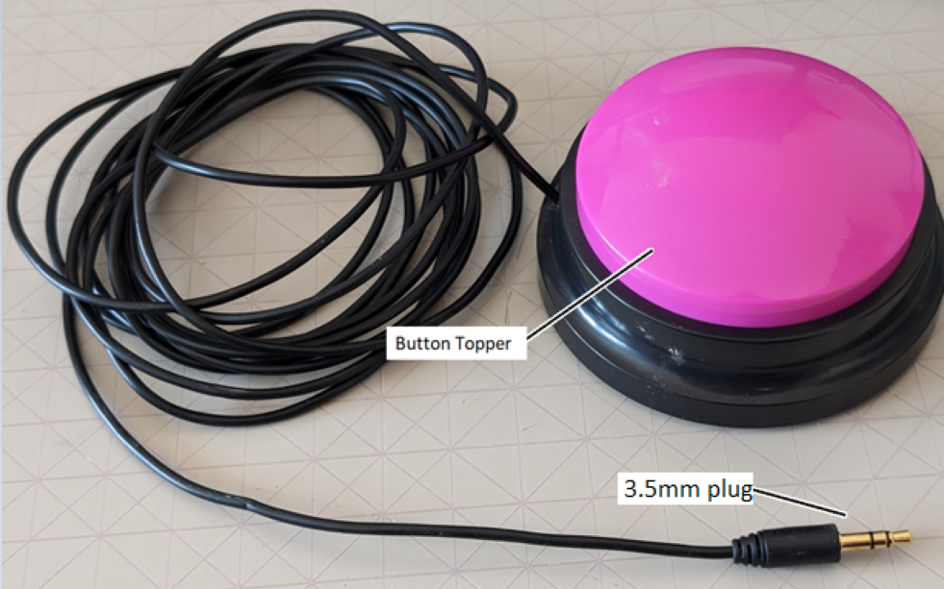

## Usage

To record a message, flip over the button and hold the small black button on the bottom. The button will beep and then record audio for 30 seconds or until the button is released, whichever comes first.

The 3.5mm cable can be connected to an accessible device, and then when the button is pressed it will activate the connected device and play back the recorded message.

## Compatibility

This device is compatible with any accessible device that works with 3.5mm switches.

## Specifications

Diameter: 90mm

Height: 45mm

Weight: 322 grams

Activation force: 250g

## Cleaning

Device can be wiped clean with a damp cloth.