**Title**

Project Core 3D Symbols

**Subtitle**

A set of 3d printable tactile representations of Universal Core Vocabulary

## Device Specifications

Designer: Center for Literacy and Disability Studies

Build Time: 1-4 hr

Cost: $6-$20

Stage: User Tested

Skills Required: 3D Printing

Disability Type: Visual, Cognitive/Learning

Difficulty: Beginner

Time to Complete: 1-4 hr, >10 hour

License: Attribution 4.0 International

Usage: Communication Aids (AAC)

Type: n/a

## Device Details

### Overview

The Project Core 3D symbols are a set of 3D printable three-dimensional (3D) symbols that represent words in the [Universal Core vocabulary](https://www.med.unc.edu/ahs/clds/universal-core-vocabulary/). The Universal Core vocabulary is ‘a set of 36 highly useful single words that can be used alone or in combination to communicate for a range of purposes on countless topics with a wide variety of communication partners.’

For the 3D symbols, the individual word is indicated with a unique raised element, the printed word, and the word in Braille. The word category is indicated with the shape, texture, and color of the base.

Project Core also provides the symbols in different formats.

### Usage

These symbols may be useful to help students with visual impairments and/or significant cognitive impairments communicate. For instructions on how to introduce and use these symbols, refer to the original site: http://www.project-core.com/3d-symbols/

### Cost

Each symbol requires less than $1 of plastic. The cost of materials for the three starter symbols is about $1.50. A full set requires $18 worth of plastic. The total cost to produce these may be increased if the different colors are required. (A 1 kg roll of filament is typically $25-35)

### Build Instructions

Each symbol is 3D printed. The files can be found at the linked GitHub repository or on the original site.

#### Skills Required

* **3D printing**

#### Time Required

Each symbol takes approximately 2 hours to 3D print on its own. A total set may then take up to 73 hours to print.

#### 3D Printing

The symbols are a simple print and do not require support. Refer to the 3D Printing Guide for instructions. Multiple symbols of the same color may be printed at the same time. The red symbols may require two setups.

### Attribution

The 3D Universal Core Vocabulary Symbols were designed by [The Center for Literacy and Disability Studies](http://www.project-core.com/3d-symbols/).

The Bill of Materials and the 3D Printing Guide were created by Neil Squire / Makers Making Change.

## Project Core 3D Symbols

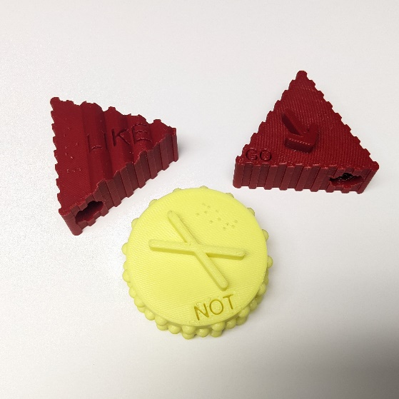

**MMC Library Link:**

<https://makersmakingchange.com/project/project-core-3d-symbols/>

### Overview

The Project Core 3D symbols are a set of 3D printable three-dimensional (3D) symbols that represent words in the [Universal Core vocabulary](https://www.med.unc.edu/ahs/clds/universal-core-vocabulary/). The Universal Core vocabulary is ‘a set of 36 highly useful single words that can be used alone or in combination to communicate for a range of purposes on countless topics with a wide variety of communication partners.’

For the 3D symbols, the individual word is indicated with a unique raised element, the printed word, and the word in Braille. The word category is indicated with the shape, texture, and color of the base.

Project Core also provides the symbols in different formats.

### Usage

These symbols may be useful to help students with visual impairments and/or significant cognitive impairments communicate. For instructions on how to introduce and use these symbols, refer to the original site: http://www.project-core.com/3d-symbols/