## Introduction

The Pull-Tab Tin Can Opener is a device to help those with arthritis, limited finger dexterity or limited finger strength open tin cans with pull-tabs.

## Features

**Pull-Tab Hook**

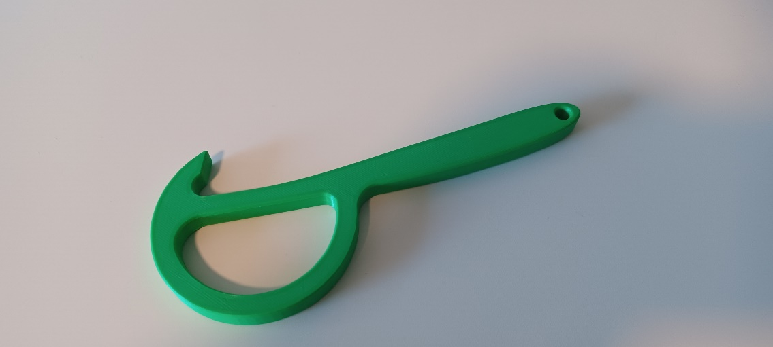

**Handle**

## Usage

**Step 1**

Slide the hook under the pull-tab of the can.

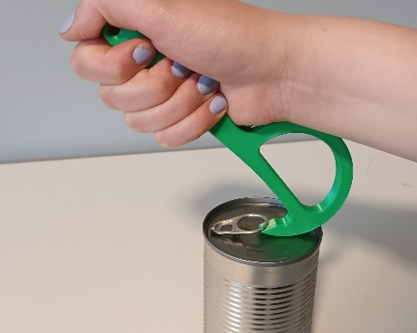

**Step 2**

Slide the hook into the pull-tab so that the outer ring sits into the groove and the seal of the can breaks.

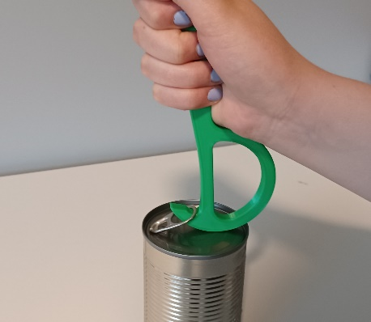

**Step 3**

Lever the can opener backwards to pull open the top of the can.

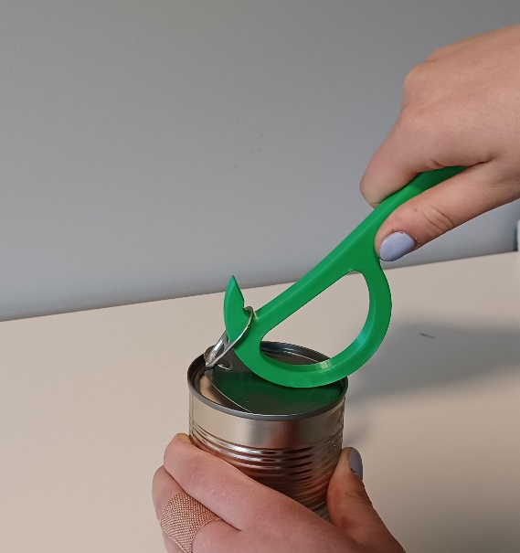

**Step 4**

Continue to pull the can opener and can lid off until the can is open.

## The Pull-Tab Tin Can Opener peels the lid off the pull-tab of a can.

## Compatibility

This device is compatible with any tin can with a pull-tab, such as tuna, pet food or soup cans.

## Specifications

This device is 17.7 cm long, 7.5 cm wide, and 1 cm tall.

## Cleaning

Use sterilizing wipe or spray. Do not place in dishwasher or expose to high heat.