# Overview

The Design Rationale is intended to provide designers and maker information about the design process and design decisions behind the development of the Raindrop Switch, a small, cost-effective, 3D-printed assistive switch.

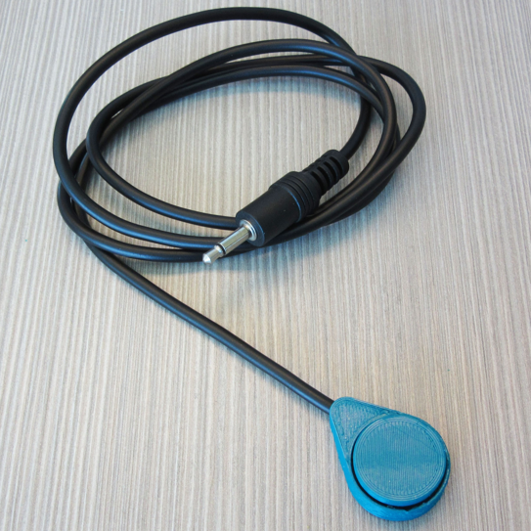

Contents

Overview 1

Introduction 3

Requirements 3

Goals 3

Functional Requirements 3

Non-functional Requirement 3

Constraints 4

Commercially Available Options 4

AbleNet Mini Cup Switch 4

Detailed Design 5

Physical Component / Enclosure 6

Electrical Components 6

Opportunities for Improvement 7

Physical Component / Enclosure 7

# Introduction

The Raindrop switch originated as an open source equivalent of the Mini Cup switch from AbleNet

An adaptive switch is an input-output device that allows an individual with a physical disability or limitation to independently activate assistive technology devices and switch-enabled devices.

The proposed switch use push/press as activation method to activate other assistive technologies. The commercial small push/press AT switches cost roughly $75. The proposing switch intends to lower the cost down without losing necessary functionalities.

# Requirements

The goals and requirements outlined here can be used to assess if a device would meet the needs of a user, and determine when a design is sufficient for release.

## Goals

|  |  |
| --- | --- |
| G01 | The mini cup switch shall work as well as other commercially available assistive switches. |
| G02 | The switch shall be activated when a user applies force to the top of the switch. |

## Functional Requirements

|  |  |
| --- | --- |
| F01 | The switch shall be activated by applying an activation force. |
| F02 | The activation force shall be no larger than 140 gf (1.37 N). |
| F03 | The activation travel shall be no larger than 4 mm. |
| F04 | The activation surface shall have a contact area no larger than 25 cm diameter. |
| F05 | The switch shall operate in any orientation. |
| F06 | The switch shall activate when the activation force is applied at any point on the activation surface. |

## Non-functional Requirement

|  |  |
| --- | --- |
| NF01 | The switch must be able to be assembled by a maker. |
| NF02 | No specialized tools shall be required to assemble the switch. |
| NF03 | The user contact surface shall be cleanable with a damp cloth. |
| NF04 | The user contact surface should be cleanable with alcohol. |

## Constraints

|  |  |
| --- | --- |
| C01 | The total material cost of the switch shall not exceed $10. |

## Commercially Available Options

Options that can be purchased but not made by a maker.

### AbleNet Mini Cup Switch

|  |  |
| --- | --- |
| **Title / Name of device** | Mini Cup Switch |
| **Link** | <https://www.ablenetinc.com/mini-cup-switch/> |
| **Author** | AbleNet |
| **Cost** | $85.00 USD |

The AbleNet Mini Cup Switch is a small, durable accessible switch that works with any 3.5mm compatible device.

|  |  |
| --- | --- |
| **Requirements Met** | **Requirements Unmet** |
| G01, G02, F01, F02, F03, F04, F05, F06, NF03, NF04 | C01, NF01, NF02 |

#### Useful Design Features

* Waterproof

# Detailed Design

The final design for the raindrop switch is a 3D printed enclosure around a standard tactile button. A monocable is soldered to the button, and hot glue is used to attach the cap to the button, the button to the base, and for strain relief on the cable.

### Physical Component / Enclosure

The base and cap of the switch are 3D printed, with the electronics held in place with hot glue.

### Electrical Components

The final electronic components are a tactile switch, and a 3.5mm mono cable.

# Opportunities for Improvement

### Physical Component / Enclosure

Use of hot glue could be eliminated, with a captured switch cap that is resistant to bumps and falling apart.