Contents

Introduction 2

Features 2

Specifications 2

Compatibility 2

Usage 3

Initial Setup 3

Regular Use 3

Takedown / Storage 3

Cleaning 3

Care 3

Disposal 3

## Introduction

The Raindrop Switch is a cost-effective accessibility switch, an assistive device used by people with physical disabilities to control electronics (e.g. phones, computers, adapted toys,  game controls, etc.).

This particular switch is well-suited for use by a finger. It can be plugged into any standard 3.5 mm AT interface and even the Xbox Adaptive Controller. Users can arrange multiple switches in an array to get input from more than one finger. The switch can be mounted using adhesive on the rear surface.

## Features

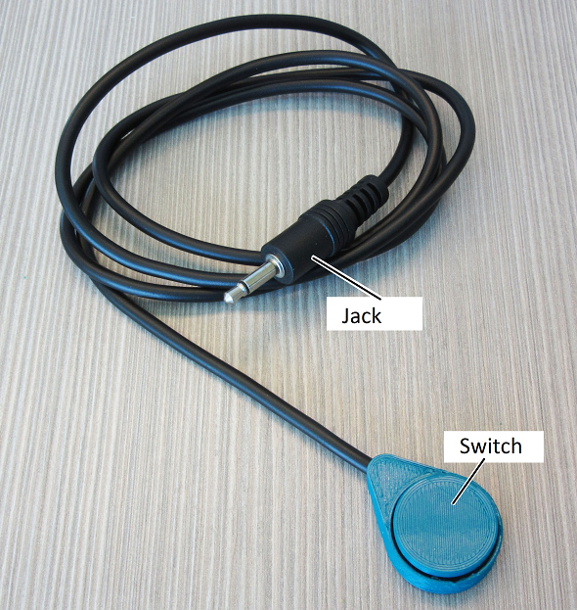

The Raindrop switch has two main components, the jack and the switch. The jack is the component that allows the Raindrop Switch to connect to the accessible device, and the switch is the component that allows the user to activate the connected device.

## Specifications

|  |  |
| --- | --- |
| Item | Raindrop Switch |
| Size (Length x Width x Height) [mm] | 31x23x10 |
| Mass [g] | 35 |
| Number of jacks | 1 |

## Compatibility

The Raindrop Switch is compatible with all accessible devices that have a 3.5mm plug.

## Usage

### Initial Setup

Take the jack on the switch, and plug in into the 3.5mm plug on the accessible device.

### Regular Use

After plugging the switch into the accessible device, pressing the button will activate the plug that the switch is connected to.

### Takedown / Storage

Holding the jack as close as possible to the accessible device, and gently pull on it to unplug it from the device. Loosely coil the wire and store it in a cool place out of direct sunlight.

## Cleaning

The Raindrop Switch can be wiped with a damp cloth.

## Care

The Raindrop Switch is made of 3D printed plastic. Exposure to high heat may cause warping and/or negatively affect function. Extended exposure to sunlight will also weaken the plastic on the device.

The Raindrop Switch contains electronics and is not waterproof. If the device becomes wet, make sure it is off and do not use it until it has completely dried. It may help to open any electronic enclosures to speed up drying and ensure it has completely dried.

## Disposal

PLA filament may be industrially compostable in your area. Check with your waste management company if PLA can be composted or must be thrown in the garbage.

Disassemble the Raindrop Switch and separate out the recyclable and compostable components, and those that must be thrown out. Electronics and batteries should be disposed of following your local waste management guidelines.