# Overview

This document contains the necessary information to use the Redwood Joystick, a robust analog USB joystick that can be used for digital access or adaptive gaming. This design is based off of Ultimarc’s UltraStik 360 joystick (<https://www.ultimarc.com/arcade-controls/joysticks/ultrastik-360-oval-top-clone/>) and 3D printed enclosure and various toppers have been added to this design.

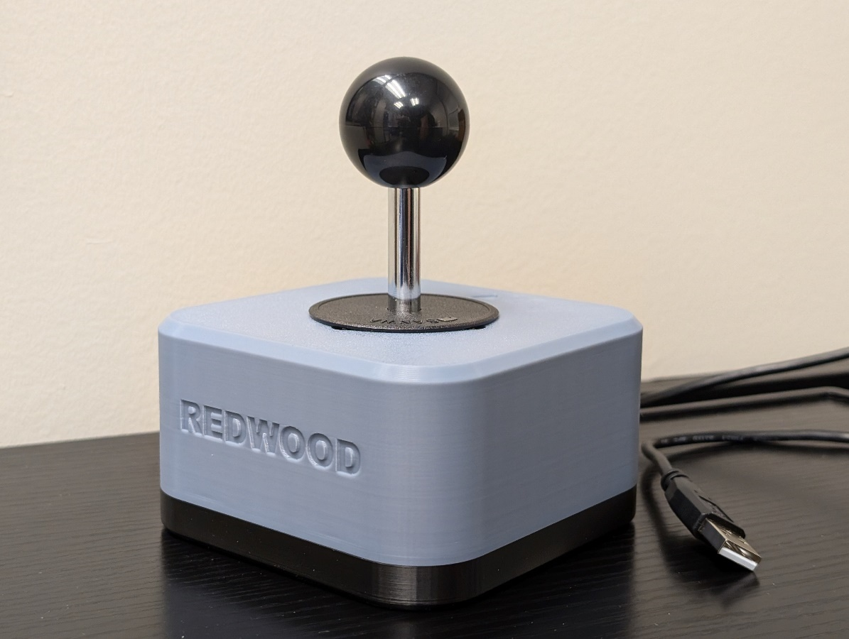

Contents

Overview 1

Introduction 3

Features 3

Oak Toppers 4

Specifications 4

Compatibility 5

Usage 5

UltraMap – Mode Selection 5

Takedown / Storage 6

Care 6

Cleaning 6

Disposal 6

## Introduction

The Redwood Joystick is a robust analog USB joystick that can be used for digital access or adaptive gaming. The Redwood was designed for users with gross motor movement and high strength that other joysticks may not be able to withstand.

## Features

The Redwood Joystick uses the Ultimarc Ultrastik Joystick as the main internal component. This comes with a default ball topper. If you need other toppers such as goalpost, concave, stick, etc. the Topper Adapter Nut can be used to attach our Oak Joystick toppers. Using the mounting adapters you can mount the joystick on RAM or ¼-20 camera mounts.

|  |  |  |
| --- | --- | --- |
| Number | Feature | Functionality |
| 1 | Ultimarc Ball topper | Default topper that comes with the joystick. |
| 2 | Ultimarc Dust Cover | Prevents dust and grime to enter the inside of the enclosure. |
| 3 | USB Type-A | Allows for connection to devices. |
| 4 | Oak Joystick Toppers | Any of the Oak Joystick toppers will fit the Redwood Joystick using the Topper Adapter Nut. See all small, medium, and large Oak toppers here: <https://tinyurl.com/OakTopper> |
| 5 | Topper Adapter Nut | Adapter that allows any Oak Joystick topper to fit the Redwood Joystick. |
| 6 | 1 inch RAM Mount Adapter | Can be attached to the bottom of the Redwood Joystick to attach to 1 inch (Type B) RAM mounts. |
| 7 | Camera Mount Adapter | Can be attached to bottom of Redwood Joystick to attach to ¼-20 mounting (common camera mount) |

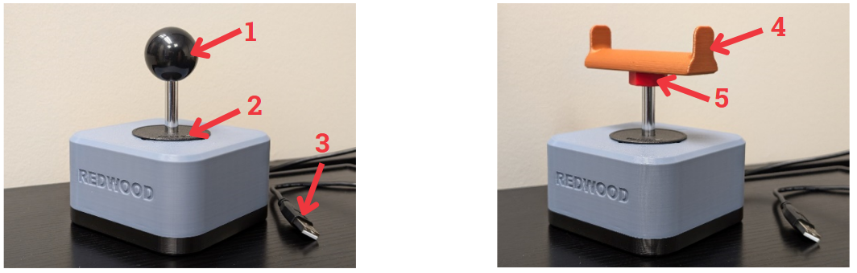

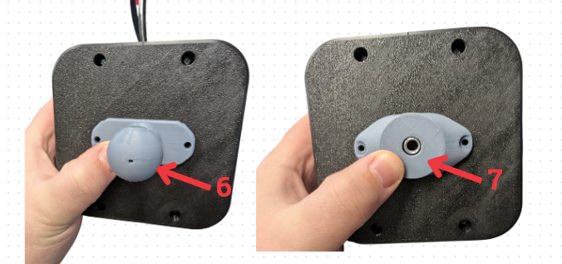

### Oak Toppers

To add any of the Oak toppers, screw on the Topper Adapter Nut to the threads on the stick until secure. Then thread on the Oak topper of your choice.

The Oak Joystick toppers come in a standard small, medium, and large size and can be customized by the maker. There is a stick, goalpost, ball, concave, and convex topper. These are all compatible with the Redwood Joystick using the Topper Adapter Nut. If you are wanting to evaluate the size of the toppers, please see the Oak Joystick Topper Guide: <https://github.com/makersmakingchange/Oak-Compact-Joystick/blob/main/Documentation/Oak_Joystick_Topper_Guide.pdf>

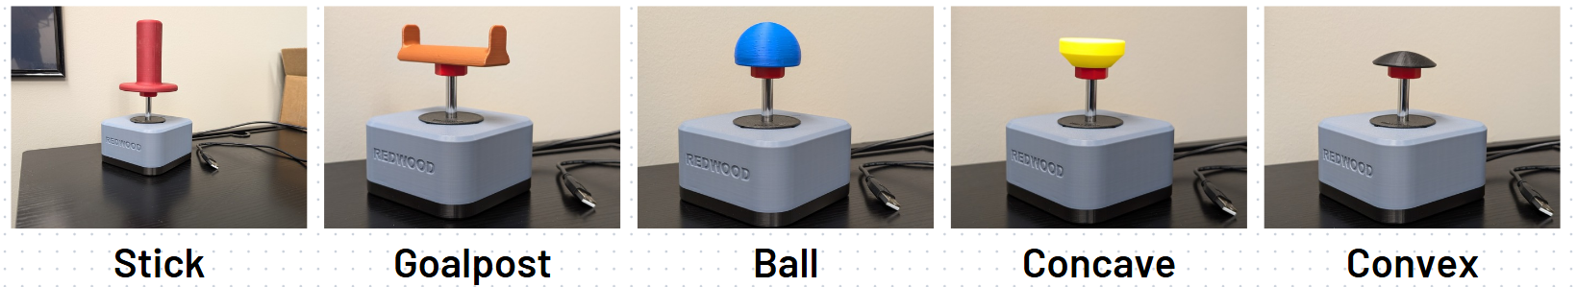

## Specifications

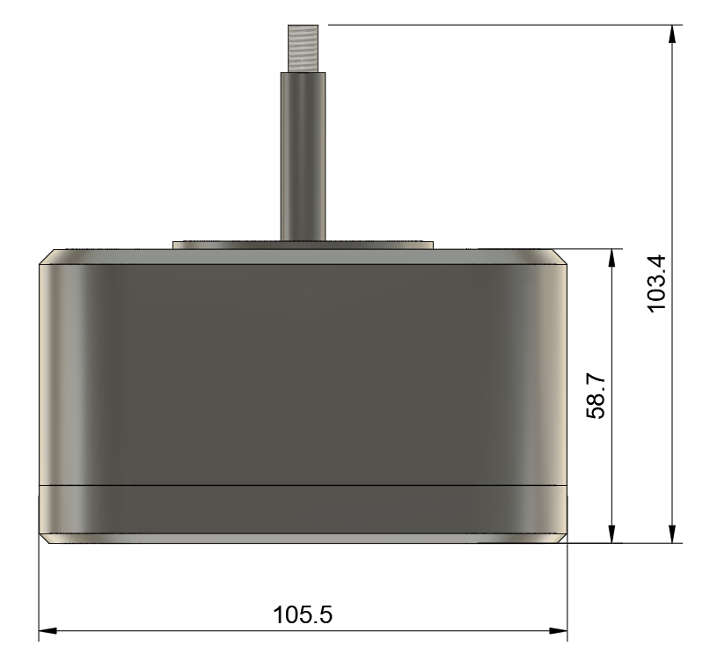

|  |  |
| --- | --- |
| Item | Redwood Joystick |
| Size (Length x Width x Height) [mm] | 105.5 x 105.5 x 58.7 (not including height of stick)  105.5 x 105.5 x 103.4 (Including height of stick) |
| Mass [g] | 274 |
| Type of Cable | USB Type-A |
| Operating Force (grams) | 298 |
| Range of Motion (degrees) | ±15.5° |

## Compatibility

More testing is required to see if the joystick will work on macOS.

|  |  |
| --- | --- |
| Item | Redwood Joystick |
| PC (Windows XP or Newer) | Yes |
| macOS | Unknown |
| IOS | Yes, however only in mouse mode. Using the default analog mode will cause drift. See section below on how to change to mouse mode. |
| Android (Oreo or newer) | Yes |
| Xbox Adaptive Controller | Yes |
| Sony Access Controller | No (Sony Access Controller does not have USB port) |
| Hori Flex Controller | Yes |

## Usage

Connect the Redwood Joystick to your device using the provided USB cable. You may need an adapter or dongle to get the USB connected to your system. The Joystick is by default in Analog Gamepad mode. This means it will act as a joystick for a gamepad system. You can change the mode it is in by using the UltraMap application created by Ultimarc. See the modes available below. Download the software here: <https://www.ultimarc.com/arcade-controls/joysticks/ultrastik-360-oval-top-clone/>

### UltraMap – Mode Selection

By default, the Redwood Joystick will be in Analog mode. The UltraMap application allows you to program the joystick in the following modes:

|  |  |
| --- | --- |
| Mode | Description |
| 2-Way, Up & Down | The joystick restricts movement to only two directions: up and down. |
| 4-Way | Movement is limited to the four cardinal directions: up, down, left, and right. |
| 4-Way, Diagonals Only | Movement is restricted to diagonal directions (e.g., up-right, up-left, down-right, down-left). |
| 8-Way | Full freedom of movement in eight directions: up, down, left, right, and all four diagonals. |
| 8-Way, Easy Diagonals | Similar to 8-Way but optimized for smoother diagonal inputs, reducing the effort required to hit diagonal positions accurately. |
| Analog | Behaves like a gamepad joystick with proportional controls. |
| Mouse Pointer | Behaves like a USB mouse pointer. No left or right click buttons included. |

To change modes, download the UltraMap application to a computer and plug in the Redwood Joystick. Scan for Ultrastik Joysicks and then select the mapping you want under the “Joystick Map” drop down. Then click the download button and wait for the mode to change. Then, the joystick will behave in that mode across all devices until you upload a different mode to it. See the Ultrastik installation instructions for more details: <https://www.ultimarc.com/arcade-controls/joysticks/ultrastik-360-oval-top-clone/>

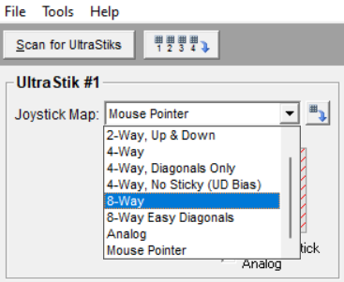

### Takedown / Storage

When not in use, the Redwood Joystick should be stored in a cool place out of direct sunlight.

### Customization

Ultimarc offers an optional “Hard Spring”. Purchasing this spring and swapping it out with the spring inside of the joystick will result in a higher force needed to operate. Link to the Hard Spring can be found here: <https://www.ultimarc.com/arcade-controls/joystick-accessories/ultrastik-360-optional-hard-spring/>

## Care

The Redwood Joystick is made of 3D printed plastic. Exposure to high heat may cause warping and/or negatively affect function. Extended exposure to sunlight will also weaken the plastic on the device.

The Redwood Joystick contains electronics and is not waterproof. If the device becomes wet, make sure it is off and do not use it until it has completely dried. It may help to open any electronic enclosures to speed up drying and ensure it has completely dried.

### Cleaning

The Redwood Joystick can be wiped with a damp cloth. The Redwood Joystick can also be cleaned by scrubbing with warm water and dish soap. Do not use hot water or clean in a dishwasher.

If using warm water and dish soap, ensure any electronic components have been removed before washing.

## Disposal

PLA filament may be industrially compostable in your area. Check with your waste management company if PLA can be composted or must be thrown in the garbage.

Disassemble the Redwood Joystick and separate out the recyclable and compostable components, and those that must be thrown out. Electronics and batteries should be disposed of following your local waste management guidelines.