**Resistive Touch Switch: Quick Guide**

# Introduction

The Resistive Touch Switch is an assistive switch that can be operated by gently touching a touchpad with a finger. This type of switch may be suitable for users with limited finger strength as minimal force is needed to activate the contact area.

User should have clean skin not covered in gloves or coated in paint, glue or other non conductive substances. The switch is not recommended for users who have abnormally dry or thickened skin due to illness or medical condition causing an inability to produce normal skin moisture levels.

# Features

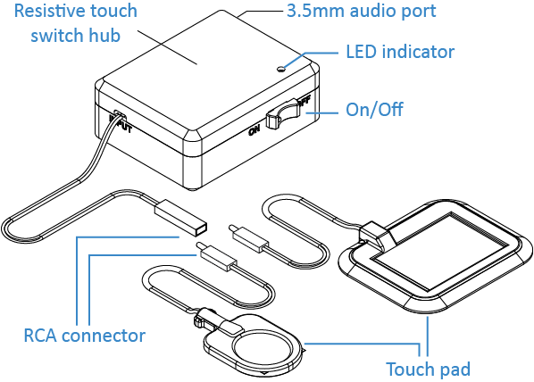

# Connecting the Touch Pad

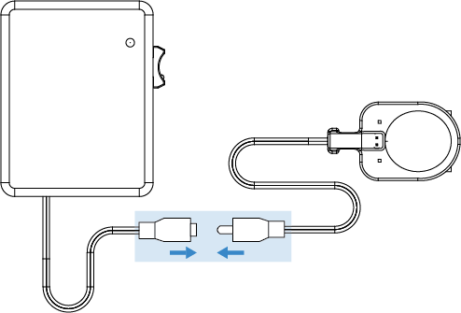

To use the Touch Switch, firmly plug the connector end of the touch pad into the socket of the hub.

# Usage

1. Connect the 3.5 mm audio cable from the hub to the assistive device.

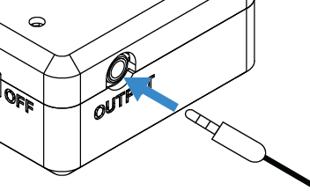

1. Turn the hub on.

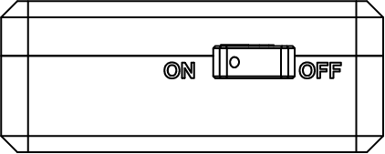

1. Tap the touchpad to use. When the touchpad is activated, the LED indicator will turn red and a mild clicking sound will be heard.

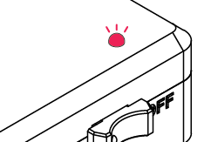

# Specification

|  |  |
| --- | --- |
| Size | 73 x 60 x 29 mm (hub only) |
| Battery Life | >2 years |
| Cleaning | Clean or disinfect with touch pad with isopropyl alcohol |