# Introduction

The Rocket Switch Interface is a small USB switch interface which enables users to operate their digital devices using up to two assistive switches. This guide will go over how to setup the Rocket Switch Interface on an iPhone or iPad using either Switch Control or AssistiveTouch on iOS or iPadOS. For more information on using the Rocket Switch Interface itself, see the User Guide.

# Connecting the Rocket Switch to the iPhone or iPad

## What you need

To use a Rocket Switch Interface on an iPhone or iPad you will need:

* iPhone or iPad
* Charging cable for your mobile device
* USB Adapter with Charging port
* Rocket Switch Interface
* 1 or 2 Assistive Switches

See below for more information on each device.

### iPhone or iPad

These instructions work for iPhones with iOS 13 and newer, or iPads with iPadOS 13 and newer.

### Charging Cable for your iPhone or iPad

This is the cable that you use to charge your iPhone or iPad.

Use this cable to determine if your device has a Lightning charging cable or a USB-C charging cable. Use the table below as a reference:

|  |  |
| --- | --- |
| **Lightning Cable** | **USB-C Cable** |
| Close up picture of a Lightning Cable connector. | Close up picture of a USB-C Cable connector. |
| iPhones 14 and older  iPad 9 and older, iPad Mini 4 and older, iPad Air 3 and older, iPad Pro 2 and older | iPhones 15 and newer  iPad 10 and newer, iPad Mini 5 and newer, iPad Air 4 and newer, iPad Pro 3 and newer |

### USB Adapter with Charging Port

This adapter will depend on whether your device uses a Lightning or USB-C cable (see section above)

|  |  |  |
| --- | --- | --- |
| **Type of Cable** | **Photo of Adapter** | **Link to Purchase** |
| Lightning Cable | White USB adapter plugged into an iPhone. Shows a charging cable plugged into it and an empty USB port. | [Lightning to USB 3 Camera Adapter - Amazon](https://a.co/d/hhut9rg) |
| White Lightning to USB adapter shown laying flat. | [Lightning to USB 3 Camera Adapter - Apple](https://www.apple.com/ca/shop/product/MX5J3AM/A/lightning-to-usb-3-camera-adapter) |
| USB-C Cable | USB-C to USB adapter with additional power port. | [USB-C to USB Camera Adapter - Amazon](https://a.co/d/628FUra) |

## Steps

1. Plug charging cable into adapter.
2. Plug Rocket Switch Interface into adapter (ensure it is plugged in in the correct orientation).
3. Plug 1 or 2 assistive switches into the Rocket Switch Interface.
4. Plug the adapter into your iPhone or iPad.

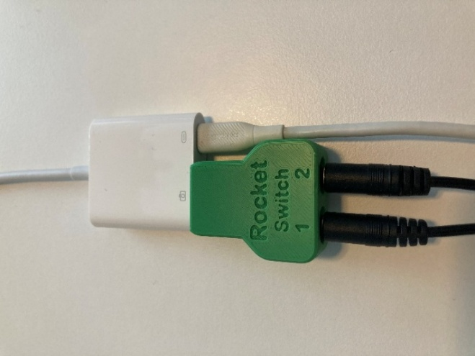

Plug into iPhone or iPad

# Setting up the Rocket Switch on the iPhone or iPad

There are two main ways to set up the Rocket Switch Interface on an iPhone or iPad, either through Switch Control or Assistive Touch.

Switch Control uses switch scanning, while Assistive Touch is typically used for cursor control or for buttons to activate shortcuts.

It is recommended to setup your Rocket Switch Interface for Switch Control, unless you are using another device for a cursor/mouse and you want to add mouse clicks (left click and right click) or you want to use the Rocket Switch Interface to activate accessibility controls or shortcuts such as media controls (play/pause, next song, volume, etc).

## Setting up with Switch Control

Using Switch Control with your Rocket Switch Interface can allow your iPhone or iPad to be completely controlled using one or two assistive switches.

To set up Switch Control, first make sure the Rocket Switch Interface is in the correct mode, then follow the steps below, or see [this Switch Control Guide from Apple](https://support.apple.com/en-ca/guide/iphone/iph400b2f114/ios).

### Step 1: Rocket Switch Interface Operating Mode

For Switch Control on an Apple device, make sure the Rocket Switch Interface is in Mode 1 – Switch Mac mode, which is indicated by a Teal coloured light on the Rocket Switch Interface. If the LED is not teal, you will need to switch modes by pressing and holding Switch 1 for 4 seconds, cycling through the modes until the LED is teal.

### Step 2: Add Switches and Assign Actions

1. Navigate to Settings > Accessibility > Switch Control > Switches
2. Tap Add New Switch…
3. Select “External” and activate one of the switches plugged into your Rocket Switch Interface.
4. Assign an action to the switch.

This will depend on the number of switches you are using and which switch scanning style you choose. If you don’t know which to assign, try the following:

* + Using 1 Switch: Map to **Select Item** (this will be compatible with Auto Scanning)
  + Using 2 Switches: Map switch 1 to **Select Item** and switch 2 to **Move To Next Item** (this setup will be compatible with Manual Switch Scanning)

Repeat this step if you are using two switches.

### Step 3: Choose a Scanning Style

By default, the cursor automatically moves from one item to the next after a specified duration. If you prefer to move the cursor manually, you can choose a different scanning style.

Go to Settings > Accessibility > Switch Control > Scanning Style, then choose one of the following:

* **Auto Scanning:** The cursor automatically moves to the next item after a specified duration. This is the default scanning style.
  + If you use Auto Scanning with just one switch, make sure the Select Item action is assigned to the switch.
* **Manual Scanning:** When you activate your Move to Next Item switch, the cursor moves to the next item.
  + Manual Scanning requires at least two switches. Make sure the Move to Next Item action is assigned to one switch, and the Select Item action is assigned to another switch.
* **Single Switch Step Scanning:** When you activate the Move to Next Item switch, the cursor moves to the next item; if no action is taken within a specified duration, the current item is automatically selected.
  + This scanning style requires only one switch. Make sure the Move to Next Item action is assigned to the switch.

### Step 4: Fine Tune Switch Control Settings

There are many settings that can be used to adjust the behaviour of Switch Control to suit your needs, to learn more please see this guide: [Set up and turn on Switch Control on iPhone](https://support.apple.com/en-ca/guide/iphone/iph400b2f114/ios), and go to Step 4.

If you are using Auto Scanning for example, you may want to adjust the *Auto Scanning Time.*

### Step 5: Turn on Switch Control

Go to Settings  > Accessibility > Switch Control, then turn on Switch Control.

Now you can use your Rocket Switch Interface to control your iPhone or iPad!

## Setting up with AssistiveTouch

Using Assistive Touch with your Rocket Switch Interface is a great way to map assistive switches to specific functions or shortcuts. This may not provide full control of your iPhone or iPad.

### Step 1: Rocket Switch Interface Operating Mode

For Switch Control on an Apple device, make sure the Rocket Switch Interface is in Mode 3 – Mouse mode, which is indicated by a purple coloured light on the Rocket Switch Interface. If the LED is not purple, you will need to switch modes by pressing and holding Switch 1 for 4 seconds, cycling through the modes until the LED is purple.

### Step 2: Turn on Assistive Touch

Go to Accessibility > Touch > AssistiveTouch and then turn on AssistiveTouch.

### Step 3: Add Buttons and Assign Functions

1. Navigate to Accessibility > Touch > AssistiveTouch > Devices.
2. Select your device under “Connected Devices” it will likely be the only one. It may be named “Rotary Trinkey M0”.
3. Press “Customize Additional Buttons”
4. Activate your switch.
5. Assign a function to the switch, there are a long list of available functions, or you can create your own shortcut to activate with your switch (see the next section).
   1. Some examples of functions: Home, App Switcher, Scroll Down, Accessibility Shortcut

### Step 4: (Optional) Create a Custom Shortcut

Custom shortcuts can be created for a large number of actions on Apple devices. To learn more, see the [Shortcuts User Guide](https://support.apple.com/en-ca/guide/shortcuts/welcome/ios). Explore the Shortcuts app for different actions you can use in a shortcut, and what might be the most helpful for you.

Some common shortcuts that people might want to map to assistive switches, are media controls such as Play/Pause, or Next Song.

To create a shortcut:

1. Navigate to the Shortcuts app.
2. Go to All Shortcuts, and press the + in the top right corner
3. Press Add Action, and then browse or search for the action you would like, such as searching “Pause” and then selecting “Play/Pause” under the “Media” category.
4. If you want, you can name your shortcut at the top of the window.
5. Press Done in the top right corner.
6. Go back to Step 3 and when assigning a function for the switch, select the name of your new shortcut.

Now you can use your Rocket Switch Interface for AssistiveTouch controls and shortcuts!