## Introduction

The Round Touch 60 Switch can control 3.5 mm audio outputs like in the Xbox Adaptive Controller and other switch adapted products. This device may benefit users with limited hand dexterity and strength who find it challenging to trigger mechanical switches.

## Features

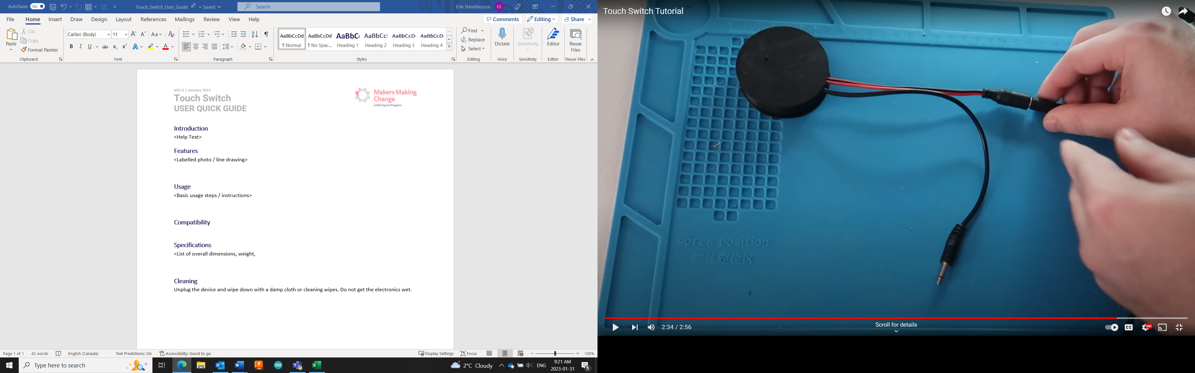

## Usage

To use this device, plug in the power supply and connect the mono cable to a switch-controlled device. Simply touch the top surface to engage the switch, indicated by a red LED.

## Compatibility

This device can trigger any device that requires a 3.5 mm momentary switch.

## Specifications

|  |  |  |  |
| --- | --- | --- | --- |
| **Diameter** | **Height** | **Power Input** | **Switch Output** |
| 6.1 cm | 1.8 cm | 5V 2A | 3.5 mm mono cable |

## Cleaning

Unplug the device and wipe down with a damp cloth or cleaning wipes. Do not get the internal electronics wet.