Overview
This document contains the necessary information to build the Shrub Hub, a low cost, easy to build digital switch interface.
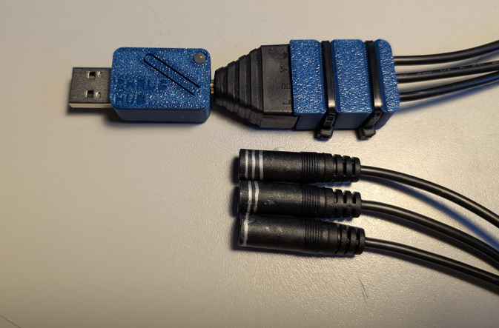

Contents
Overview 1
Maker Checklist 3
Maker To Do List 3
Items to Give to User 3
Tool List 4
Tools / Equipment 4
Customization Guide 5
3D Printing Guide 5
3D Printing Summary 5
3D Printing Settings 5
Post-Processing 5
Examples of Quality Prints 5
Maker Component List 6
Assembly Guide 7
Part A: Required Tools and Supplies 7
Part A: Shrub Hub Assembly Steps 7
Part B: Flashing Firmware to Shrub Hub 12
Part B: Required Tools and Supplies 12
Step B-01: Connect Shrub Hub to the Computer 12
Step B-02: Setup Arduino IDE on Computer 12
Step B-03: Setup Arduino IDE for TRRS Trinkey 12
Step C-04: Install Libraries 12
Step C-05: Setup Local Code Directory 13
Step C-05: Flash Firmware to the Shrub Hub 13
Testing 13
Troubleshooting 13

Maker Checklist
This list provides an overview of the steps required to build and deliver the Shrub Hub.

Maker To Do List
- Read through the Maker Guide to become familiar with required components, tools, supplies, safety gear, and overall assembly steps.
- Talk to the User about customization options
  - Colour of printed enclosure
  - How they would like to receive the “User Guide” (PDF or physical copy)
- Order hardware components
- Gather tools, supplies, and safety equipment.
- Assemble the device
- Flash firmware to Shrub Hub
- Test the Shrub Hub
- Print “User Guide” (if the User would like a physical copy)

Items to Give to User
- Shrub Hub
- “User Guide”

Tool List

Tools / Equipment
Tool ID | Description | Required / Recommended | Notes
T01 | Wire Strippers | Recommended | Stripping mono cable wires.
T02 | Small Phillips head screwdriver | Recommended | Operating TRRS terminal screws
T03 | Silver Sharpie | Recommended | Marking each cable

Customization Guide
The device can be printed in the user’s desired colour.

3D Printing Guide
The device was originally printed on a Bambu P1S using BambuStudio.

3D Printing Summary
Metrics | Single Unit
Total Print Time (hour min) | 0:25
Total Number of Components | 4
Typical Total Mass (g) | 10
Typical Number of Print Setups | 1

3D Printing Settings
Note that the 3D printing material should be assumed to be PLA unless otherwise noted in the table below.
Print File Name | Qty | Total Print Time (hr:min) | Mass (g) | Infill (%) | Support(Y/N) | Layer Height/ Nozzle Diameter(mm) | Notes
Shrub Hub Base.stl | 1 | 0:06 | 3 | 20 | N | 0.2/0.4
Shrub Hub Lid.stl | 1 | 0:05 | 2 | 20 | N | 0.2/0.4
Strain Relief Base.stl | 1 | 0:08 | 3 | 20 | N | 0.2/0.4
Strain Relief Top.stl | 1 | 0:06 | 2 | 20 | N | 0.2/0.4

Post-Processing
Inspect the 3D printed parts for any printing defects, sharp edges, or burrs. Sharp edges and burrs can be removed with sanding or deburring tools.

Examples of Quality Prints
Compare your 3D prints to the images here. If there are significant differences, you may need to reprint the part.
Shrub Hub 3D Prints
Shrub Hub Base.stl | Shrub Hub Lid.stl | Strain Relief Base.stl
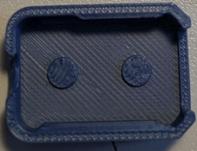 | 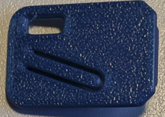 | 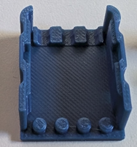
Strain Relief Top.stl
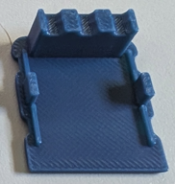

Maker Component List
Part A Components
A01 | TRRS Trinkey |  | QTY: 1 | A02 |  | Shrub Hub Base.stl | QTY: 1 | A03 |  | Shrub Hub Lid.stl | QTY: 1
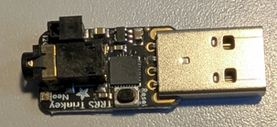 |  |  |  |  |  |  |  | 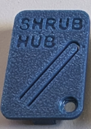
A04 | Light Pipe | QTY: 1
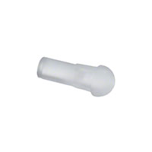

Part B Components
B01 | TRRS Terminal | QTY: 1 | B02 | Female Mono Cable | QTY: 3 | B03 | Strain Relief Base | QTY: 1
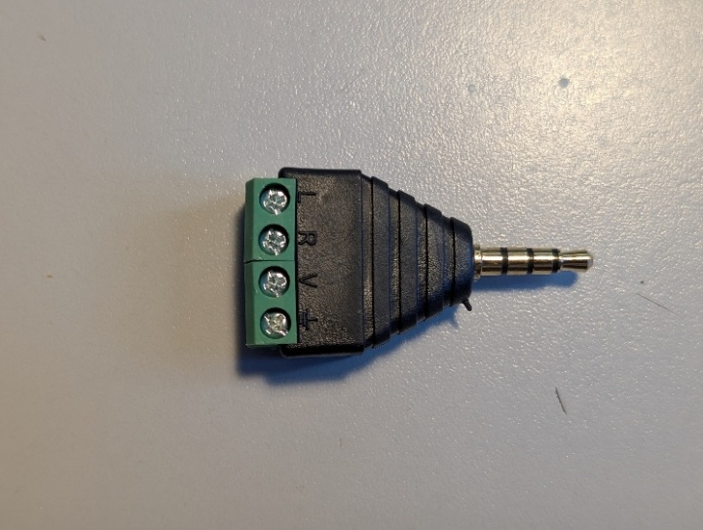 |  |  | 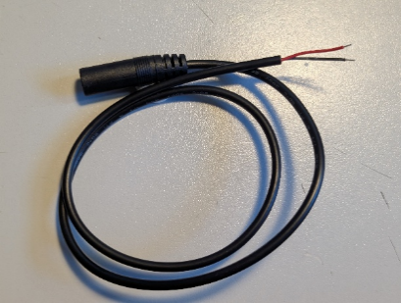 |  |  | 
B04 | Strain Relief Top | QTY: 1 | B05 | Cable Tie | QTY: 2
 |  |  | 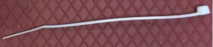

Assembly Guide

Part A: Assembling the Shrub Hub

Part A: Shrub Hub Assembly Steps

Step A-01: Attach the enclosure to the Trinkey
Take the light pipe (A04) and press it into the hole on the enclosure top(A03).
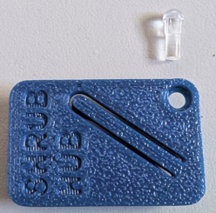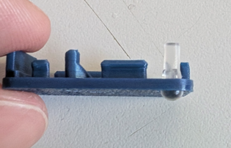

Step A-02: Attach the enclosure to the Trinkey
Place the TRRS Trinkey (A01) into the base of the enclosure(A02), then snap the top of the enclosure(A03) on top of it to lock the Trinkey in place.
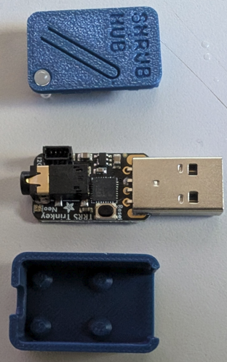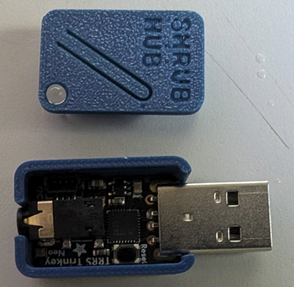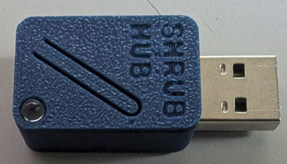

Part B: Assembling the Cable Splitter

Part B: Required Tools and Supplies
- Small Phillips screwdriver
- Wire Strippers
- Silver Sharpie

Part B: Cable Splitter Assembly Steps

Step B-01: Strip the mono cables
Using wire strippers (T01), strip the ends on each mono cable(B02) so there is 1cm of wire exposed. The wires do come pre stripped, but having slightly more wire available makes the next step easier.
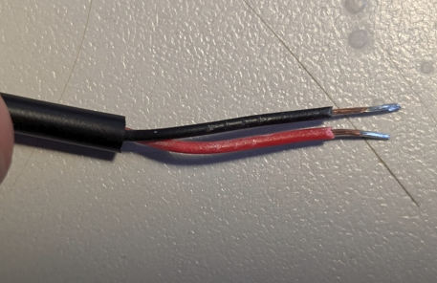

Step B-02: Connect the mono cables to the terminal
Using a small Phillips screwdriver (T02), open the terminals on the TRRS terminal jack(B01). Put the black wires from all three of the stripped mono cables into the terminal marked V and then tighten the terminal to lock all the wires in place. Take the red wire from each of the mono cables attach one to each of the remaining terminals, one to L, one to R, and one to the ground.
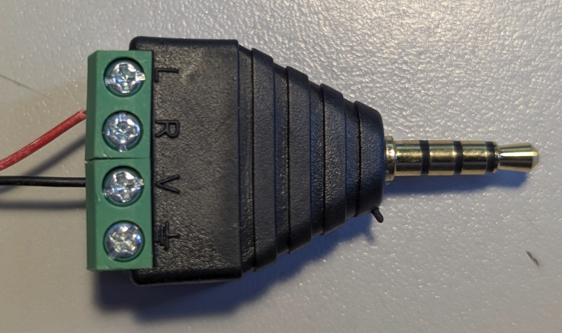
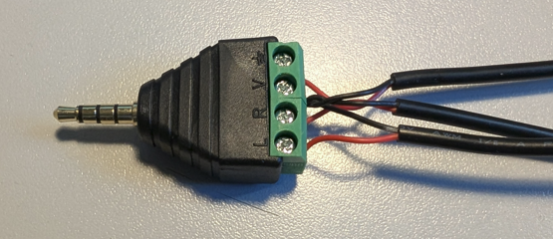

Step B-03: Mark the cable connectors
Using a silver sharpie (T03) or other marking device, mark the cable plug for switch 1, switch 2, and switch 3. Switch 1 is the one with the red wire connecting to the L terminal, switch 2 connects to the R terminal, and switch 3 connects to the ground terminal.
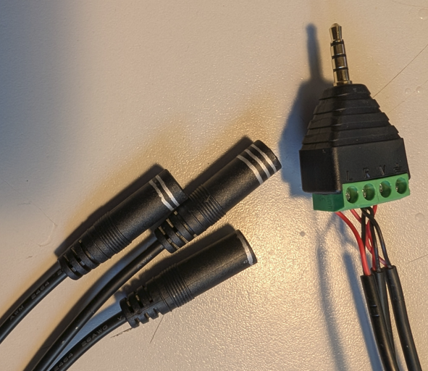

Step B-04: Assemble the strain relief
Take the strain relief base (B03) and place the four pegs on one side into the four screw holes in the terminal jack. Line up the three cables with the three slots on the base, then place the strain relief top (B04) on top.
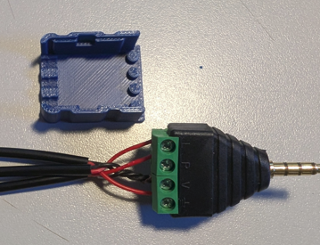
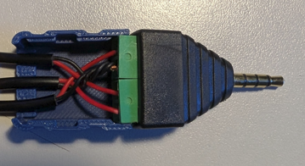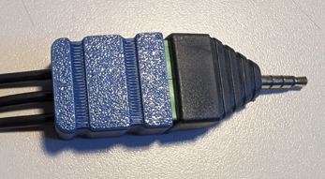

Step B-05: Cable tie the strain relief together
Take two cable ties (B05) and wrap them around the strain relief enclosure, lying them into the slots in the enclosure. Tighten them as tight as possible, then trim them flush.
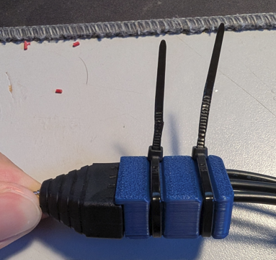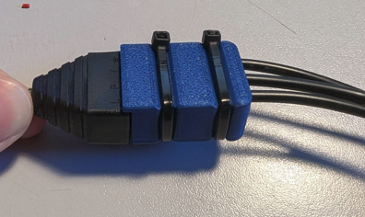

Part C: Flashing Firmware to Shrub Hub

Part C: Required Tools and Supplies
- Computer that is able to install Arduino IDE and other Arduino libraries to flash firmware

Step C-01: Connect Shrub Hub to the Computer
Plug the Shrub hub into a USB port on the computer. If the computer does not have a USB A port, an adapter may be required to connect the Hub to the computer.

Step C-02: Setup Arduino IDE on Computer
- Download Arduino IDE for your operating system at https://www.arduino.cc/en/software.
- Install the Arduino IDE.

Step C-03: Setup Arduino IDE for TRRS Trinkey
- Open Arduino IDE.
- Click on File -> Preferences
- Locate the text field that reads Additional Boards Manager URLs beside it.
- Copy and paste the following link into the field as a new line:
https://adafruit.github.io/arduino-board-index/package_adafruit_index.json
- Click on OK.
- Restart the Arduino IDE by closing and opening the program.
- Open the Boards Manager option from the Tools -> Board -> Boards Manager… menu.
- Search for “Arduino SAMD” and select “Arduino SAMD Boards” by Arduino. Make sure you select the exact board manager name stated as there may be some with similar names that will not work.
- Click Install to install the board.
- Still in the Boards Manager menu, search for “Adafruit SAMD” and select “Adafruit SAMD Boards” by Adafruit. Make sure you select the exact board manager name stated as there may be some with similar names that will not work.
- Click Install to install the board.

Step C-04: Install Libraries
- Go to the Tools -> Manage Libraries… menu.
- For each library in the table below, search for the name. Ensure the Author and Version is correct, then install the library. If prompted to install any dependent libraries, click OK.
Library Name | Author | Version
Keyboard.h | Arduino | 1.0.2
Adafruit NeoPixel.h | Adafruit | 1.12.5
Adafruit_SleepyDog.h | Adafruit | 1.6.5

Step C-05: Setup Local Code Directory
- Download the Firmware_Files from the GitHub Repository
https://github.com/makersmakingchange/Shrub-Hub/blob/main/Build_Files/Firmware_Files/TRRS_Switch_Control.zip
- Extract / unzip the folder to a known location on your computer.
- Confirm you have the following folder structure:
- TRRS_Switch_Control
  - TRRS_Switch_Control.ino
  - my_inputs.h
  - my_stuff.h

Step C-06: Flash Firmware to the Shrub Hub
- Open the TRRS_Switch_Control.ino with Arduino IDE.
- Select Adafruit TRRS Trinkey M0 from the Tools -> Board -> Adafruit SAMD menu
- Plug the Shrub Hub into the computer.
- Select the correct port from the Tools -> Port menu. It will say COMX (Adafruit Trinkey M0 (SAMD21)) where COMX is replaced with the number of the port that it is connected to, i.e. COM7
- Verify and upload to code by clicking the arrow in the top-left corner of the Arduino program.

Testing
Once the Shrub Hub is programmed, connect switches to each of the 3.5mm ports. Test that each switch produces the correct output, and that holding any switch for more than 4 seconds switches modes. Mark each switch port with the correct switch input number.
Input | Output
 | Mode 1 (Teal) | Mode 2 (Purple) | Mode 3 (Yellow) | Mode 4 (Green)
Switch 1 | Enter | F1 | 1 | F13
Switch 2 | Space | F2 | 2 | F14
Switch 3 | Tab | F3 | 3 | F15
Switch 1 + 2 | Backspace | F4 | 4 | F16
Switch 2 +3 | Escape | F5 | 5 | F17
Switch 1 + 3 | Currently Unused | Currently Unused | Currently Unused | Currently Unused
Switch 1 + 2 + 3 | Currently Unused | Currently Unused | Currently Unused | Currently Unused

Troubleshooting
- A switch input is constantly being held/the Shrub Hub constantly cycles through modes
  - Check the cables in the splitter for a short between two of the cables

