Overview
The Device Summary is intended to be a detailed summary of the device, product and maker information for the Shrub Hub, making it easier to add to the Makers Making Change website. It is intended for anyone who will view the device listing.
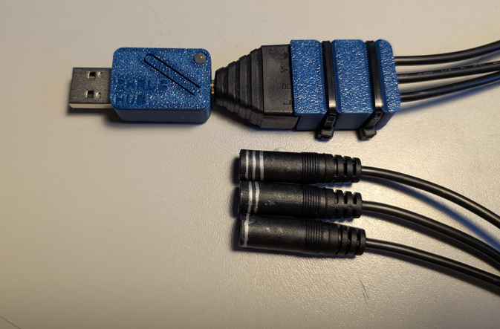

Product Information

Product Name
Shrub Hub

Device Category
Mark any relevant categories with an “X”:

 | Adapted Toys
 | Aids for Daily Living (ADL)
 | Assistive Switches
 | Communication Aids (AAC)
X | Computer Access
 | Environmental Controls
 | Gaming
 | Keyguard
 | Kits
 | LipSyncs
 | Mounting
 | Recreation and Leisure
 | Seating and Positioning
 | Switch Interfaces
 | Writing Aids

User Value Statement
The Shrub Hub allows users who are unable to operate a digital device such as a computer to send keystrokes to navigate webpages, switch scan, and control software.

Designer
Chris Young,
Bill Binko,
Neil Squire Society

Device Information

Overview
The Shrub Hub is a low-cost digital switch interface that takes up to three assistive switch inputs and can output up to seven keystrokes to the connected digital device.

Disability Type
Select one or more disability types and mark with an “X”:

X | Agility / Dexterity
 | Arthritis
 | Cognitive
 | Hearing
 | Mobility
 | Pain
 | SCI
 | Vision
 | Other

Disability Type Description
The Shrub Hub is designed for users who cannot use digital devices and needs a digital switch interface to control the device using assistive switches.

How To Use
The Shrub Hub is plugged into a computer or other digital device like a USB flash drive, then up to three assistive switches can be connected to it. Each switch can be pressed to send a different keystroke, or multiple switches can be pressed at the same time to send a different keystroke than any of the individual buttons. There are four different modes that each have their own unique sets of keystrokes.

Estimated Cost
The estimated material cost of the device for a single build:
 | $0 - $10
 | $11 - $25
x | $26 - $50
 | $51 - $100
 | $101 - $250
 | $250+

Attribution
The initial device and code that the Shrub Hub is based on was the TRRS Switch Control by Chris Young and Bill Binko.

Maker Information

Project Skills
Mark the required project skills with an “X”:

X | 3D Printing
 | Custom PCB
 | Electronics
 | Laser Cutting
 | Mechanics
 | Software
 | Soldering
 | Woodworking
 | Other

Skills Description
The only skill needed is being able to download and operate the Arduino IDE

Tools Needed

X | 3D Printer
X | Common Hand Tools
 | Common Power Tools
 | Laser Cutter
 | Soldering Iron
 | Specialized Tooling

Print time (hrs)
0.1667

Assembly time (hrs)
0.2

Build Instructions
This build is mainly snapping together a 3D printed enclosure. The splitter build involves stripping wires and screwing them into a terminal, but the build involves no soldering or custom PCBs

Download Link
https://github.com/makersmakingchange/Shrub-Hub/archive/refs/heads/main.zip

Project Link
https://github.com/makersmakingchange/Shrub-Hub

License

License
Hardware: CERN-OHL-W v2
Software: MIT License
Documentation: CERN-OHL-W v2

