Overview
This document contains the necessary information to use the Shrub Hub, a low cost, easy to build digital switch interface.
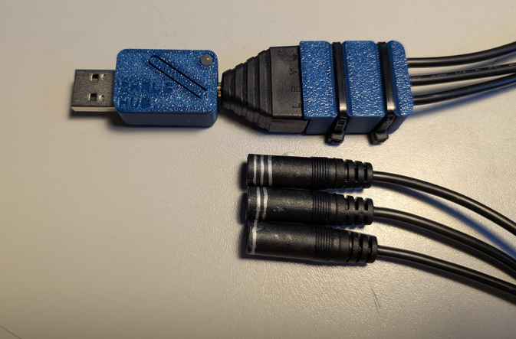

Contents
Overview 1
Introduction 2
Features 3
Specifications 3
Compatibility 3
Usage 3
Initial Setup 4
Regular Use 4
Takedown / Storage 5
Care 6
Cleaning 6
Disposal 6

Introduction
The Shrub Hub is a low cost easy to assemble digital interface that allows three switches to be used to send keystroke inputs to a connected device. The Shrub can be built without any soldering or custom circuit boards.

Features
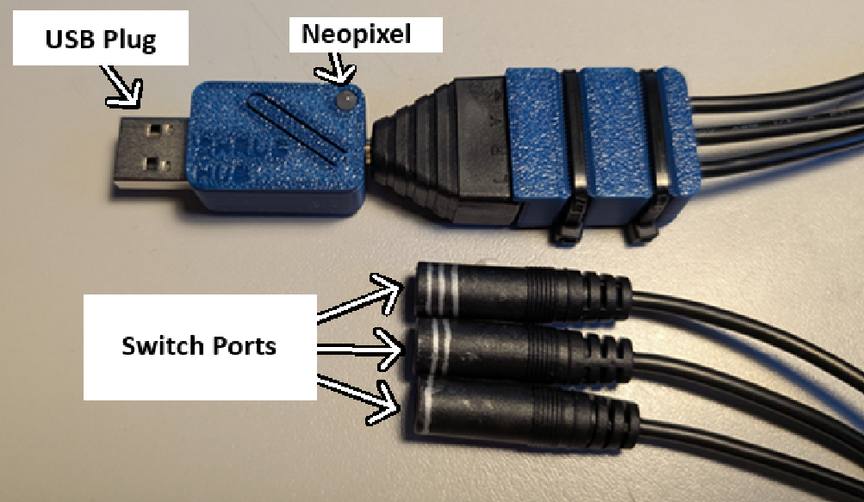
Switch Ports: The switch ports where 3.5mm assistive switches can be connected.
USB Plug: The USB Plug is a USB A connector that can be used to plug into a device like a USB storage stick.
NeoPixel: The NeoPixel is a multicolour LED that indicates the mode of the Shrub Hub

Specifications
Item | Shrub Hub
Size (Length x Width x Height) [mm] | 40x20x10
Mass [g] | 8
Switch Inputs | 3
Switch Outputs | 5

Compatibility
The Shrub hub is compatible with any digital device that has a USB port that accepts USB HID inputs, typically a computer or mobile device. If the connected device does not have a USB A port, an adapter will be needed, and if used with an iOS device, it will need a separate power source, described in the iOS use section.

Usage

Initial Setup
When setting up the Shrub Hub, the first step is to plug the splitter cable into the Shrub Hub
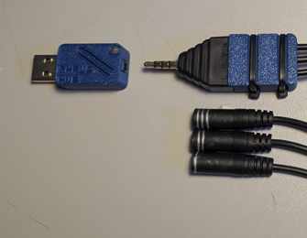

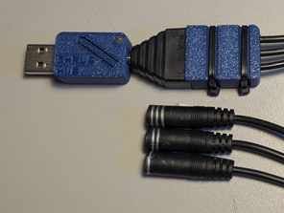
After plugging in the splitter cable, plug switch 1 into the cable 1, switch 2 into cable 2, and switch 3 into cable 3. The cables may have been marked by the maker of the device, but if not, they will need to be marked on the first use to make future setups easier. The easiest way to mark them will be to plug in the device and press each button. Refer to table 1 on the last page of the guide for which button should output which keystroke.

Regular Use

Computer
After plugging in the switches to the Shrub Hub, plug the hub into a USB port on the computer. A light on the hub will turn on indicating its mode, at which point the hub is ready to use.
Once the hub is ready to use, any of the connected switches can be pressed to send a keystroke to the device, or some can be pressed at the same time to send a different output than either of the two switches. See the below table for the full list of outputs.
The hub mode can be changed to change the keystrokes that the hub sends. To change modes, hold any switch for more than four (4) seconds.

Android
After plugging in the switches to the Shrub Hub, plug the hub into a USB port on the device. You will need an adaptor to connect the USB A on the hub to the USB port on the device. A light on the hub will turn on indicating its mode, at which point the hub is ready to use.
Once the hub is ready to use, any of the connected switches can be pressed to send a keystroke to the device, or some can be pressed at the same time to send a different output than either of the two switches. See the below table for the full list of outputs.
The hub mode can be changed to change the keystrokes that the hub sends. To change modes, hold any switch for more than four seconds.

iOS
The Shrub Hub cannot draw power from an iOS device and needs a powered USB hub or powered USB splitter to connect the Shrub Hub to the iOS device. Once the device is connected, a light on the hub will turn on indicating the mode, at which point the hub is ready to use.
Once the hub is ready to use, any of the connected switches can be pressed to send a keystroke to the device, or some can be pressed at the same time to send a different output than either of the two switches. See the below table for the full list of outputs.
The hub mode can be changed to change the keystrokes that the hub sends. To change modes, hold any switch for more than four seconds.

Table 1: Keystroke outputs for each mode
Input | Output
 | Mode 1 (Teal) | Mode 2 (Purple) | Mode 3 (Yellow) | Mode 4 (Green)
Switch 1 | Enter | F1 | 1 | F13
Switch 2 | Space | F2 | 2 | F14
Switch 3 | Tab | F3 | 3 | F15
Switch 1 + 2 | Backspace | F4 | 4 | F16
Switch 2 +3 | Escape | F5 | 5 | F17
Switch 1 + 3 | Currently Unused | Currently Unused | Currently Unused | Currently Unused
Switch 1 + 2 + 3 | Currently Unused | Currently Unused | Currently Unused | Currently Unused

Takedown / Storage
When not in use, the Shrub Hub should be stored in a cool place out of direct sunlight.

Care
The Shrub Hub is made of 3D printed plastic. Exposure to high heat may cause warping and/or negatively affect function. Extended exposure to sunlight will also weaken the plastic on the device.
The Shrub Hub contains electronics and is not waterproof. If the device becomes wet, make sure it is off and do not use it until it has completely dried. It may help to open any electronic enclosures to speed up drying and ensure it has completely dried.

Cleaning
The Shrub Hub can be wiped with a damp cloth while unplugged from the device.

Disposal
PLA filament may be industrially compostable in your area. Check with your waste management company if PLA can be composted or must be thrown in the garbage.
Disassemble the Shrub Hub and separate out the recyclable and compostable components, and those that must be thrown out. Electronics and batteries should be disposed of following your local waste management guidelines.

