# Introduction

The Simple Switch Tester is a device used to test the functionality of an assistive switch with a 3.5 mm connection. that allowsenables a user to test the switch they have built, in order to determine if they assembled it successfully and that all the components are working. When a switch is plugged into the 3.5 mm jack and activated, an LED will light up indicating a successfully operating switch. The device can be used at build events to test a series of switches, or at home during a digital build event. The switch tester is a simple device made up of six main components: the 3.5 mm jack, a AAA battery holder, two AAA batteries, an LED, a 68 Ω resistor, and a tactile switch working in parallel that can test the batteries as well as the switch. The total cost of the device is well below other equivalent devices on the market by sourcing inexpensive components and utilizing FDM 3D printing.

Table 1: Commercially Available Options

|  |  |  |  |
| --- | --- | --- | --- |
| Name | Vendor | Cost | Link |
| Single Switch Tester | AbleNet | $55 USD Switch Tester | https://www.ablenetinc.com/technology/single-switch-tester |

Switch Selection

Currently, only one design, created by AbleNet, is available commercially as a Switch Tester.

# Ideation

## Feedback

The core purpose of the test is to provide some sort of feedback to the user if a connected with

The Simple Switch Tester incorporates an enclosure and more cost-effective components than the previous version. Below is a picture of some concepts that were explored in the ideation process. Between different enclosure shapes, components, and snap-fit and solderless methods, the newest version was created. Different circuits were considered (below sketches) when thinking of the functionality of the design, ultimately opting for a parallel circuit battery tester, as well as an external switch tester to ensure that there is no miscommunication between a dead battery versus an incorrectly assembled switch. A lithophane was chosen as the top of the enclosure because the LED can shine through, displaying whatever image and/or text is on it. In case the user can only use black or very dark filament for the lithophane, there is a version of the model with a hold for the LED to shine through. The idea of disassembling locally sourced devices and utilizing their components was explored but later decided against for reasons of consistency and availability of the components. It was discovered that the 6” wires that come with the battery holder can serve as wire for the entire circuit, eliminating the need for external wire.

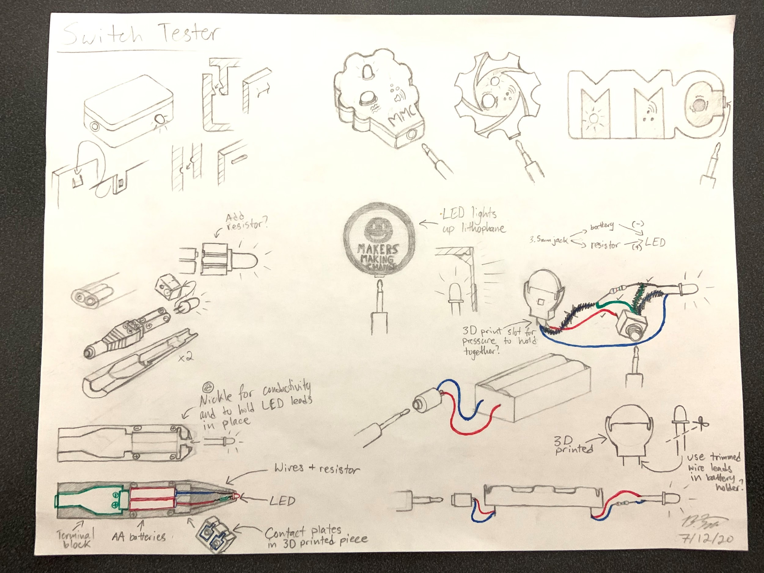

## Circuit Options

**Persistent Power Light and Master On/Off Switch Momentary battery tester**

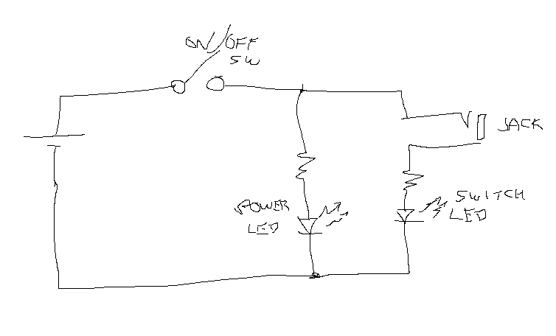 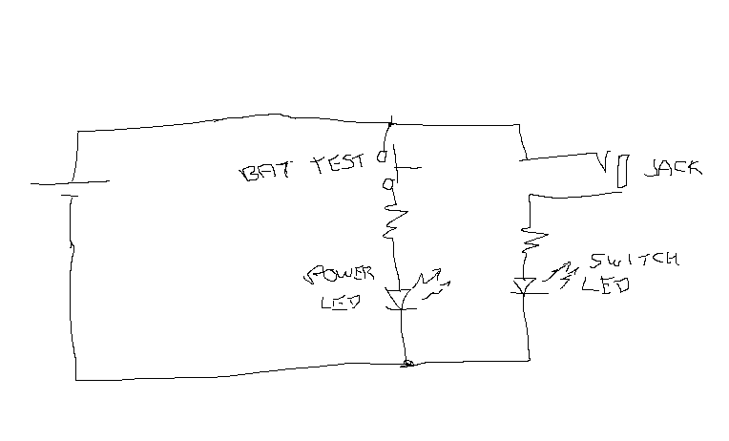

**Simplest Version - No battery tester Simple Version with test button**

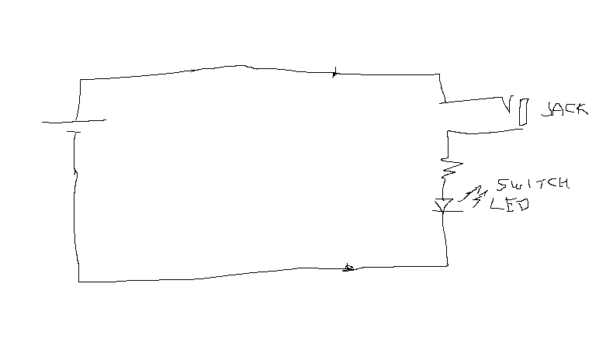 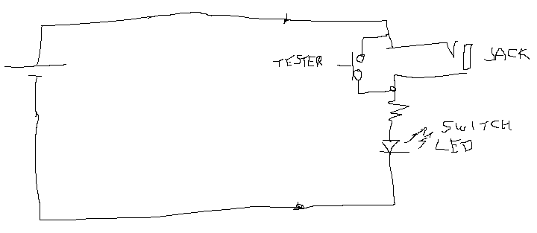

## Power Source

The Switch Tester requires a power source to test the switch and provide feedback to the user. Since the design is meant to be portable, it was necessary for the tester to have a portable power source as well. This rules out using a plug / line voltage and directed to some type of battery.

A number of battery options were considered. The primary options were either two AA/AAA cells or a 3V lithium coin cell.

# Version 1.0

The final design is comprised of a simple battery operated circuit that is soldered together and then inserted into a 3D printed enclosure. The 3D printed enclosure consists of a base, a top with a cover.

## Circuit

For this version, a circuit with a parallel test button and light feedback was selected. The components for the device can be found at online retailers such as Digi-key.

## Enclosure

The enclosure is comprised of a two-part case that connects together with a snap-fit.

### Snap-Fit

### Labelling

The top edges of the enclosure have a fillet/round, while the bottom edges of the enclosure have a small chamfer. This is a feature to help indicate how the enclosure is expected to sit on the table. The small chamfer on the bottom edge improves 3D printability.

## Components

The battery will be easily accessible if it needs to be changed.

The 3D printed enclosure can be printed in any material, but PLA is preferred for cost, availability, and ease-of-printing. PETg is a good alternative option.

## Assembly

The device requires the following tools and equipment for assembly: a *soldering iron, pliers, wire strippers, flush cutters, and a 3D printer (or temporary access to one)*. After the enclosure is 3D printed, the device can be assembled in a few short steps. The 3D printed enclosure is snap-fit and requires no additional parts to assemble it. The total build time should be under thirty minutes after the enclosure is finished printing.

Wiring

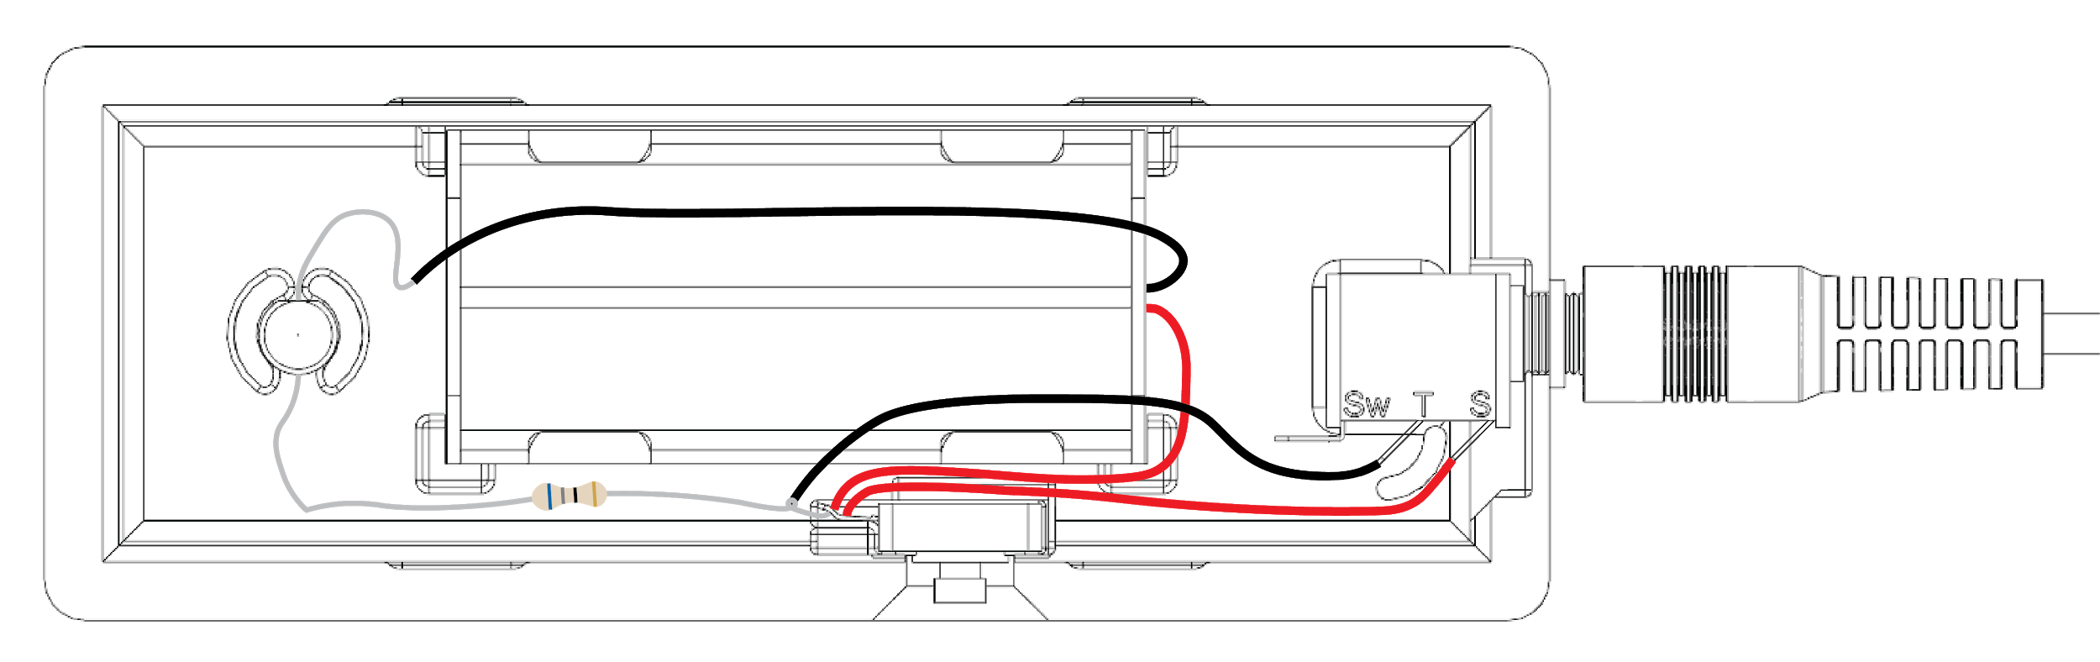

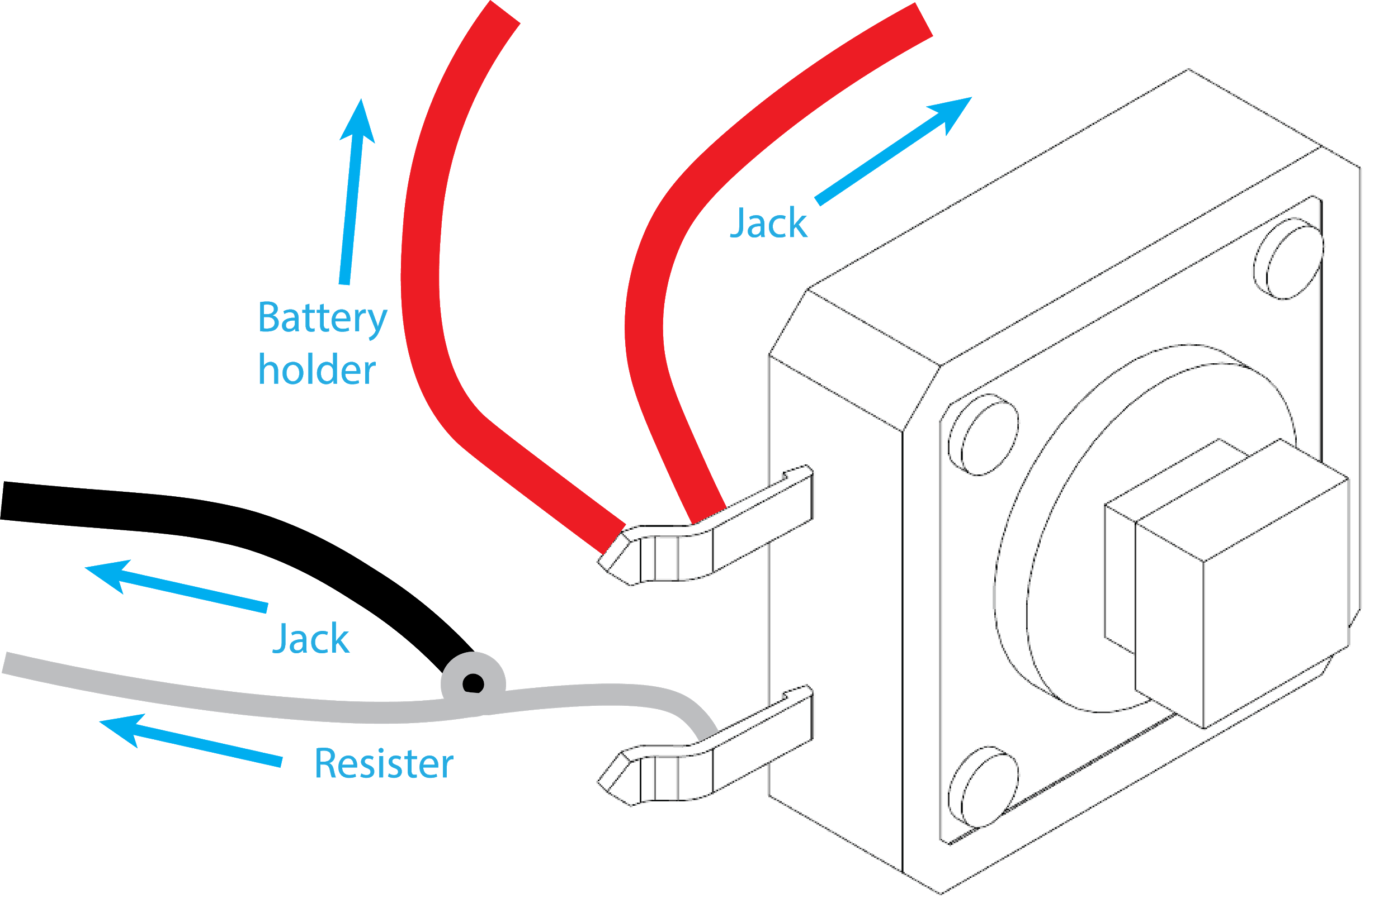 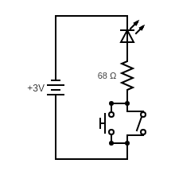

# 

# 

# Possible Future Developments

**Feedback**

A future version of the switch tester could include haptic as well as auditory feedback on top of the visual LED feedback it already provides. Of these, auditory feedback is probably the most desirable and easiest to implement.

**Case Design**

The enclosure could be modified slightly to fit new or existing components better (i.e. sinking the area where the nut screws on to the jack).

The option to use different lithophanes; such as seasonal, event-specific, personalized, etc. could also be explored.

**Easier Enclosure Opening**

Depending on the tolerance of the printing, the snap fit may be quite tight, making it difficult to open the case to swap the batteries. A feature could be added to help make it easier to open the case. For example, a slot that could be used with a screwdriver / butter knife / coin to help pry open the case.

**Lithophane**

The enclosure could be modified to capture the Lithophane from the bottom and avoid the use of super glue to attach it to the top. This would make it easier to temporarily swap out the cover for special events as well.