Introduction

The Simple Switch Tester enables a user to test the functionality of an assistive switch equipped with a 3.5 mm plug. When a switch is plugged into the 3.5 mm jack and activated, an indicator light will illuminate indicating a successfully operating switch.

Features

Indicator Light

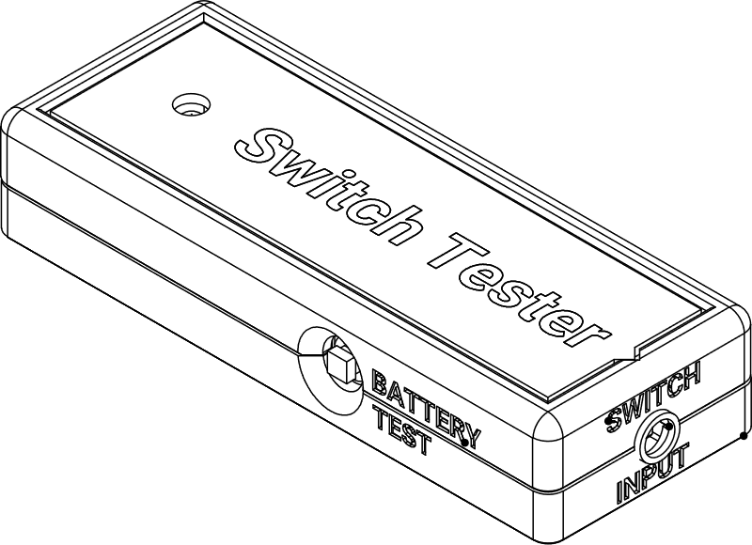

Battery Test Button

3.5 mm Switch Input Jack

Specification

|  |  |
| --- | --- |
| Size | 110 x 42 x 21 mm (w x d x h) |
| Input | 3.5 mm |
| Batteries | 2 X AAA |
| Disinfection | Ethyl Alcohol, Isopropyl Alcohol, Hydrogen Peroxide |

Usage – Check Tester

1. Press the “BATTERY TEST” button on the side of the enclosure.
2. If the batteries are working, the indicator light will turn on.



Usage – Test Switch

1. Plug an assistive switch into the 3.5 mm input jack on the end of the enclosure.
2. The indicator light should NOT turn on. If it does, there may be something wrong with the switch.
3. Activate the assistive switch.
4. The indicator light should turn ON. If the light does not turn on, there may be something wrong with the switch.



Cleaning

Wipe the exterior of the enclosure with a damp cloth.

Troubleshooting

Issue: Indicator light does not turn on when the “BATTERY TEST” button is pushed:

1. Check that the batteries are fresh and installed in the correct direction (indicated on the battery holder).

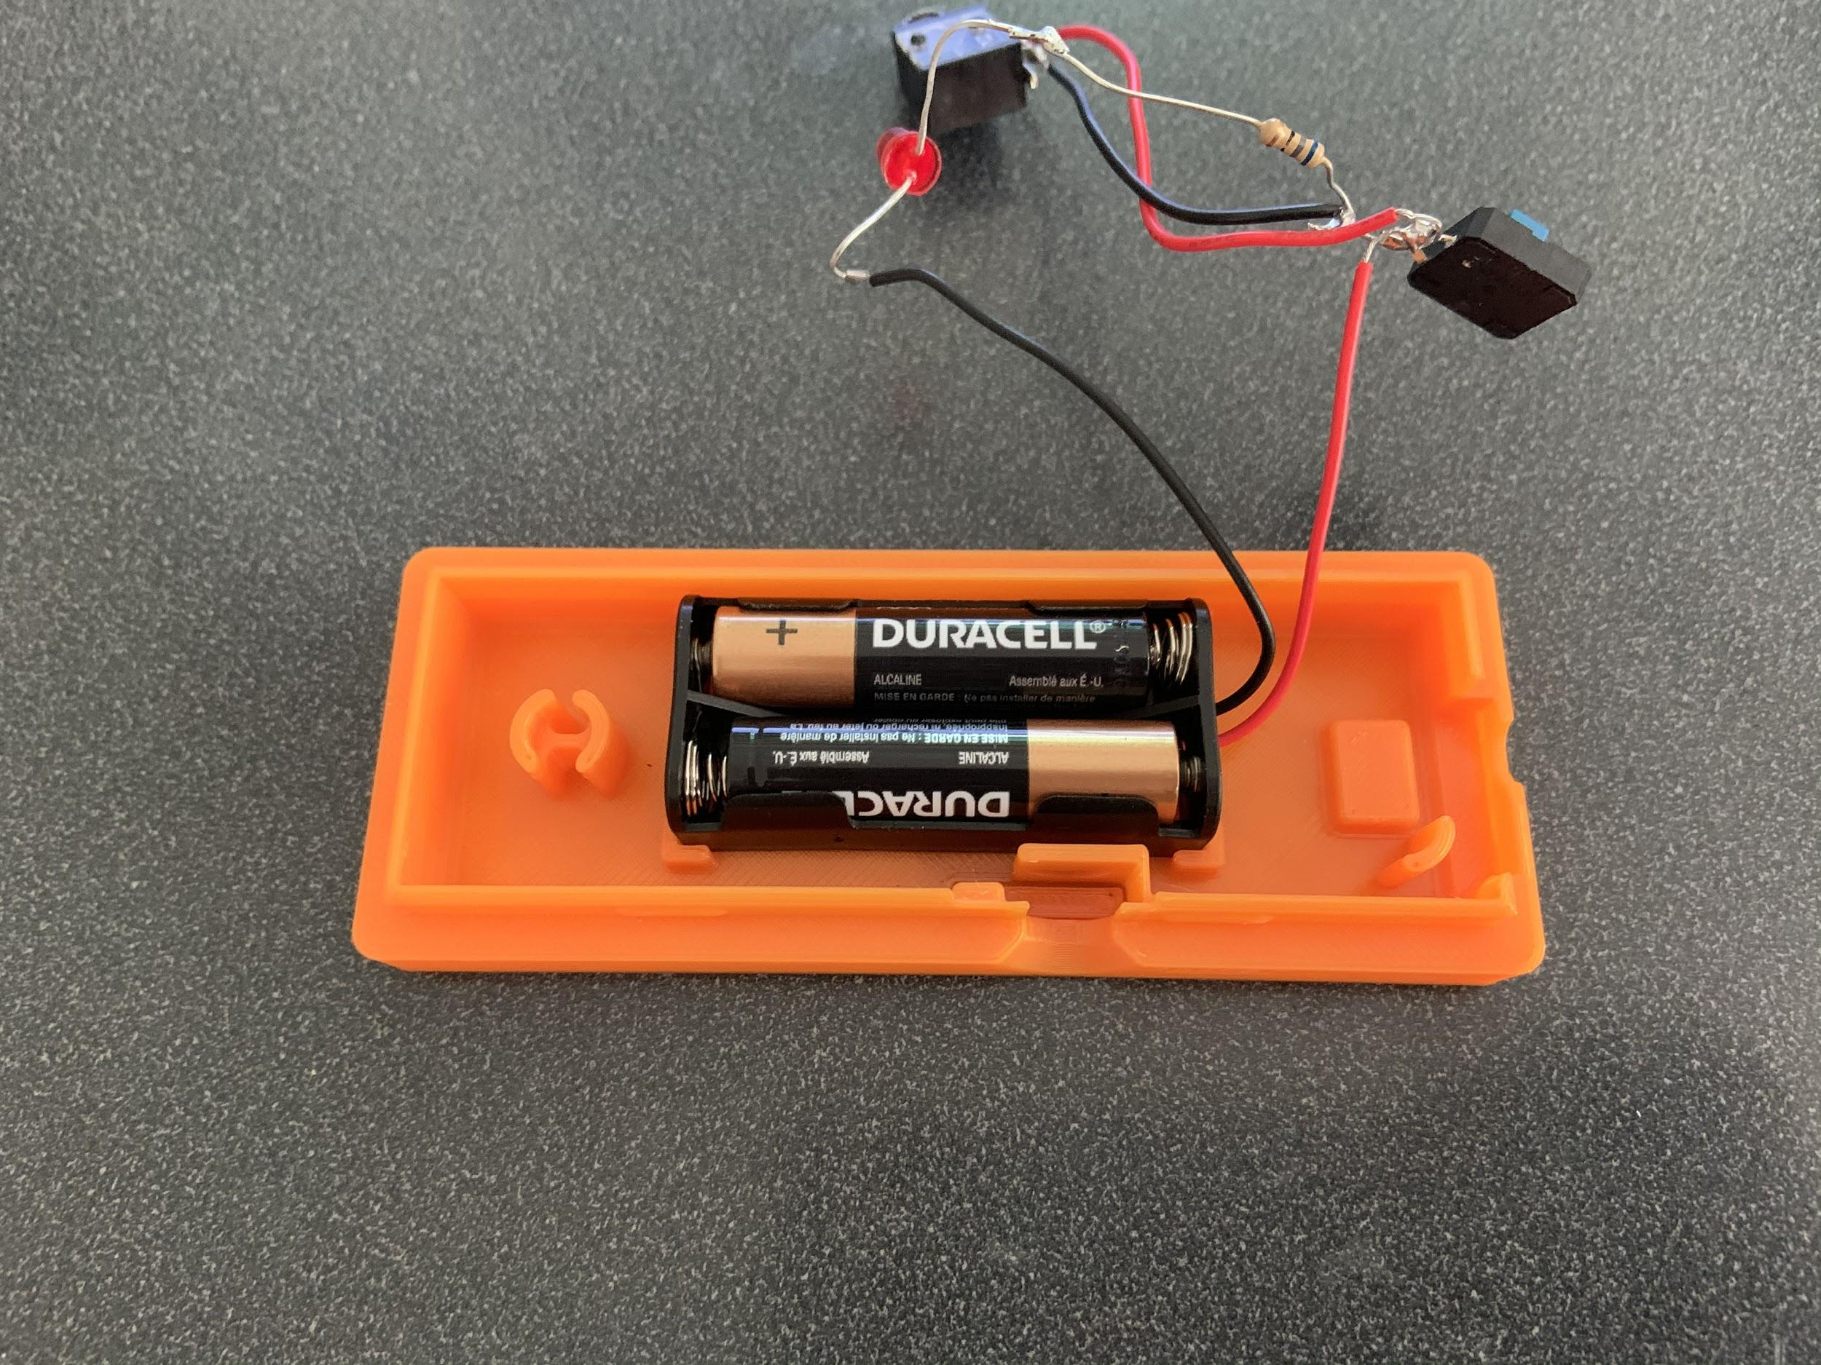

1. Check to make sure all the wires are connected correctly and in the right spots.

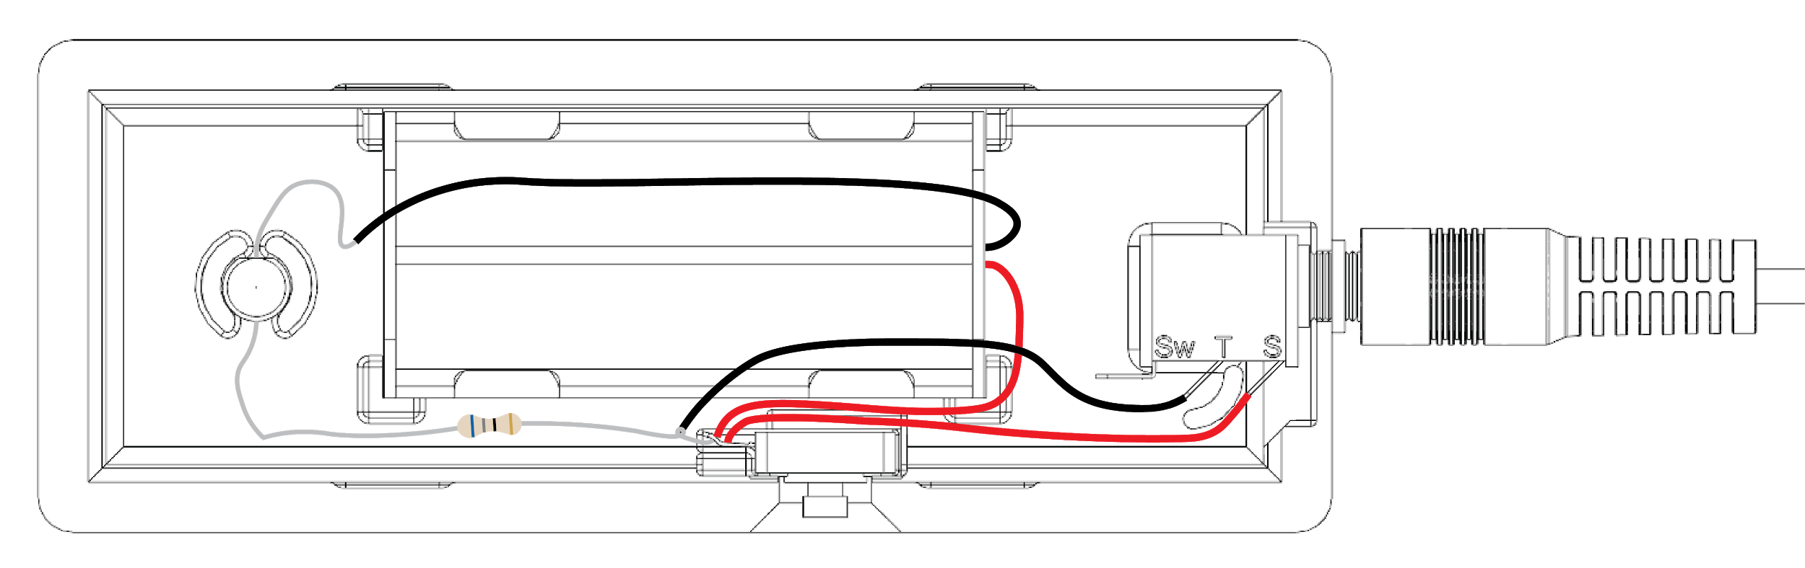

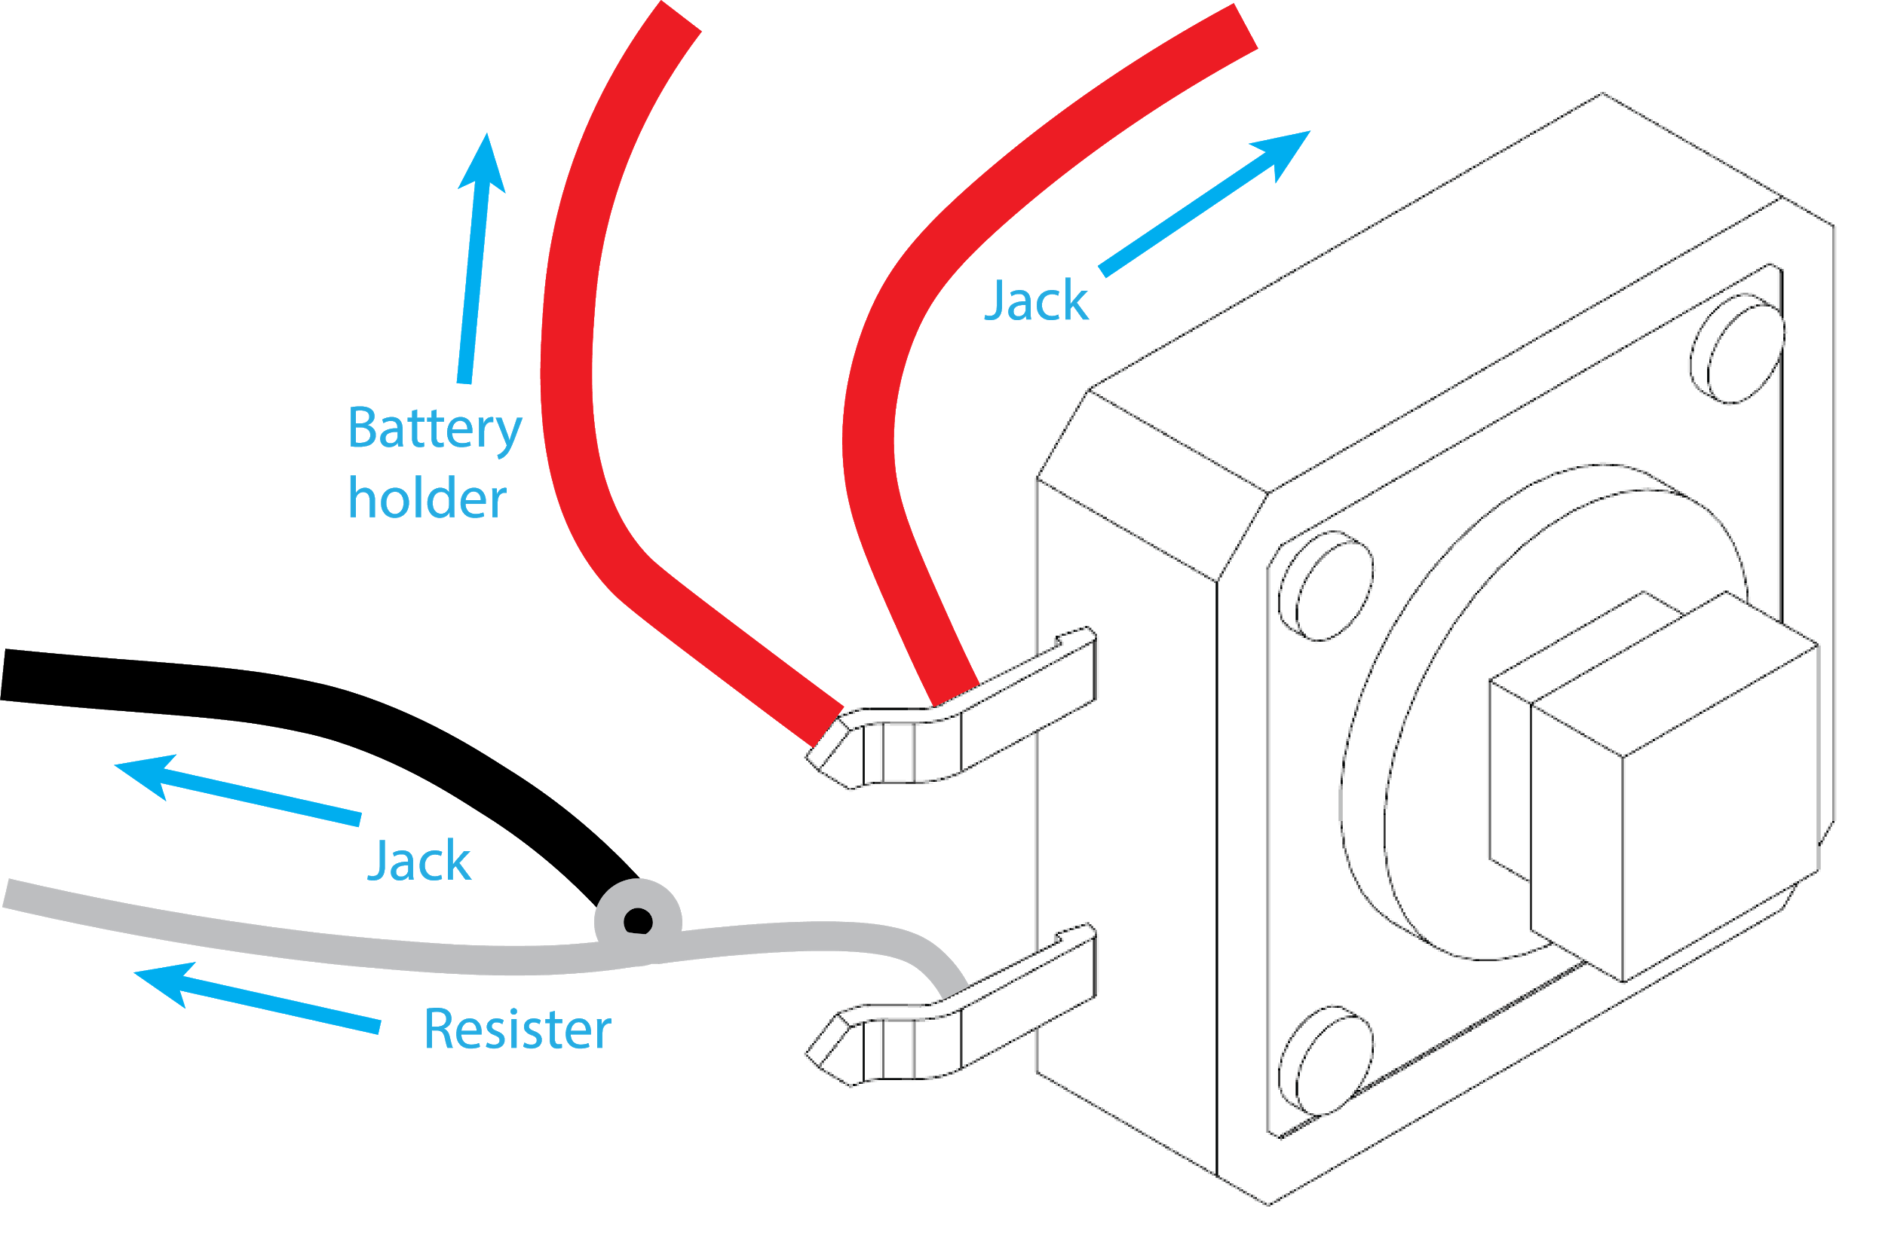

The LED stays on all the time:

1. Make sure the wires are not accidentally touching each other or soldered together incorrectly.

The LED turns on when the test button is pushed, but not when the assistive switch is activated:

1. Check to ensure the assistive switch is plugged into the jack correctly/all the way.
2. The assistive switch may not be assembled correctly/not working.

Replacing Batteries

*Replacing the Batteries*

1. Loosen the 3.5 mm jack nut without removing it and pull apart the two halves of the enclosure, exposing the electronics inside.
2. Remove the old batteries and dispose of them appropriately (recycle or recharge).
3. Insert the two new AAA batteries. Ensure they are installed in the correct orientation.
4. Check the tester by pressing the “BATTERY TEST” button to see if the indicator light illuminates.
5. Re-assemble the enclosure. Snap the two halves back together and tighten the nut on the 3.5 mm jack.