## Introduction

The Single Message Playback Switch is a device that records a single 30 second message and plays it back when either the built-in button or external switch is activated. The device can be used both as a toy, and as a communication aid.

## Features

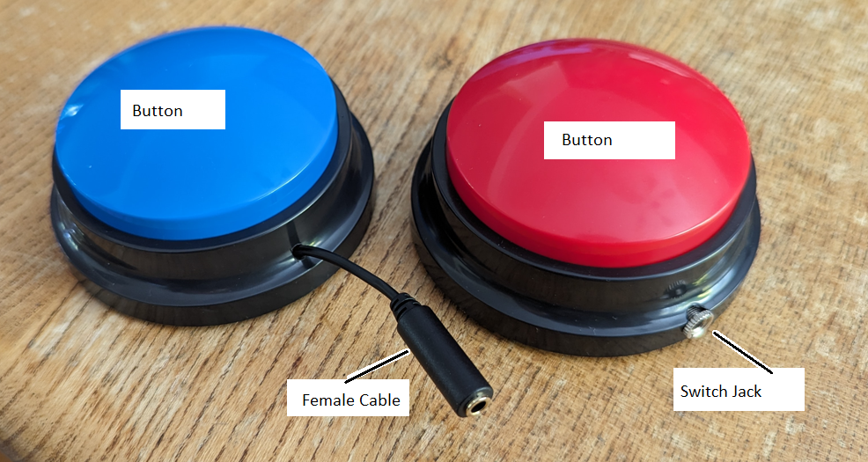

## Usage

To use, connect a switch to the jack or female cable attached to the device. The Playback Switch can then be activated with the connected switch.

To record a message, flip over the button. There will be a small black button on the base. Hold this button to record a message, recording will last for 30 seconds or until the button is released, whichever comes first.

## Compatibility

The device is compatible with and 3.5mm switch.

## Specifications

Diameter: 90 mm

Height: 40 mm

Weight: 72.5g

## Cleaning

Wipe clean with damp cloth.