**Analog Sip and Puff: One Page Quick Setup Guide**

**Notes:**

For overview, detailed instructions, cleaning, battery and specs, refer to document: **Analog Sip and Puff User Guide**

1. **Hook up the air tube:**

Connect the mouthpiece to the Sip and Puff Switch main box, as shown in Fig1: 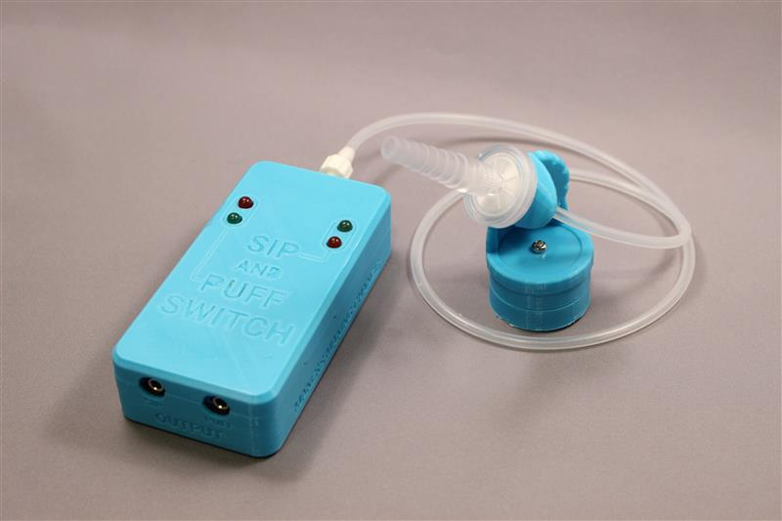 **Fig. 1**

1. **Turn on the main box:**

Slide the **power** **switch** **left,** (center of fig 2) towards the air tube connection, using a pen tip.

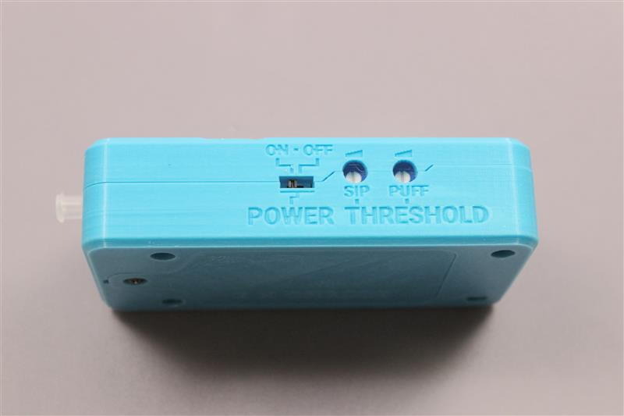**Fig. 2**

**3) Reset The Sip and Puff thresholds**:

Using a small flat screwdriver, turn both thresholds (Fig2, right of switch) fully clockwise.

**4) Set The Sip threshold**:

Dial the first adjustment left, until the red (sip) LED just goes out (and stays out).

**5) Set The Puff threshold**:

Dial Second adjustment left, until the red (puff) LED just goes out (and stays out).

**6) Test the unit**:

(Disinfect mouthpiece!) Sip and puff on the mouthpiece to confirm proper operation.

The red Puff LED (Left Fig.1) should turn on when you puff on the mouthpiece.

The red Sip LED (Right Fig.1) should turn on when you sip on the mouthpiece.

**7) Attach your controlled devices to Sip & Puff switch:**

Hook your puff device to 3mm Jack (Fig1, case bottom left) on the main unit.

Hook your sip device to 3mm Jack (Fig1, case bottom right) on the main unit.