**Analog Sip and Puff User Guide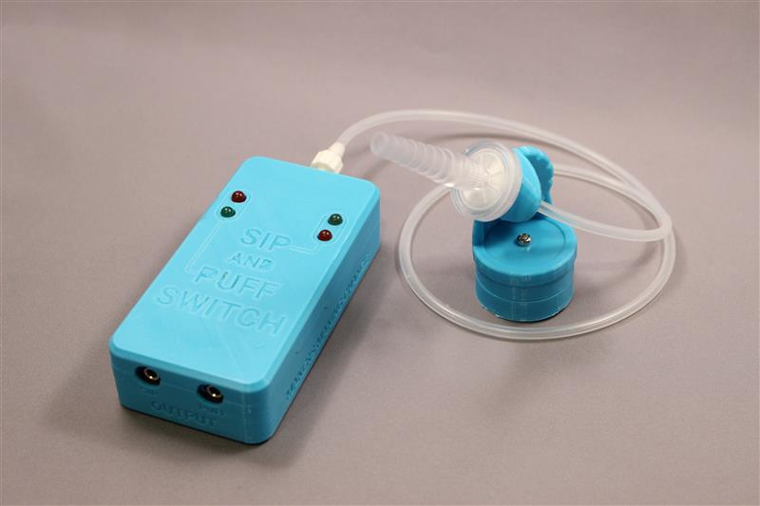Fig. 1**

**Overview:**

The MMC Analog Sip and Puff Switch is an assistive switch able to be operated by softly sipping or puffing air in or out of a mouthpiece. The user should have the ability to blow air into, or draw or draw air from a straw . The switch is not recommended for persons who are unable to consciously control air movement in their lungs or mouth. The Analog Sip and Puff Switch consists of a rectangular control box to which an air tube and mouthpiece can be attached. Inside the box there is an air pressure sensor, and two independent momentary switches. The first switch normally triggers when drawing in (sipping) air through the mouthpiece. The second switch normally triggers when blowing (puffing) air through the mouthpiece. The sensitivity level of the sip and puff functions are individually adjustable using two side mounted controls that can be set with a small screwdriver. The internal switches on the unit connect to the external being controlled via two 3mm audio jacks using standard 3mm mono audio cables.

**Setup & Adjustment:**

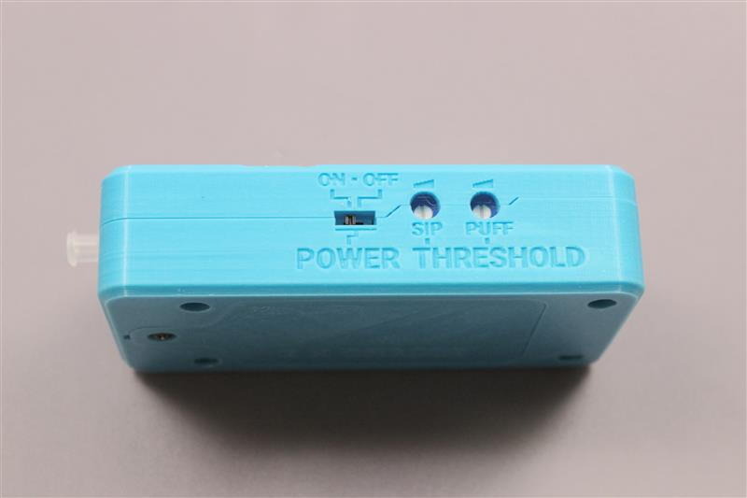**Fig. 2**

To get started, connect the mouthpiece to the Sip and Puff Switch main box as shown in Fig 1. The unit should be turned on by sliding the power switch (Fig. 2) left, towards the air tube connection, using a pen tip. The switch is recessed to reduce the chance of the unit being turned on or off accidentally. Once the unit is turned on, you should notice some LED’s glowing on the top panel. Normally, you should not see a red LED turned on, unless the user is sipping or puffing into the mouthpiece, as red indicates a triggered (on) state. The quickest way to adjust thresholds, is to use a small screwdriver and dial both adjustments fully clockwise (maximum sensitivity). Then, dial the left (sip) adjustment counterclockwise, until the red sip LED goes out, and the green sip LED (closest to air tube inlet) just stays on. Next, dial the right (sip) adjustment counterclockwise, until the red puff LED goes out, and the green puff LED (furthest from air tube inlet) just stays on. If the sip or puff sensitivity triggers too easily, it’s sensitivity can be reduced by further turning the adjustment counterclockwise.

**Installing or changing batteries:**

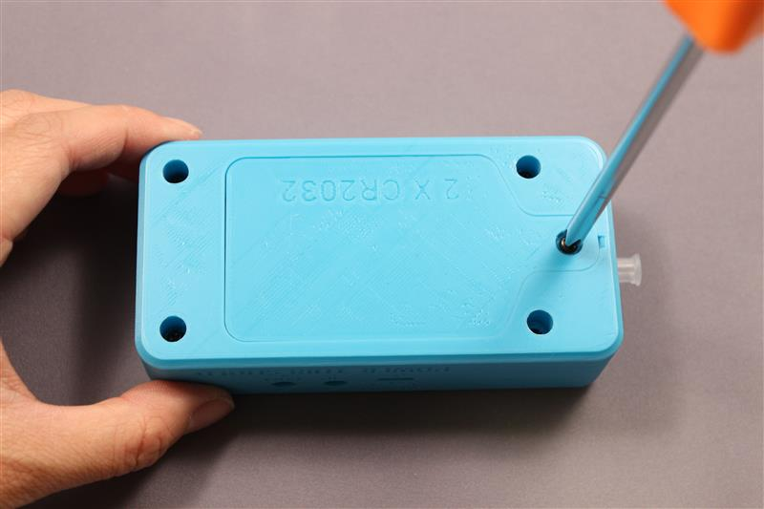**Fig. 3**

The batteries in the Sip and Puff Switch can be changed by using a medium sized Phillips screwdriver, to remove the battery lid screw (closest screw to air tube connector) as shown above.

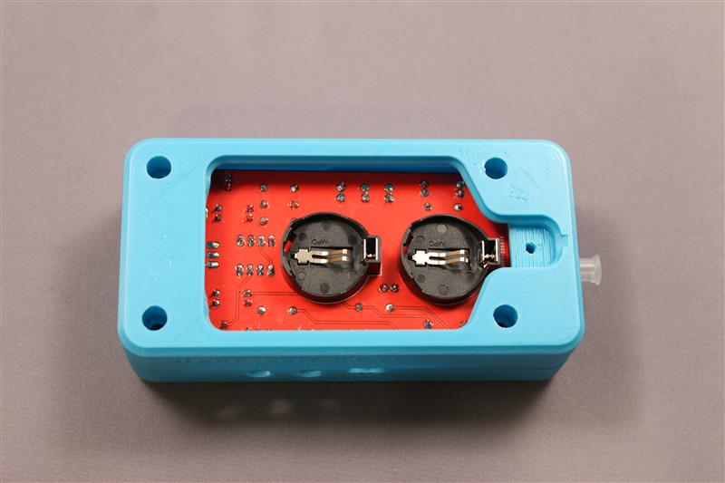**Fig. 4**

The Sip and puff switch accepts two CR2032 coin cells into the round battery holders shown in Fig.4. The battery positive terminal is marked with a ‘+’ which must face up while being installed

**Important:** The lithium batteries should be changed in pairs to prevent damage to the batteries.

Specifications:

Size: 119mm X 56mm X (the unit sits 11mm higher with the mounting adaptor attached.)

Switch connectors: Dual 3mm mono audio type jacks. Accepts standard 3mm mono plug cables.

Recommended tubing 4mm OD 2mm ID Food

Maximum switching voltage: 48V, DC or AC.

Maximum switching current: 1 Amp, DC or AC.

Battery: Two CR2032 3V cell (replaceable)

Current draw 6.5ma

Expected battery life: 24 hours.

Cleaning: Clean or disinfect with bleach 2 teaspoons of 5 percent laundry bleach in one cup of water.

Do not use alcohol on the air tube or air tube fitting.