## Introduction

The Switch Adapted Spinning Light Wand toy provides a way to activate and hold the toy for users who may otherwise have difficulty playing with it independently.

## Features

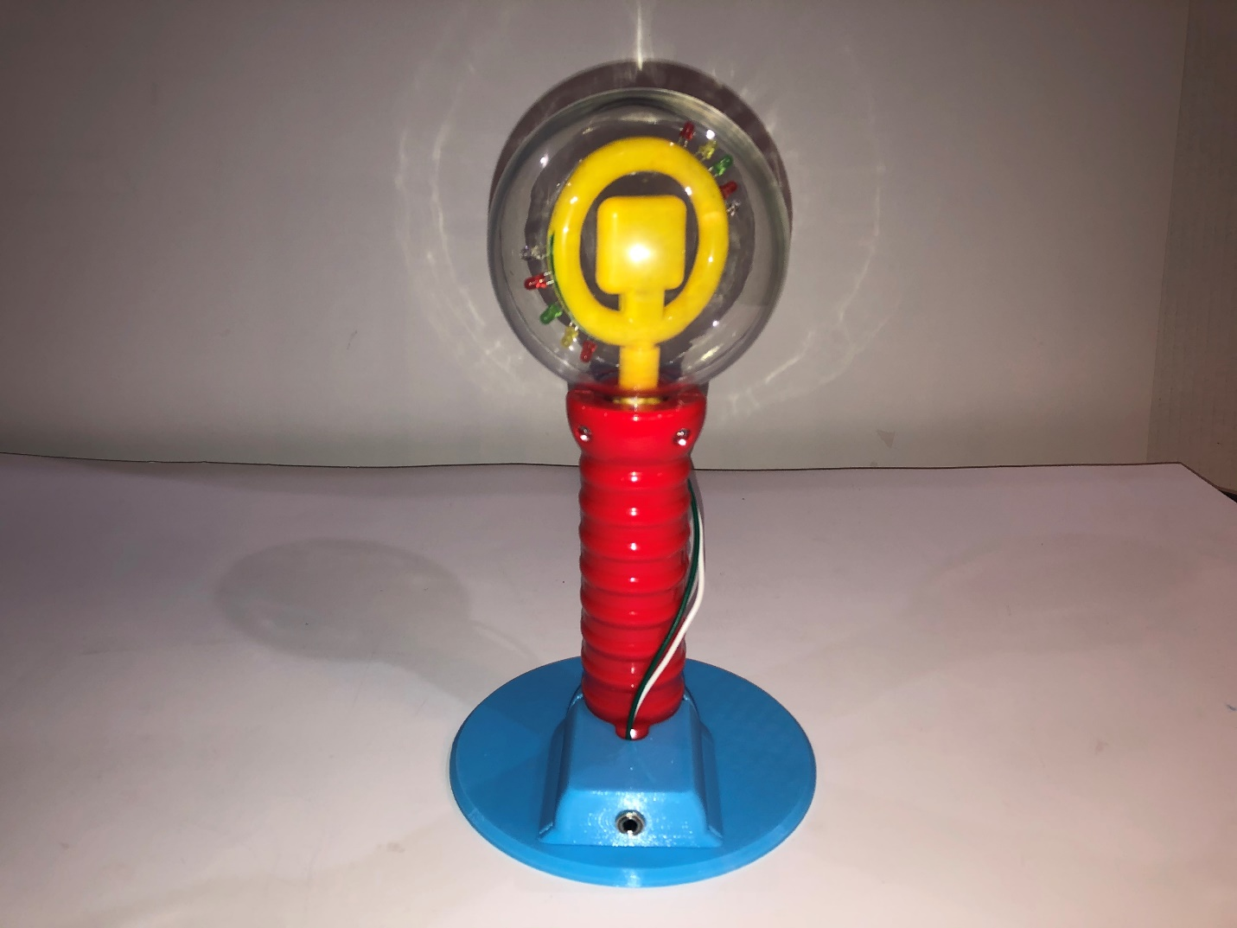

**Spinning Light Wand**

**3D Printed Wand Stand**

**3.5mm Input Jack**

## Usage

An assistive switch with a 3.5 mm mono plug is connected to the Switch input port on the Base. When the switch is activated, the lights will turn on and spin within the plastic globe.

## Compatibility

This adapted toy is compatible with assistive switches that have a 3.5 mm plug.

## Cleaning

The 3D printed base can be wiped down with a cloth. Do not submerge.