## Introduction

The Switch Adapted Nerf Gun is designed to be a switch adapted toy for an older audience. The majority of switch adapted toys are designed for a younger audience, so this project aims to adapt a toy aimed at older users and make it switch accessible.

## Features

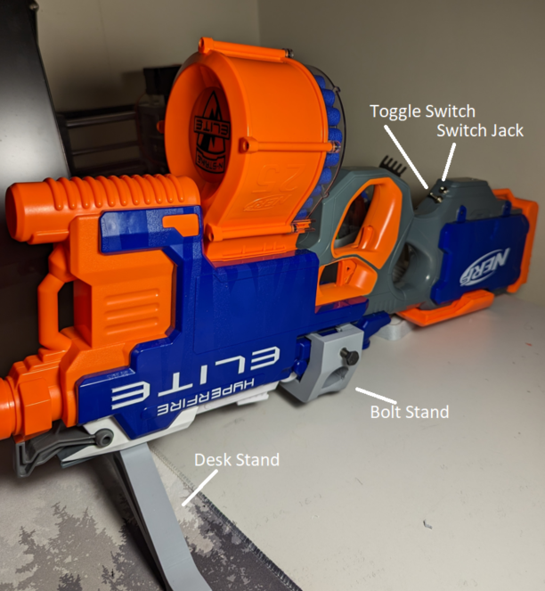

## Usage

To set up the Nerf gun on a flat surface, take the Desk stand and slide it onto the top attachment rail. This will allow the gun to stand by itself upside down.

To set up the Nerf gun on a ¼-20 bolt system, take the bolt stand and attach it to the section of the gun above the trigger as seen below. This will allow the gun to be attached to any ¼-20 mount system.

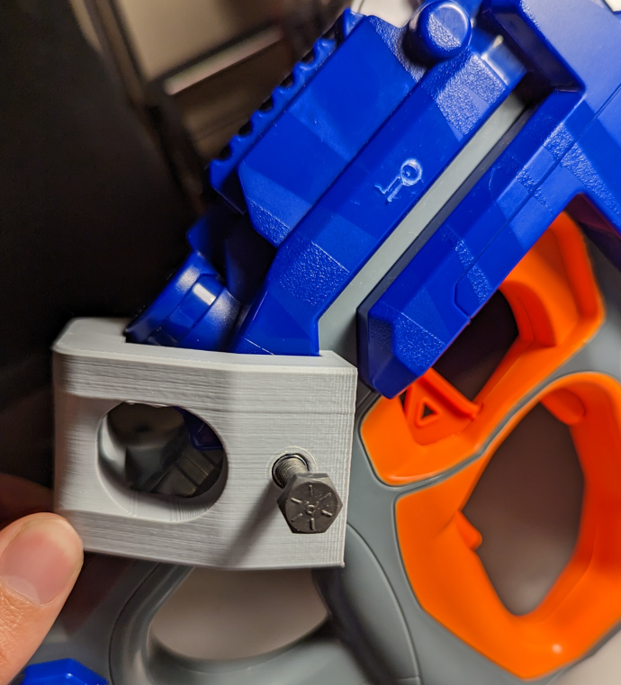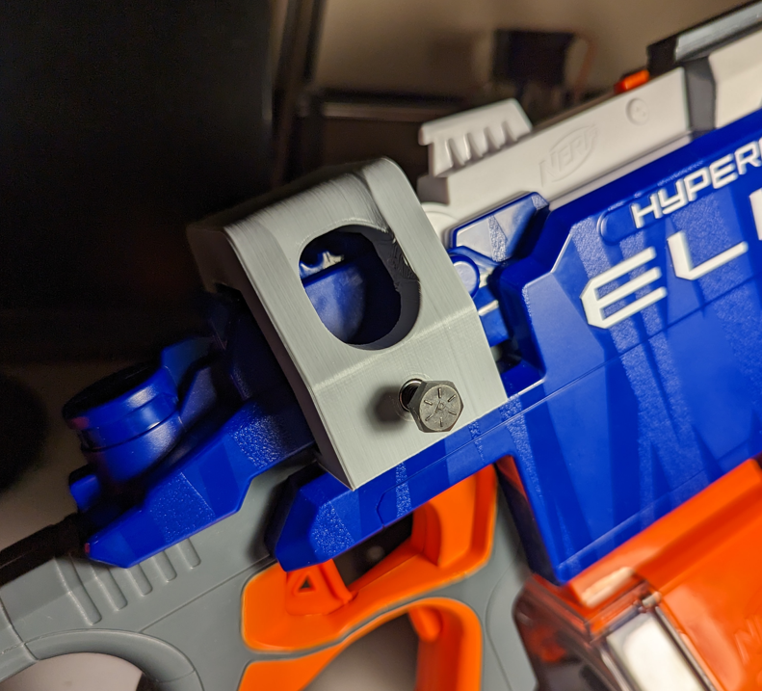

To use the gun, a 3.5mm switch can be plugged into the jack, and a secondary user can flick the toggle switch to activate the flywheel motors. Once the motors are spinning, the switch can be pressed and held to activate the feed motor for as long as the button is held.

## Compatibility

The device is compatible with standard 3.5mm switches as well as Nerf Elite darts.

## Cleaning

The device can be wiped clean with a damp cloth