## Introduction

The **Dual Mono-Stereo Adapter** enables two separate switches to be connected into a single stereo input. This is equivalent to a 3.5 mm TRS to Dual 3.5 mm TSF Stereo Breakout Cable.

## Features

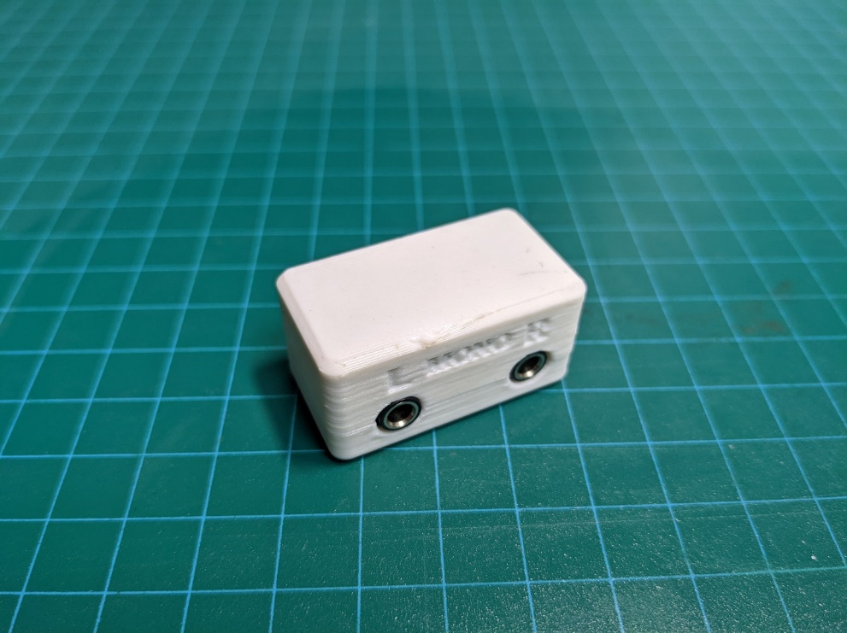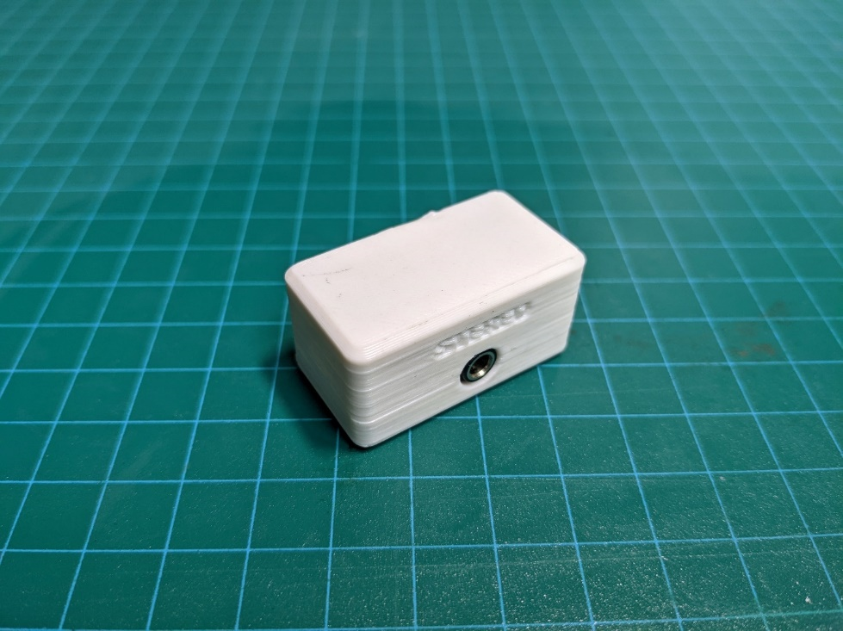

Left Mono Input Right Mono Input Single Stereo Output

## Usage

Connect the switches to the desired left of right input jack. Use a 3.5 mm extension cable to connect the output to the input on the assistive device.

## Compatibility

**Switches**: Assistive switches and devices with 3.5 mm output plug.

**AT Devices:** Assistive devices with 3.5 mm stereo input plug (e.g., Origin SWIFTY, Origin TAPIO, Origin HEADMOUSE, Darci USB)

## Specifications

|  |  |
| --- | --- |
| Mass | 12 g |
| Dimensions (length x width x height) | 38 mm X 21 mm X 19 mm |

## Cleaning

The Dual Mono-Stereo Adapter can be wiped down with sanitizing cleaners.

* Do not submerge in liquid.
* Do not expose to high heat.