# Introduction

This assistive switch mounting plate is ideal for individuals looking for a cost-effective way of mounting an assistive switch and hoping to utilize readily available GoPro mounting accessories.

This assistive switch mounting plate may be useful for those looking to mount an assistive switch and may include individuals with limited mobility of fine motor skills, such as those with disabilities, elderly users, or individuals recovering from injury.

# V1.0 Design

The Switch Plate – GoPro Compatible consists of a single 3d printed part with a flat narrow disc and a GoPro-compatible mounting interface on the bottom. The disc has an outer diameter of approximately 89 mm (3.5 in).

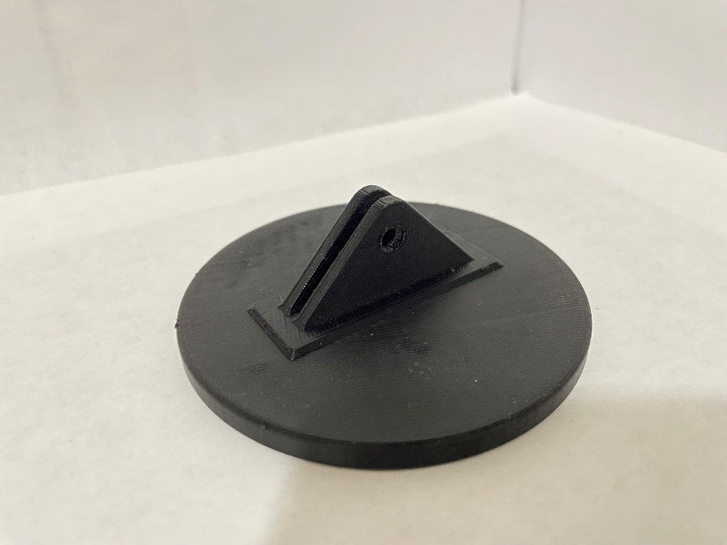

Figure 1. Switch Plate - GoPro Compatible. Resting upside down.

The Switch Plate is sized for use with small Assistive Switches that have a flat bottom, such as the [AbleNet Jelly Bean](https://www.ablenetinc.com/jelly-bean), or DIY OpenAT options like the [Interact Switch](https://www.makersmakingchange.com/s/product/interact-switch/01tJR000000698vYAA) or the [MMC60 Switch](https://www.makersmakingchange.com/s/product/mmc60-switch/01tJR000000693rYAA). The Assistive Switch is intended to be attached to the Switch Plate using hook and loop fastener (e.g., VELCRO) or double-sided adhesive.

The GoPro-compatible mounting interface has a similar shape and size to the mounting interface found on the bottom of a GoPro HERO camera or camera case. The two fingers are intended to engage with a variety of mounting solutions.

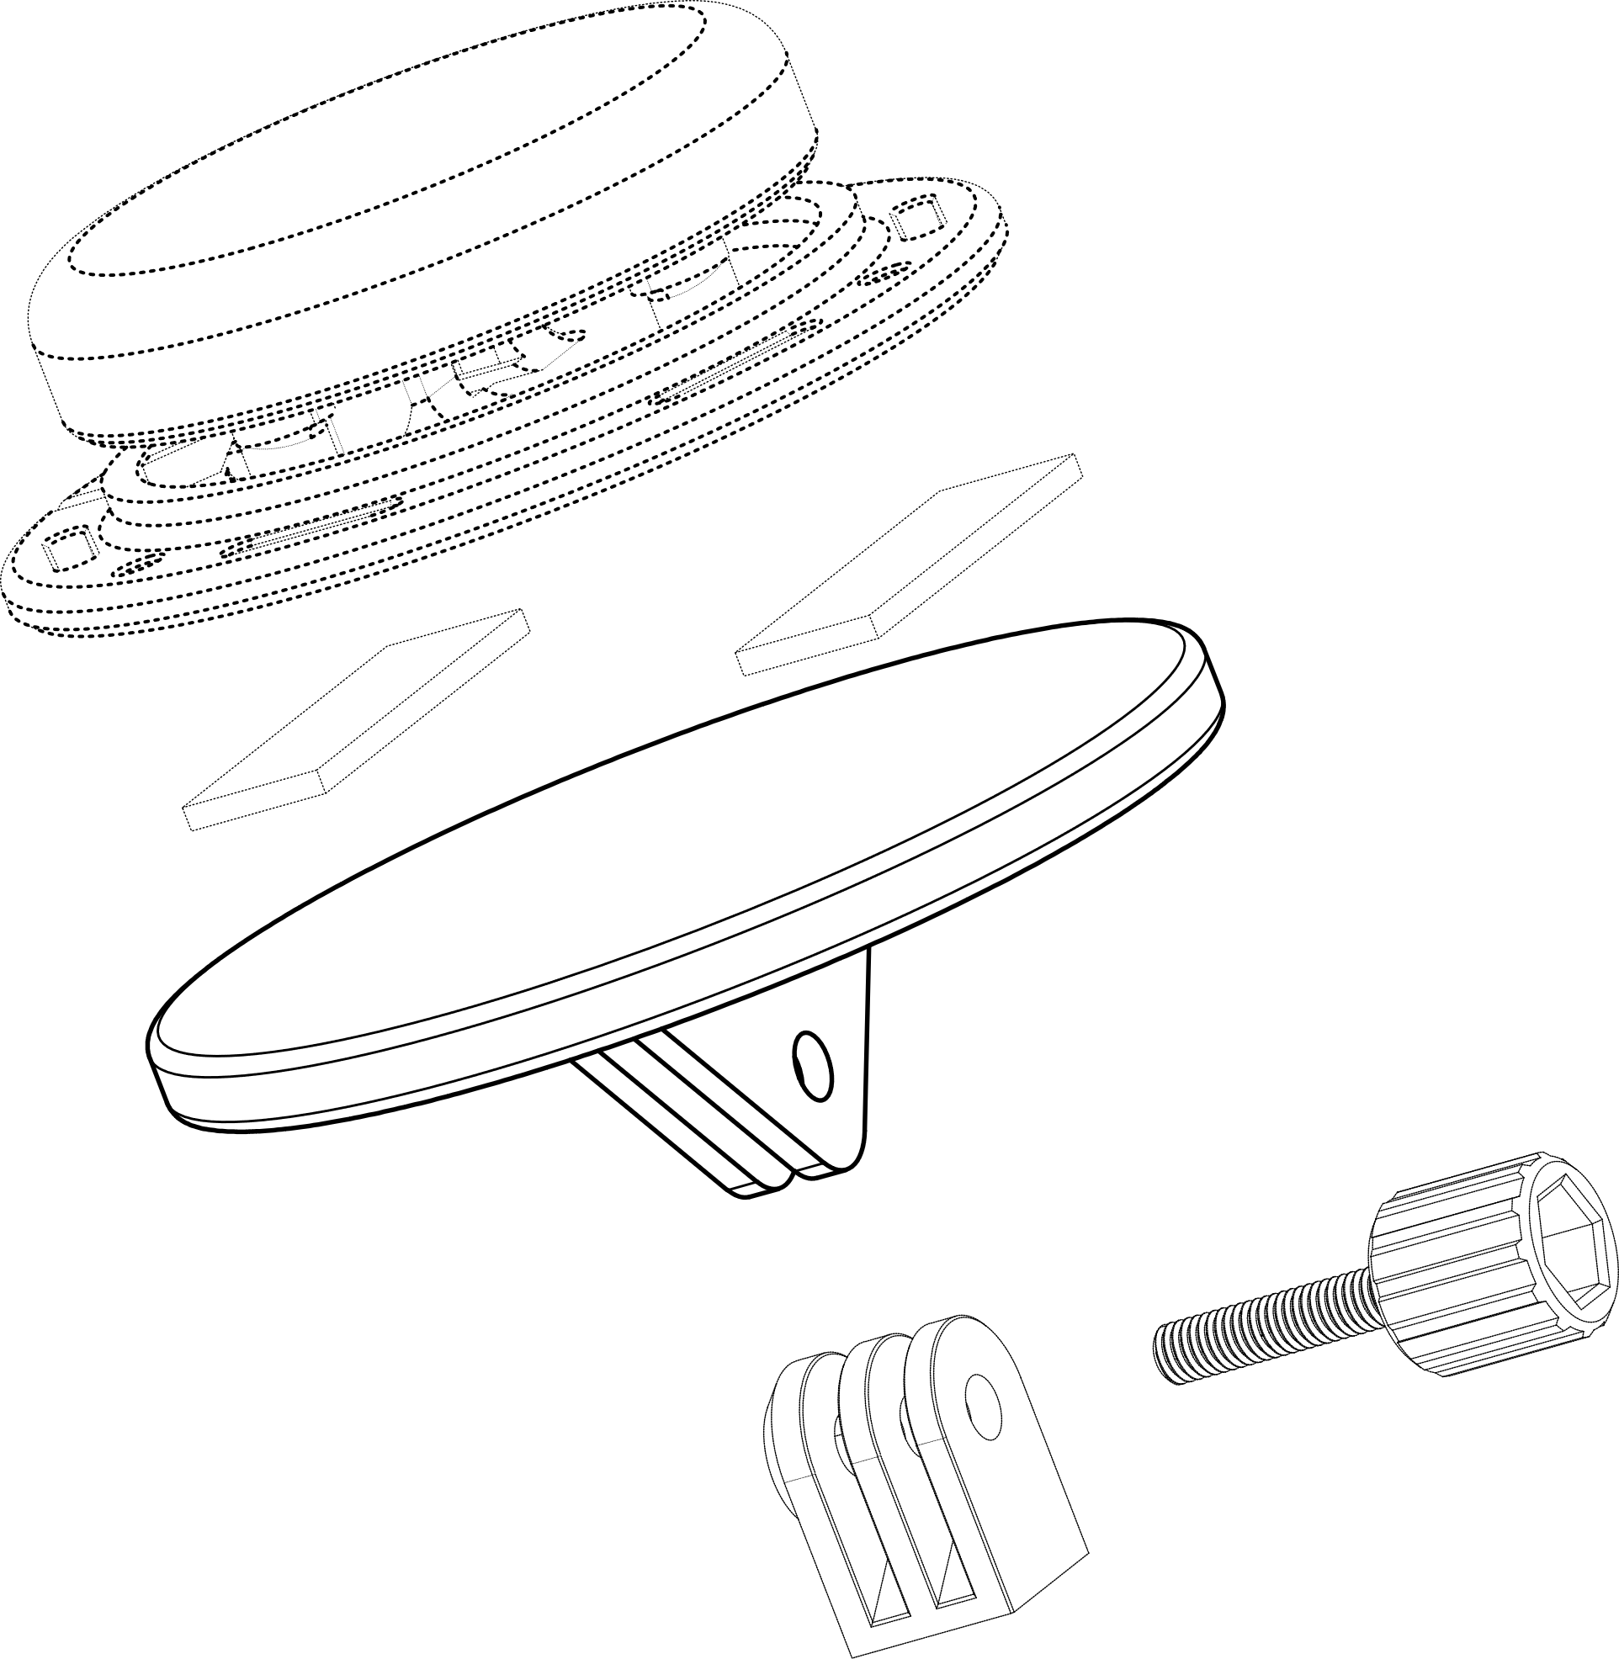

Assistive Switch

Adhesive OR   
Hook and Loop

GoPro Mounting Finger Adapter

Switch Plate

GoPro Thumb Screw

Figure 2. Switch Plate Assembly with Assistive Switch and GoPro Mounting Hardware.

GoPro Mounting Accessories uses a multi-fingered pivoting joint that is locked via friction applied by a fastener. The system uses an M5 machine screw or thumb screw, a 3-fingered mounting adapter, and a M5 locking hex nut.

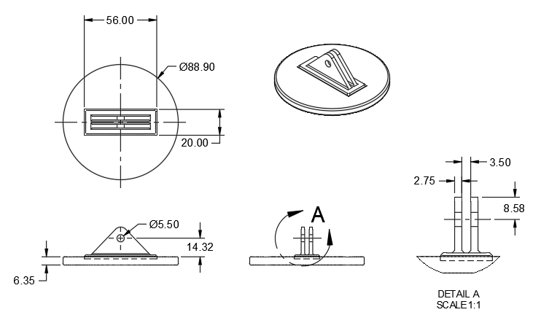

Figure 3. Key Dimensions of Switch Plate.

## Mounting System Adapters

There is a range of GoPro compatible mounting hardware available commercially from GoPro and other vendors. There is also at least one open source 3D printable options for mounting components. Below is a non-exhaustive list of some of these solutions that are relevant for mounting assistive switches.

### GoPro

GoPro carries a variety of mounting solutions for mounting their cameras in a variety of applications. One example that is relevant for mounting assistive switches is the [Jaws](https://gopro.com/en/ca/shop/mounts-accessories/jaws/ACMPM-001.html), which consist of a camera clamp mount and an and an adjustable neck. The adjustable neck appears to be similar to, and may consist of Loc-Line segments.

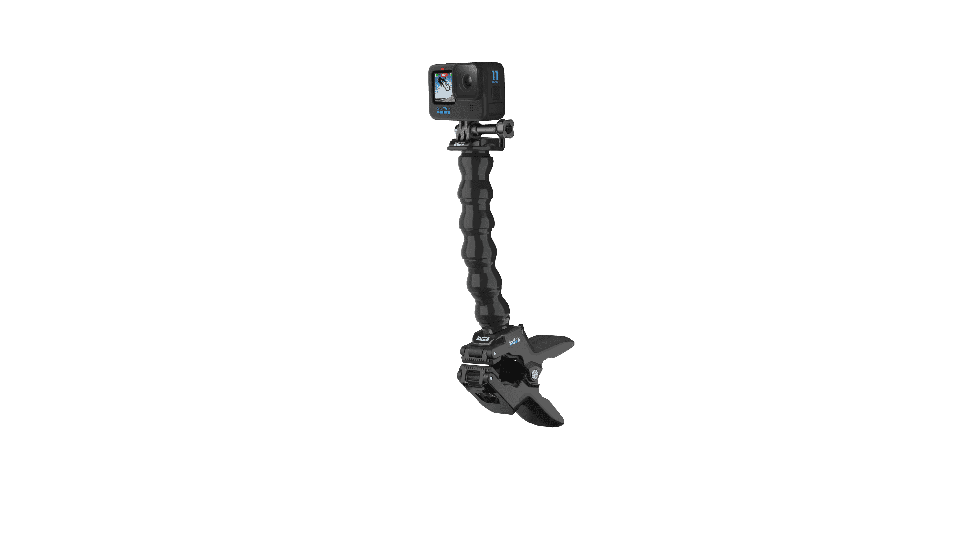

Figure 4. GoPro Jaws. Copyright © 2024 GoPro, Inc.

### RAM

RAM Mounts are a modular mounting solution based on a ball-and-socket system that are commonly used to mount phones, tablets, and camera in a range of environments and applications. RAM has an [Action Camera Universal Ball Adapter](https://rammount.com/products/rap-b-202u-gop1) that can be used to attach the Switch Plate to a standard B-sized 1” ball for use with other RAM mounting hardware.

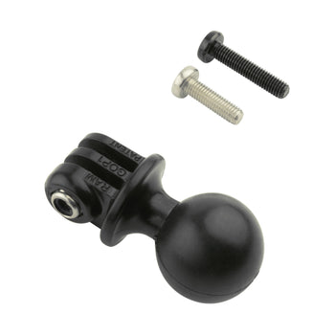

Figure 5. RAM Action Camera Universal Ball Adapter. Image Copyright ©2024 National Products Inc.

### Modular Mounting System

The Modular Mounting System was developed by Ryan Huang ([HeyVye](https://www.thingiverse.com/HeyVye)) and released on Thingiverse (<https://www.thingiverse.com/thing:2194278>) under a [Creative Commons – Attribution license](https://creativecommons.org/licenses/by/4.0/). It is a collection of modular mounting components that are also compatible with GoPro mounting accessories.

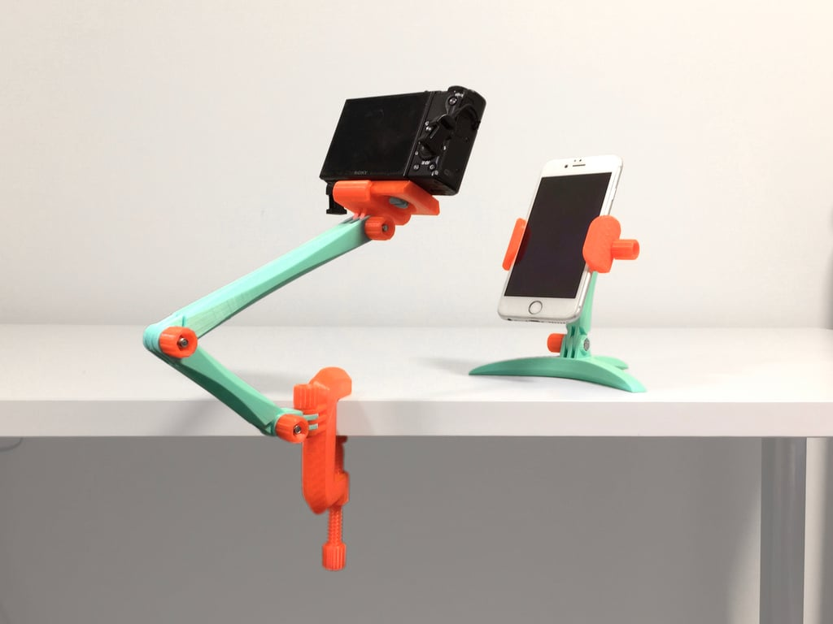

Figure 6. Modular Mounting System. Ryan Huang. CC-BY.