## Introduction

This mounting plate is ideal for individuals looking for a cost-effective way of mounting an assistive switch and hoping to utilize readily available GoPro mounting accessories.

## Features

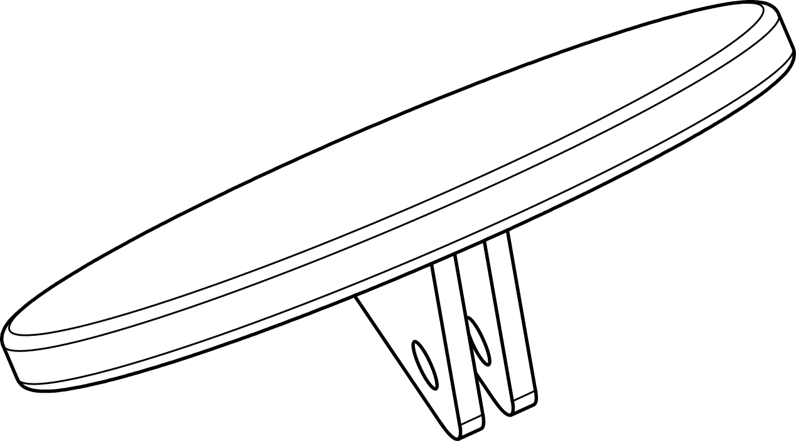

Assistive Switch Mounting Surface

GoPro-compatible Mounting Interface

## Usage

### Connecting to GoPro Mounting Accessory

The two-finger mounting interface on the back of the Switch Plate is inserted into the three fingers of the GoPro Mounting Finger Adapter and secured with the GoPro Thumb Screw.

### Attaching Assistive Switch

Attach the Assistive Switch to the Mounting Surface of the Switch Plate using hook and loop fastener (e.g., VELCRO) or double-sided adhesive.

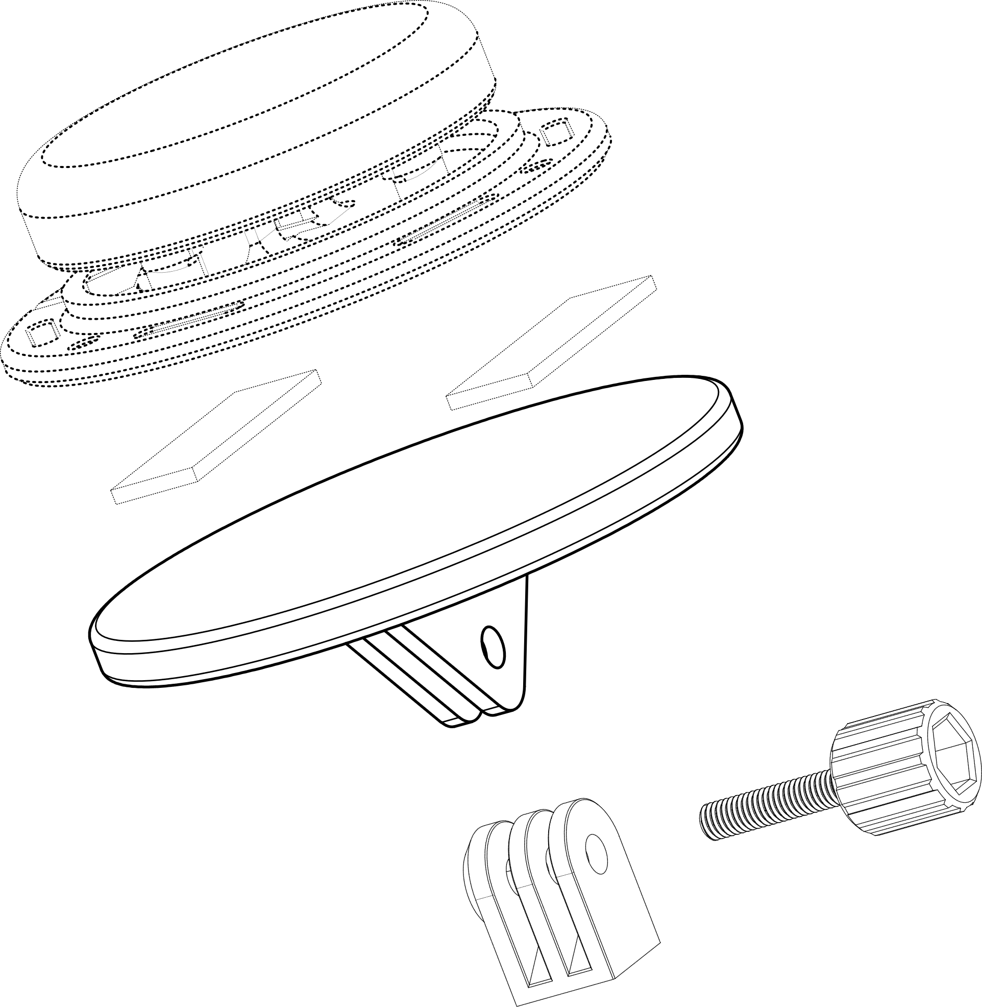

Assistive Switch

Adhesive OR   
Hook and Loop

GoPro Mounting Finger Adapter

Switch Plate

GoPro Thumb Screw

## Specifications

|  |  |
| --- | --- |
| Diameter | Ø89 mm (Ø3.5 inch) |
| Mass | 25 g (Switch Plate Only) |

## Cleaning

The Switch Plate can be cleaned with a damp cloth. The Switch Plate can also be cleaned by scrubbing with warm water and dish soap. Do not expose to hot water or a dishwasher. Do not use harsh cleaners.