Required Components
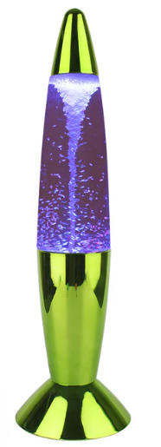 | 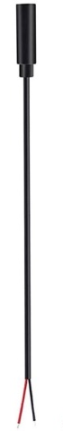  2. | BOM  - Tornado Lamp (Canadian Tire)  - 3.5 mm Female Mono Cable  - Cable Tie  - 3 AA batteries (included)  Refer to the Tool and Component List for purchasing details.
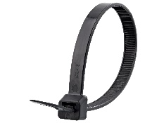 | 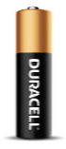

Required Tools
- Screwdriver
- Soldering iron
- Wire stripper
- Flush cutter
- Drill and ¼ drill bit

Required Personal Protective Equipment (PPE)
- Safety Glasses

Assembly Instructions

Step 1
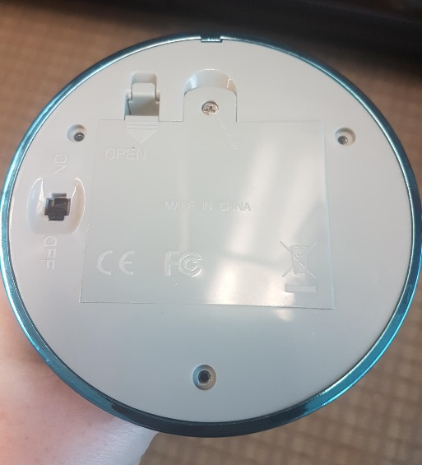 | - On the bottom of the lamp, locate 3 screws that hold the bottom plate in place  - Using a screwdriver, turns screws indicated in the red circles to remove bottom covering  - Also unscrew and take off the battery cover  - Set screws aside in a safe place

Step 2
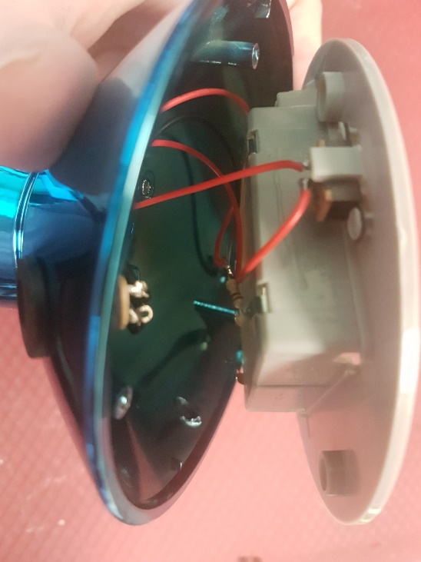 | - After the screws are undone, gently take the bottom of lamp off and set to the side. Be very careful while doing this as to not pull off any existing wires or connections  - The wires may be short, leaving little space for the toy to be opened wide  - Locate where the original on/off switch is inside the toy

Step 3
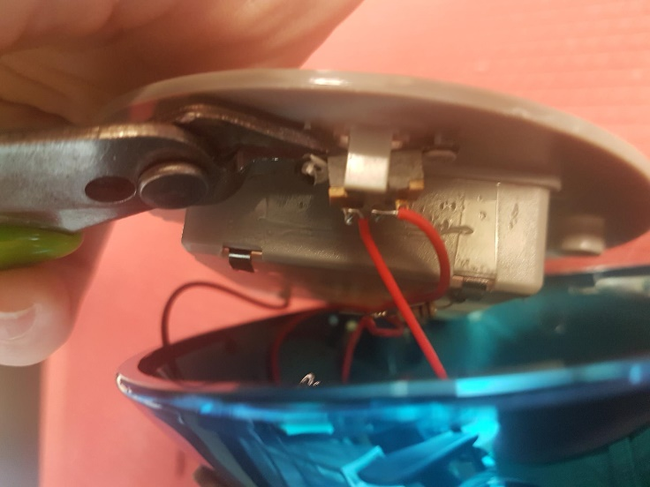 | - You will need to remove the original switch from the plastic holder  - To do this, use your flush cutters to trim the plastic on either side of the switch  - You can also use your flush cutters to wiggle or push the original switch from the plastic

Step 4
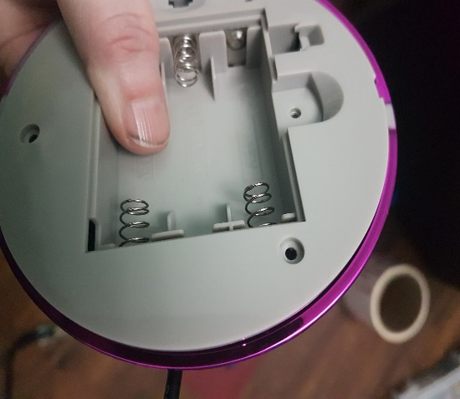  Cable  Top of battery compartment | - Using a 1/8 drill bit, drill a hole on the side of the toy  - The hole is best drilled to the right of the battery compartment, on the side of the stand  - Check that the mono cable can be threaded through the hole with the exposed wires going into the toy

Step 5
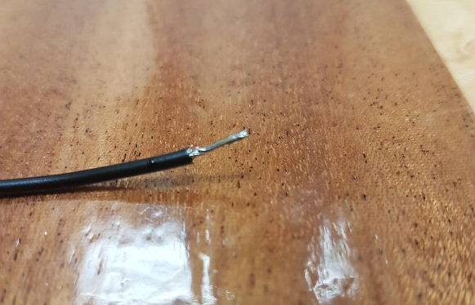 | - Making sure the cable is going through your drilled hole, it is now time to solder  - First, you are going to “tin” the end of both of your wires, which is when you cover the exposed end of the wire in solder  - This process will make it easier to solder that end of the wire to the original switch which is in the next step

Step 6
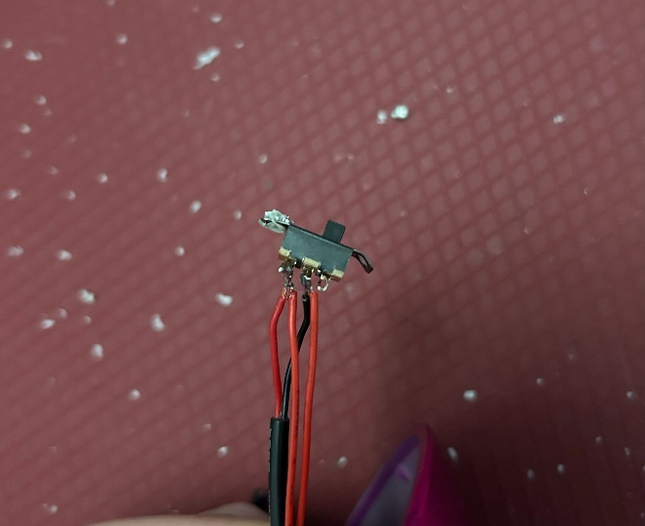 | - The original switch has 2 wires attached to it on 2 metal prongs  - You will be attaching the wires you just prepared to this same spot: with the original wires  - To do this, hold one tinned wire end to the metal prong (where there is also an original wire attached)  - Then bring your solder iron to the spot with your two wire ends, and hold for about 3 seconds: this will heat the pre-existing solder of the original solder, and the solder of the wire you had just tinned, combining for one spot on the metal prong

Step 7
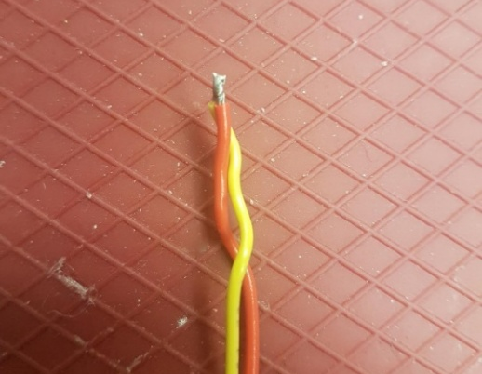 | - If your original wire comes loose, that is ok  - You can then twist the original wire with one of the new wires and use solder to cover the two ends of wire  - Then bring the wires to the metal prong, where the original wire was connected, reheat the solder so it once again sticks to the metal prong where it was originally

Step 8
- Repeat Step 6 (and Step 7 if needed) with the second wire
- Make sure there is no solder going between the two metal prongs or that the wires ends are not touching
- If needed, you can use electrical tape to help with separation
- When complete you should have two metal prongs, each with two wires attached: one original wire and one new wire
- Test the new connection using an assistive switch – you will need to add batteries

Step 9
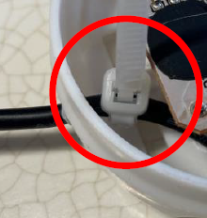 | - After Testing, before reassembling, add a cable tie around the cable inside of the toy  - This is to help the cable from being pulled through the hole  - You can snip the long end of the cable tie

Step 10
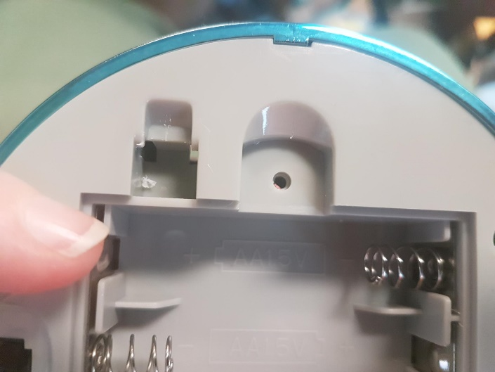 | - Replace the bottom of the lamp  - If it is difficult to find the original position, look for the slight notch at the top to help you match the correct position  - Replace and tighten the screws

Step 11
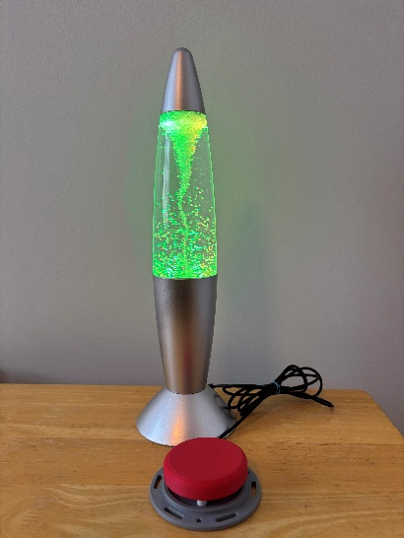 | - Test the toy again with an assistive switch, if it is still working properly, congratulations! You have completed the toy!

