Required Components
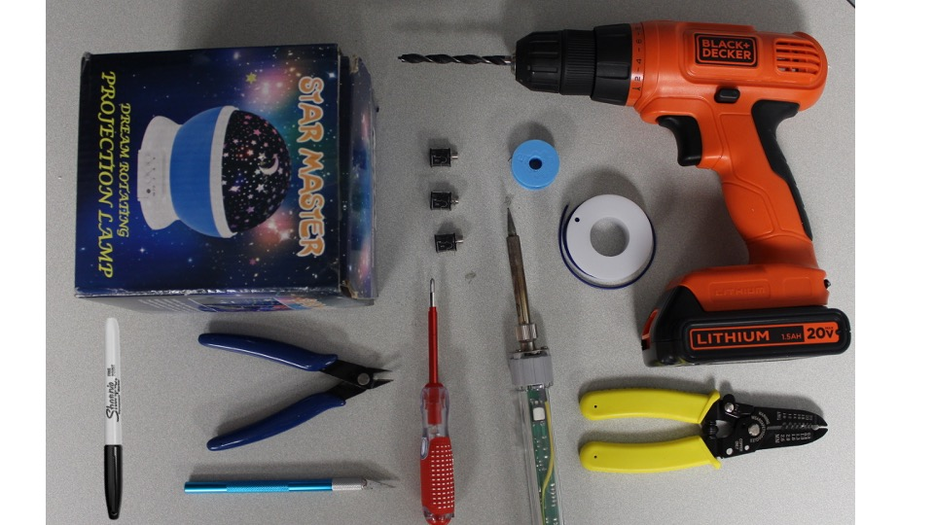  12  11  10  9  8  5  7  6  4  3  2  1 | BOM  - Drill  - Wire strippers  - Wire  - Solder  - Soldering iron  - ¼” Drill bit  - Mono jacks  - Philips head screwdriver  - Moon and Star Projector Toy (Amazon)  - Flush cutters  - Craft knife  - Permanent marker  Refer to the Tool and Component List for purchasing details.

Required Tools
- Drill
- Wire strippers
- Solder
- Soldering iron
- ¼” Drill bit
- Philips head screwdriver
- Flush cutters
- Craft knife
- Permanent marker

Required Personal Protective Equipment (PPE)
- Safety Glasses

Assembly Instructions

Step 1
Open the toy carefully and keep the original packaging in good condition.
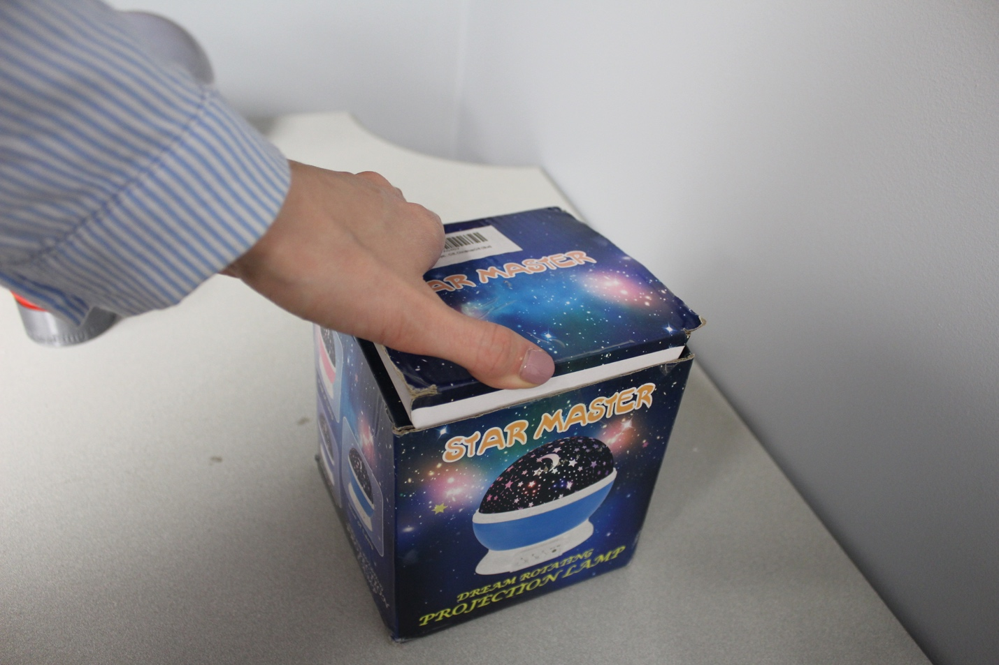

Step 2
Remove the battery cover and ensure there are no batteries installed.
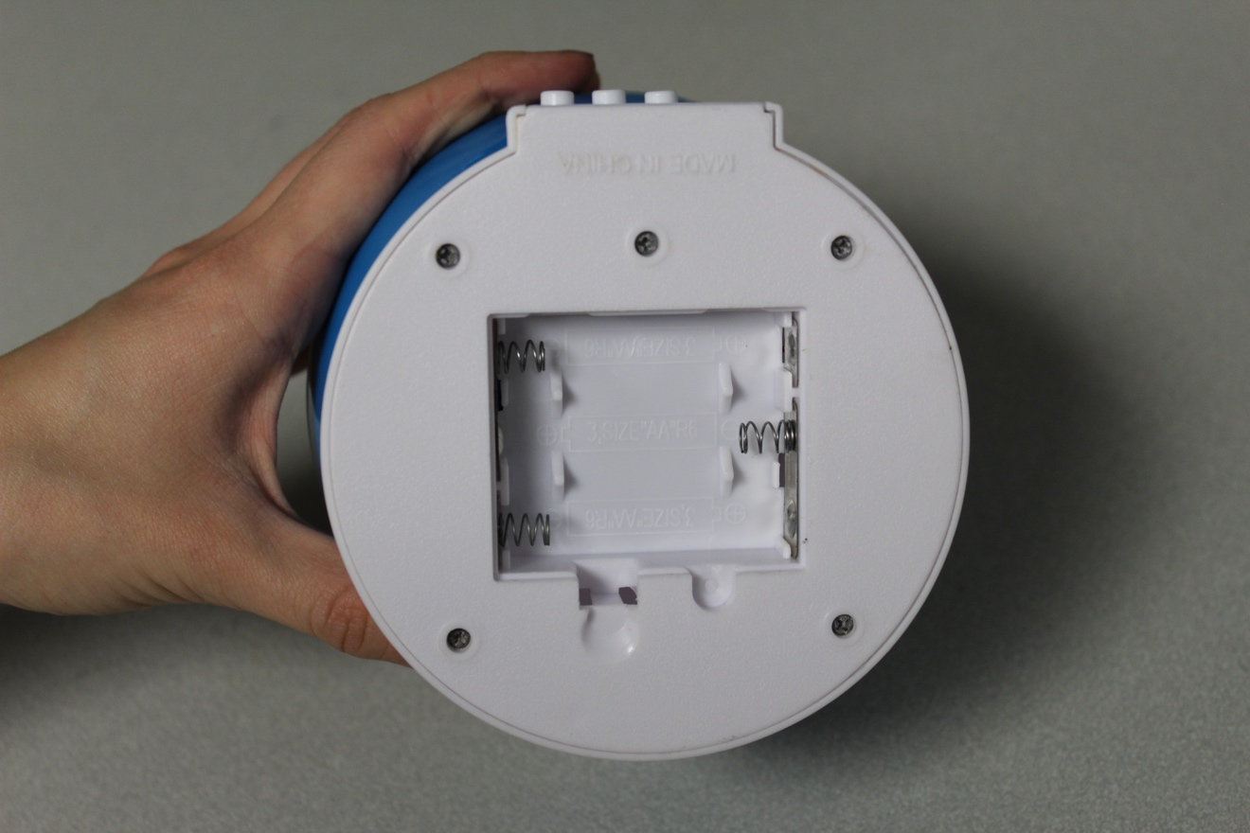

Step 3
Remove the top of the toy.
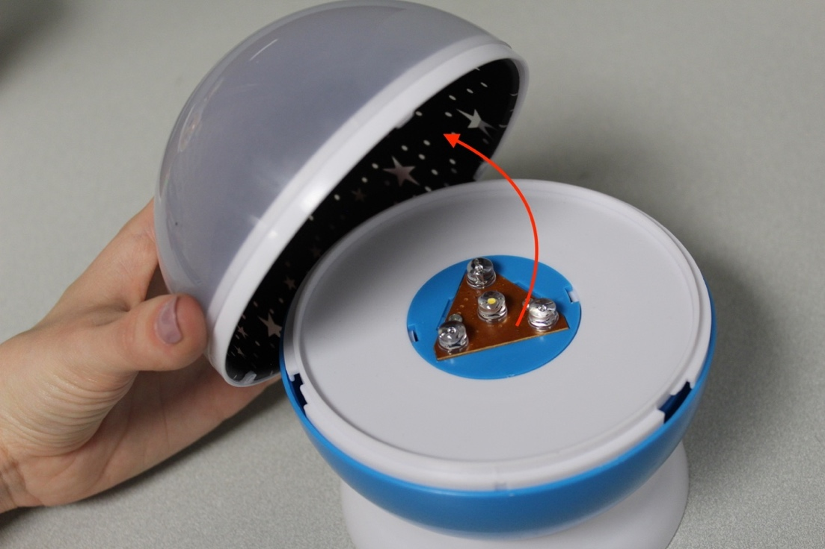

Step 4
Remove the five screws that hold the bottom of the toy on with a screwdriver.
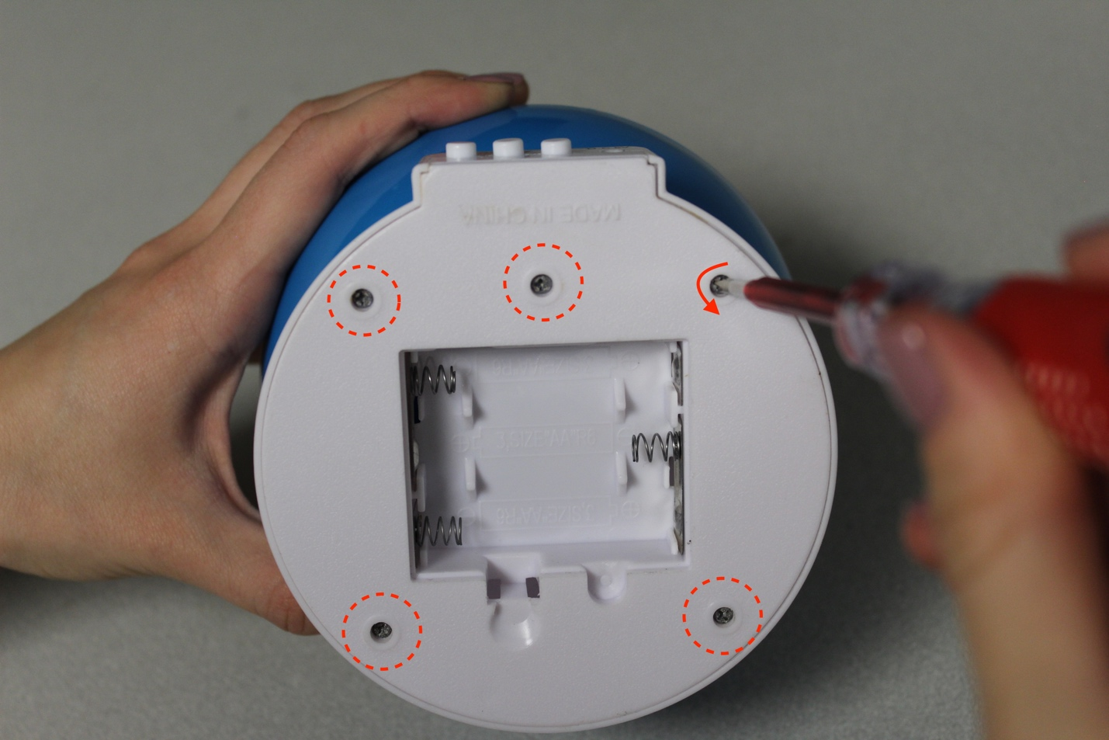

Step 5
Use a screwdriver to gently pry off the back of the toy.
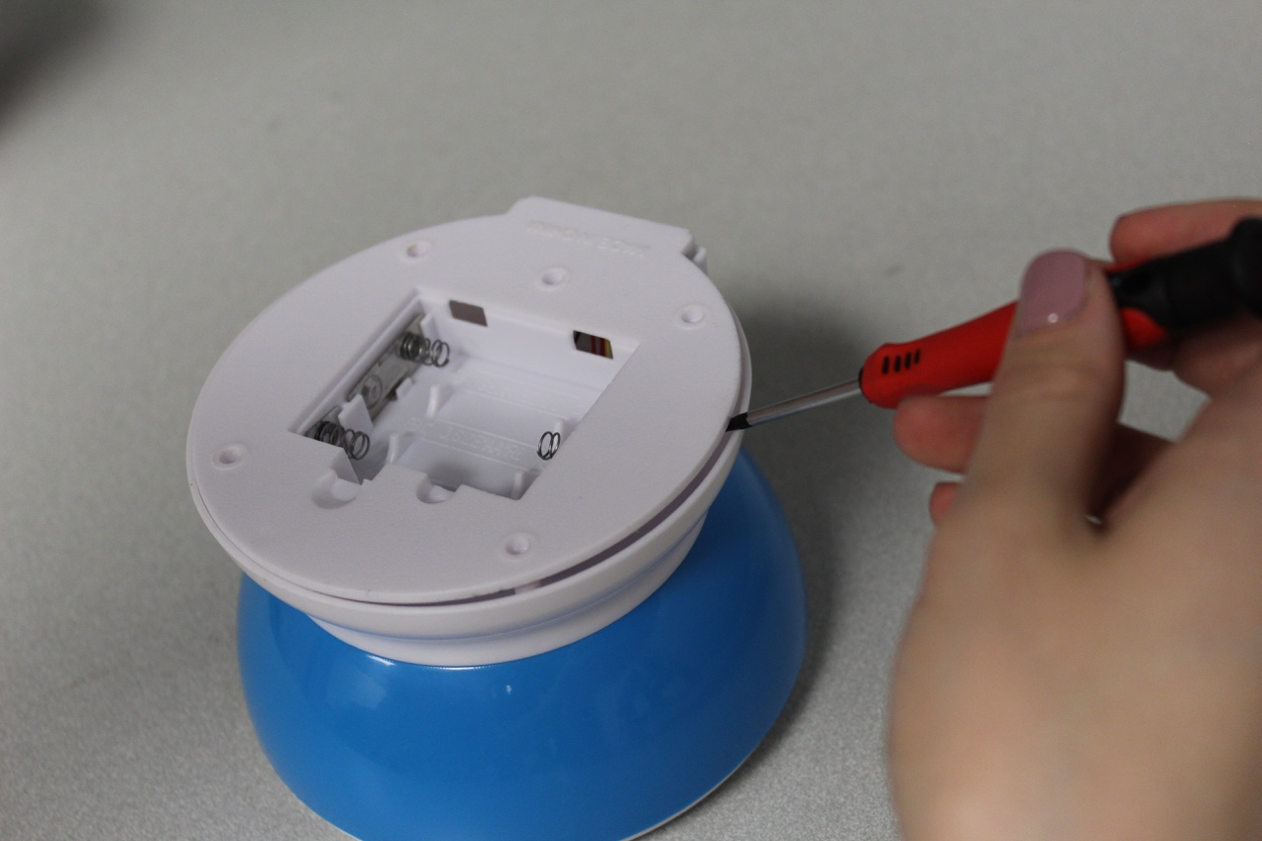

Step 6
Remove the three button covers from the buttons and set them aside.
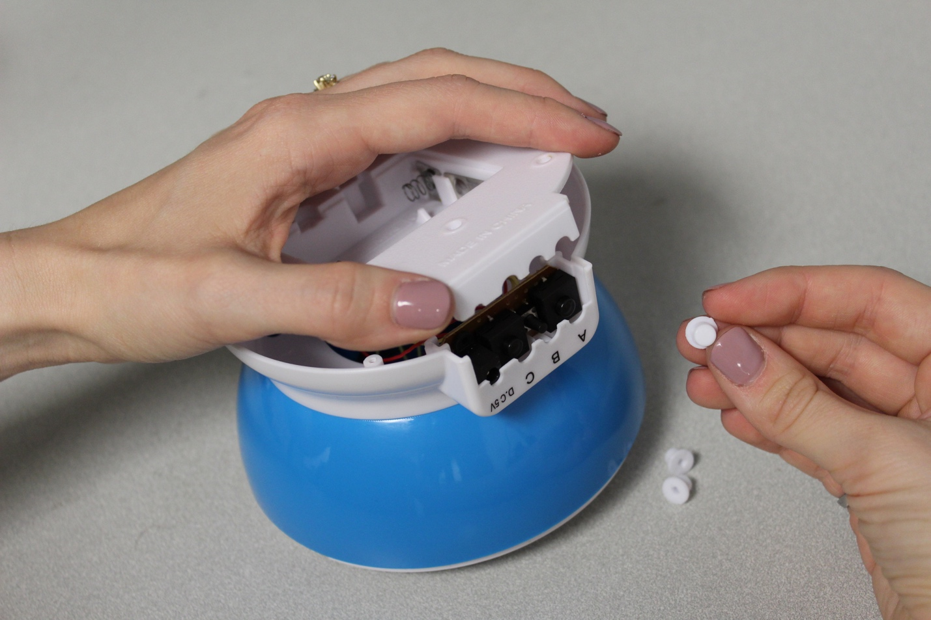

Step 7
Mark three holes to one side of the circuit board. Ensure the holes are far enough away from the edge so that the mono jack that will be installed are not interfering with where the lid sits. This is about 1 cm from the edge.
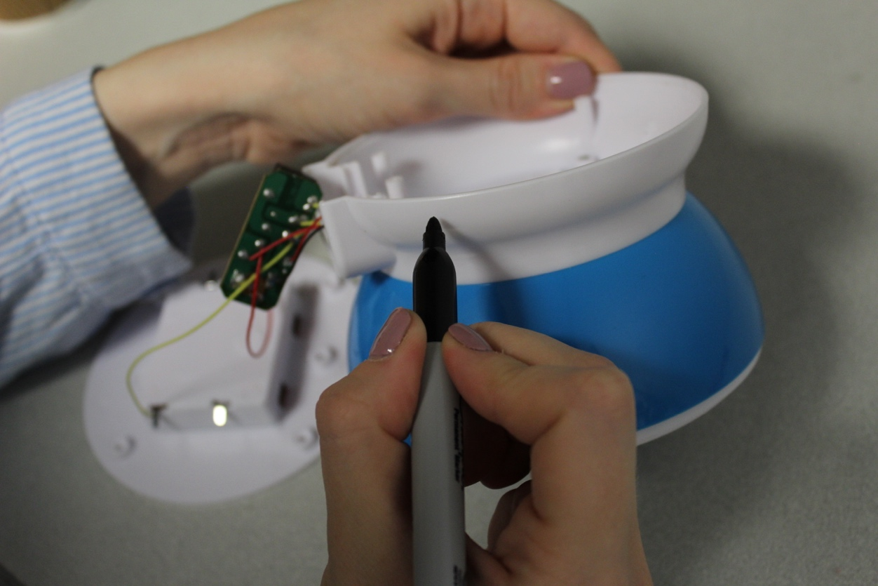

Step 8
Drill three ¼” holes on these marks.
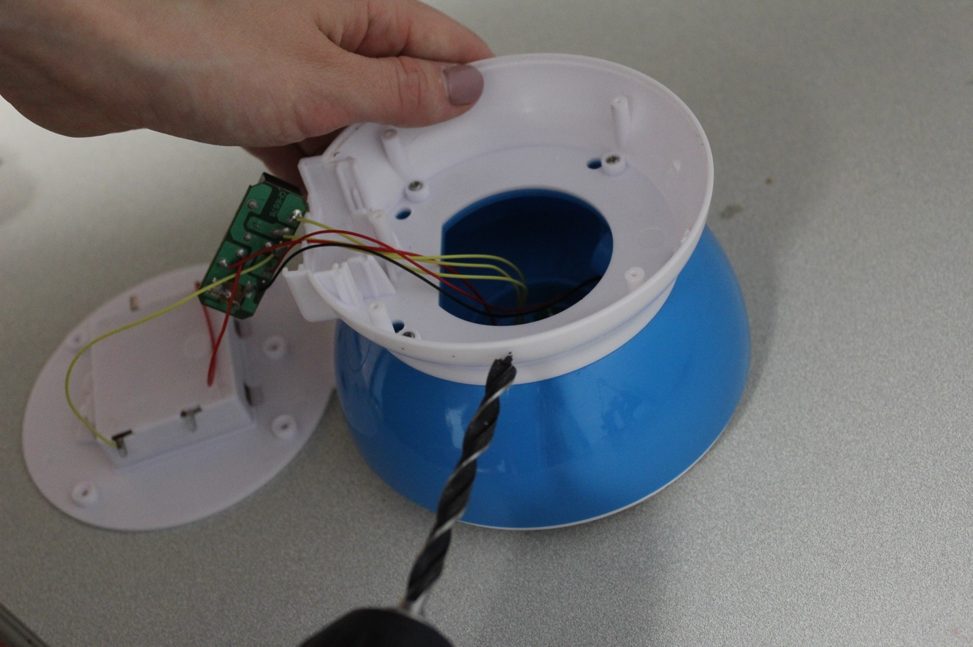

Step 9
Use a craft knife to clean the edges of the drilled holes.
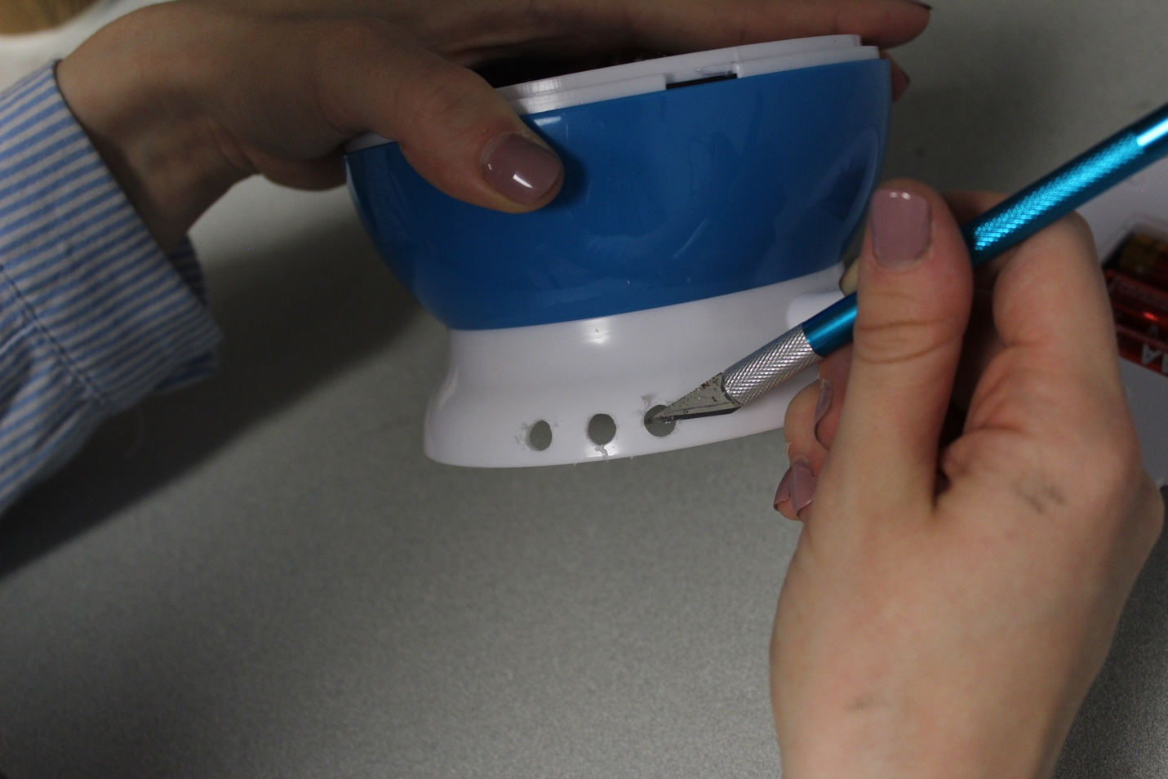

Step 10
Cut six pieces of wire 10cm long. Strip about 0.5cm of insulation off each end.
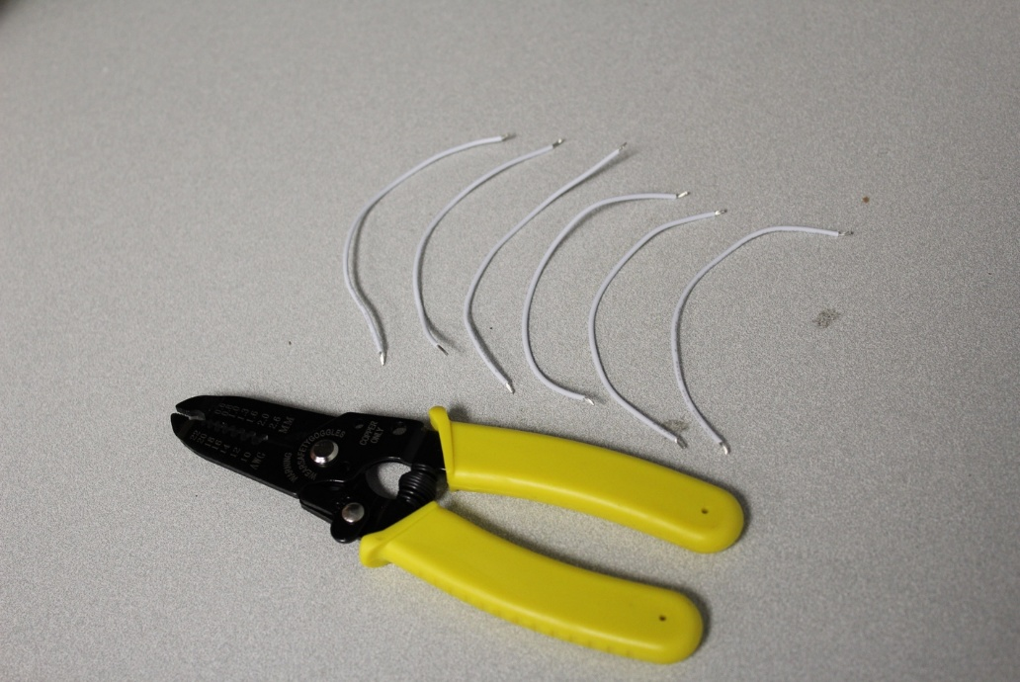

Step 11
Remove the circuit board from its resting place.
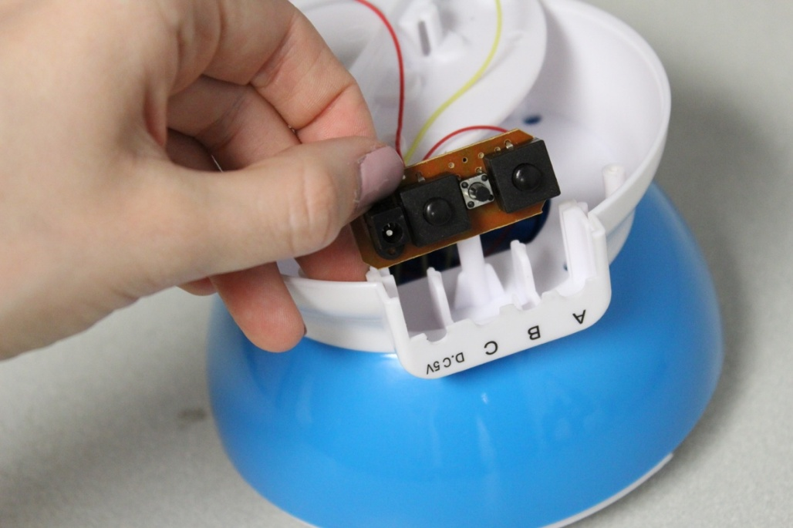

Step 12
Solder one end of a wire onto the first leg of the mono jack. Solder one end of another wire onto the middle leg of the mono jack. Repeat for the other two mono jacks.
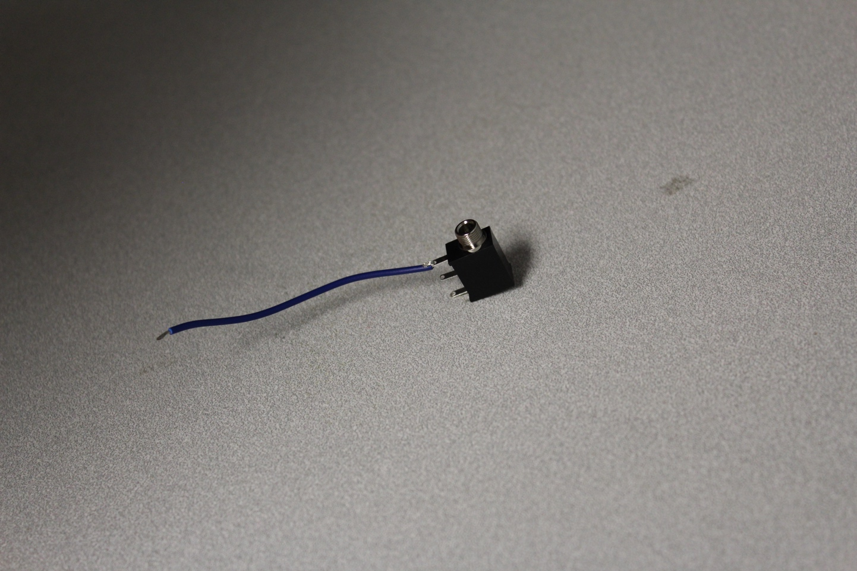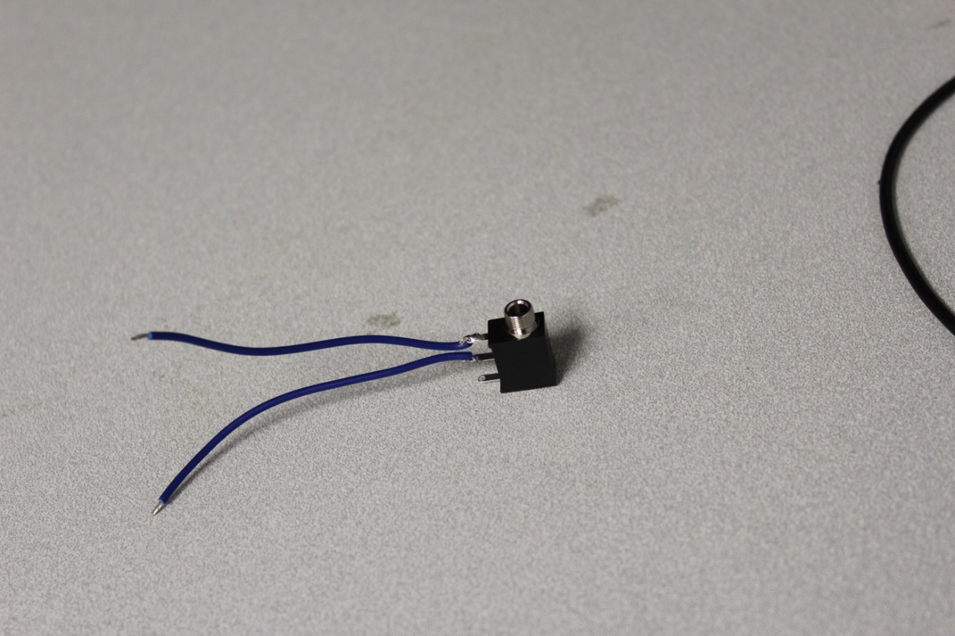

Step 13
Flip the circuit board over and locate the nodes that will be soldered. There are a couple of versions of the board – identify which one you are working on. Solder the wires on the mono jacks to the nodes on the circuit board shown below.
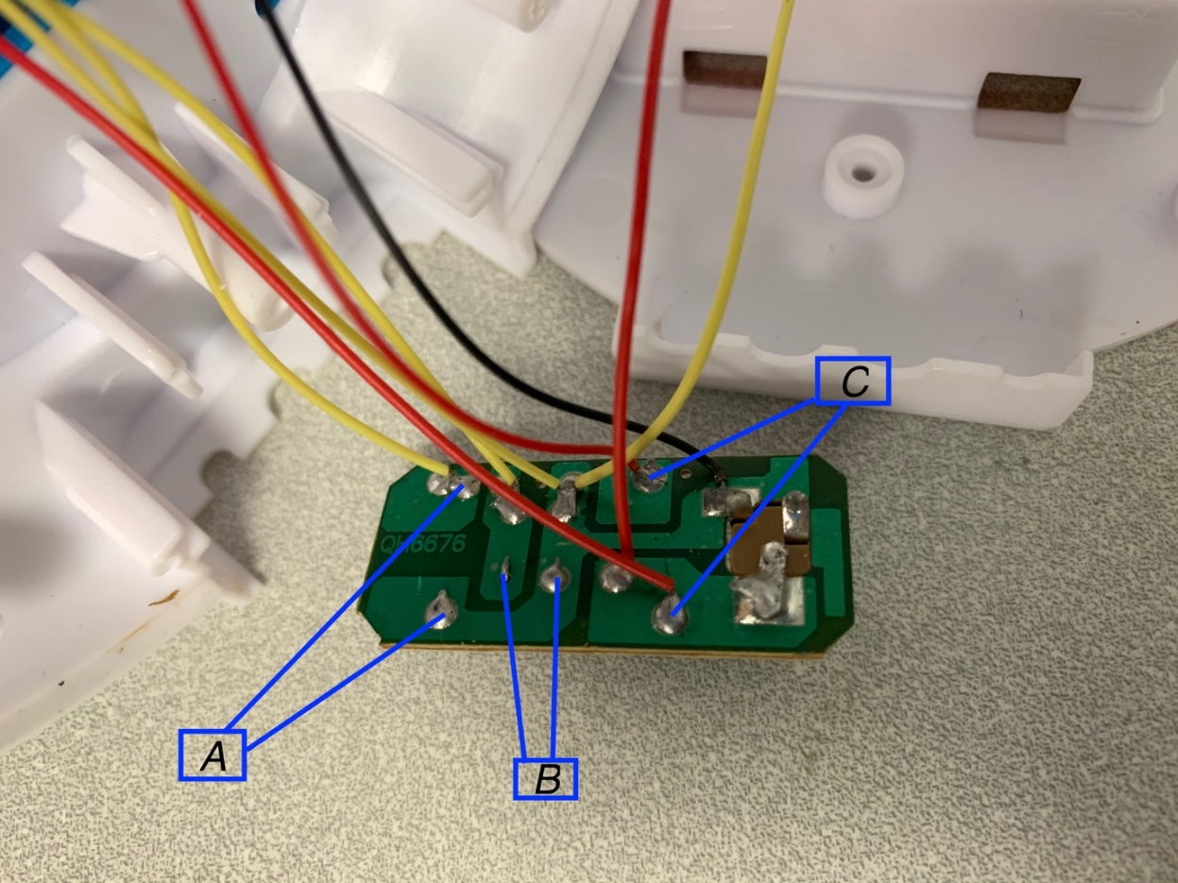
Figure 1: Original PCB Type

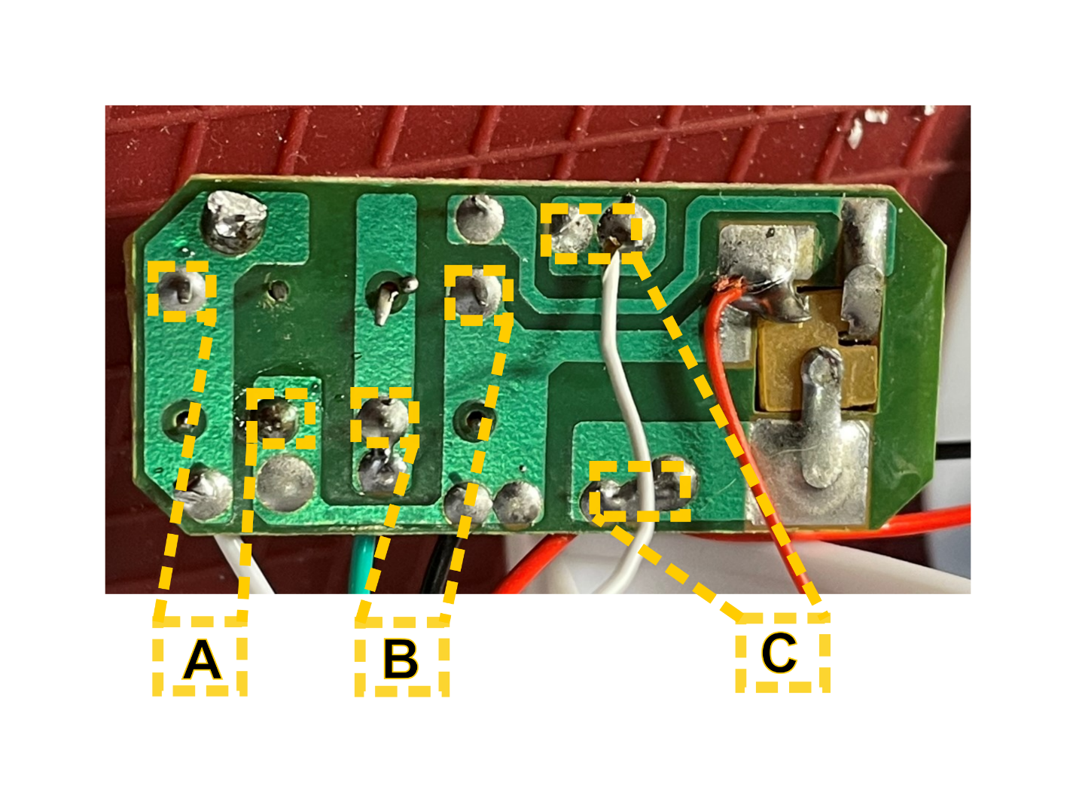
Figure 2. Updated PCB Type

Step 14
Unscrew the nut from the mono jacks. Push the “A” mono jack through the first hole, and re-screw the nut onto the mono jack from the outside. Repeat for the “B” mono jack in the second hole, and “C” in the third hole.
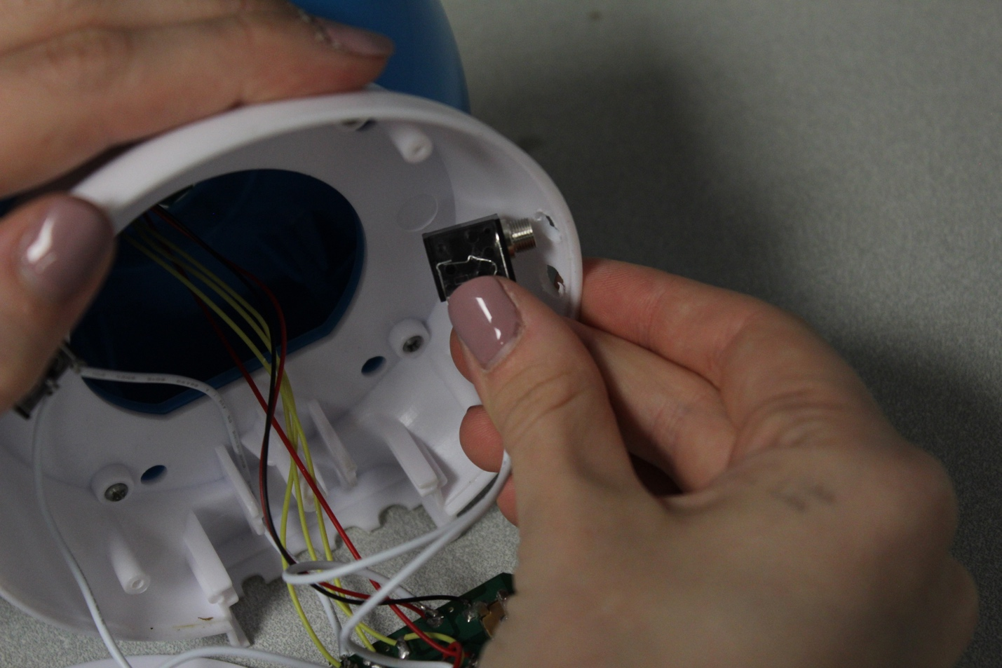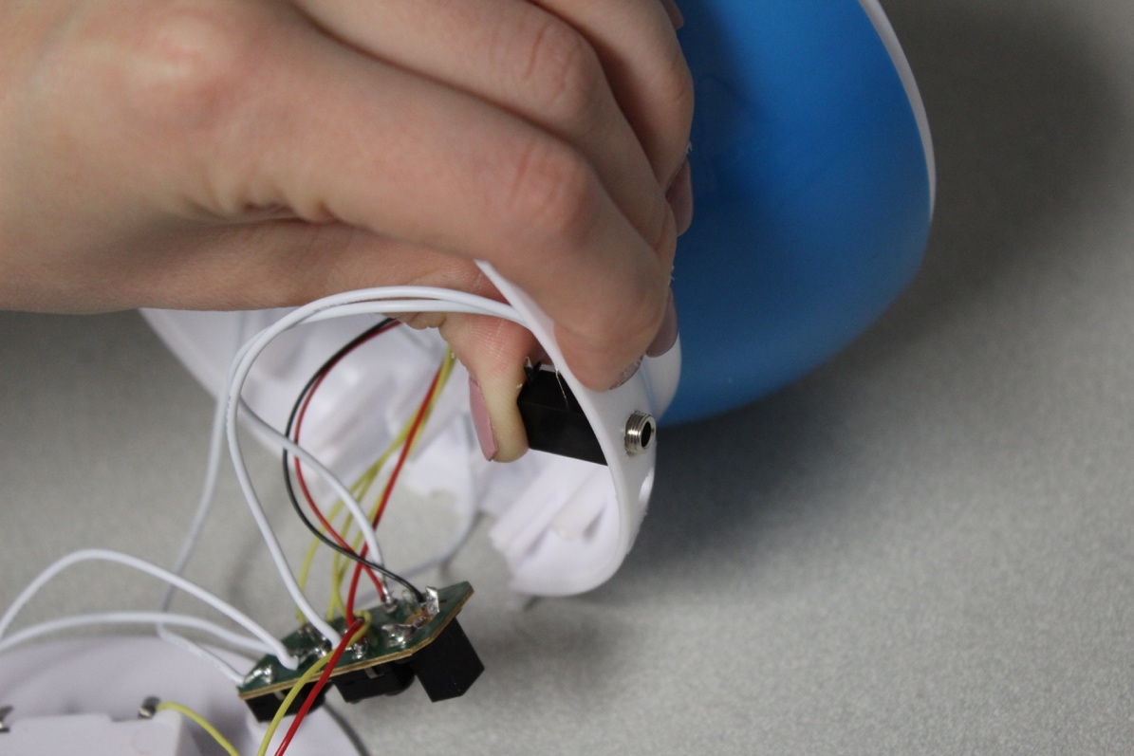
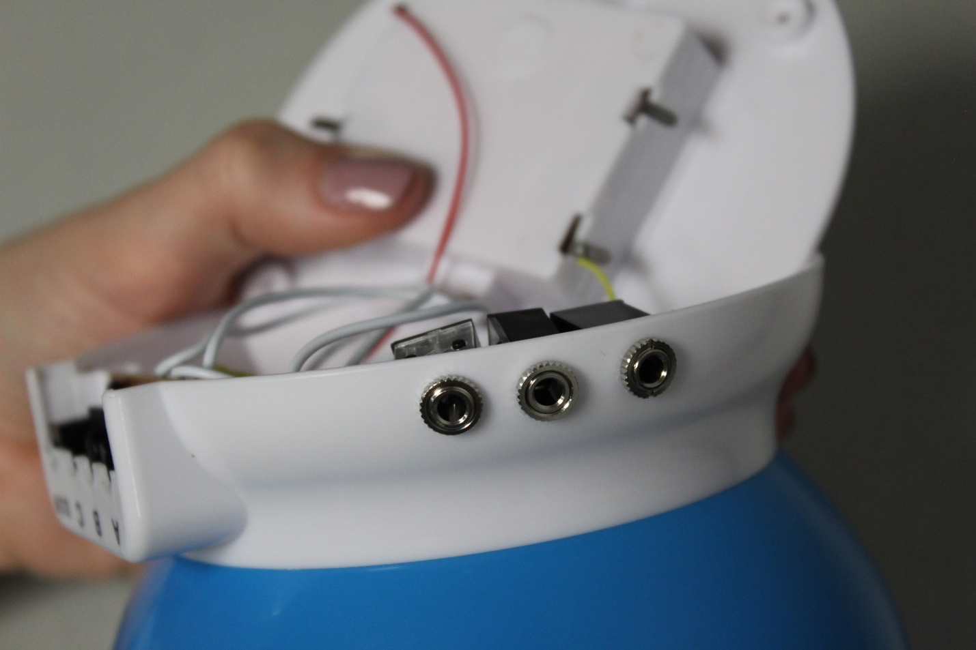

Step 15
Push the circuit board back into its original resting place.
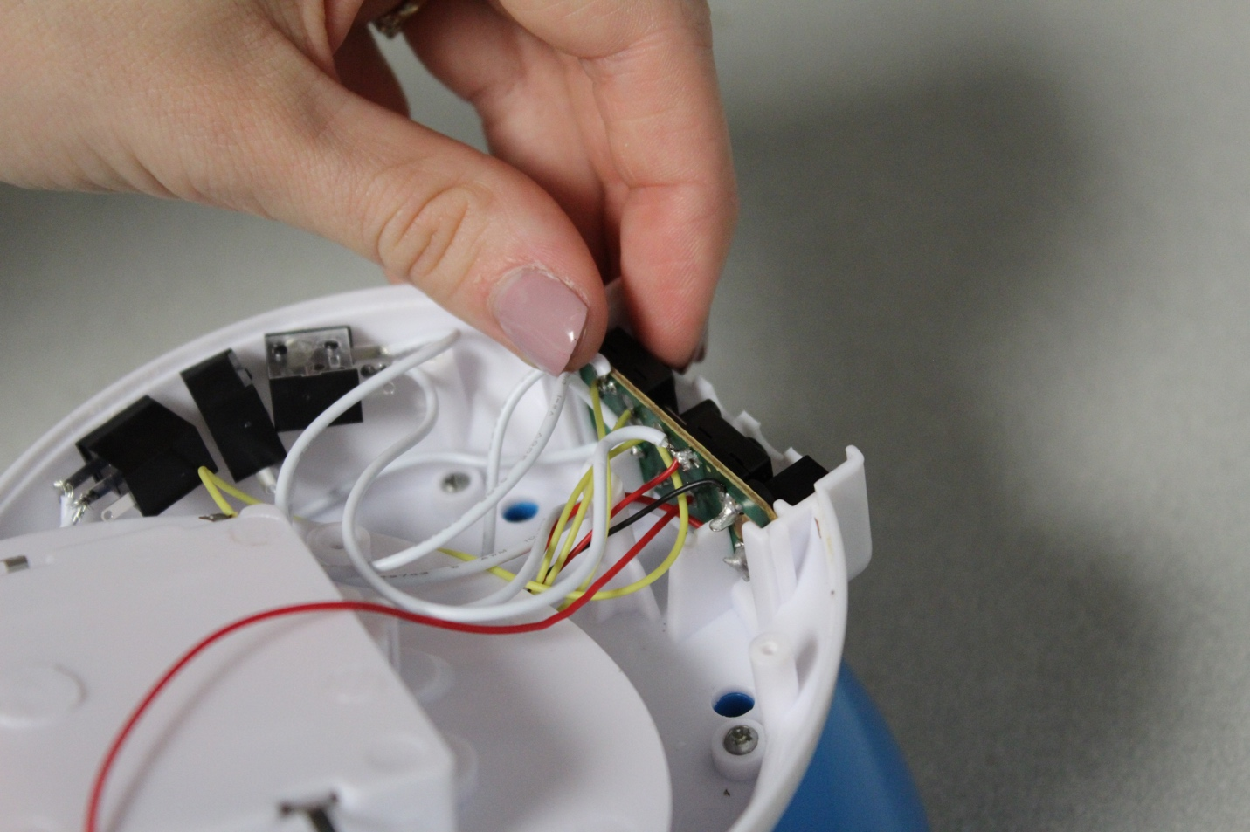

Step 16
Place the plastic button covers that were removed, back onto the buttons.
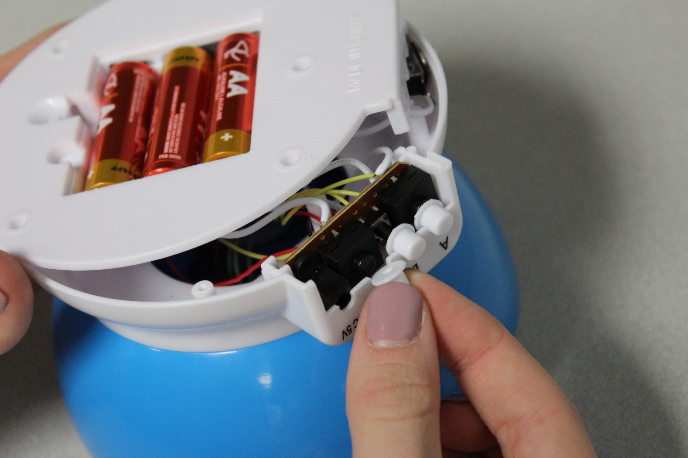

Step 17
Place the back of the toy back on.
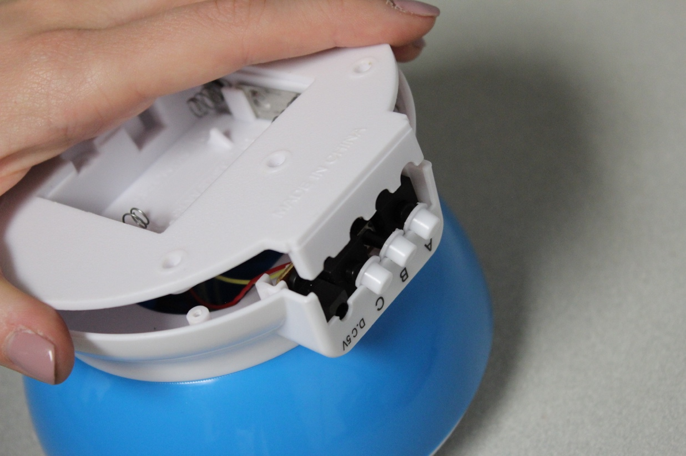

Step 18
Reinstall the five screws that holds the back on.
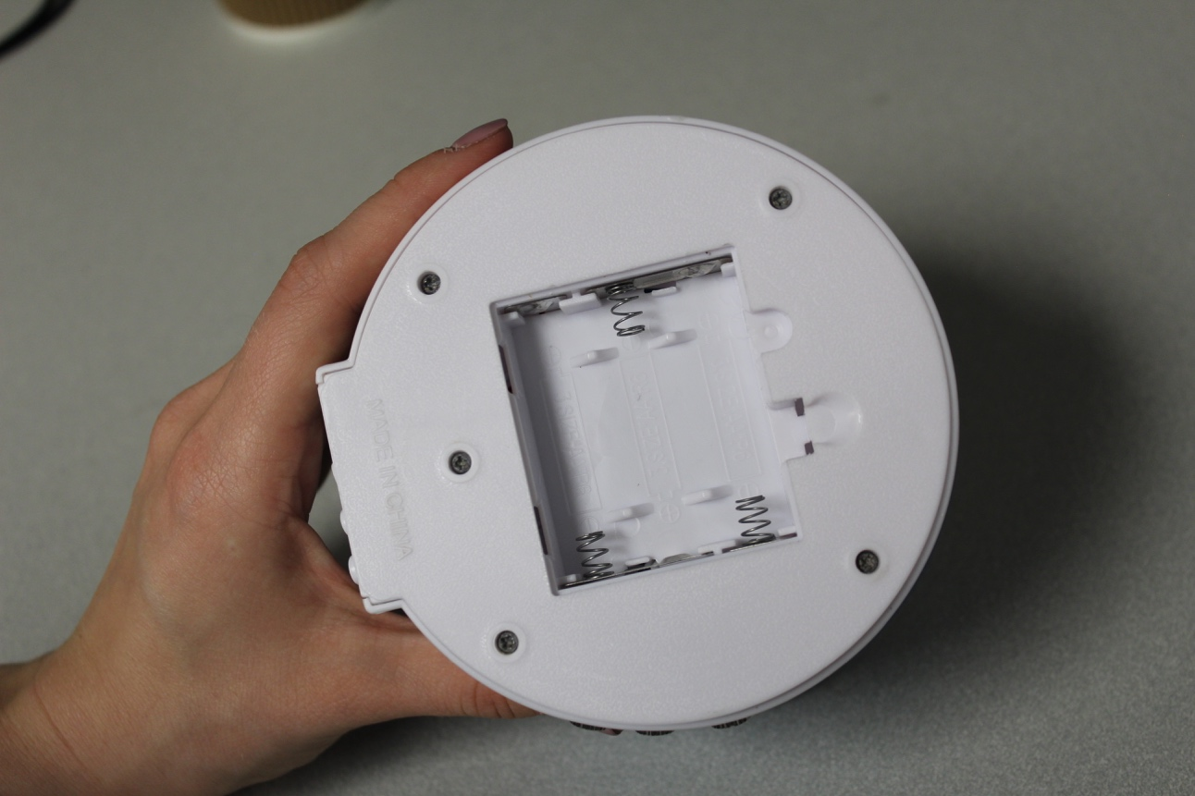

Step 19
Reinstall the batteries and put the battery cover back on.
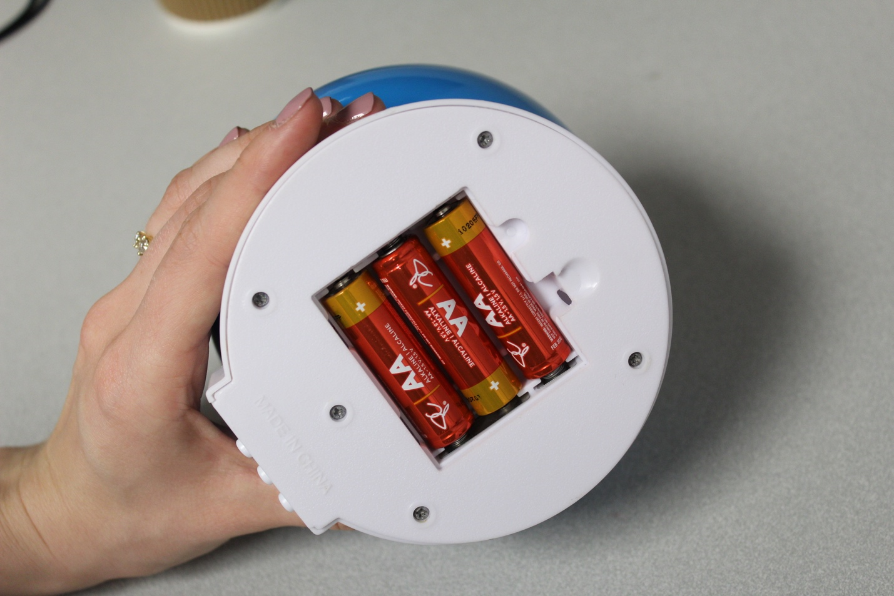

Step 20
Put the top sphere back onto the toy.
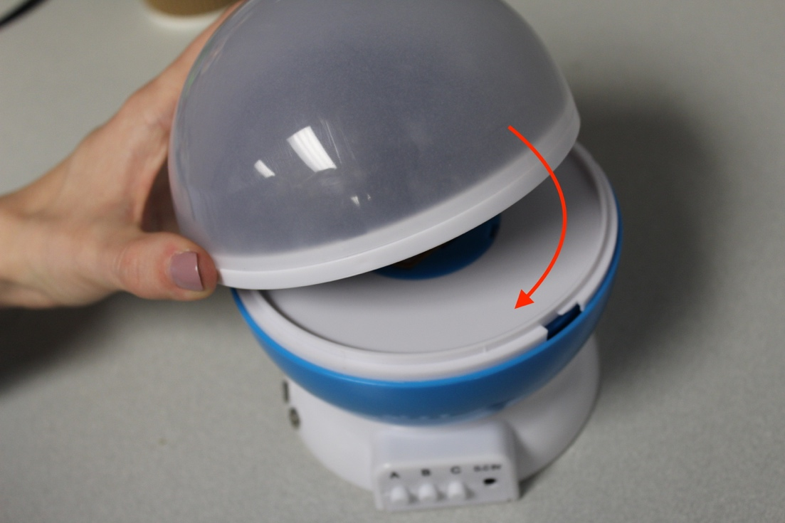

Step 21
Plug switches into the mono jacks and test the toy.
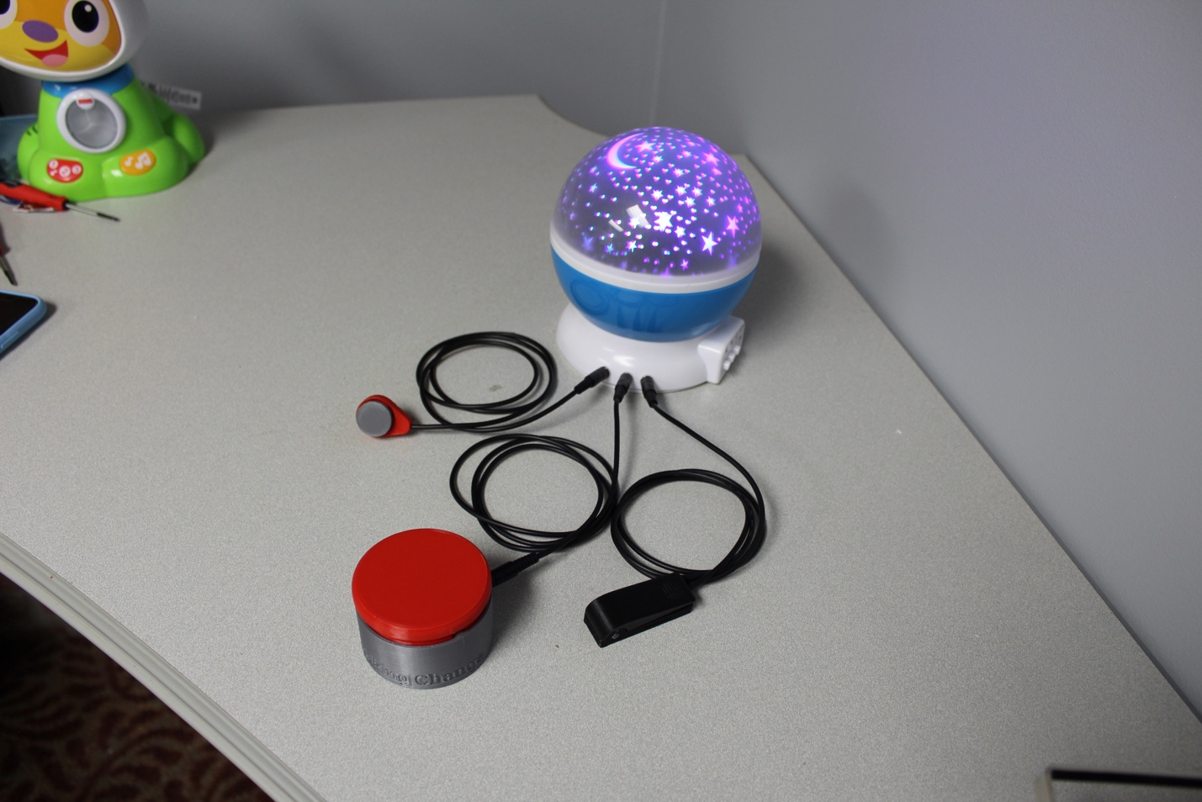

Step 22
Repackage the toy.
