Introduction
The star master projector switch adapted toy projects the image of stars and the moon around the room and imitates the night sky by slowly spinning. It also has a cover that diffuses the light so the toy acts as a lamp. It can be used with 3.5mm cable switches.

Features
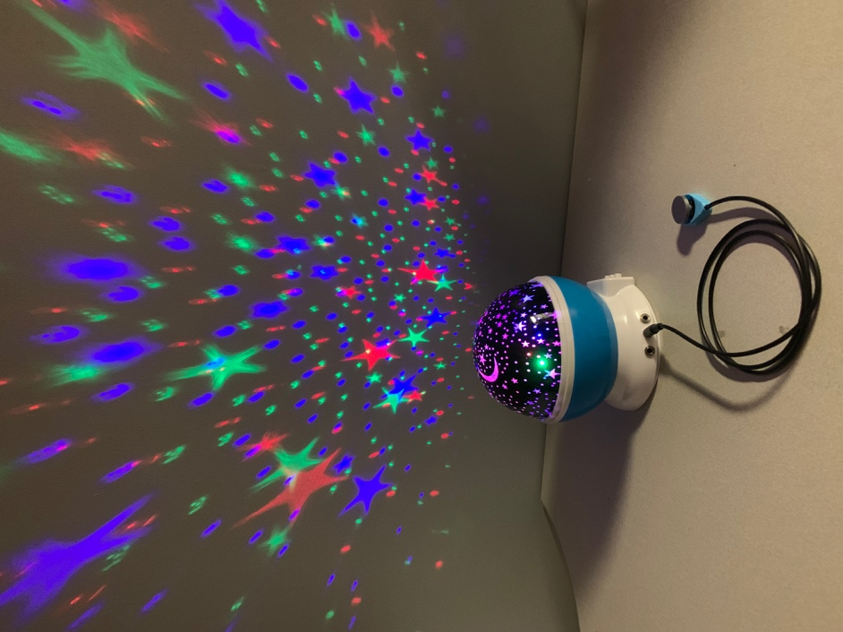
Plug in for white light
Plug in for colored light
Plug in for spinning function
Original buttons
Star projection

Usage
- Install three AA batteries into the battery compartment or plug the USB cable into the lamp and a power source.
- Plug a switch into the mono jacks. The leftmost jack controls the white light, the middle jack controls the colored light, the rightmost jack controls the spinning function.
- Press and hold the switch on the left to turn on the white light. The light will stay on for the duration the button is held.
- Press the switch in the middle jack once to turn the colored lights on. Press the switch again to turn the lights off. Press the switch again to turn on the next color. Continue to cycle through the colors in this manner until you have reached the desired color.
- Press and hold the switch on the right to turn on the spinning function. The toy will spin for the duration the button is held.
- Ensure the light is turned off and unplug the switches.

Compatibility
The star master projector switch adapted toy is compatible with any switches that have 3.5mm cable ends. The star master can be powered with three AA batteries or the included power USB cable.

Specifications
Box dimensions: 13cm x 13cm x 14.5cm

Cleaning
Wipe the lamp with a clean cloth. Be careful around the exposed electronic plug ins if the cloth is damp.

