Required Components
1.  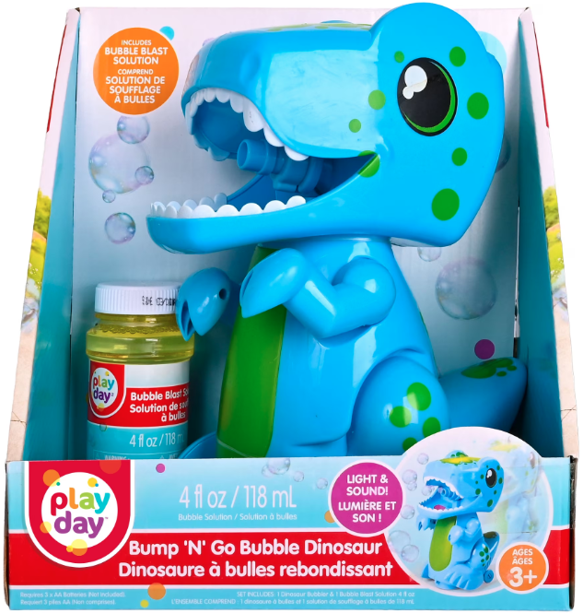 | 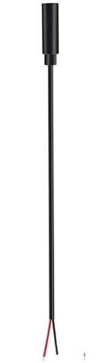  2. | BOM  - Play Day Bump N Go Dinosaur  - 3.5 mm Female Mono Cable  - Cable Tie  - 3 AA Batteries  - Electrical tape  Refer to the Tool and Component List for purchasing details.
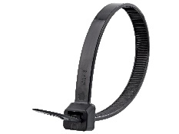 | 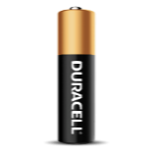     | 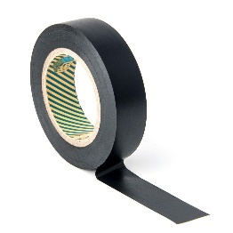

Required Tools
- Phillips Screwdriver
- Wire strippers
- Soldering iron and solder
- Drill and 5/32” drill bit
- Slip joint pliers
- Flush cutters

Required Personal Protective Equipment (PPE)
- Safety glasses

Assembly Instructions
- Carefully remove the toy from its packaging without damaging it (we will be repackaging the toy after adapting). Locate and remove the screws along the body of the toy. There should be 10 screws to remove.  *Note: keep screws, and keep track of where they came from if there are multiple different sized screws | 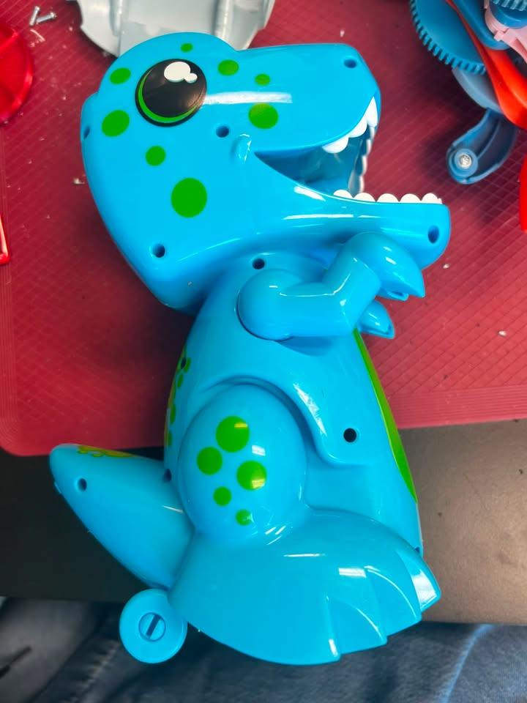
- Carefully separate the two halves of the toy. | 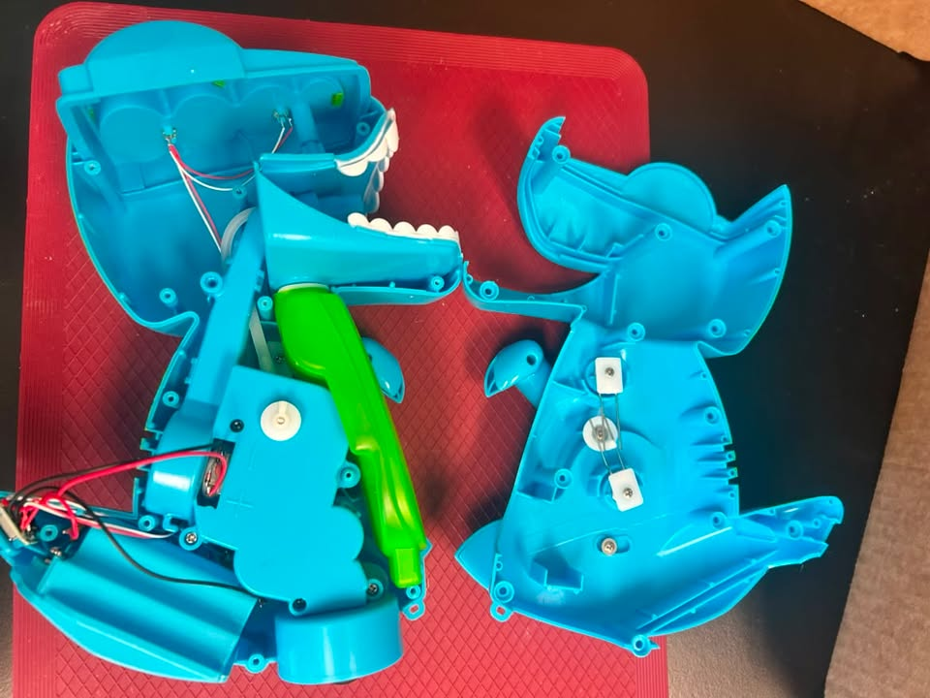
- Locate the original switch, located in the tail and the battery compartment. Carefully slide out battery compartment and switch, making note of how they fit into the toy. | 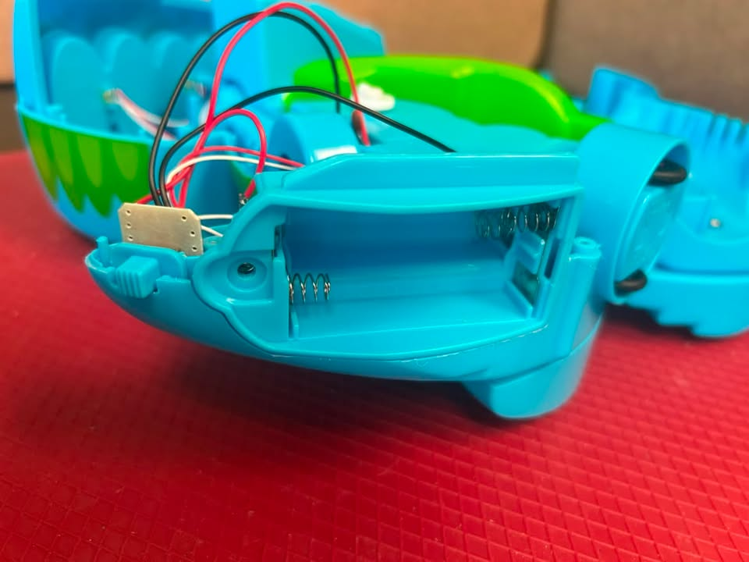
- Use wire strippers to strip approximately 2 cm off the outer wire casing, revealing two internal wires. | 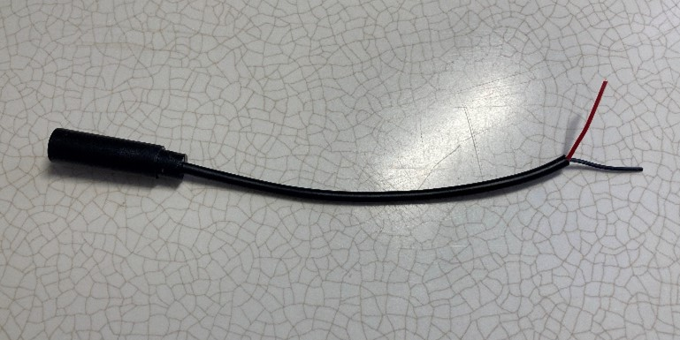
- If there are 2 internal wires, strip approximately 0.5 cm off each wire. | 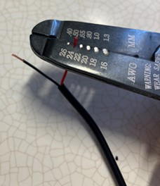
- If there are three internal wires (red, black, and exposed), strip off 0.5 cm of the red insulation and twist the red wire and exposed wire together. Strip 0.5 cm from the black wire. | 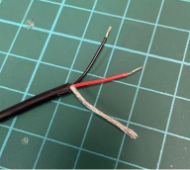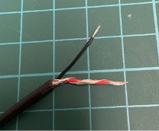
- Melt a small amount of solder over the exposed ends of the wire. | 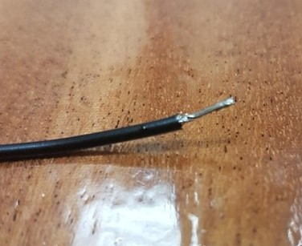
- Using a 5/32” drill bit, drill a hole into the position shown on the right. You will need to have the original switch and battery compartment out of position to access this area. Remove any loose plastic.  - Insert the mono cable through the hole from outside to inside, with the wires inside of the toy. | 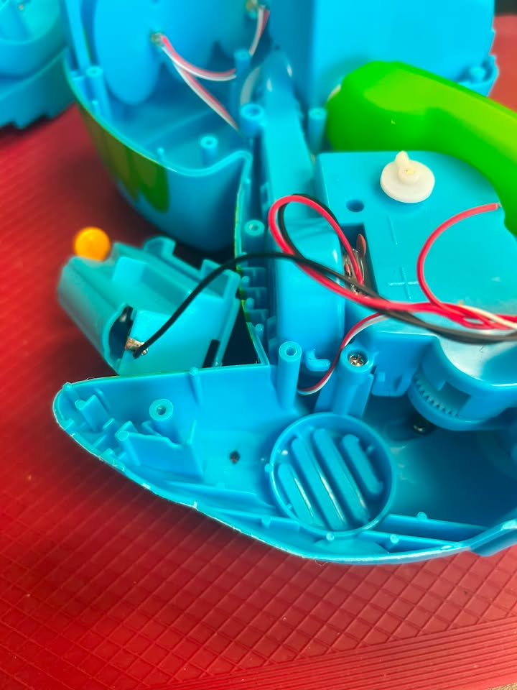
- Locate the black wire coming from the battery compartment to the original switch. There are two wires attached to the battery compartment – but we want to use the wire that is longer, and attaching to the far side, or right side of the battery compartment.  - When you have located that wire, you will cut that wire about 5-6 cm from the PCB board. | 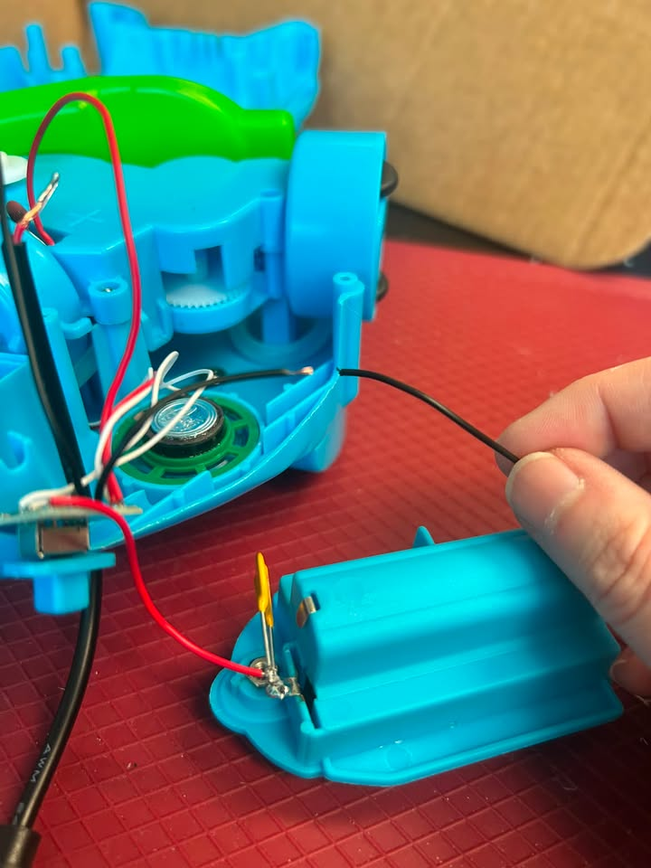  5-6 cm
- Strip the two ends of your newly cut wire to expose the metal, only strip off about 2 mm. Do this gently as these wires are very thin. Add solder, or tin, the ends of your cut wires.  - Solder one of your cable wires to one of the cut wires.  - Repeat this with your other cable wire, and the remaining wire. | 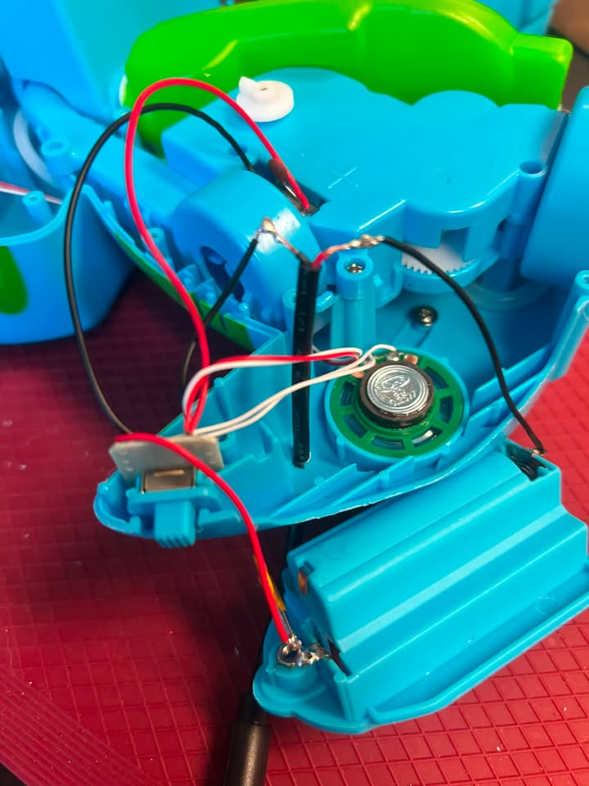
- Wrap electrical tape around your soldered joints to help keep the connection. | 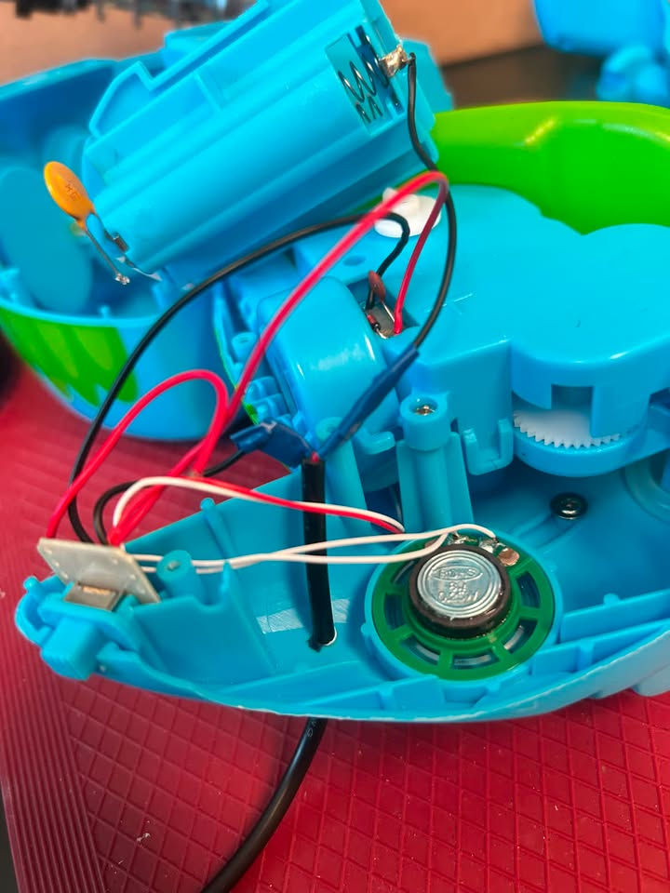
- You can now add batteries and test the toy. Plug an assistive switch into the mono cable and make sure the original switch on the toy is in the ON position. The toy should activate when the assistive switch is pressed.  Notes:  - If the toy does not turn on, please check the soldered connections.  - If the toy does not turn off when the switch is released, the connection is shorted. Check for areas of touching solder and separate using a soldering iron. | 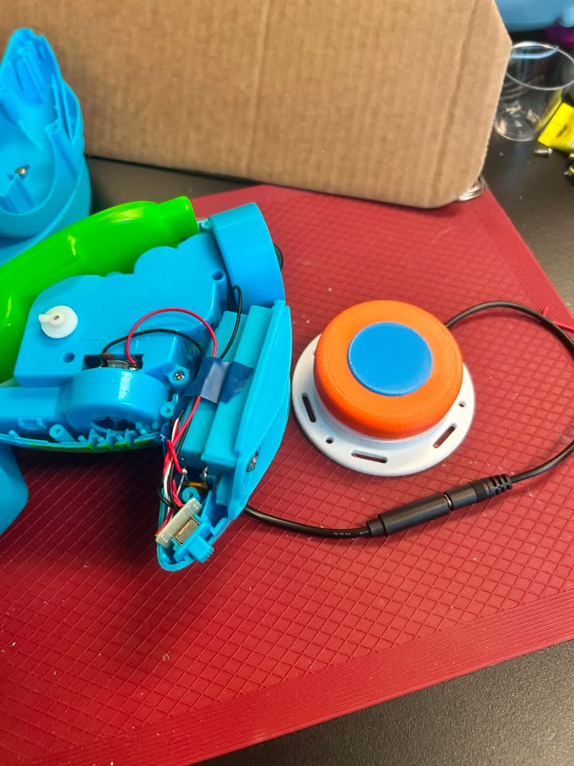
- Before reassembling the toy, gently pull your cable through the hole so that the thick black cable will be under the battery compartment, or just at the spot where the toy will be reassembled. | 
- Attach a cable tie to the cable on the inside of the toy as close as possible to where it enters.  Tighten the cable tie as much as you can and snip the excess zip tie using the flush cutters.  The cable tie will serve as strain relief, so the soldered connections do not get pulled and break. | 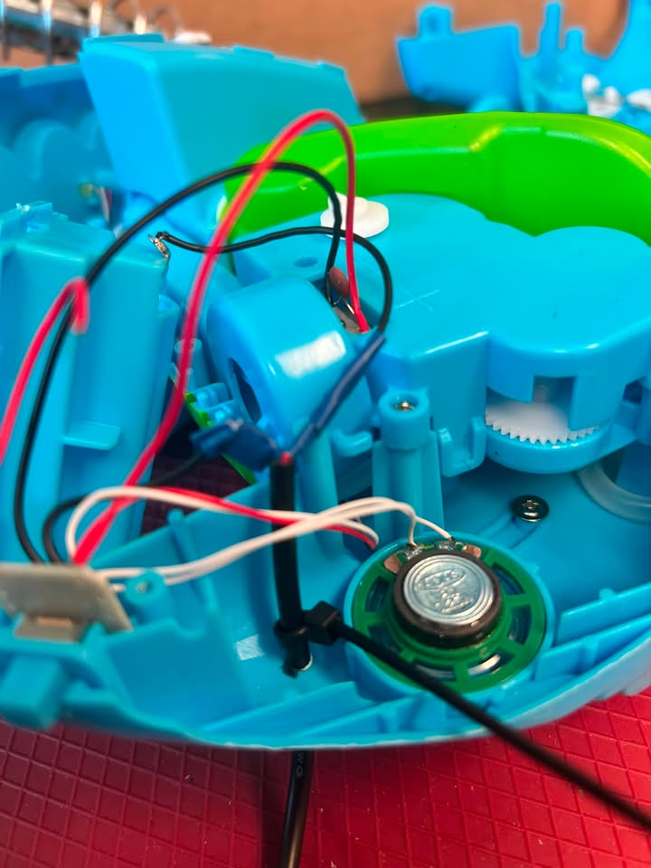
- Replace the battery compartment and switch to their original positions. Do this gently so no wires are pulled off. There is limited space within this toy, so you may need to carefully position the wires so that everything fits in the tail area. | 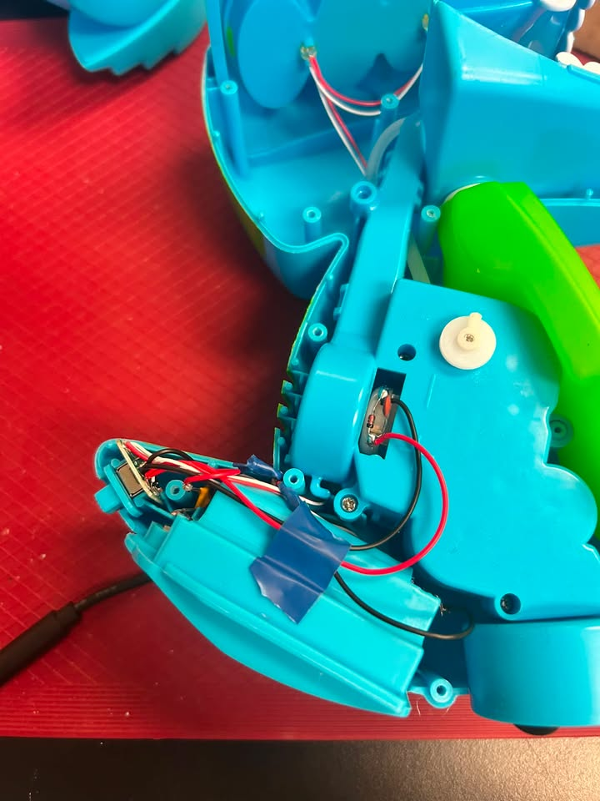
- Reassemble your toy. Be careful that no wires are pinched in this process. Replace and tighten screws.  - Test the toy again to confirm it is working. If it does not, check that the wires are all secure. | 