Required Components
 | 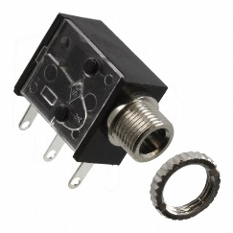 | BOM  - Zuru- XSHOT Water Turbo Stream Motor Soaker  - 3.5 mm Mono Jack and Ring  - 22 AWG Wire  - 4 AA Batteries  - 3D Printed Stand  - 1/4″-20 Tee Nut  - ¼”-20 Hex bolt, for assembly  Refer to the Tool and Component List for purchasing details.
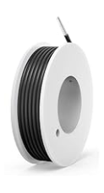 | 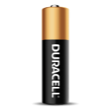      
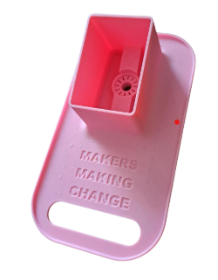 | 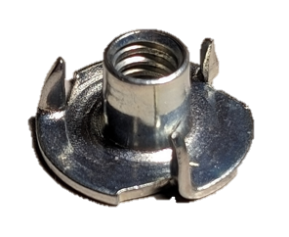 | 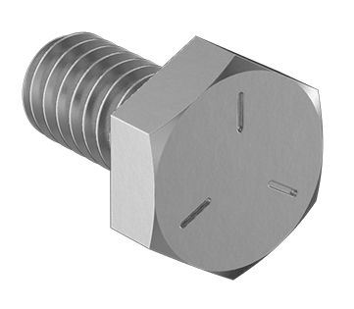

Required Tools
- Small Phillips Screwdriver 3mm Diameter
- Small Flathead Screwdriver
- Ruler
- Wire strippers
- Soldering iron and solder
- Drill and 1/4” drill bit

Required Personal Protective Equipment (PPE)
- Safety glasses

Assembly Instructions
- Carefully remove the toy from its packaging without damaging it (we will be repackaging the toy after adapting). Locate and remove the screws along the body of the toy.  *Note: keep screws in a safe place | 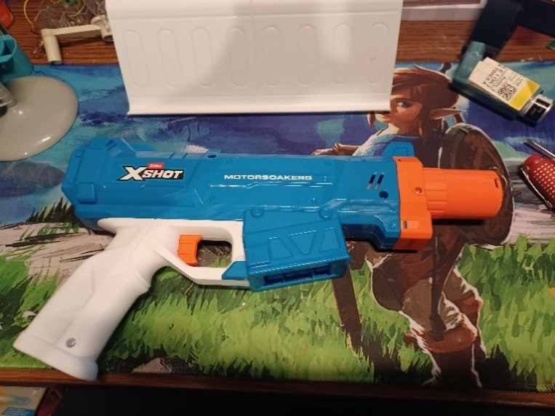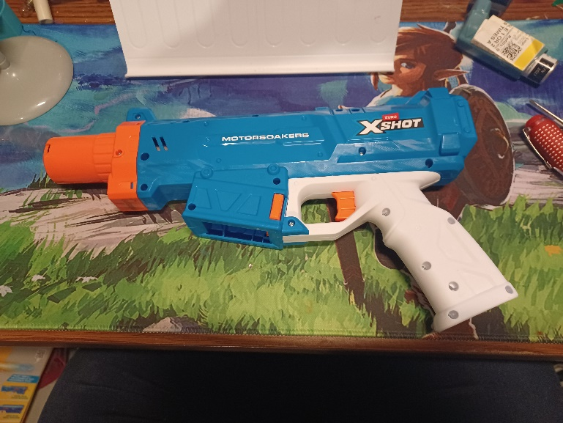
- Using a flat head screwdriver pop the plastic tabs holding the front piece inward, on both sides, and slide it off the front. |   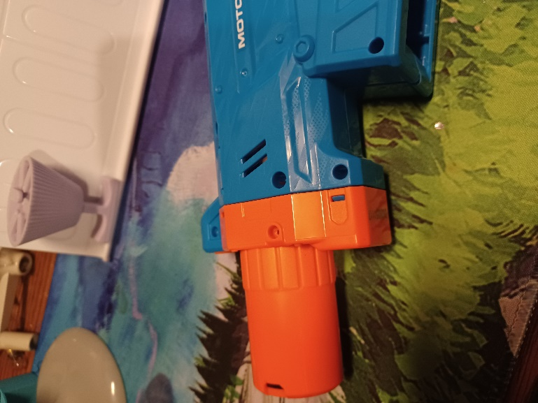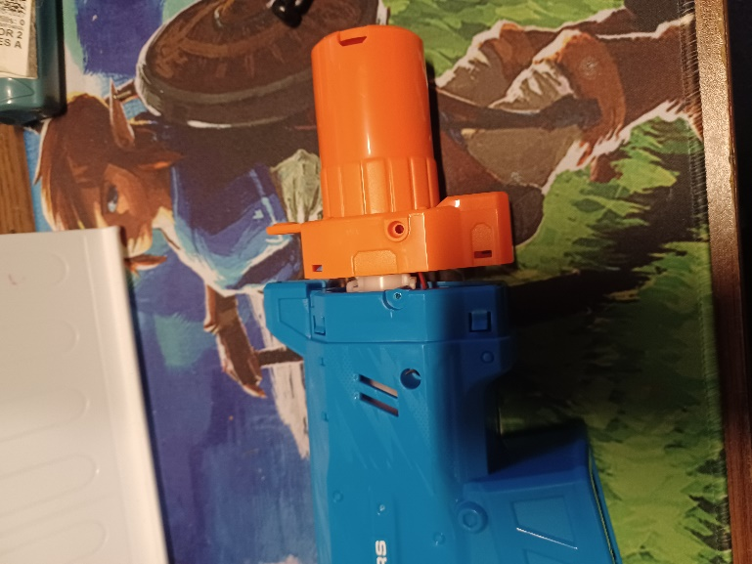
- Carefully separate the two halves of the toy. Set the empty part of the shell aside. | 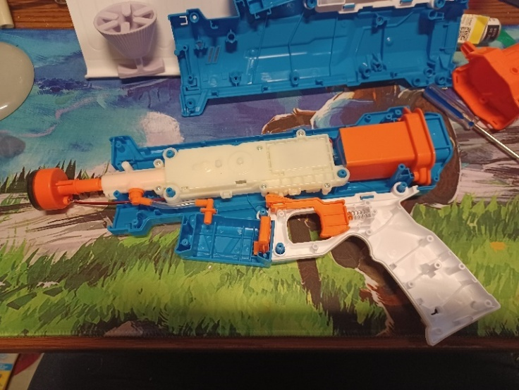
- Locate and remove the screws along the white inner portion of the toy.  Once the screws are removed you will need to unlatch the white tabs around the edge (as shown circled in the second and third pictures here). | 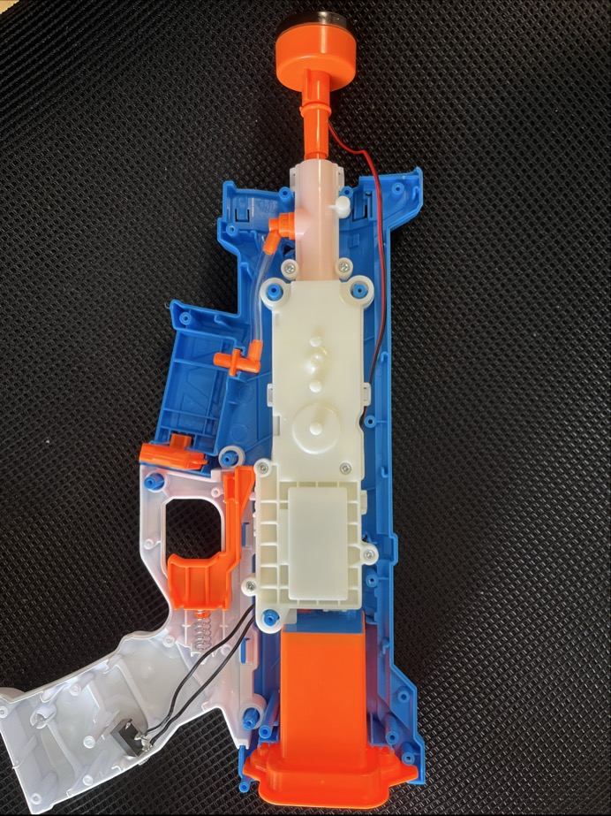  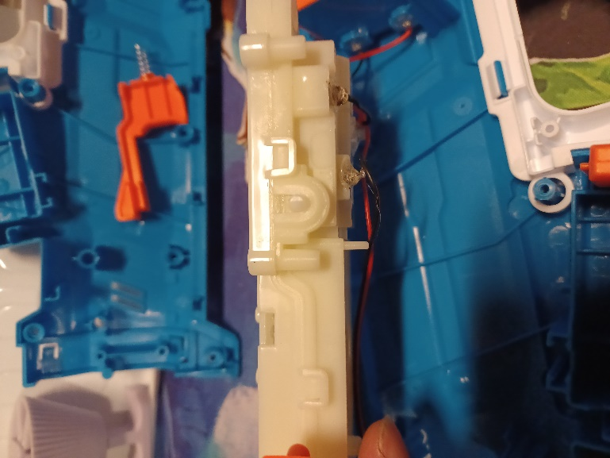  
- Carefully separate the two halves of the inner portion. Set the empty part of the shell aside. | 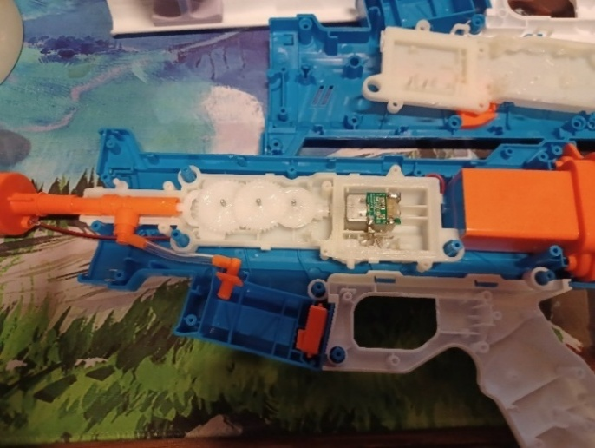
- Cut 2 pieces of wire, each 15 cm long. | 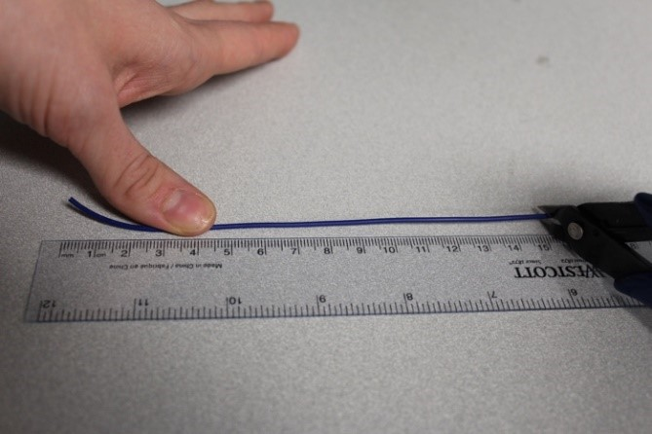
- Use wire strippers to strip approximately 0.5 cm off each end of the wires | 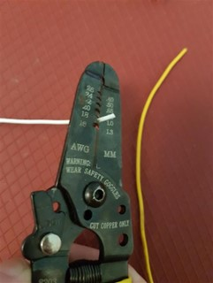
- Solder the two wires onto the front two tabs of the mono jack. | 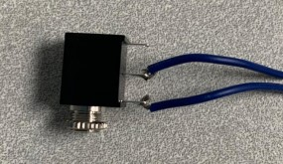
- Tin the other ends of the wires by adding a small amount of solder to each wire. | 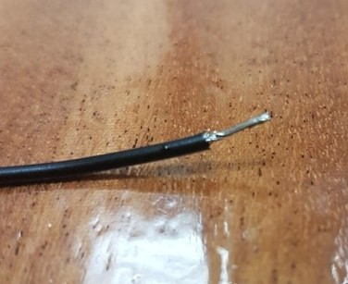
- Using a ¼” drill bit, drill a hole into the position shown on the right. Remove any loose plastic. Thread the wires through the new hole. | 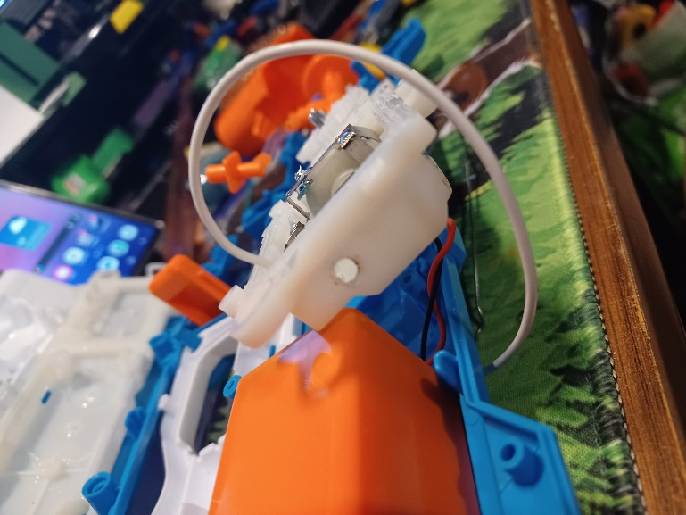
- Solder one wire to each of the metal plates. | 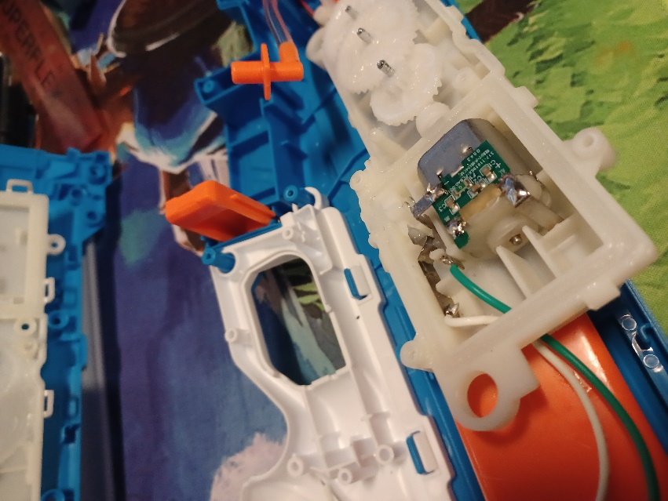
- It is now time to test the toy. Insert batteries into the battery compartment and an assistive switch into the mono jack. Test to make sure that the toy can be controlled using the original switch and the assistive switch.  Notes:  - If the toy does not turn on, please check the soldered connections.  - If the toy does not turn off when the switch is released, the connection is shorted. Check for areas of touching solder and separate using a soldering iron. | 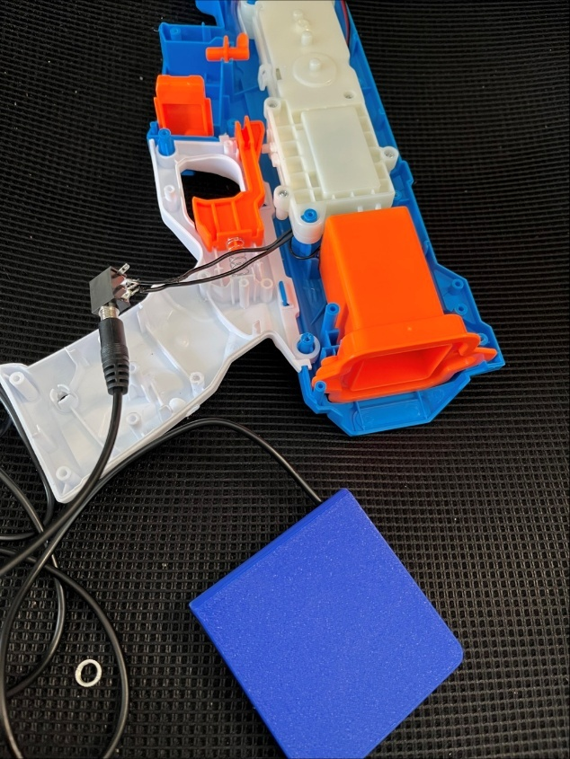
- Using a ¼” drill bit, drill a second hole into the position shown on the right. Remove any loose plastic. | 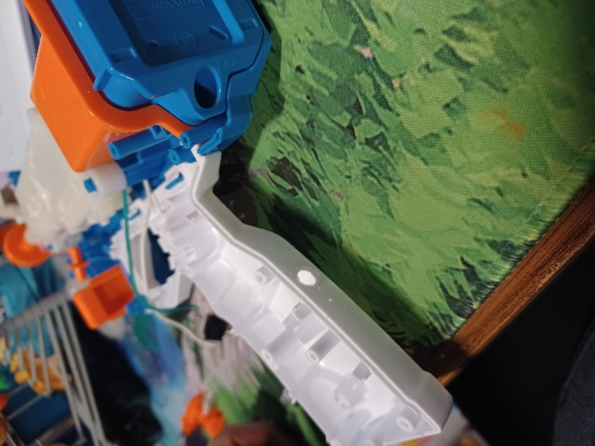
- Remove the retaining ring from the mono jack and push the mono jack through the hole from the inside. Reinstall the retaining ring on the outside of the toy and tighten to secure. | 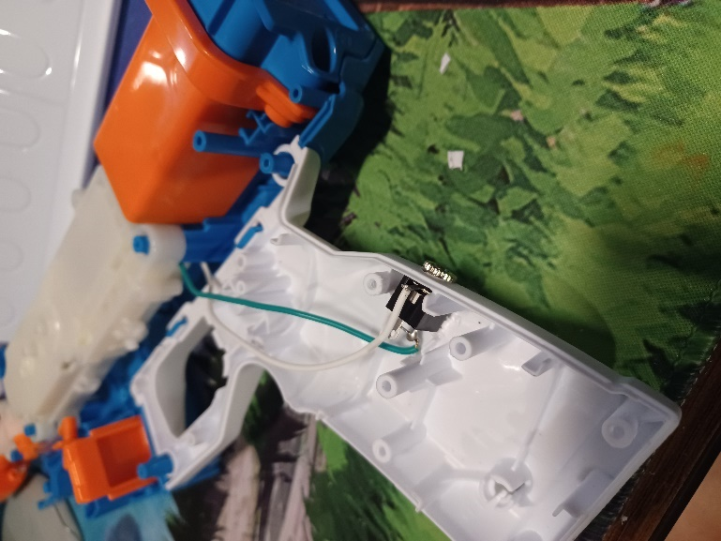
- Reassemble the toy using the screws set aside earlier. | 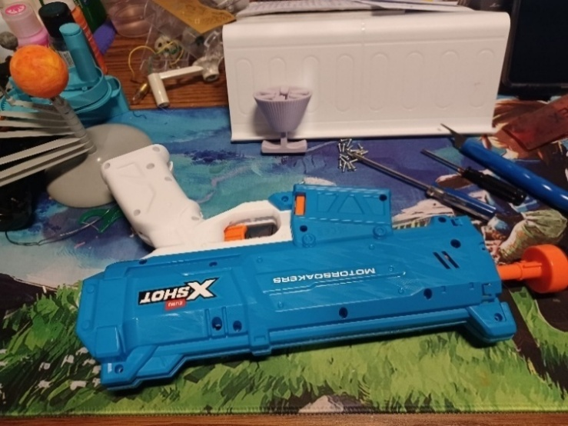
- Insert the tee nut, lining up the barbs with the slots in the 3D printed stand. | 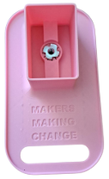
- From the bottom, screw in a ¼-20 hex bolt. Tighten the bolt until the tee nut is seated down as far as possible.  (Alternatively, if you do not have acces to a bolt, the tee nut may be press fit as long as it sits flush with the 3D print.) | 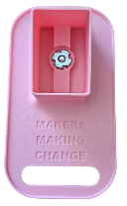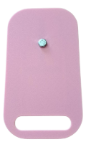
- Unscrew and remove the hex bolt. | 
- Insert the toy into the 3D printed stand and test the toy again. If it is still working properly, repackage the toy and the adapted toy is complete! | 