Required Components
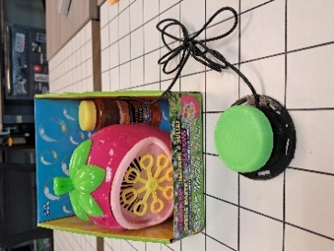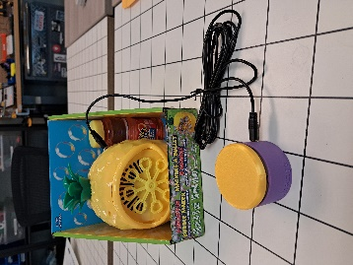 | 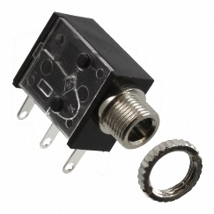 | BOM  - Placo Bubble Blower – Strawberry or Pineapple (Superstore)  - 3.5 mm Mono Jack and Nut  - 22 AWG Wire  - Electrical Tape  - (4x) AA Batteries  Refer to the Tool and Component List for purchasing details.
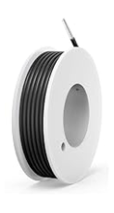 | 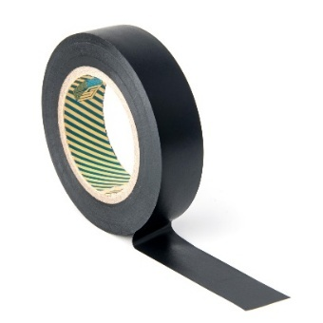 | 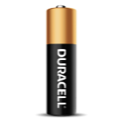      

Required Tools
- Phillips Screwdriver
- Ruler
- Wire strippers
- Soldering iron and solder
- Drill and 1/4” drill bit

Required Personal Protective Equipment (PPE)
- Safety glasses

Assembly Instructions
- Remove the toy from its original packaging, please keep the original packing in good shape, the toy will be repackaged once completed. | 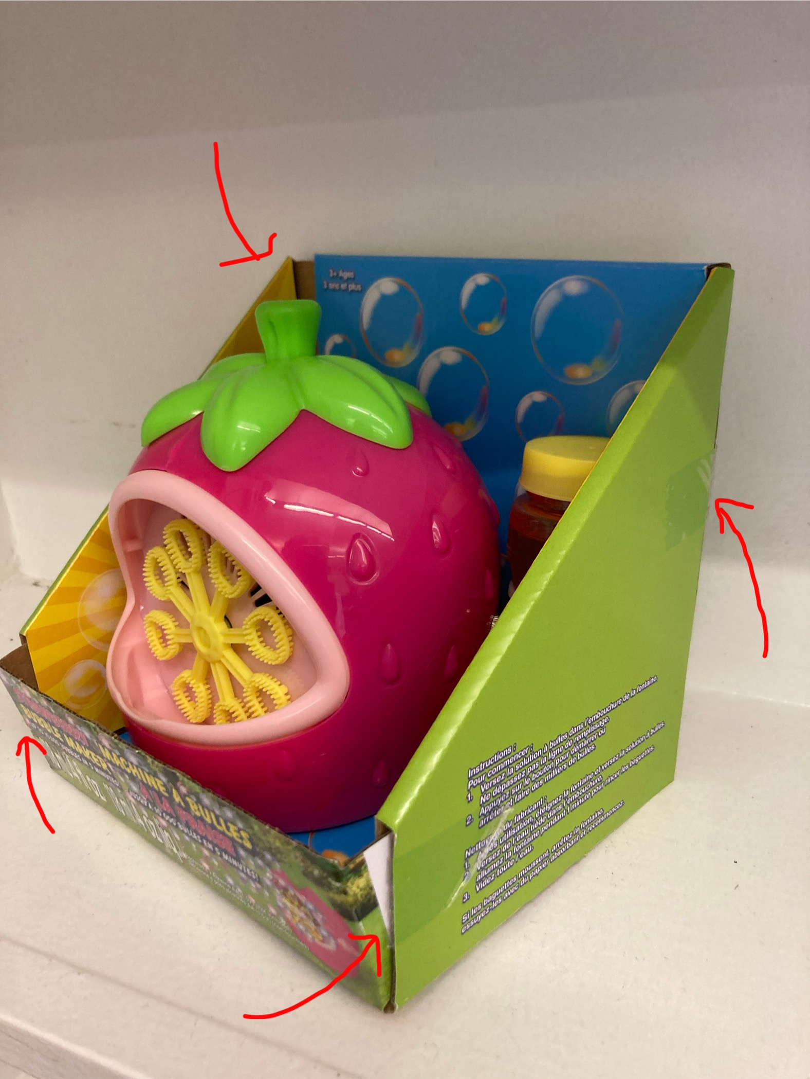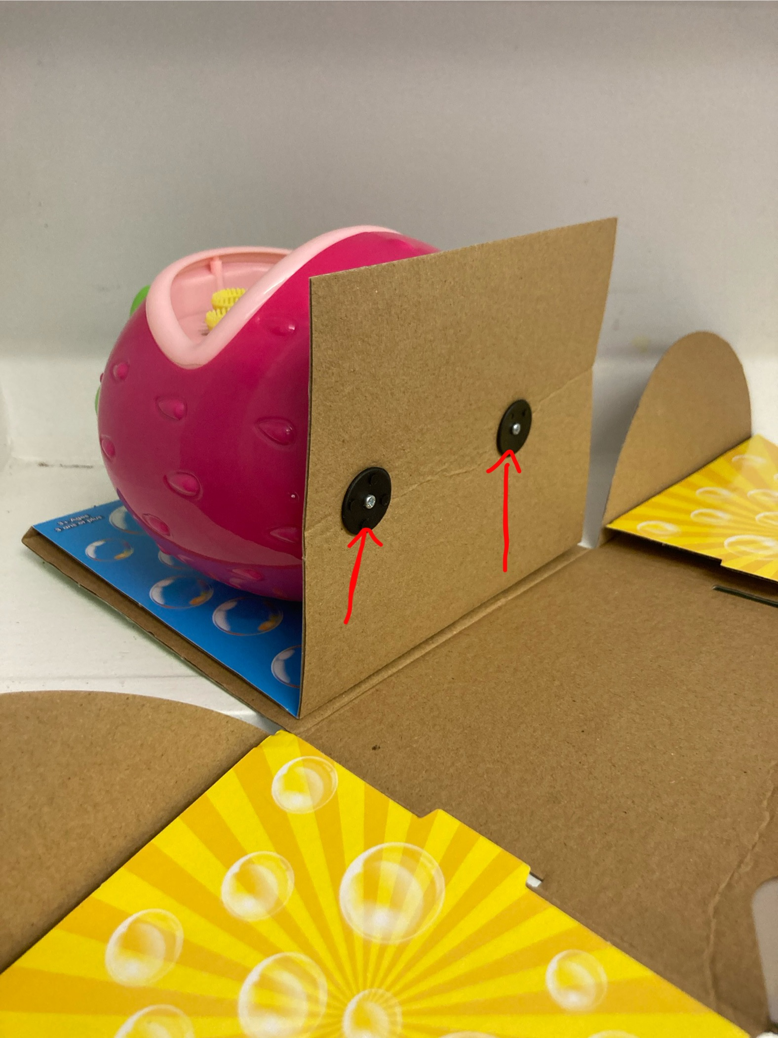
- Remove the battery cover. | 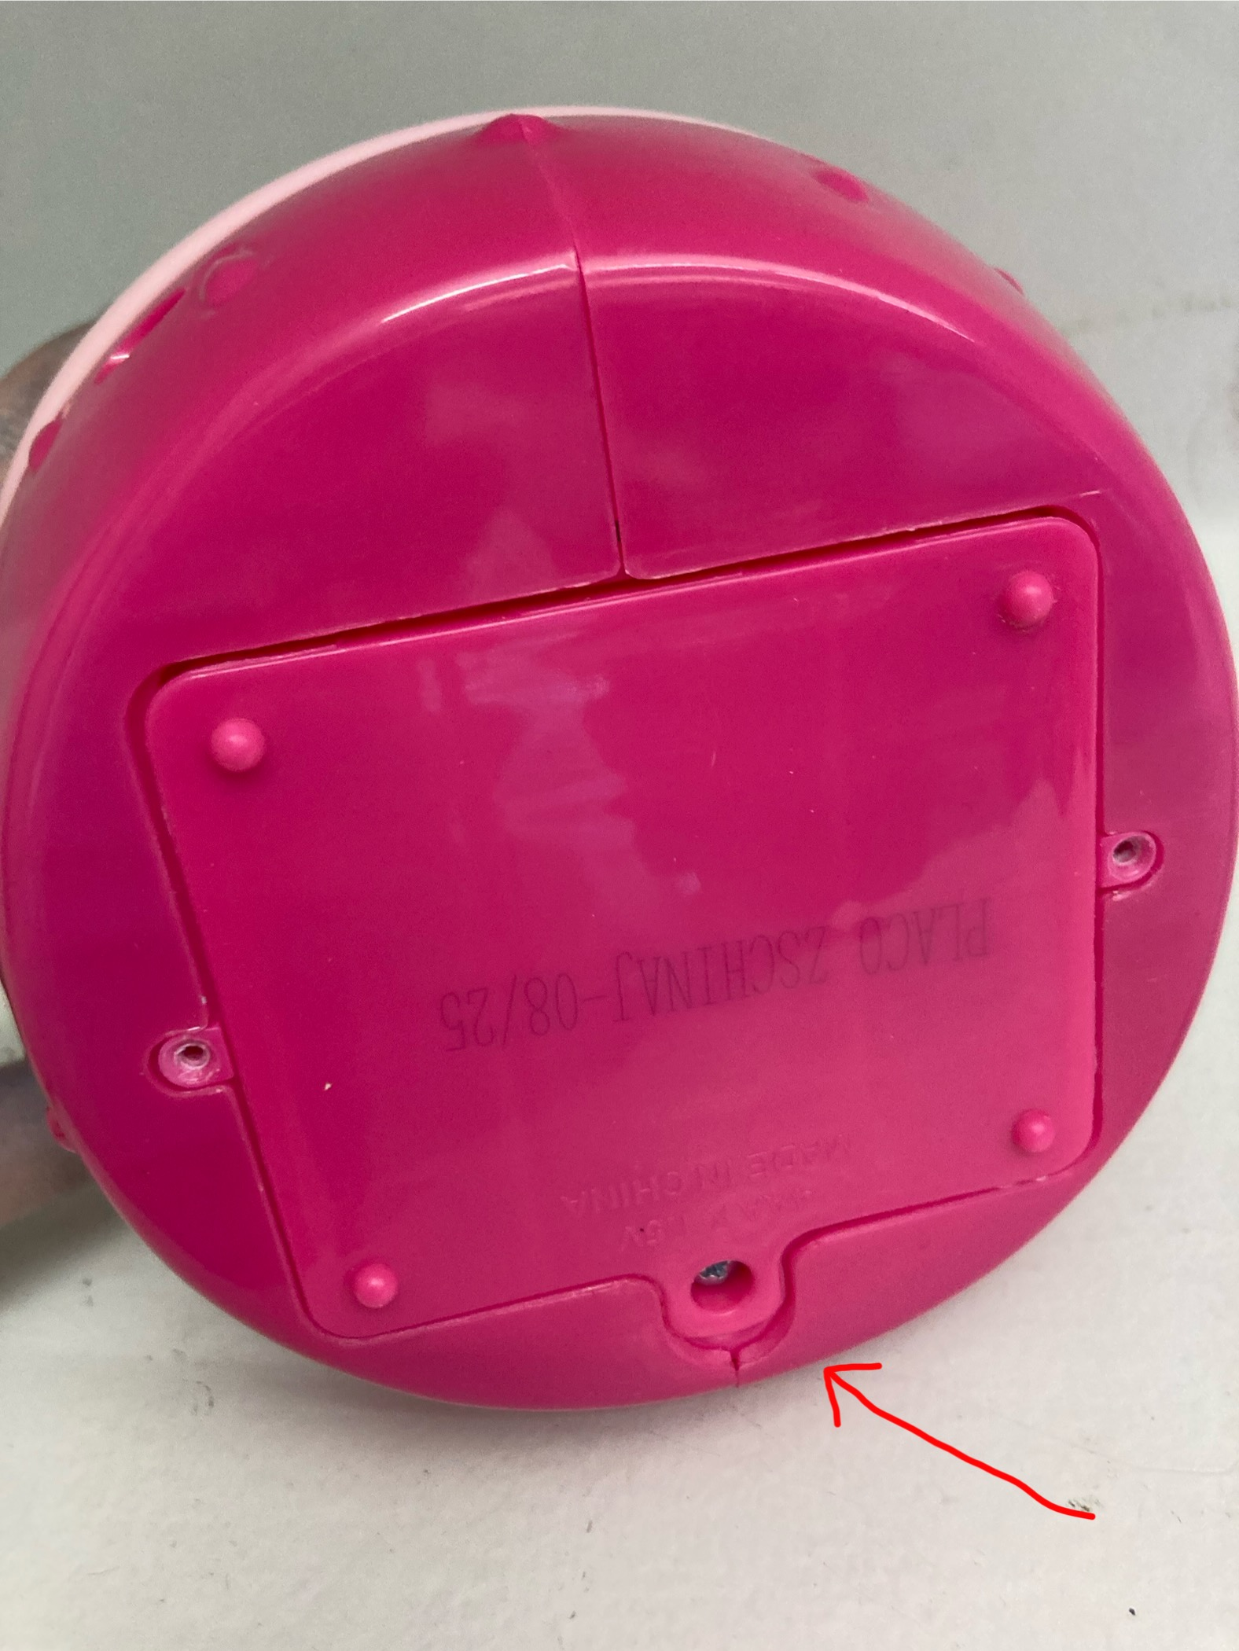
- Remove the screws and keep them in a safe location. | 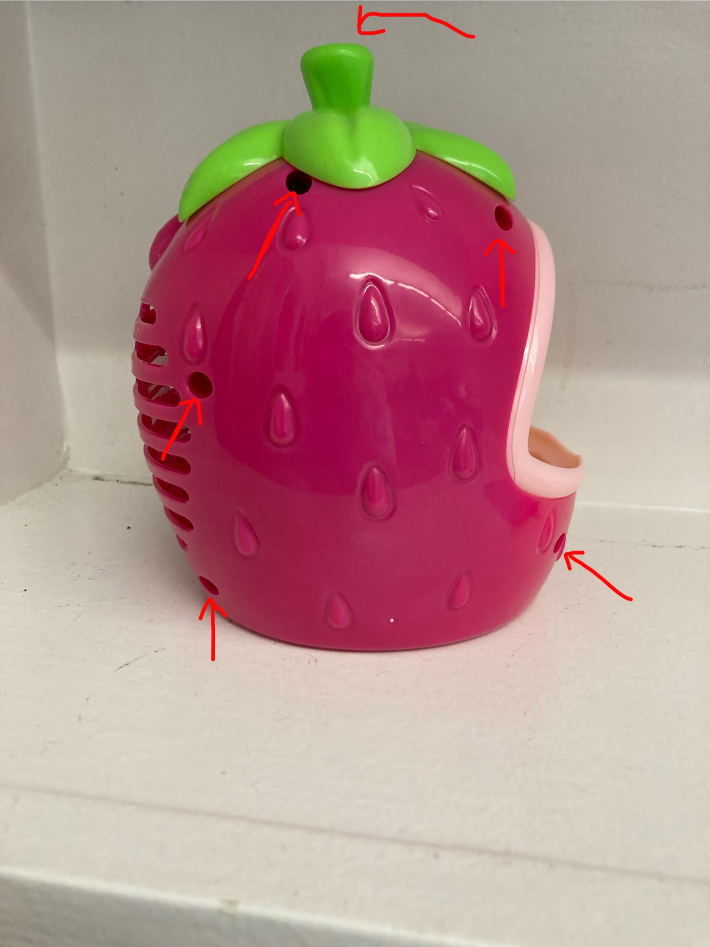
- Remove the original switch and casing, battery pack, and motor from the shell | 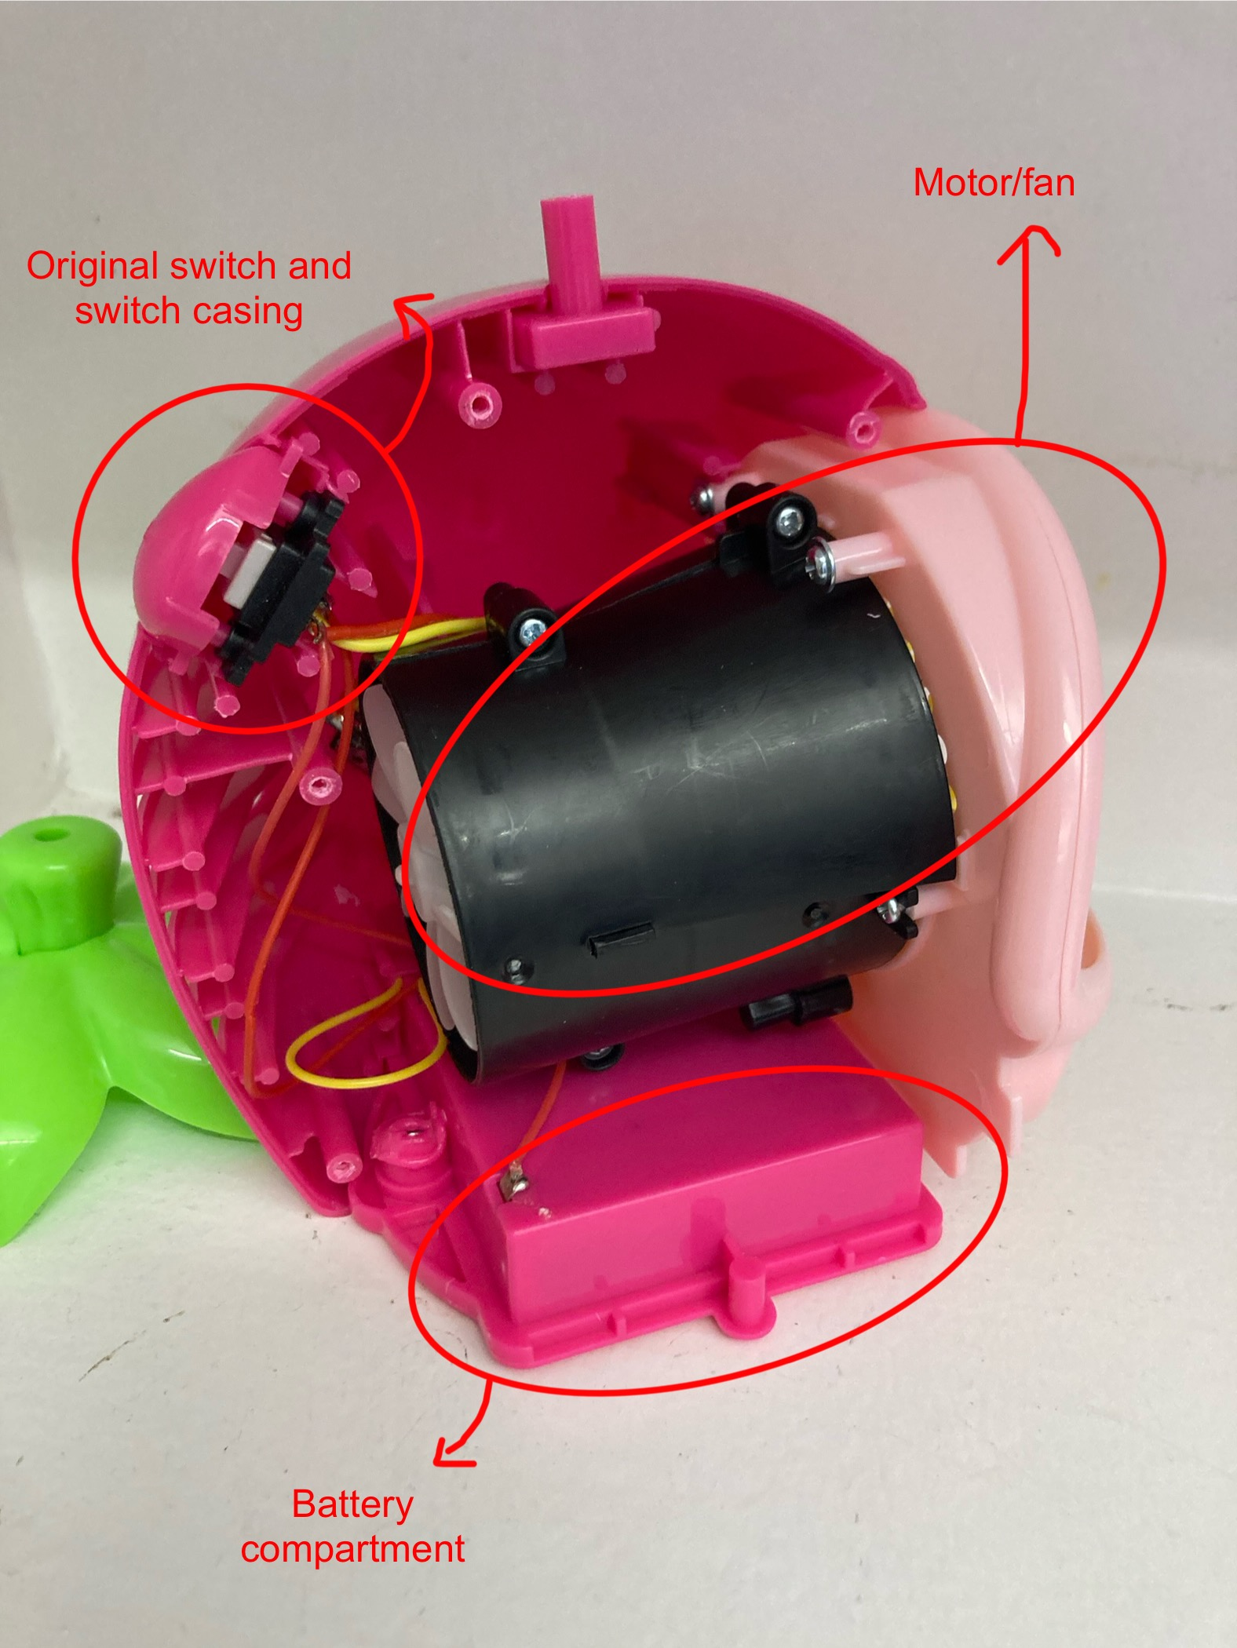
- Isolate the power switch. | 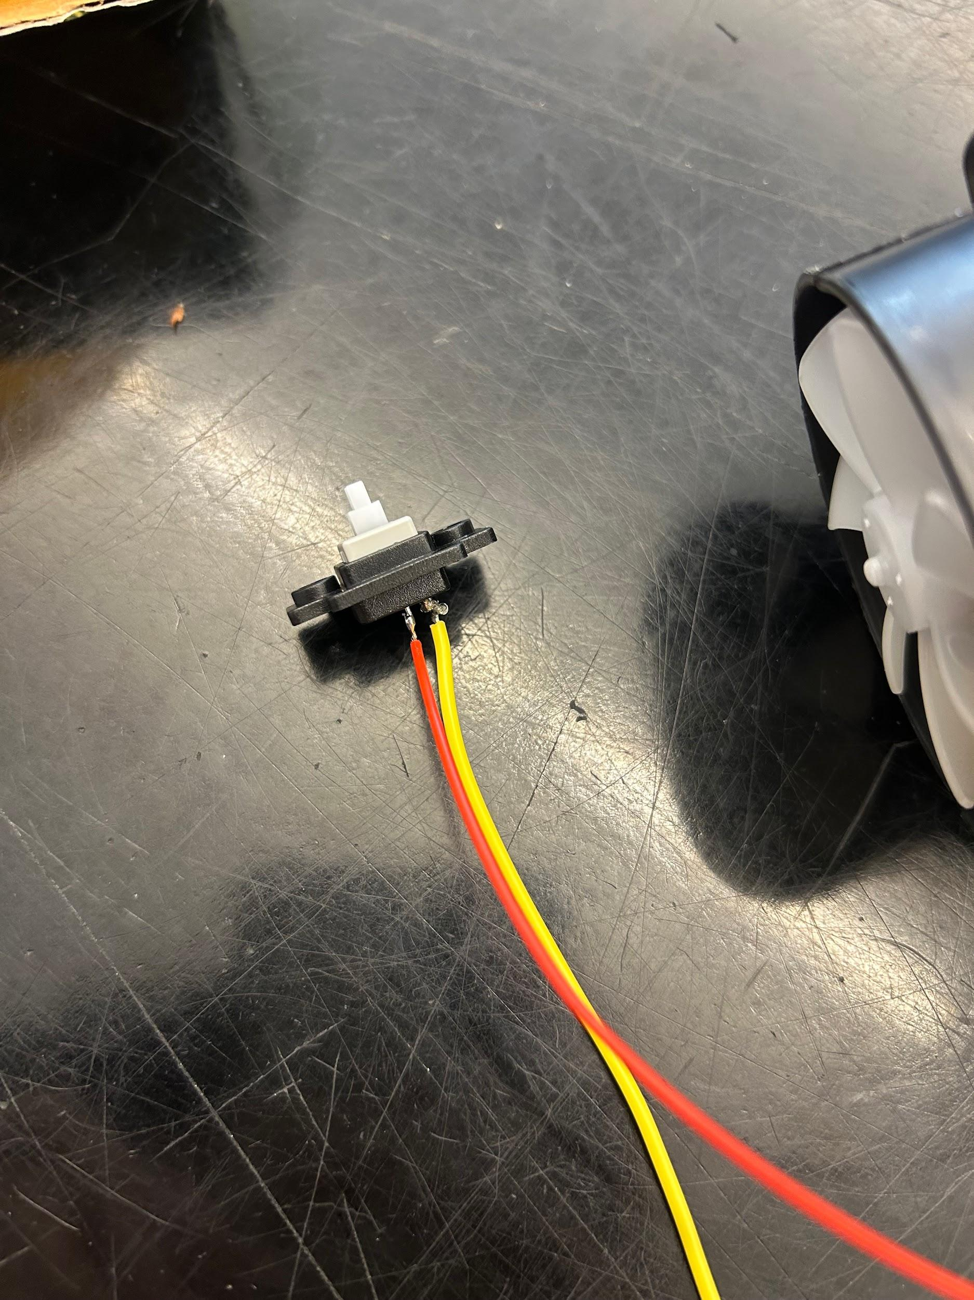
- Cut two pieces of wire, each about 10 cm long. | 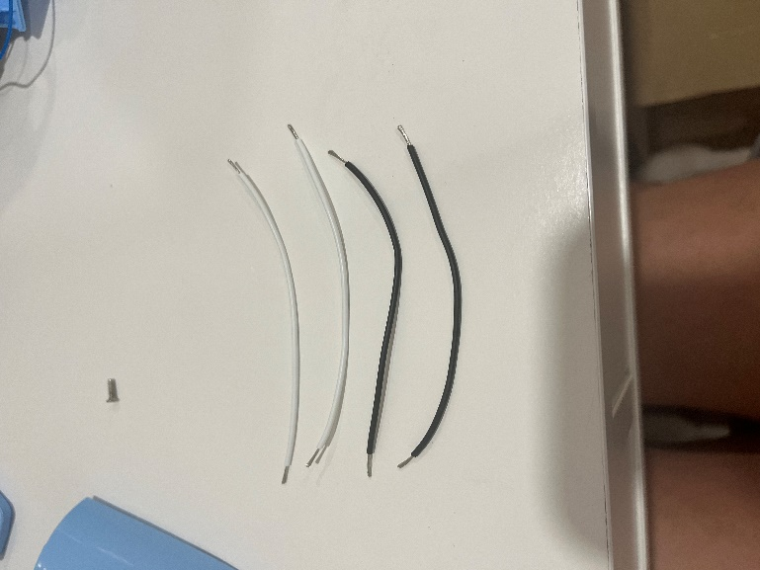
- Strip approximately 0.5cm off the end of each wire. | 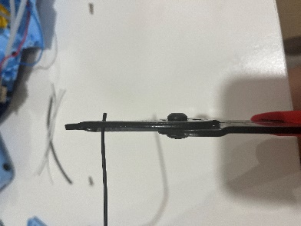
- Solder the wires onto the legs of the mono jack closest to where the cable is inserted. | 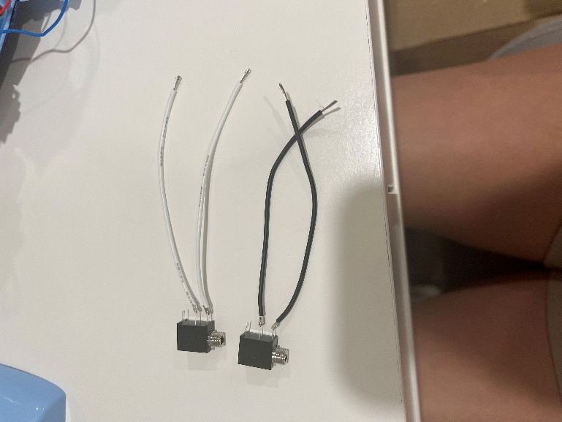
- Take the power switch (identified above) and solder one mono jack wire to one connection on the power switch (with the wire leading to the motor). | 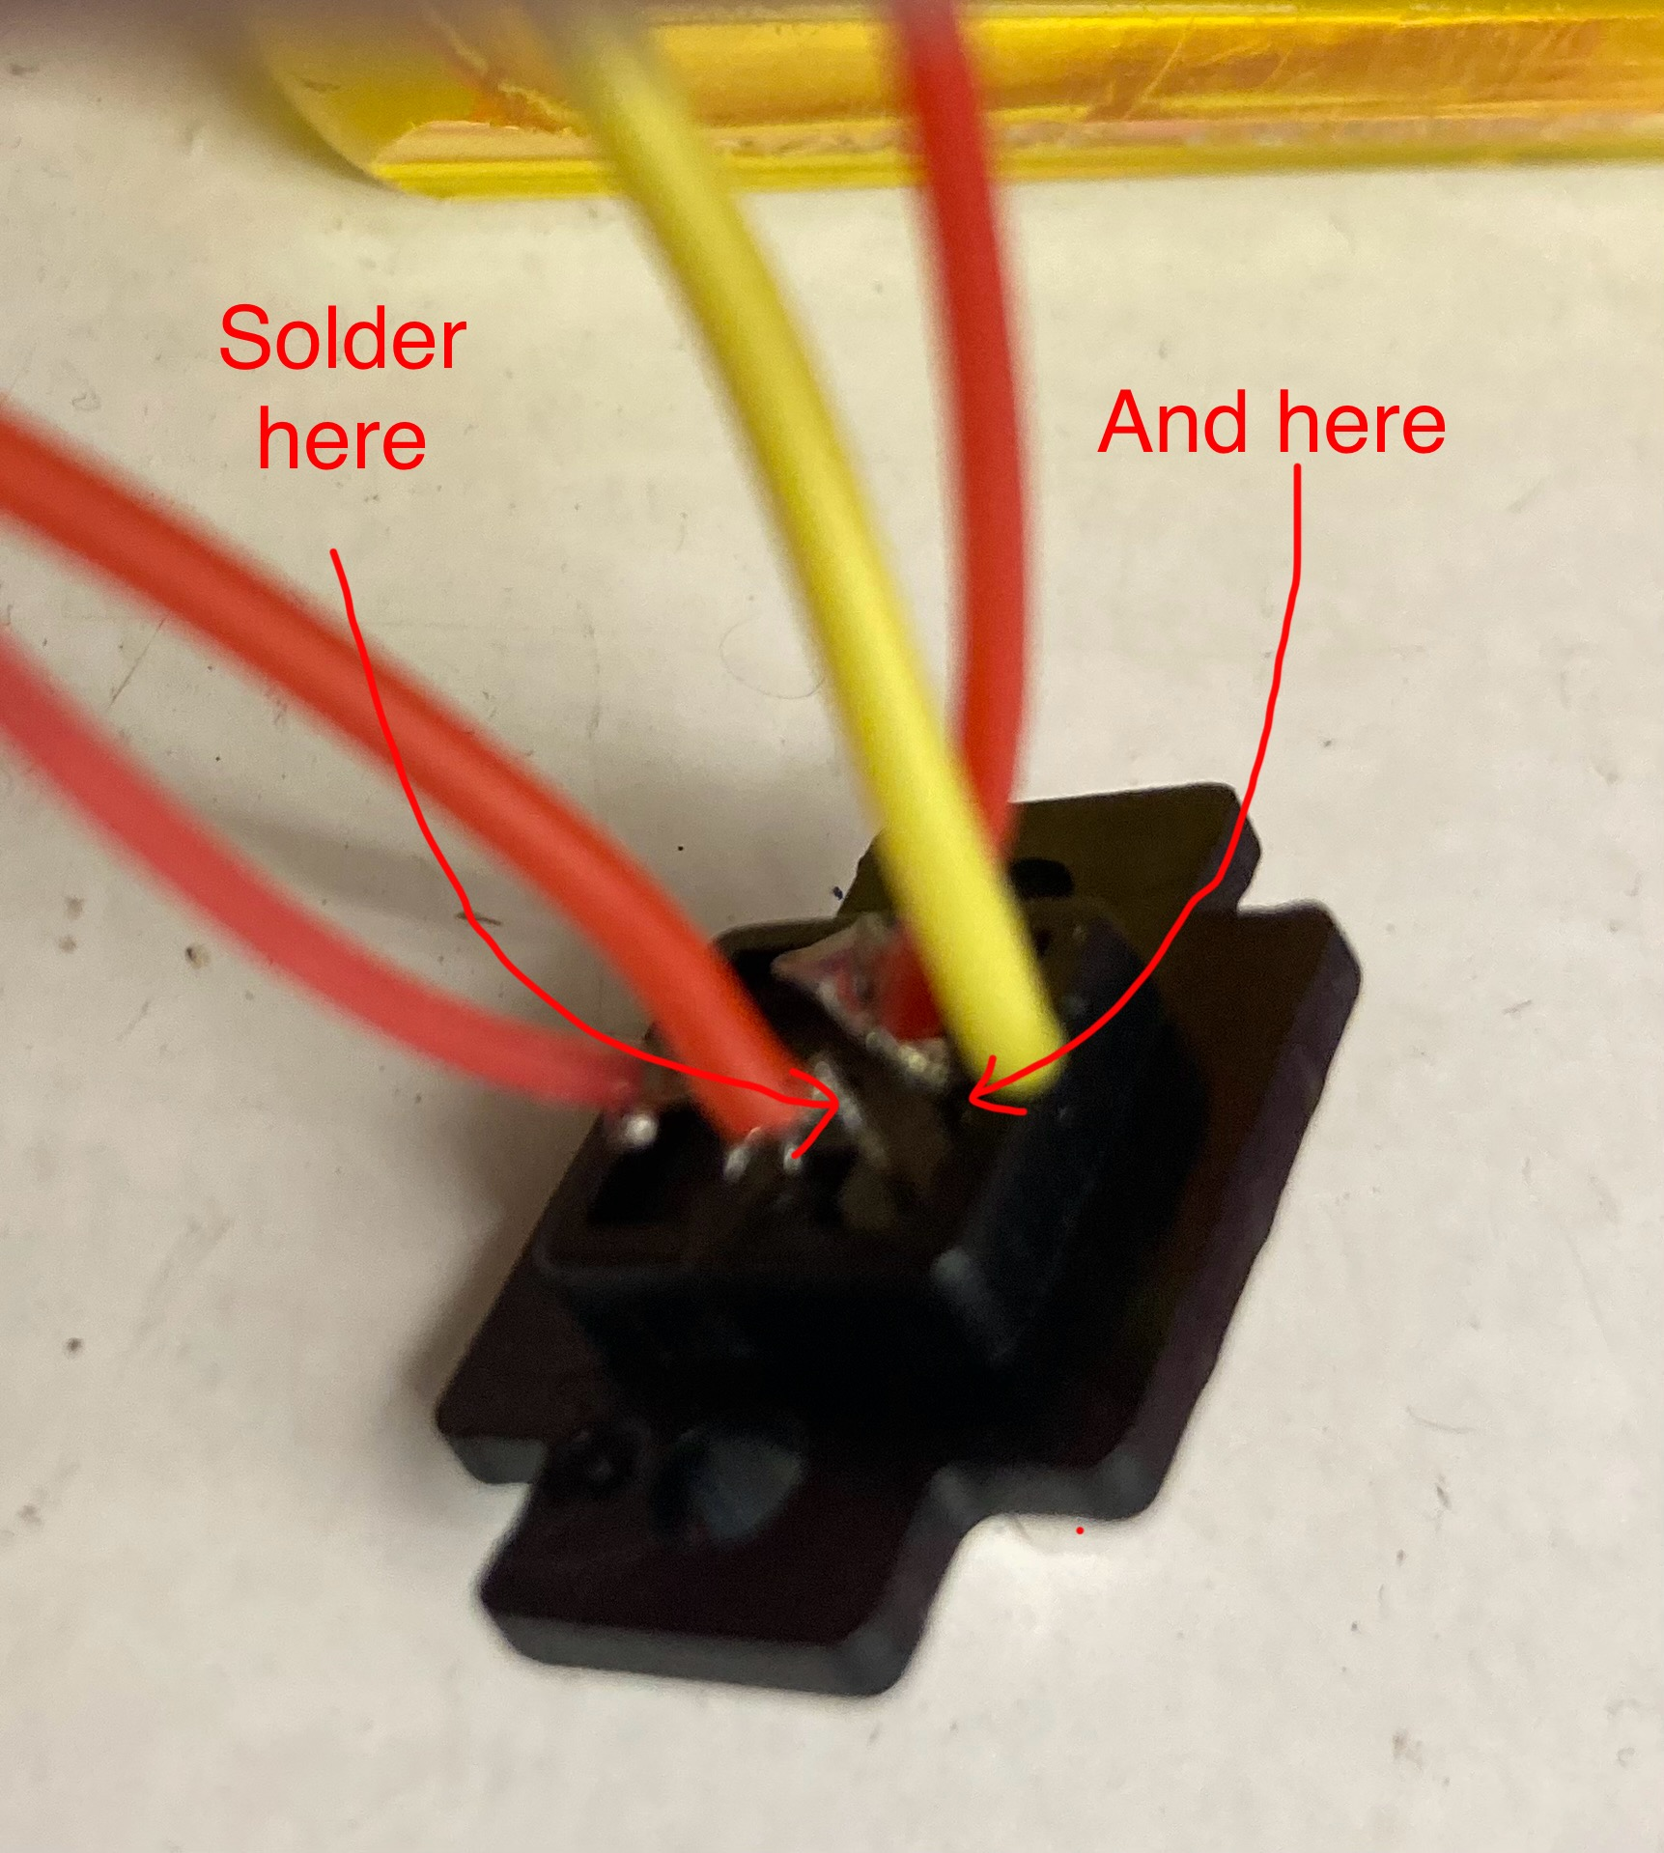
- Solder the other mono jack wire to the other connection on the power switch (with the wire leading to the battery pack). | 
- This is what it should look like once both wires from the mono jack are soldered to the power switch. | 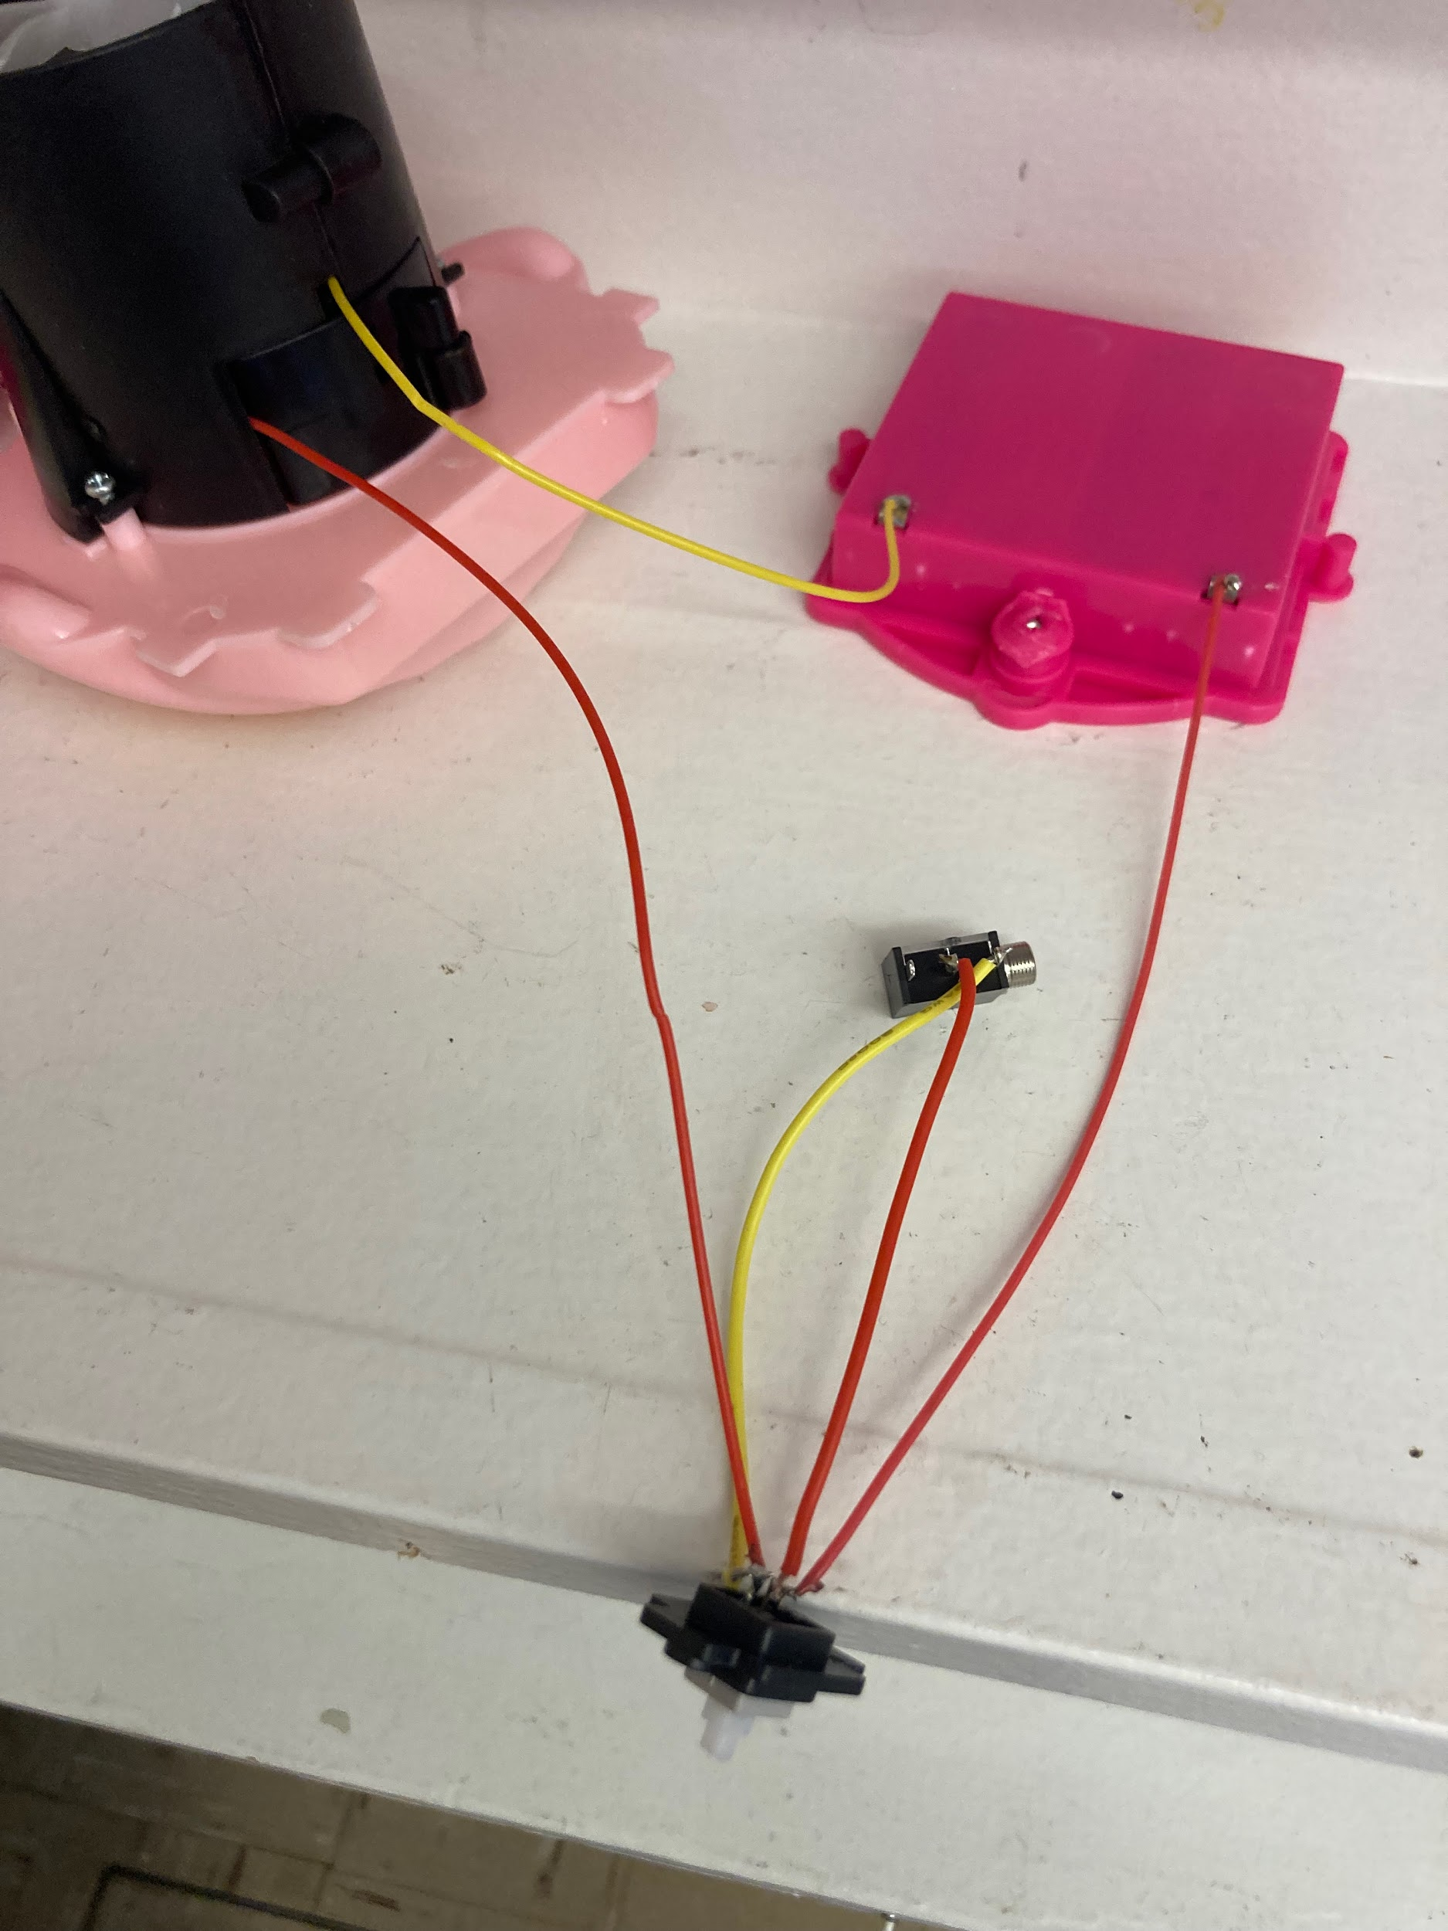
- It is now time to test the toy. Insert batteries into the battery compartment and insert an assistive switch into the mono jack. When the switch is pressed, the toy will turn on and you can move onto the next step.  Note: If the toy does not turn on, please check the soldered connections.  If the toy does not turn off when the switch is released, the connection is shorted. Check for areas of touching solder and separate using a soldering iron. | 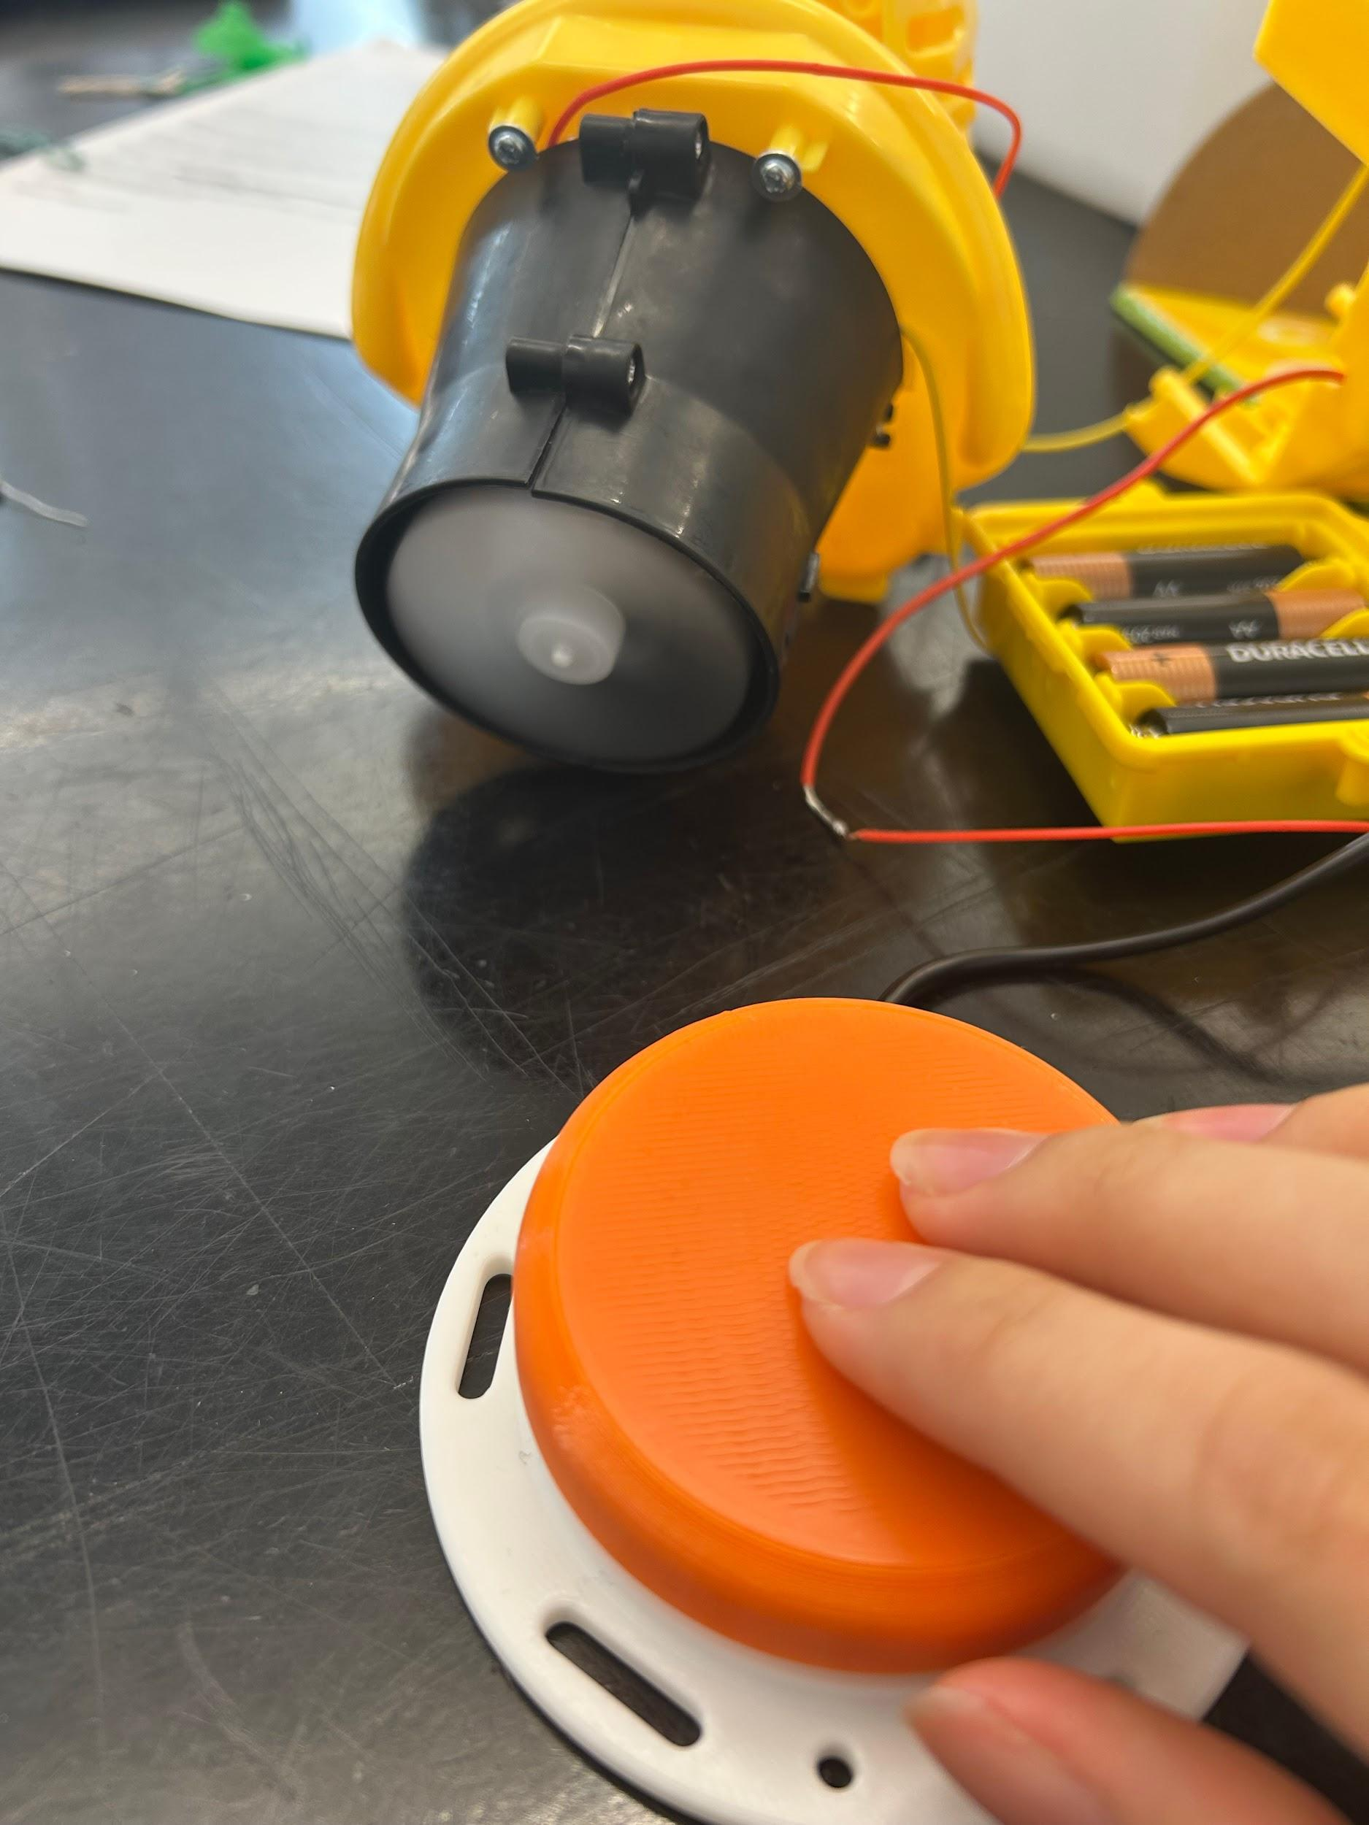
- Using a ¼” drill bit, drill a hole into the cover. Cut away any loose plastic. | 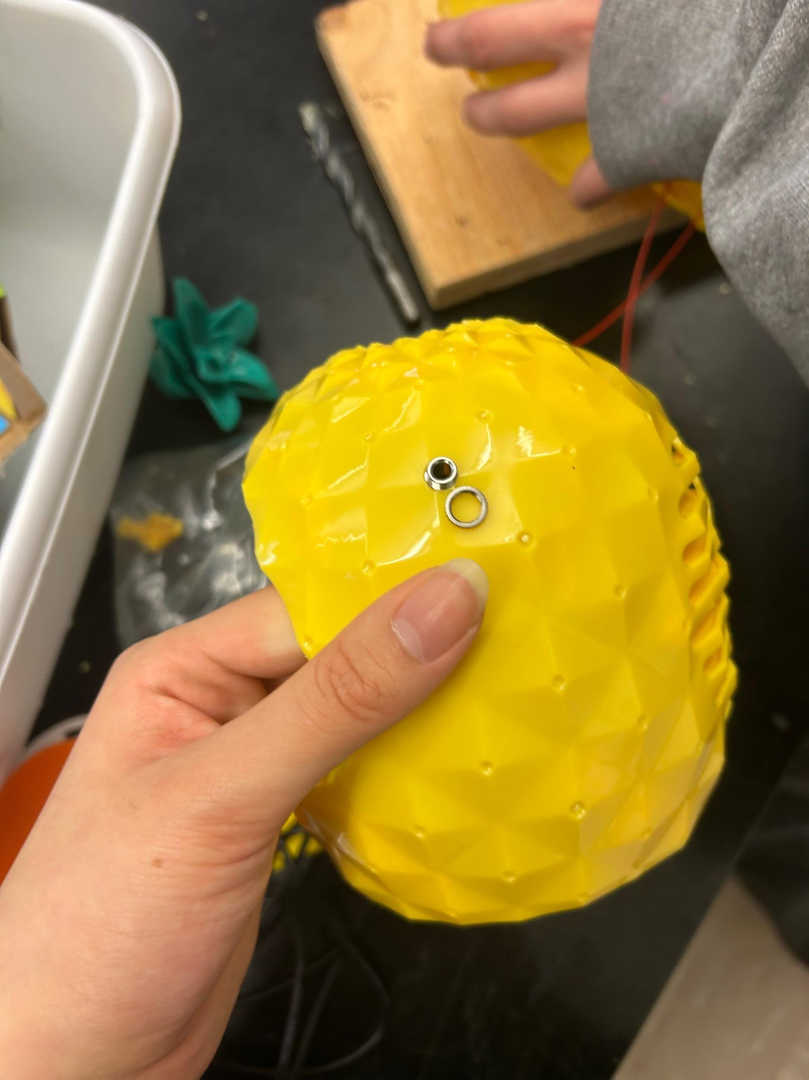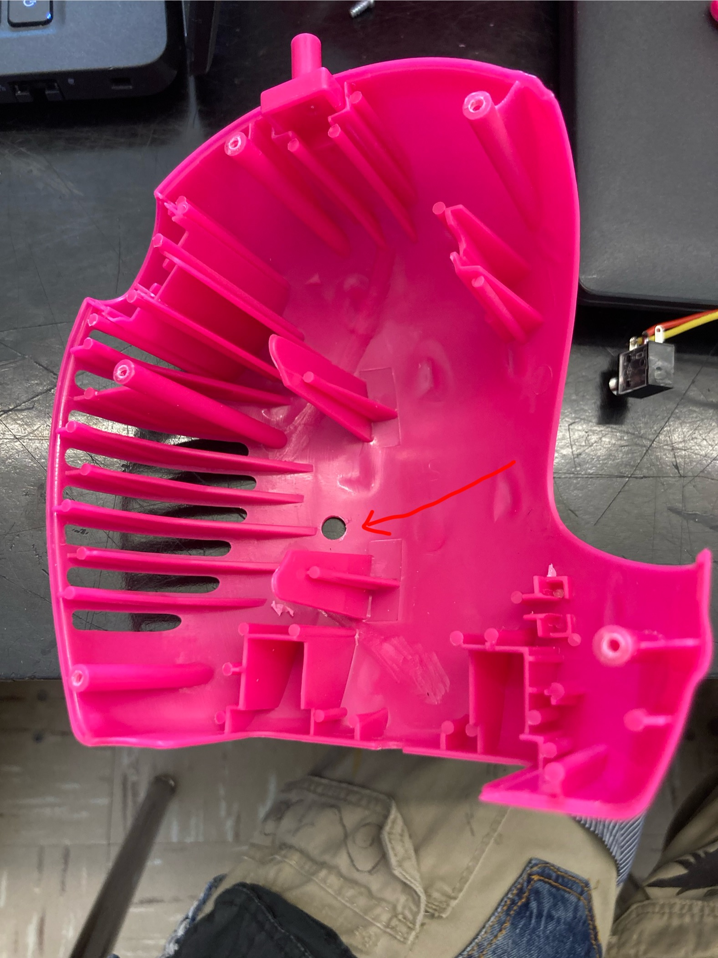
- Remove the nut from the mono jack and push the mono jack through the hole from the inside. Reinstall the nut on the outside of the toy and tighten to secure. | 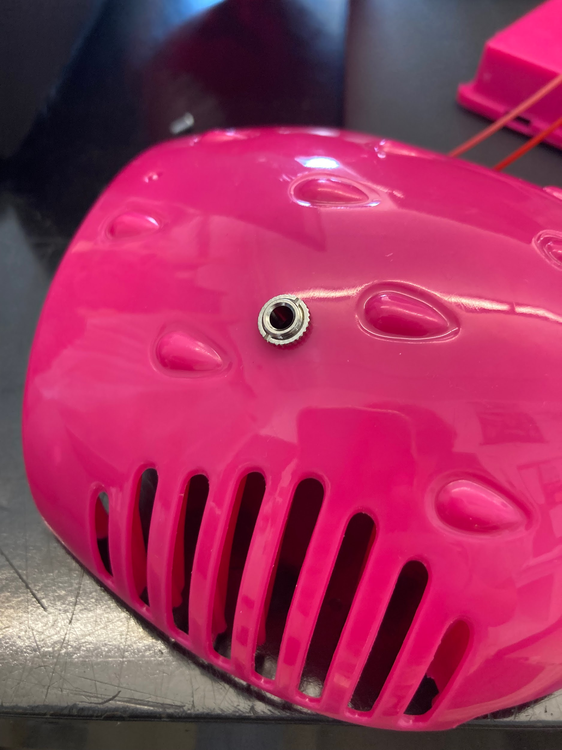
- Reassemble the toy, being careful the wires and tubes are not pinched when put back together. | 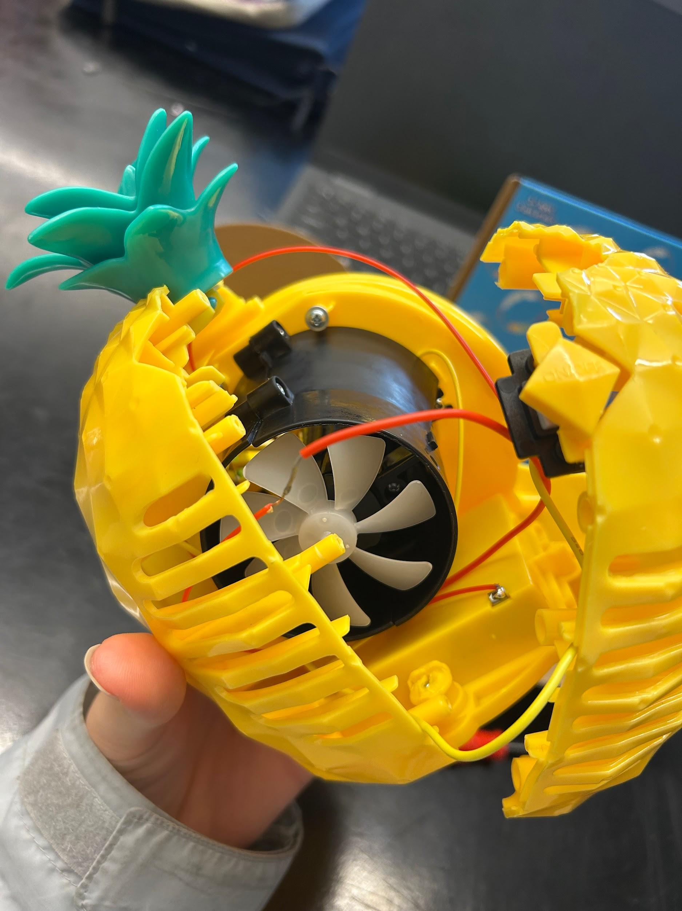
- Test the toy again. If it is still working properly, repackage the toy and the adapted toy is complete! | 