Required Components
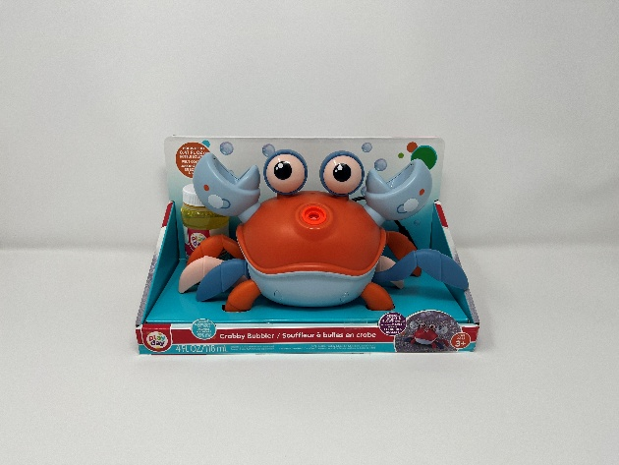 | 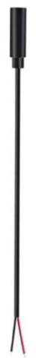  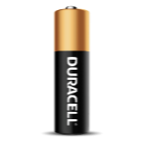 |    | BOM  - Play Day Dancing Crabby Bubble Blower (Walmart)  - 3.5 mm Female Mono Cable  - 3 AAA Batteries  Refer to the Tool and Component List for purchasing details.

Required Tools
- Phillips Screwdriver
- Soldering iron
- Wire stripper
- Flush cutter
- Drill and 1/8” drill bit
- Electrical tape

Required Personal Protective Equipment (PPE)
- Safety Glasses

Assembly Instructions
- Carefully remove the toy from the packaging. The toy will be put back in after it is adapted.  Using a flush cutter or flathead screwdriver, slide the two cylindrical screw covers (red circle) in the direction of the yellow arrows.  Dispose the covers. | 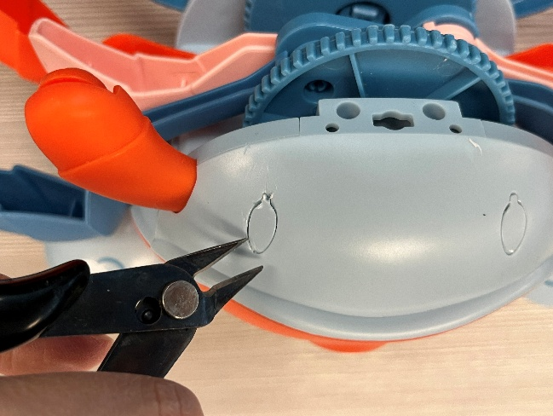  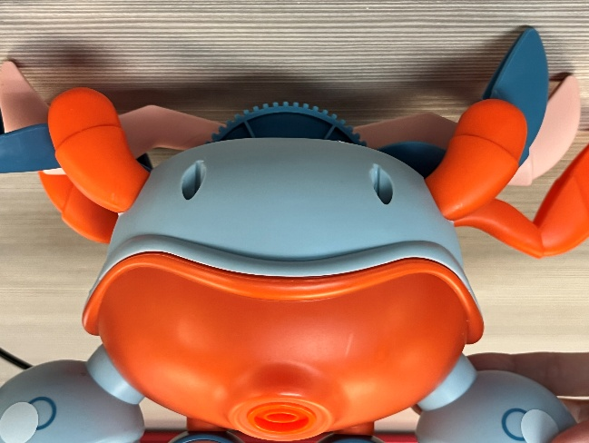
- Use a screwdriver to turn the 12 screws indicated in the red and yellow circles to open the toy.  Set screws aside in a safe place. | 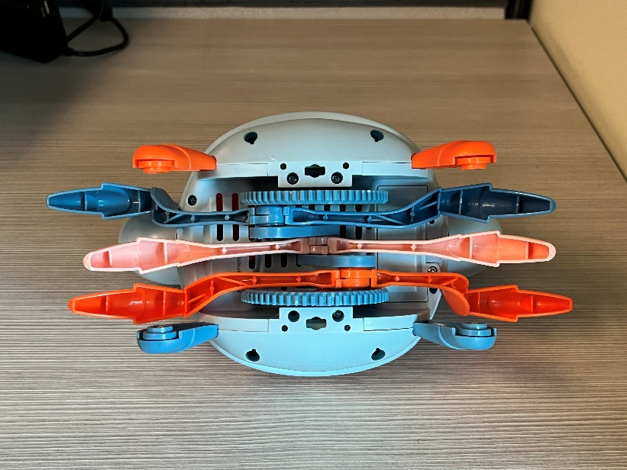
- Remove the blue front and back “belly” pieces and set aside. | 
- Gently separate the two halves of the toy, taking care not to pull any existing wires. | 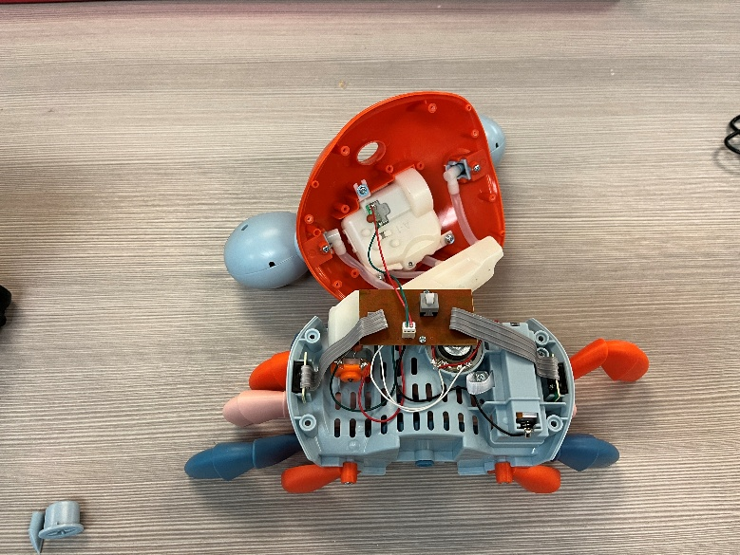
- Locate the red wire connecting the battery and PCB (top image, yellow arrow).  Cut the red wire in half where the yellow arrow is pointed to. It will look like the bottom image. | 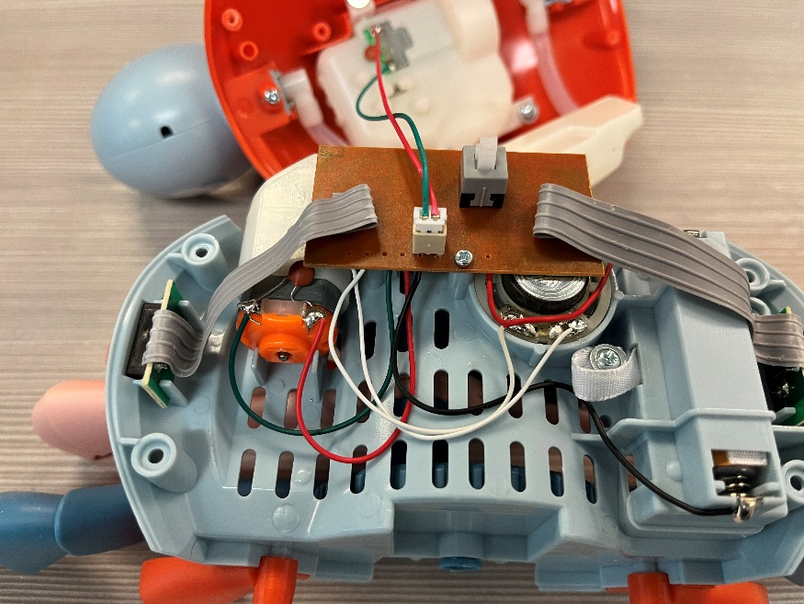  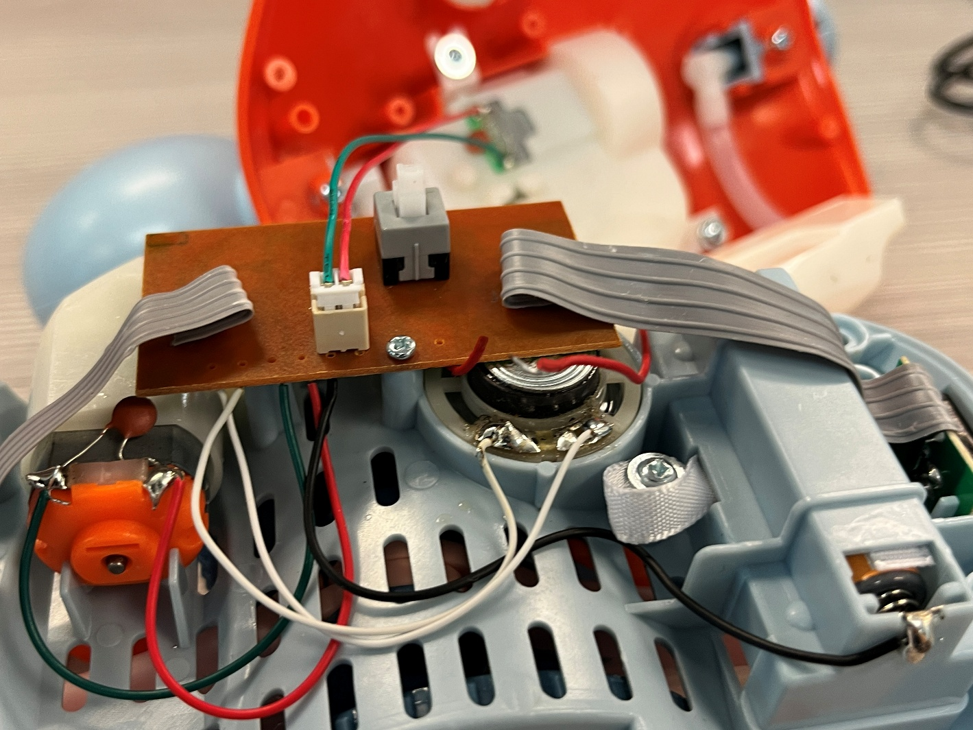
- Use wire strippers to strip approximately 0.5 cm off both wires ends from Step 5. | 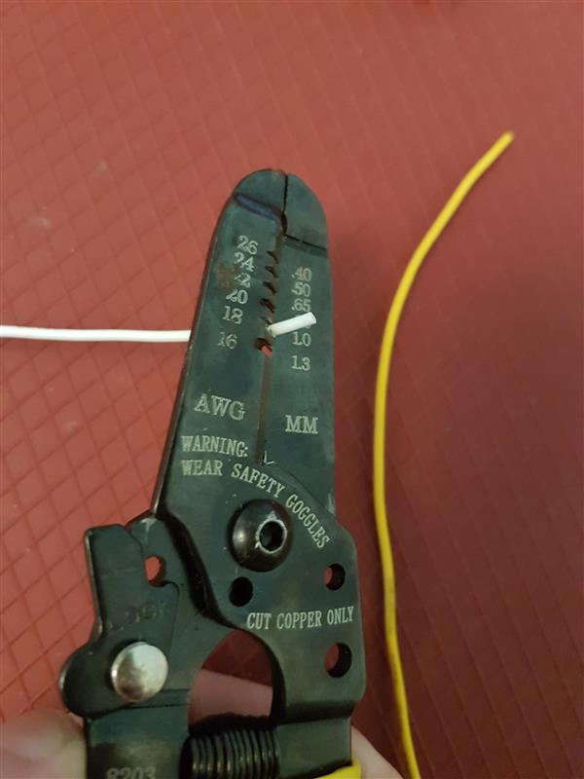
- Cut the female mono cable so it’s approximately 20 cm or 8 inches long. | 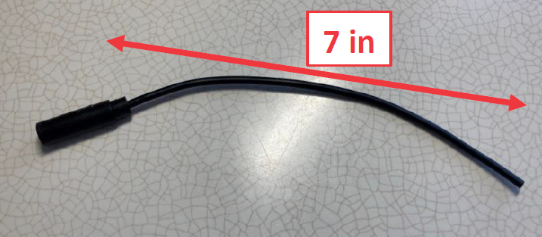  20 cm
- Strip approximately 2 cm of the outside wire, revealing the wires on the inside.  The ideal size for the wire strippers is 14 AWG, but if your wire strippers are smaller, just close them until you feel some give.  If any of the internal wires get cut, you can cut off this section of wire and try again. | 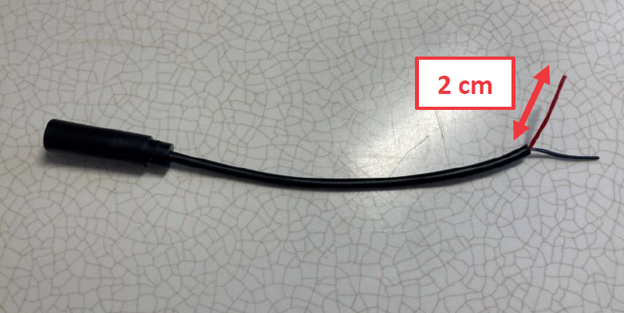  2 cm
- Next, strip approximately 0.5 cm of the individual internal wires.
- With 1/8 inch drill bit, drill a hole in the toy marked in the yellow circle. | 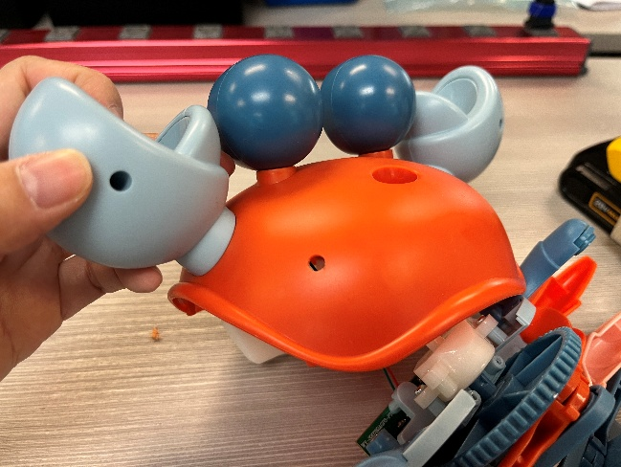
- Insert the female mono cable through the drilled hole, ensuring that the mono jack end (yellow circle) is on the outside of the toy. | 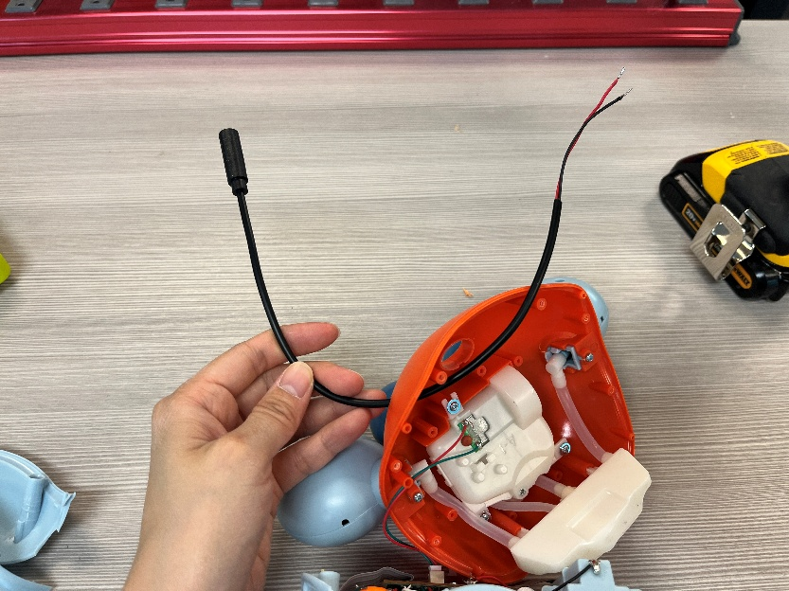
- Tie a knot in the mono cable approximately 5 cm from the end. This will be used as strain relief.  Note: if your cable is not long enough to tie a knot, you can use a cable tie around the cable near where the cable exits the toy instead. | 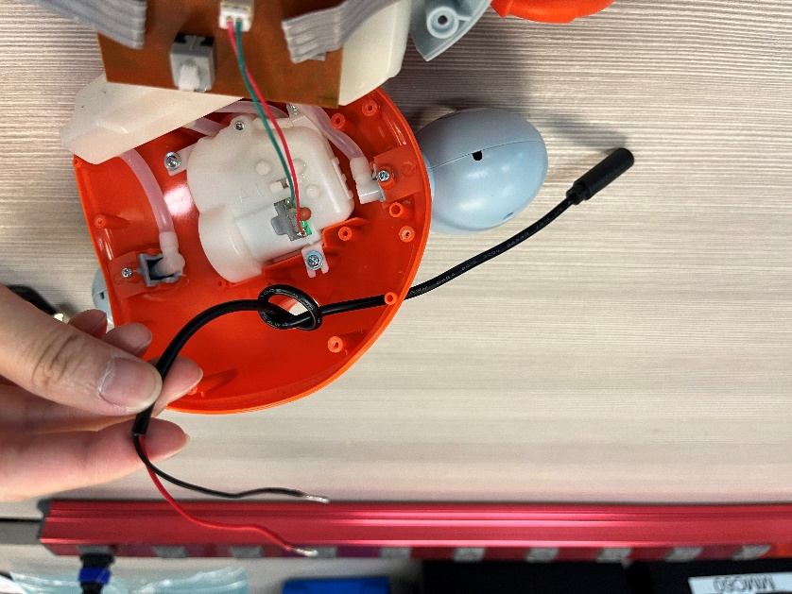  5 cm
- Twist together one wire from Step 5 (top image) and one wire from the female mono cable (middle image). The result should look like the last image. |   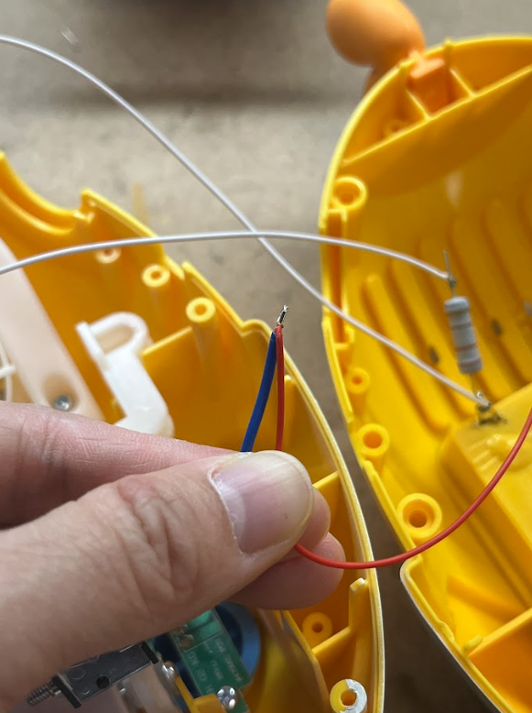
- Repeat step 13 with the remaining wires.  Twist together the second wire from Step 5 (top image) and second wire from the female mono cable (middle image). The result should look like the last image. |   
- Add solder to both wires and wrap with electrical tape. | 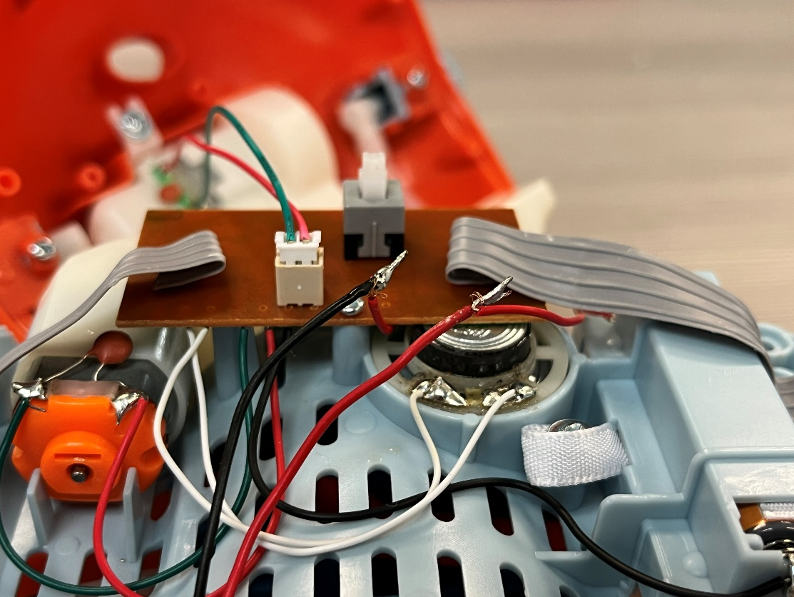
- Check that the connections were soldered correctly.  Ensure that the toy switch is turned OFF. Insert 3 AAA batteries into the toy and plug an assistive switch into the mono jack. When the switch is pushed, the toy motor should be activated, and when the switch is not pushed, the toy motor should stop.  If the motor does not whirr, check that the soldered connections are secure, if the motor does not stop when the switch is not pressed, check for accidental bridging (excess solder connecting to the two solder joints together). | 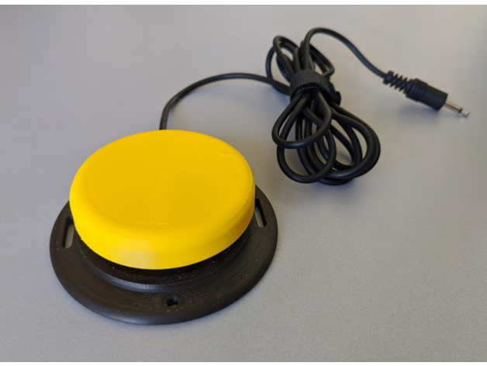
- Insert the blue button cover if it has fallen out.  Put the two halves of the toy back together. We recommend assembling it upside down so the button cover does not fall out. | 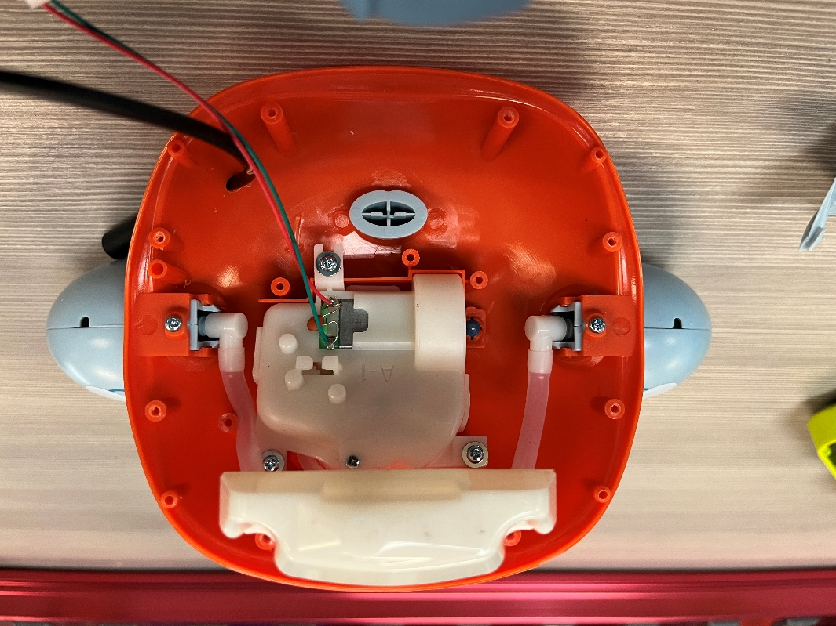  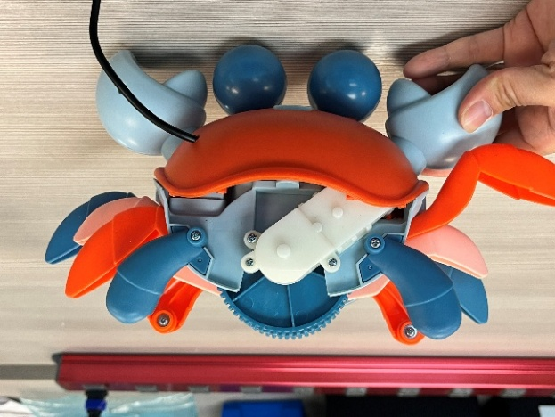
- Screw the 4 screws to hold the two halves together. | 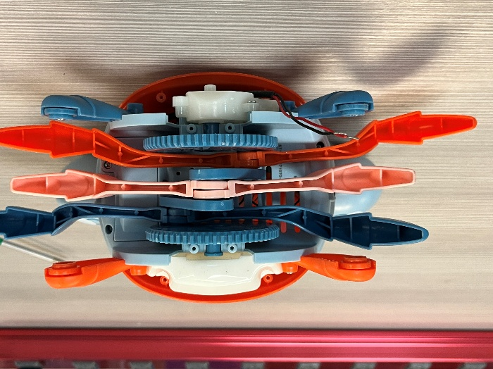
- Put back the front and back shell pieces. We recommend inserting the middle section first. | 
- Insert the 8 screws. | 
- You can check the toy again with an assistive switch to make sure it works once it is reassembled. If it does not work or stays on when the switch is not pressed, check the connections inside. This includes looking at where wires may have been pinched when the toy was reassembled.  If it all works properly, the toy is done! | 