Required Components
  1. | 2.  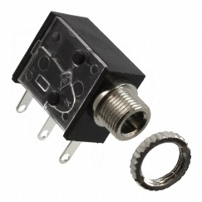 | BOM  - Hot Wheels RC Aaron Wheelz Wheelie Chair  - (4x) 3.5 mm Mono Jack  - 22 AWG Wire  - 2 AA Batteries  Refer to the Tool and Component List for purchasing details.
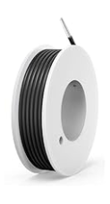 |   

Required Tools
- Screwdriver Phillips
- Wire strippers
- Soldering iron and solder
- Drill and 1/4” drill bit
- Slip joint pliers

Required Personal Protective Equipment (PPE)
- Safety glasses

Assembly Instructions
- Carefully remove the toy from its packaging without damaging it (we will be repackaging the toy after adapting). | 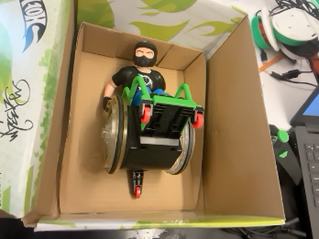
- Carefully separate the two halves of the toy by removing the 4 screws.  *Note: make sure to keep the screws and do not lose them. | 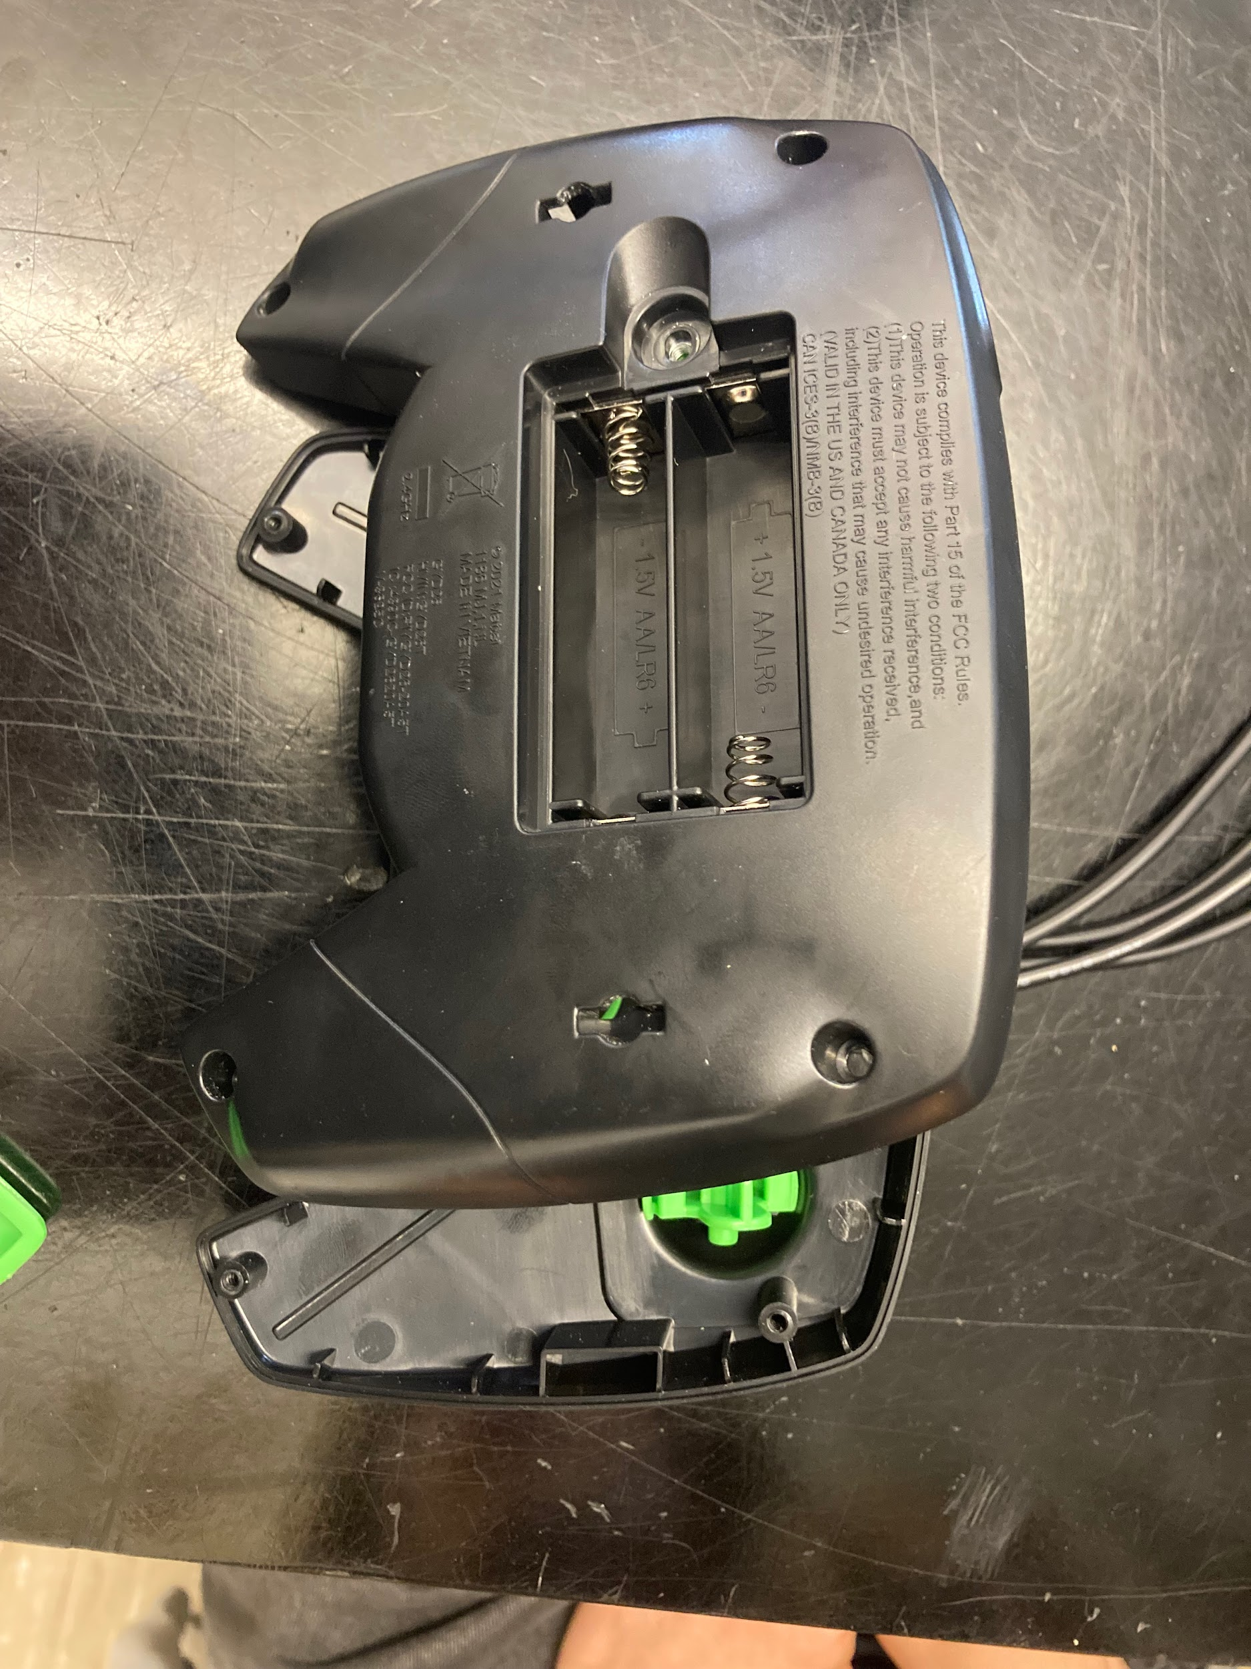
- Cut eight pieces of wire, each about 10 cm long. | 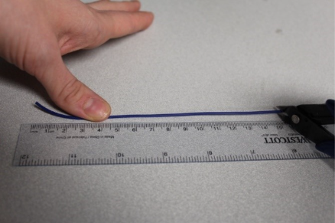
- Strip approximately 0.5cm off the end of each wire. | 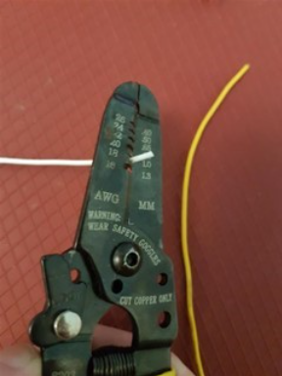
- Solder the 2 wires onto the 2 legs of the mono jack closest to where the cable is inserted. |       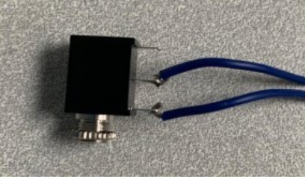
- Melt a small amount of solder over the exposed ends of the wire. | 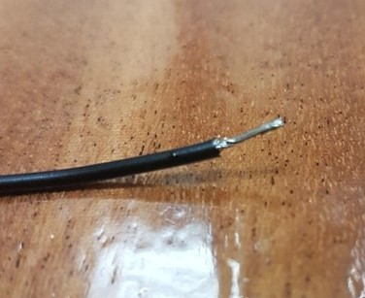
- Using a 1/4” drill bit, drill a hole into the position shown in the photo on the right. Remove any loose plastic.  Remove the retaining ring from the mono jack and push the mono jack through the hole from the inside. Reinstall the retaining ring on the outside of the toy and tighten to secure.  The holes are arranged so that the up and down controls are on the up-down side of the remote and the left and right controls are on the left-right side of the remote. | 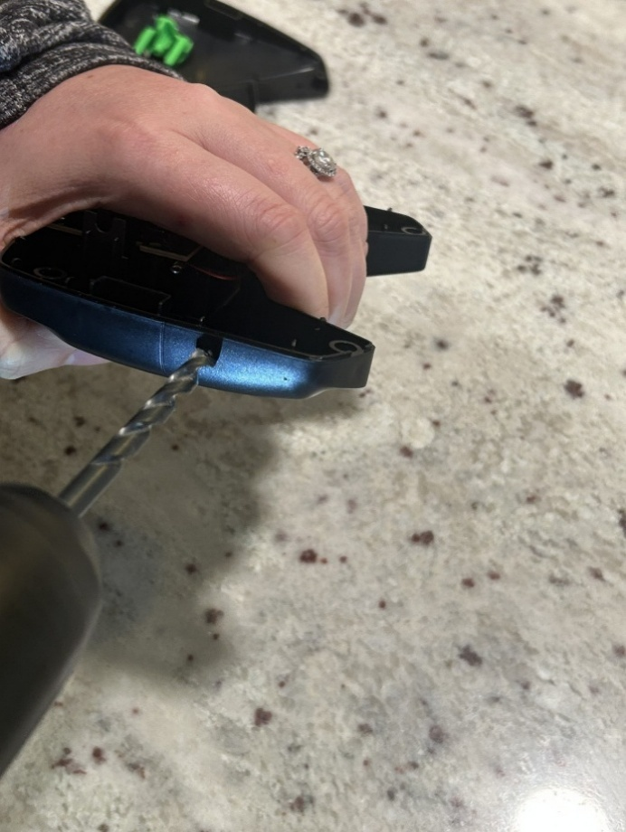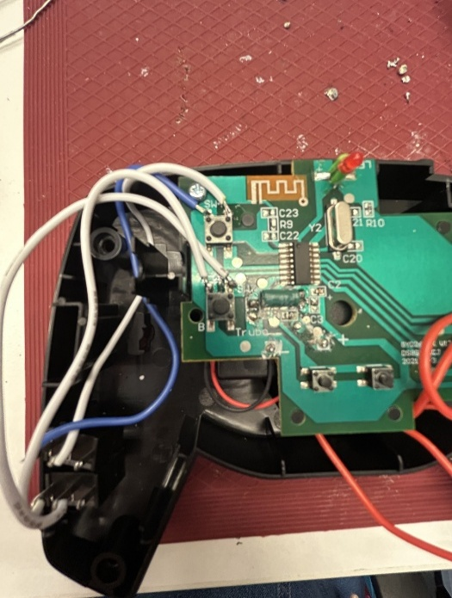
- Solder the wires to the matching spot in the photo. This will become the up control for the toy. | 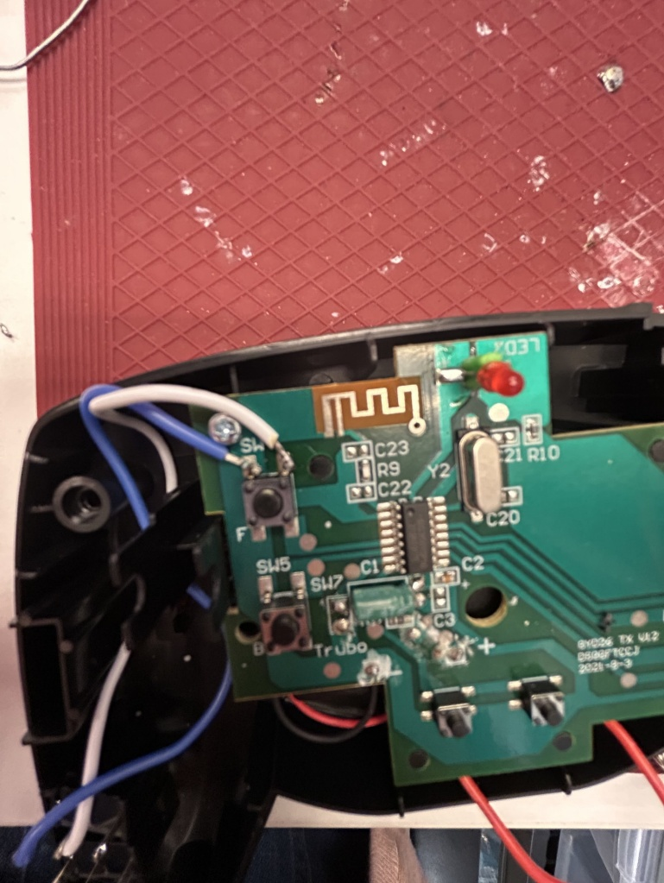
- Using a 1/4” drill bit, drill a second hole below the first hole, in the position shown in the photo on the right. Remove any loose plastic.  Remove the retaining ring from the mono jack and push the mono jack through the hole from the inside. Reinstall the retaining ring on the outside of the toy and tighten to secure.  The holes are arranged so that the up and down controls are on the up-down side of the remote and the left and right controls are on the left-right side of the remote. | 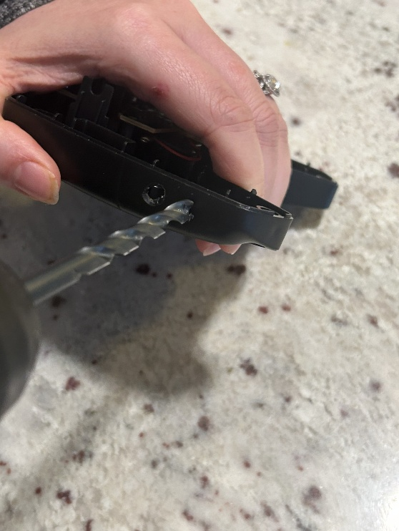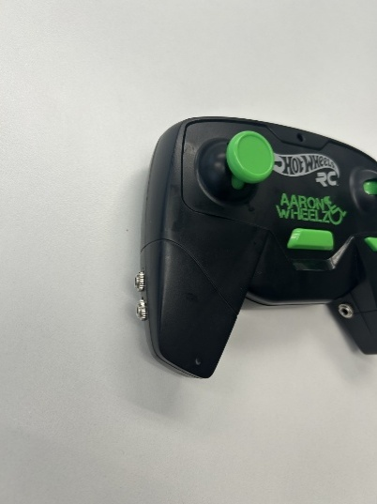
- Solder the wires to the matching spot in the photo. This will become the down control for the toy. | 
- Using a 1/4” drill bit, drill a third hole into the position shown in the photo on the right. Remove any loose plastic.  Remove the retaining ring from the mono jack and push the mono jack through the hole from the inside. Reinstall the retaining ring on the outside of the toy and tighten to secure.  The holes are arranged so that the up and down controls are on the up-down side of the remote and the left and right controls are on the left-right side of the remote. | 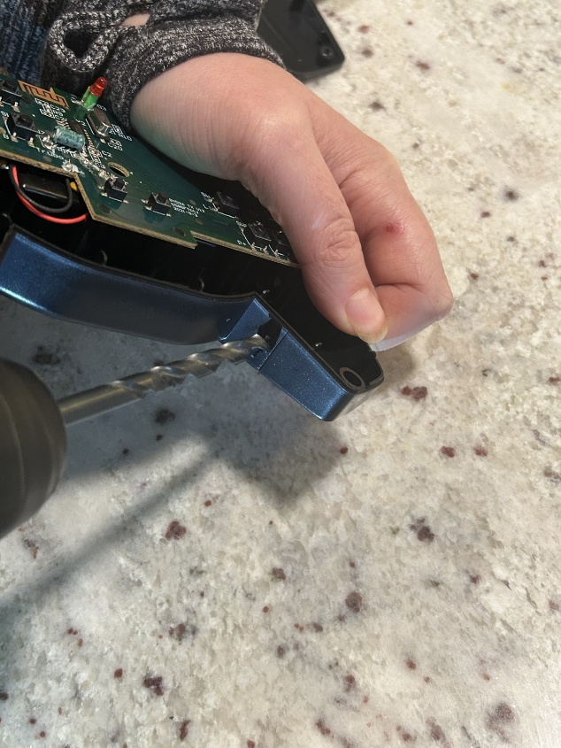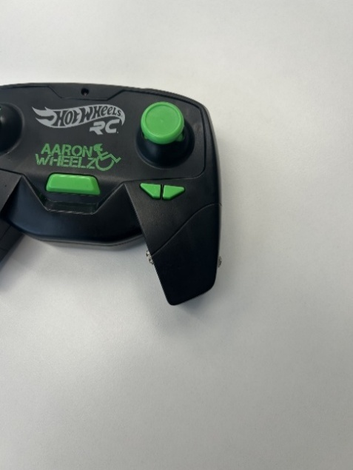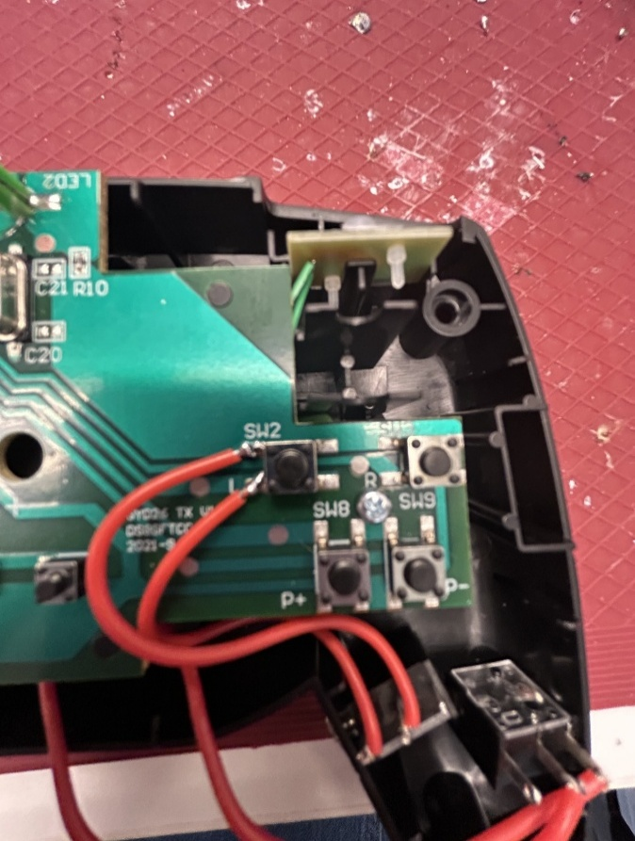
- Solder the wires to the matching spot in the photo. This will become the left control for the toy. | 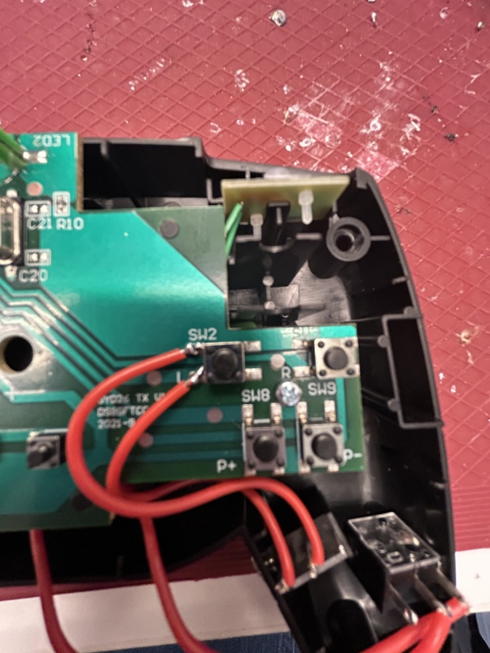
- Using a 1/4” drill bit, drill a fourth hole into the position shown in the photo on the right. Remove any loose plastic.  Remove the retaining ring from the mono jack and push the mono jack through the hole from the inside. Reinstall the retaining ring on the outside of the toy and tighten to secure.  The holes are arranged so that the up and down controls are on the up-down side of the remote and the left and right controls are on the left-right side of the remote. | 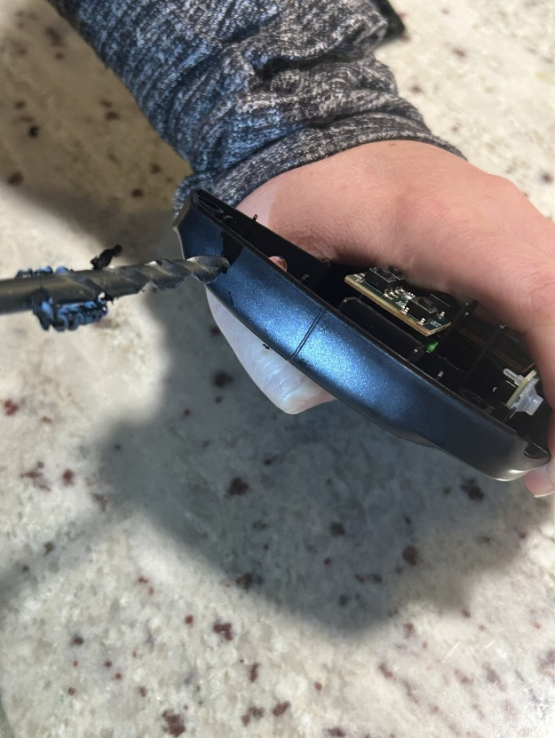  
- Solder the wires to the matching spot in the photo. This will become the right control for the toy. | 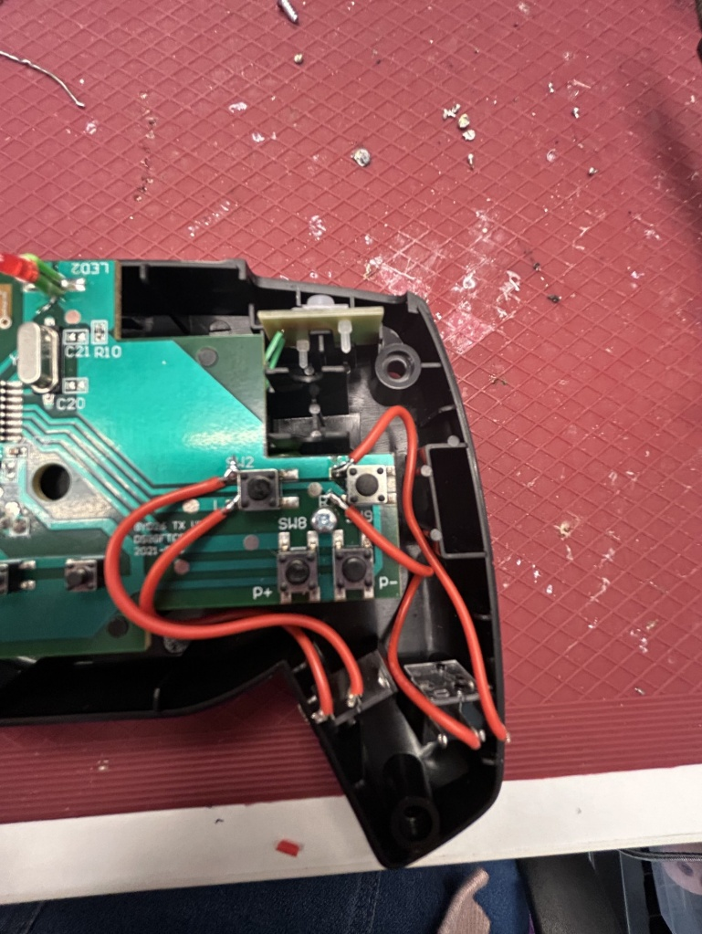
- It is now time to test the toy. Insert batteries into the battery compartment on the remote and ensure the RC wheelchair is charged. Insert an assistive switch into the mono jack. The toy will activate when the assistive switch is pressed.  Notes:  - If the toy does not turn on, please check the soldered connections.  - If the toy does not turn off when the switch is released, the connection is shorted. Check for areas of touching solder and separate using a soldering iron. | 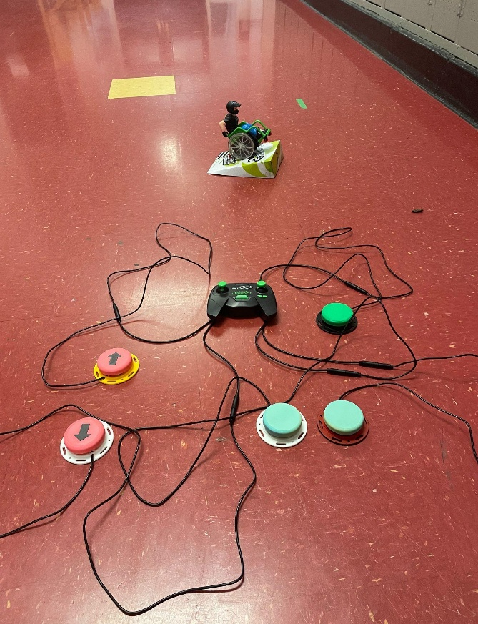
- Reassemble the toy using the screws set aside earlier. | 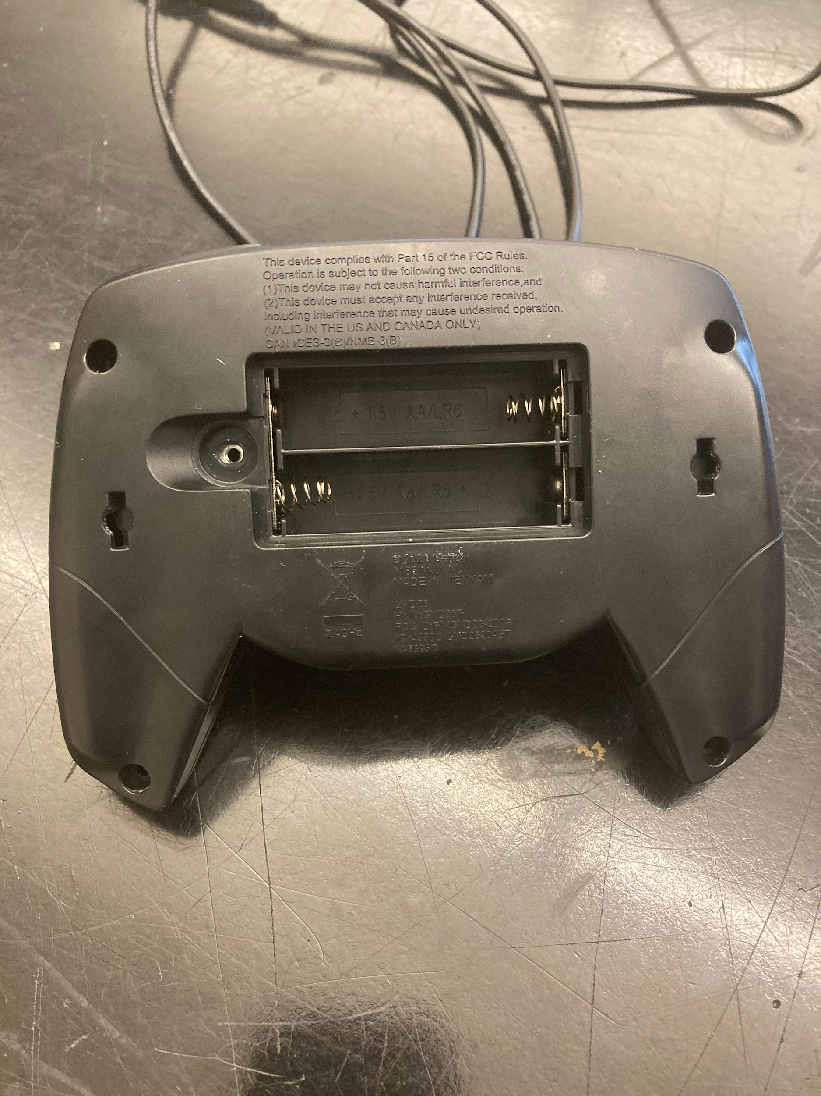
- Test the toy again. If it is still working properly, repackage the toy and the adapted toy is complete! | 