Required Components
 | 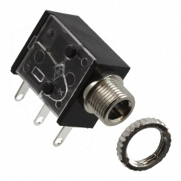 | BOM  - Disney - Stitch Coconut Bubble Machine (Walmart)  - 3.5 mm Mono Jack and Nut  - 22 AWG Wire  - 3 AA Batteries
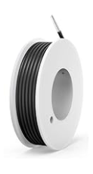 | 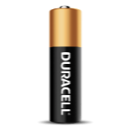    

Required Tools
- Phillips Screwdriver
- Soldering iron
- Wire stripper
- Flush cutter
- Drill and ¼” drill bit

Required Personal Protective Equipment (PPE)
- Safety Glasses

Assembly Instructions
- Carefully remove toy from cardboard, the toy will be put back in cardboard (if possible) after it is adapted  Utilizing a screwdriver, turns screws indicated in the red circles to open the toy.  There are 3 hidden screws that you will need to remove; behind the battery cover in the head and 2 under the plastic flap on the back  Set screws aside in a safe place | 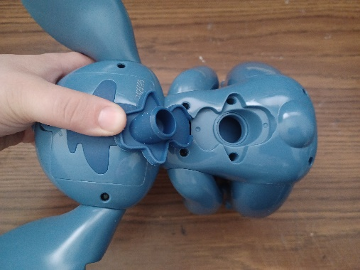  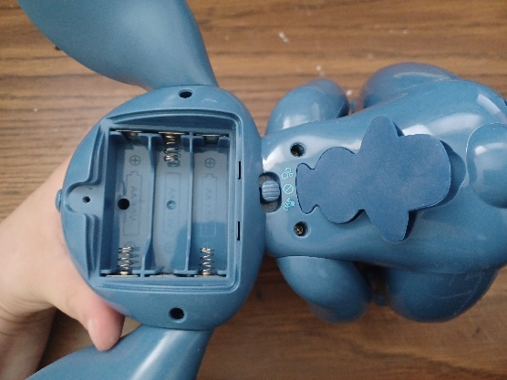  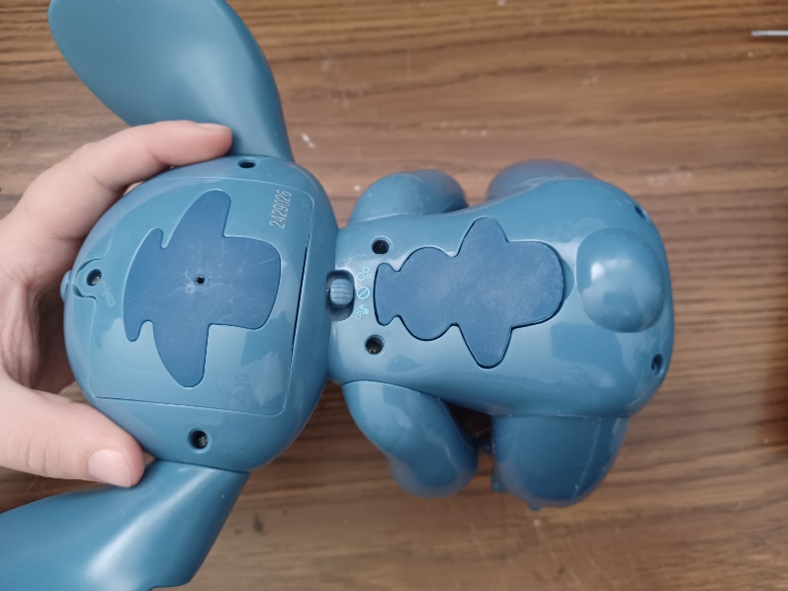
- After screws are undone, gently pull the body into two halves. Be very careful while doing this as to not pull off any existing wires or connections  If some pieces move, like the ears, just take notes of how everything fits together but they can also be set aside while you work on the toy. | 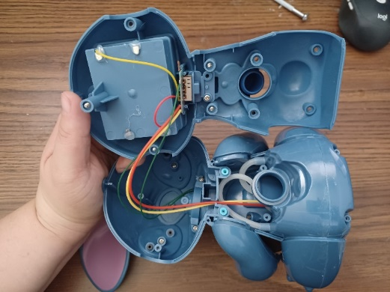
- Next we will prepare the mono jack and wires.  Cut 2 pieces of wire each 5 cms in length  Strip both ends of both wires, leaving about .5 cm of exposed wire on each end | 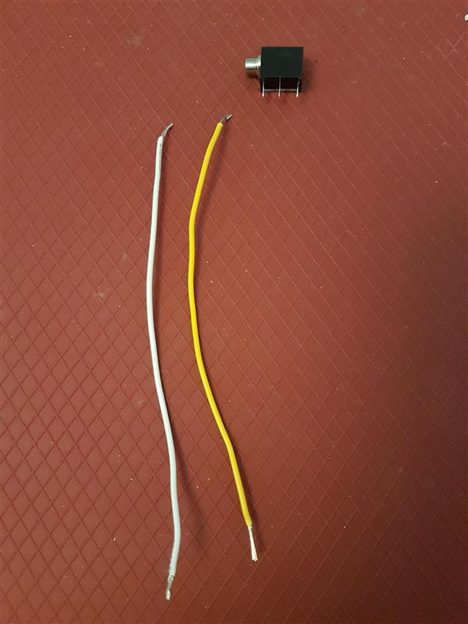  5 cm  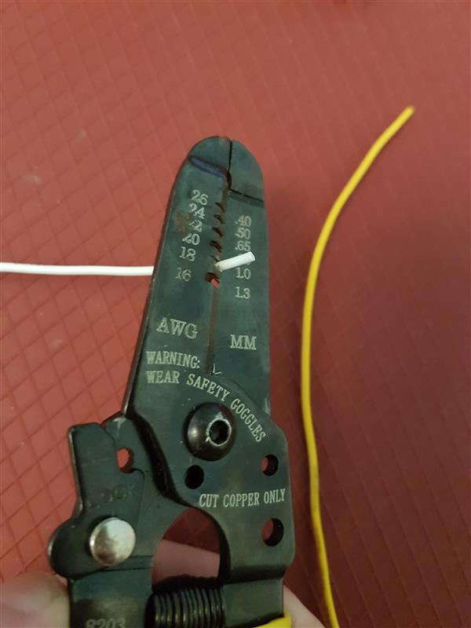
- Pick one wire, slide exposed wire into first metal arm on mono jack  With second wire, slide one end of exposed wire into the middle metal arm on mono jack  Solder wire to mono jack  Please Note: Check that you have the correct metal arms of mono jack, refer to picture | 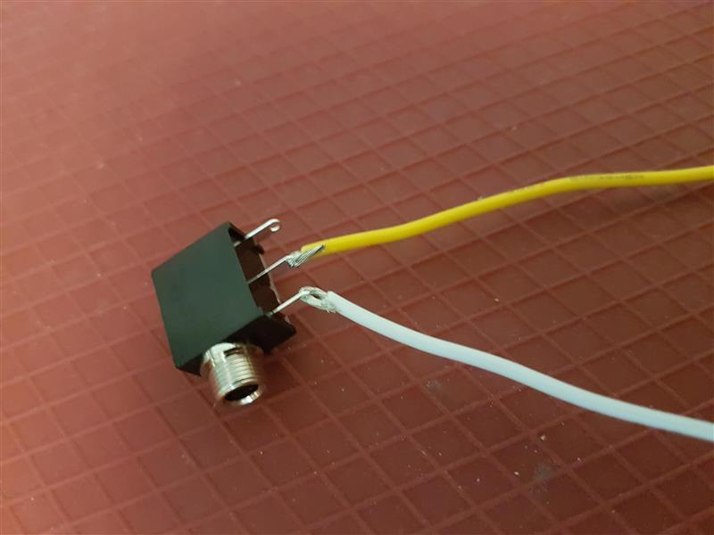
- Locate where the switch is located. There are 2 small screws, circled in red, and a blue piece of plastic holding the board down. Remove screws and blue plastic part and set aside in safe place. | 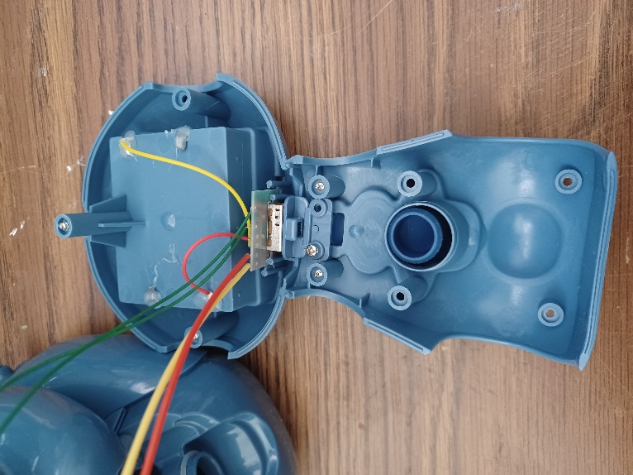
- With the screw removed, the board can be flipped over to show the wires and solder joints.  Locate the red wire on the board. This wire goes from the board to the battery compartment | 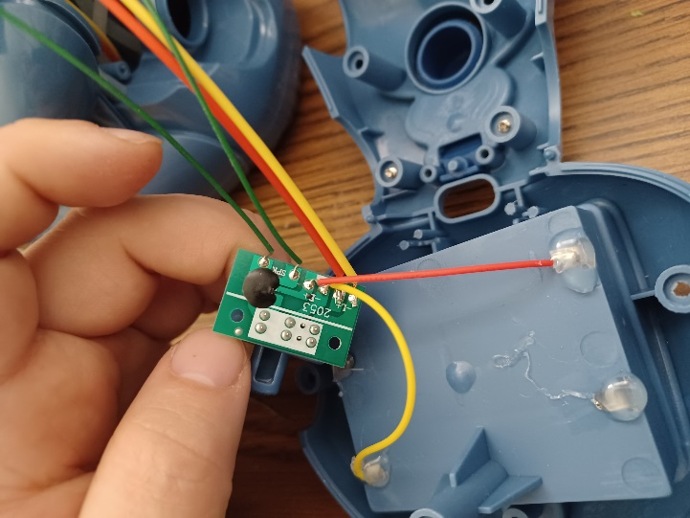
- You are going to remove the red wire from the board – but only the red wire  You will use your soldering iron to heat up on the solder on that spot, and then gently pull the red wire from that spot. | 
- Using the mono jack and wires you previously made, solder one wire to the red wire that you just removed from the circuit board. The red wire will now be connected to one of the new wires which leads to the mono jack.  Once the wires are soldered, wrap electrical tape around the area where the wires are now connected. This will just help secure the connection | 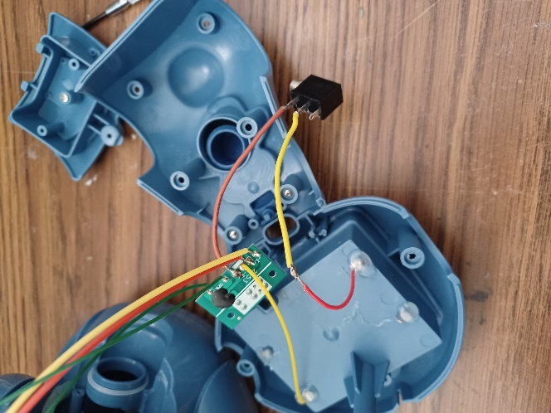
- Using the previous prepared mono jack and wires, connect the second wire (the first one was connected to the red wire) to the spot on the board where the red wire was previously  To solder the wire to the board, you may want to first add solder to the exposed part of the wire. Then, you will hold the wire on the connection point and use the soldering iron to heat up the solder that is already there  Once both wires are connected, you can also check the connections by using an assistive switch to test. Plug the switch into the input, slide the original switch to either music, or music + bubbles. The toy will be activated when the switch is pushed.  If the toy does not activate when the switch is pressed, or does not stop when the switch is no longer pressed, check the soldered connections. | 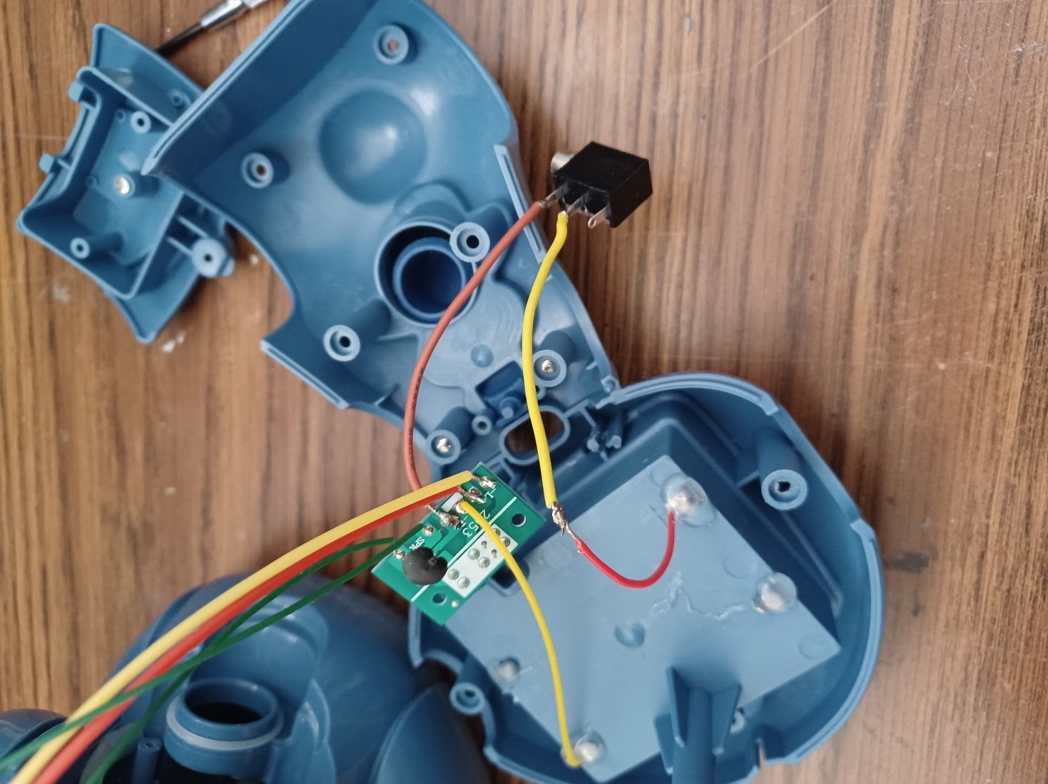
- With ¼ inch drill bit, you will drill hole in the plastic of the toy. This is so the mono jack, or input, can be accessed and a switch can be plugged in.  Before drilling, make sure your mono jack will reach the drilled hole. The hole can be drilled into the head about 4 cm above the neck.  Check that mono jack out end can fit through the hole to be accessed from outside | 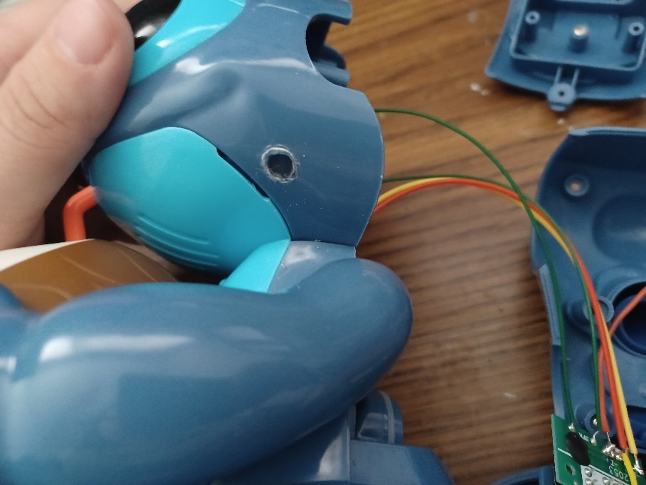
- Twist the ring onto the mono jack on the outside of the toy to secure the mono jack in place.  You will now reassemble the toy.  The circuit board can now be screwed back in its original spot.  Check that the sliding function of the original switch still works.  With everything in place, put the two halves of the toy together and add screws. | 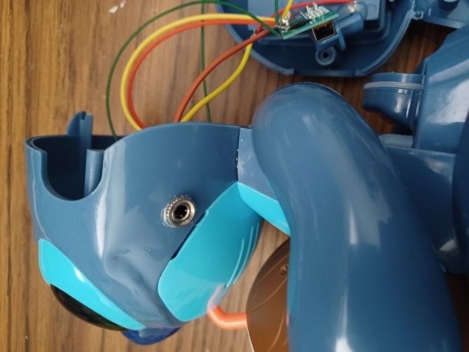  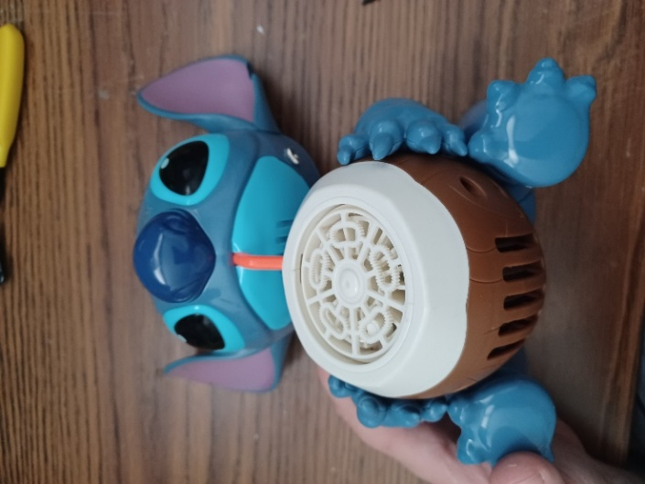
- You can check the toy again to make sure it works with an assistive switch once it is reassembled. If it does not, check connections inside – this includes looking at where wires may have been pinched when the toy was reassembled. | 