Required Components
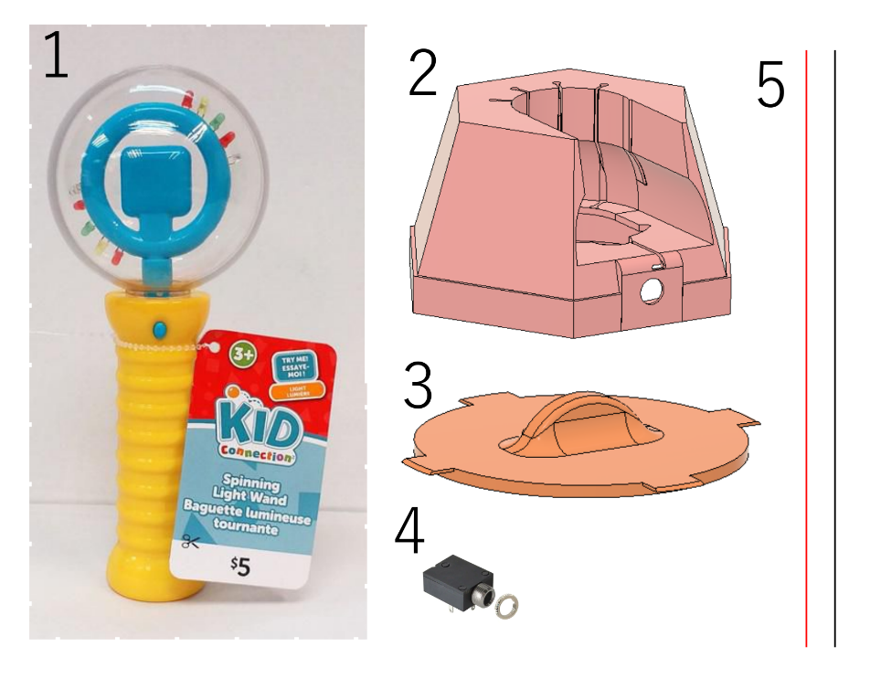 | BOM  - Spinning Wand Toy  - 3D Printed Base  - 3D Printed Base Bottom Cover  - 3.5 mm Mono jack  - 2X 20 cm 26AWG multi-core wire or stranded wire (24-26 AWG)

Required Tools
- #0 Phillips Screwdriver
- Flat head screwdriver
- Soldering Iron
- Hot Glue Gun
- Solder
- Hot Glue Sticks
- Super Glue

Required Personal Protective Equipment (PPE)
- Safety Glasses

Assembly Instructions

Step 1
Loosen the screw and remove the battery cover and batteries.  CAUTION! The springs on the battery contacts may cause the batteries to be ejected forcibly. | 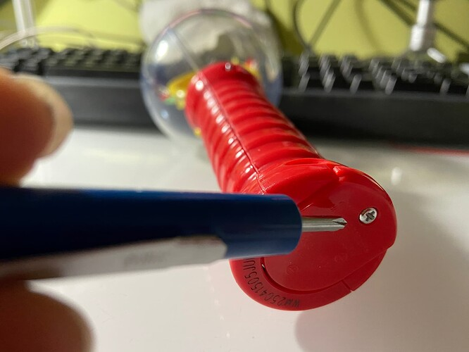

Step 2
Unscrew the four (4) screws on the back of the Spinning Light Wand. Store the screws for later reassembly.  CAUTION! Don’t lose the screws. | 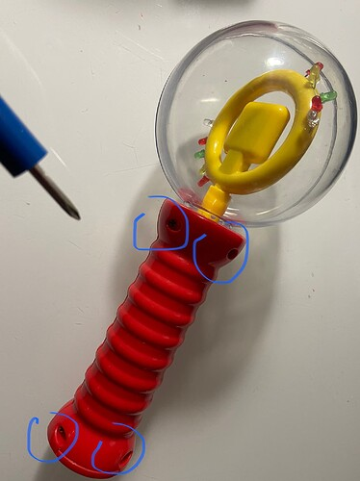

Step 3
Gently pry apart the two halves of the handle along the seam using a flat head screwdriver. | 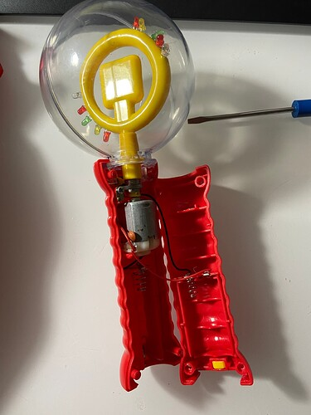

Step 4
Remove the screw holding the motor down, as shown in the photo, and remove the piece of metal contact. Keep the screw for later reassembly.  CAUTION! Don’t lose the screw or the metal contact. | 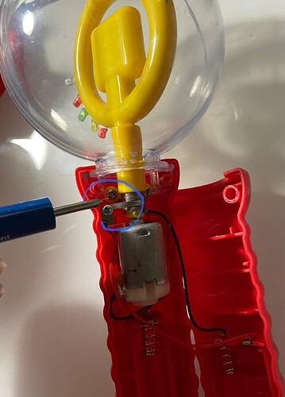

Step 5
Gently pry the clear globe free from the button half of the handle The motor and the clear globe is part of the same assembly, carefully lay all the parts out, and try and avoid putting strain on any of the solder joints. | 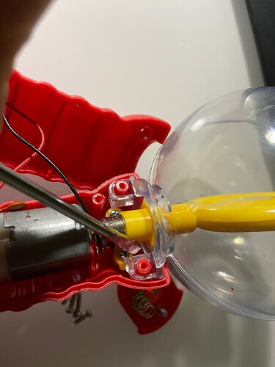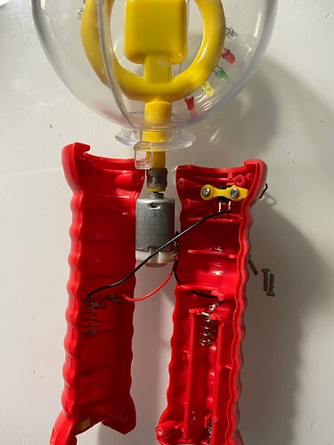

Step 6
De-solder the black wire from the top of the battery holder and the red wire on the other half from the bottom of the battery holder. For the red wire, it may be easier to loosen the screw to remove the wire from under the metal clip. | 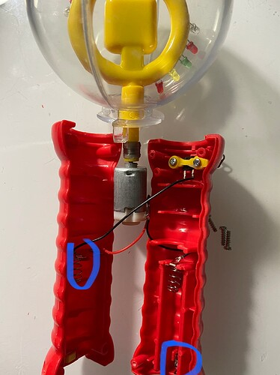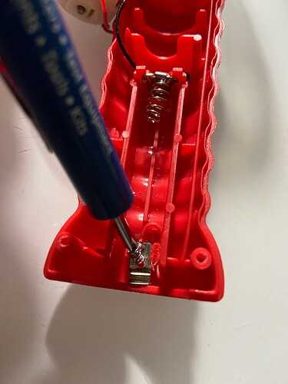

Step 7
Unscrew the screws attached to the yellow piece shown. Remove and discard the entire button assembly. They are no longer needed. | 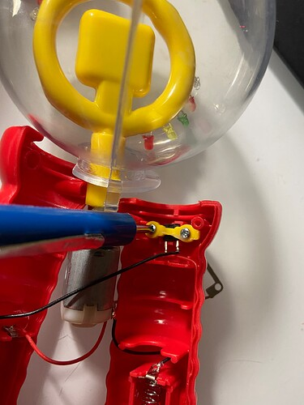

Step 8
Cut 2 pieces of wire 30cm long. Strip approximately 1cm of the insulation from one end of each of the wires. | 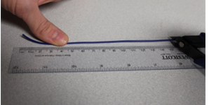

Step 9
Solder one of the wires to the bottom metal clip and route the wire as shown below. This is the same place where the original red wire was soldered. | 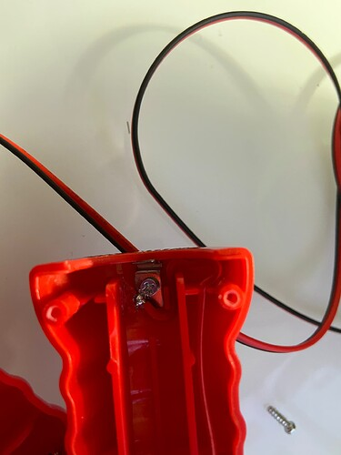

Step 10
Solder the second wire to the battery clip. This is the same place that the original black wire was desoldered from. | 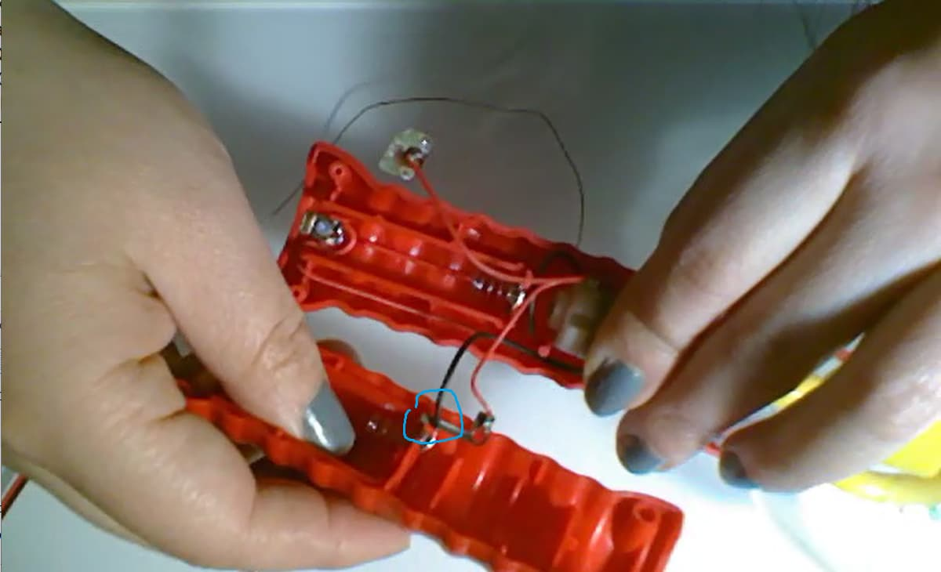

Step 11
Thread the wires through the hole that the button occupied. Avoid leaving too much slack on the wires inside as it might interfere with the moving bits. | 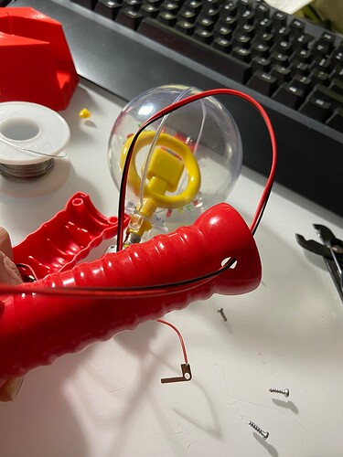
Step 12  Route the wires through the inside of the handle as shown. | 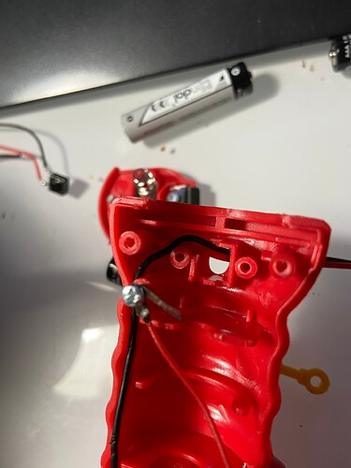

Step 13
Apply hot glue to fill up space between the wire and the hole, to add strain relief to the wire. | 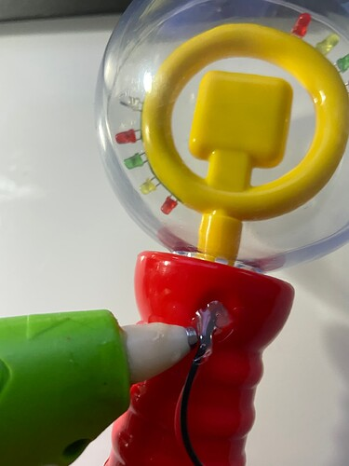

Step 14
Start reassembling the wand by putting the globe and motor assembly back into the half of the handle with the button hole. Note the alignment of the motor and the clear globe. See photos. | 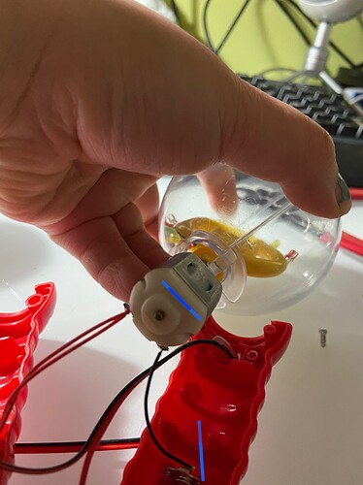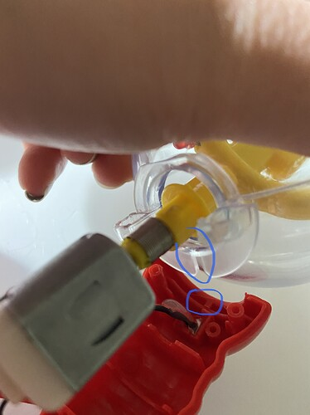

Step 15
Reattach the L-shaped metal contact. Replace the screw. | 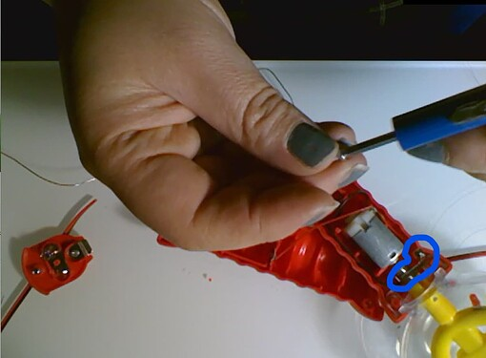

Step 16
Snap the handle closed, being careful not to pinch any wires inside. Replace all four screws. Re-insert the batteries and tighten the battery cover screw. | 

Step 17
Test the switch adaptation.
Strip the other end of the wire and touch them together. If all goes well, the motor should spin and the light would come on. If not, re-open the handle and check:
- wiring: no cold solder joints or frayed/pinched wires
- mechanical interference: now wires are rubbing on the axle
- the L-shaped metal piece is making good contact against the spring on the motor axle.

Step 18
Slide the wand into the stand. Make sure the battery cover is lined up with the opening in the stand. | 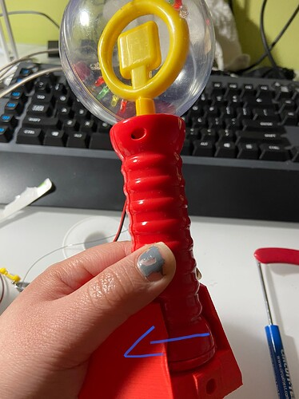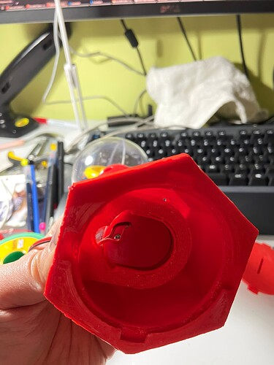

Step 19
Thread the wire through the opening of the stand. Solder the wires to a mono jack as shown in photo. The wires should attach to the tip and sleeve contacts on the jack. | 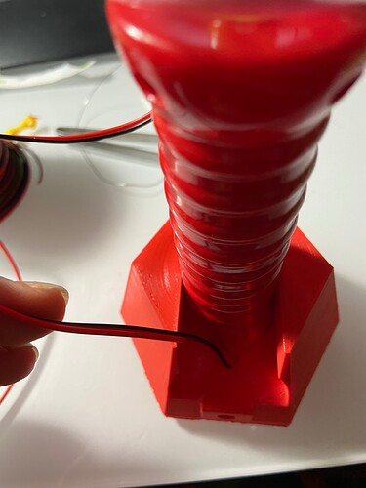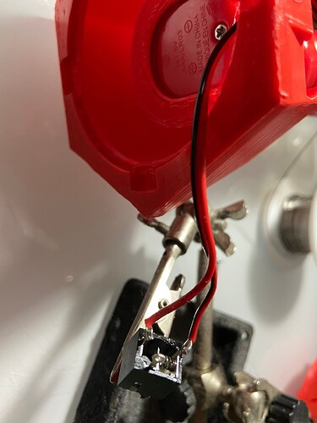

Step 20
Insert the jack into the hole in the base. Thread on the nut to secure the jack in place. | 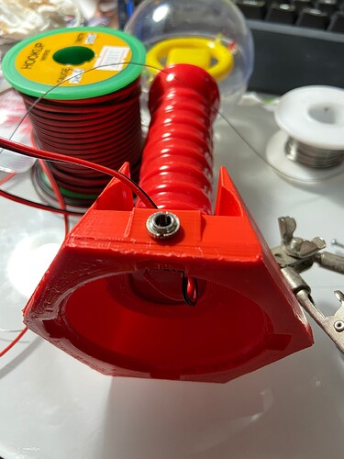

Step 21
Superglue something heavy like two hex nuts to the Base Bottom Cover to weigh the stand down. | 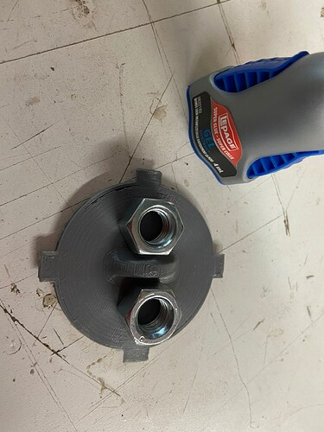

Step 22
Assemble the base bottom cover into the base.

