Required Components
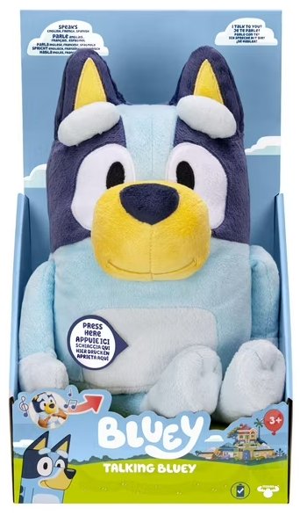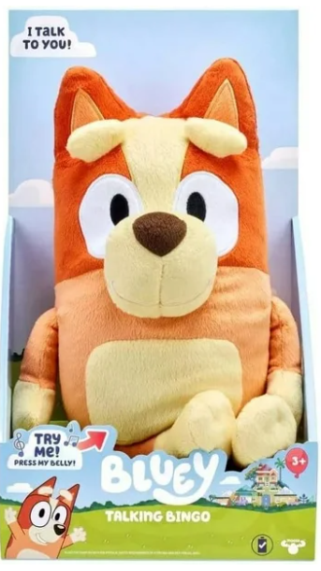 | 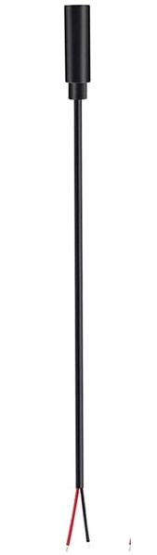 | BOM  - Moose Toys - Talking Bluey or Bingo Plush Toy (Bluey – Amazon)  - 7” cable with 3.5 mm jack (female) end  - Cable tie (small – around 15 cm)  - Cable tie (large – around 35 cm)  Refer to the Tool and Component List for purchasing details.
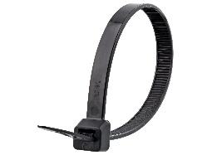 | 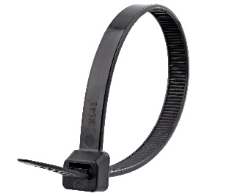

Required Tools
- Phillips Head Screwdriver
- Wire strippers
- Flush cutters
- Soldering iron and solder
- Drill and 1/8” drill bit

Required Personal Protective Equipment (PPE)
- Safety glasses

Assembly Instructions
- To start, pull the inside compartment from inside the toy. The compartment is connected and may need to be wiggled a bit to be pulled free  - Locate the original cable tie. It will be in the seam of the fabric going around the plastic compartment.  - Find an opening (you may have to snip a bit of fabric) to then snip the cable tie. When this happens, the plastic will be free from the fabric | 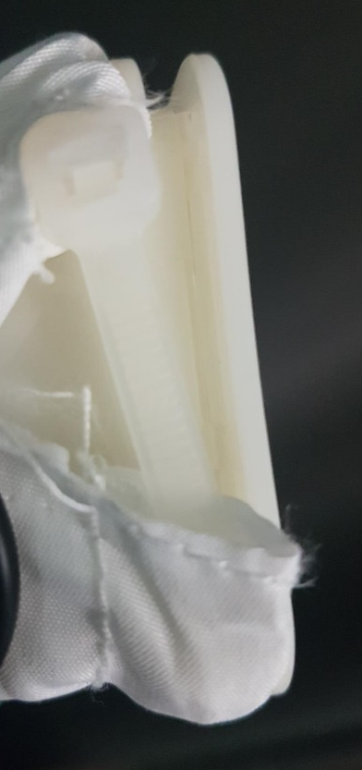
- Locate the screws on the back of the compartment and unscrew them to reveal the internal circuit board.  Gently open compartment. | 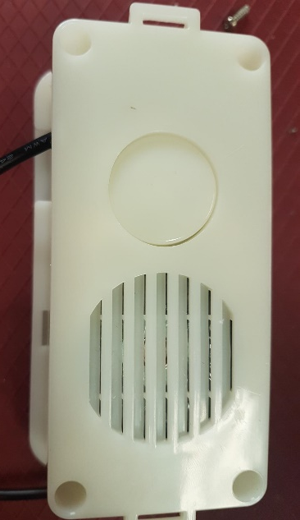
- Using a 1/8 inch drill bit, you will drill a hole for your mono cable. The mono cable will be threaded through the hole and then soldered onto the board, so this needs to be done before soldering.  The hole will be drilled into the side of the plastic compartment, the larger “bottom” part to the right side of the original large plastic button. | 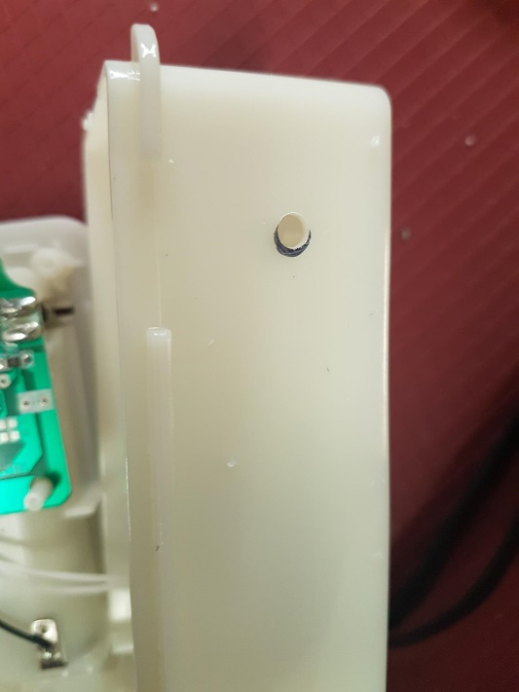
- Next you will prepare your mono cable by tinning your wire. The best way to do this is cover the exposed wire in solder. You will use your soldering iron and melt solder onto the exposed wire end and this will help you solder onto the board.  Thread your cable through the hole you drilled. | 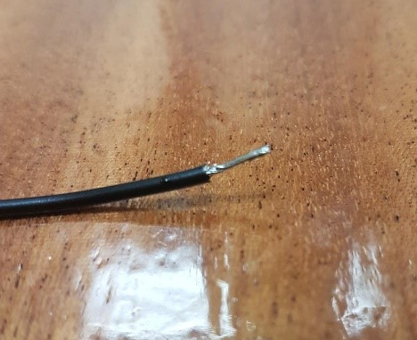
- The circuit board has a grey, silicone square. For this toy, a plastic button pushes the silicone square onto the circuit board and activates the toy. Under this, are the spots you will solder your wires. | 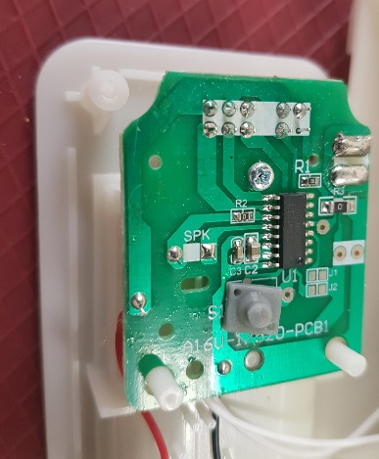
- You can take the silicone square completely off or pull one corner up and tape to the side to access the board underneath.  Now you will see silver circle with a zig zag and two very small circles next to it.  The small circles are indicated in red. | 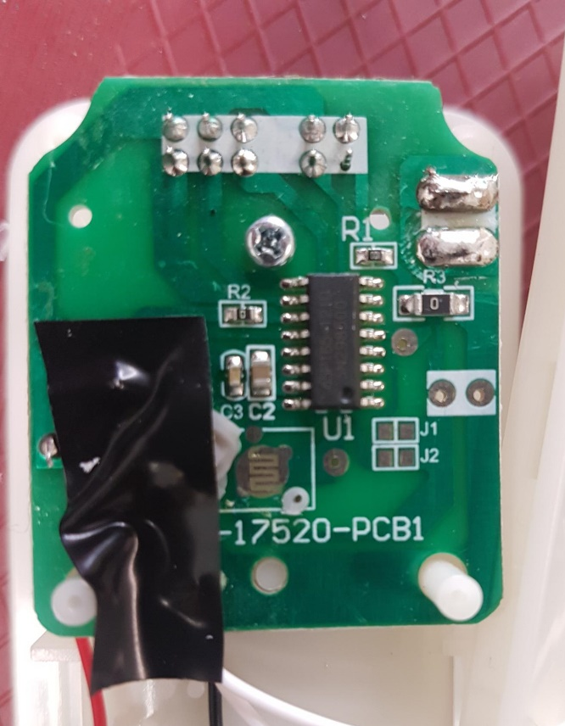
- You will be connecting your wires to the small circles, one wire soldered to each spot.  To do this, you can gently add solder to the board. On each circle, add a small blob of solder. This will give you a spot to connect the wire to. | 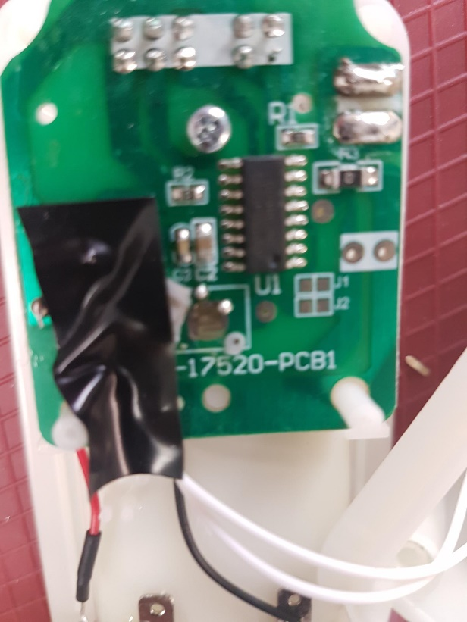
- To connect the wires, touch one of the tinned wires from your cable to your new solder blob. Use your soldering iron to heat up the solder blob and the solder on your wire. This should allow for the wire to stick to that spot on the board.  - Repeat with your other wire onto the other blob.  Please note: It does not matter which wire is connected to which spot on the board. | 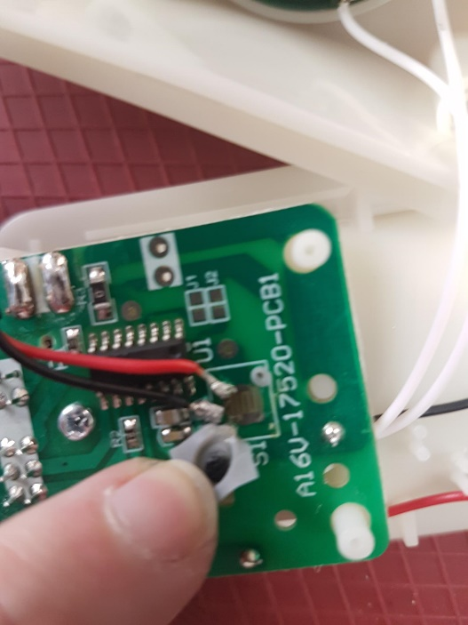
- Before we reassemble, you can test the toy by plugging a switch into the cable. When the switch is activated, Bluey will talk.  If there any issues, check the connections and that solder is not on any spots of the board it should not be.  - Next attach your small cable tie around the cable on the inside of the plastic compartment. This is to help with the cable from being pulled back through the hole. | 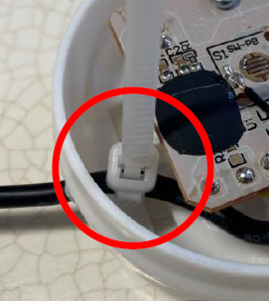
- You can now prepare to close the compartment. If possible, you can put the grey silicone square back on the board, however this may be difficult as the new wires may be in the way. Add the plastic button back into the compartment, it will no longer activate Bluey if the silicone is not there which is alright as we will now be activating the toy by cable. |  | 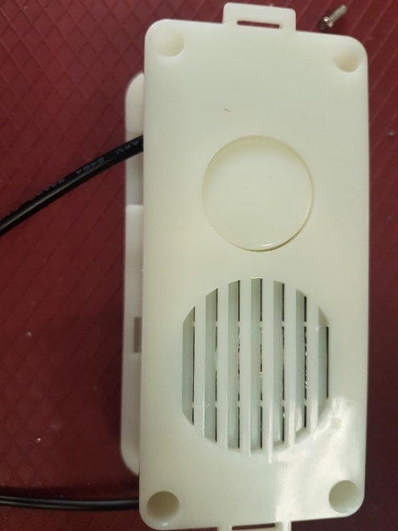
- Add the screws and close the plastic compartment.  - Locate your large cable tie and thread it through the seam in the fabric. Add the compartment back into the fabric and notice the ridge on the plastic compartment which the cable tie will go around. When the compartment and fabric is in place, tighten the cable tie so it is secure. |  | 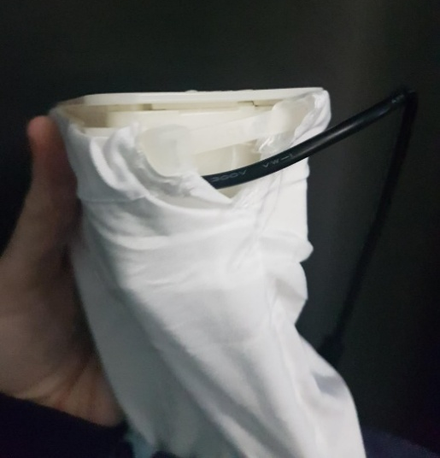
- Put the compartment back inside Bluey and close the Velcro, except for the cable. The cable should be hanging out the back so a switch can be attached for use.  - If possible, put Bluey back into its original box and seal – toy is complete! |  | 